Assignment1.2:

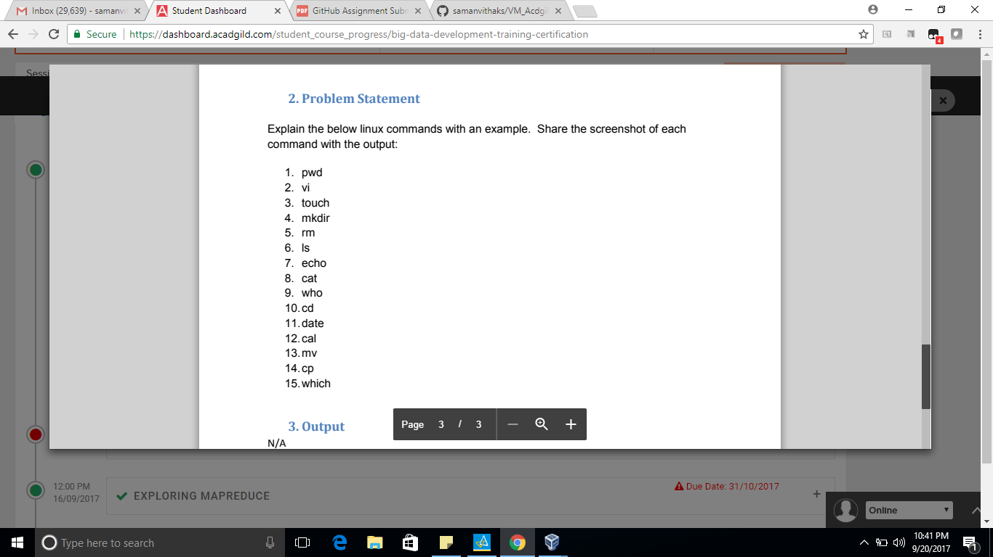

Linux commands as find below,

1. Pwd: pwd command (print working directory) writes the full pathname of the current working directory to the standard output.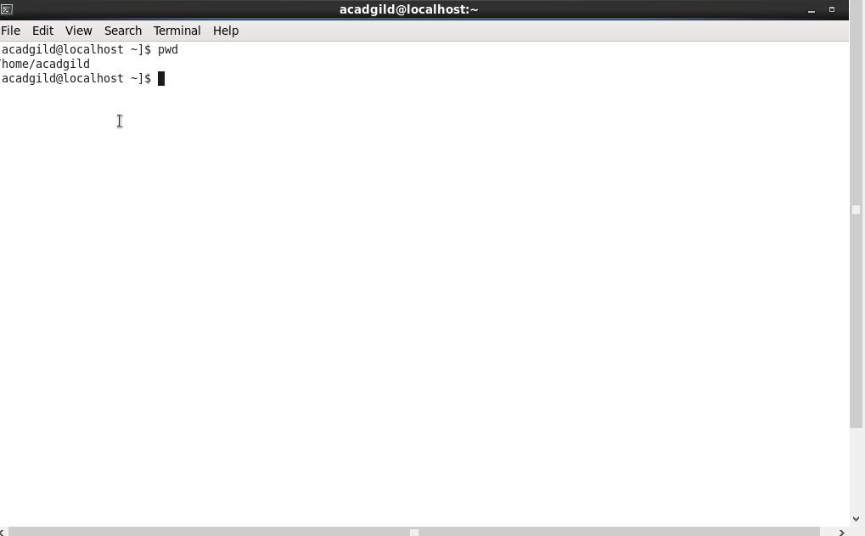

2)VI Editor: vi is a screen-oriented text editor originally created for the Unix operating system

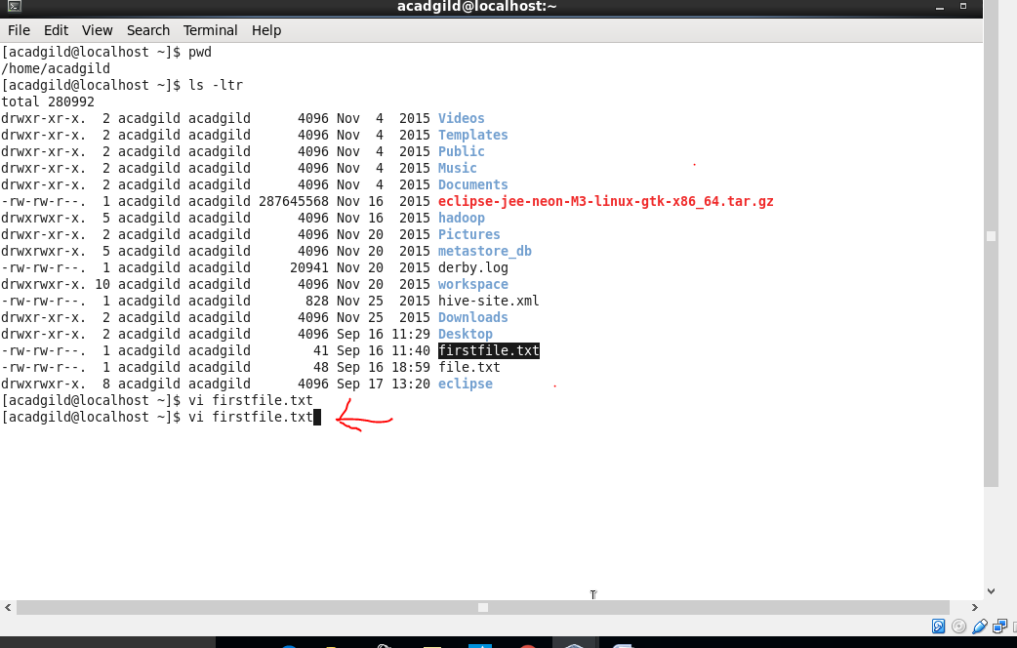

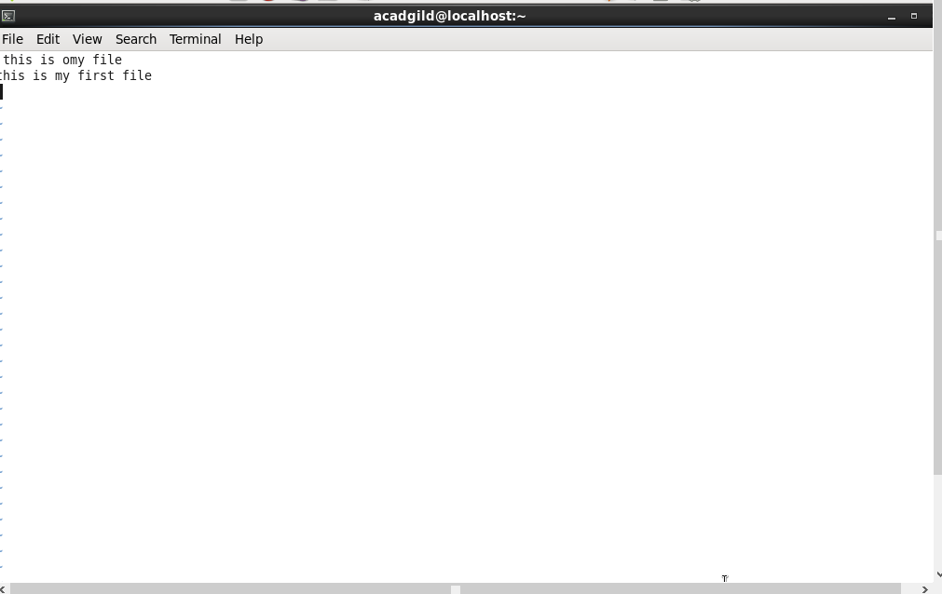

3)Touch: touch is a standard Unix command-line interface program which is used to update the access date and or modification date of a file or directory.

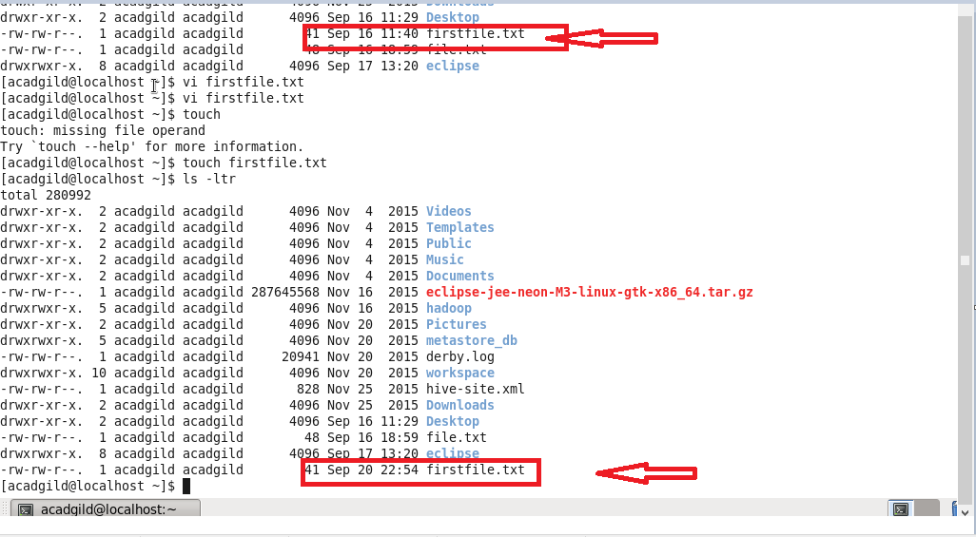

4)Mkdir: The mkdir command creates a single directories or multiple directories.

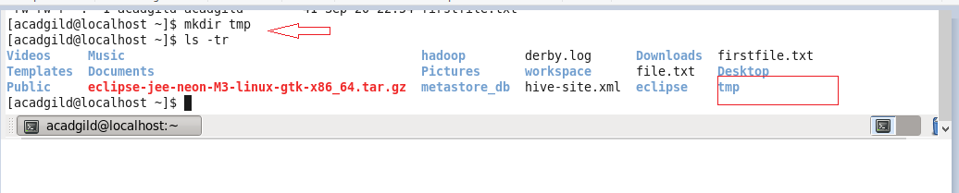

5)Rm: Rm (short for remove) is a basic UNIX command used to remove objects such as files, directories, device nodes, symbolic links, and so on from the filesystem.

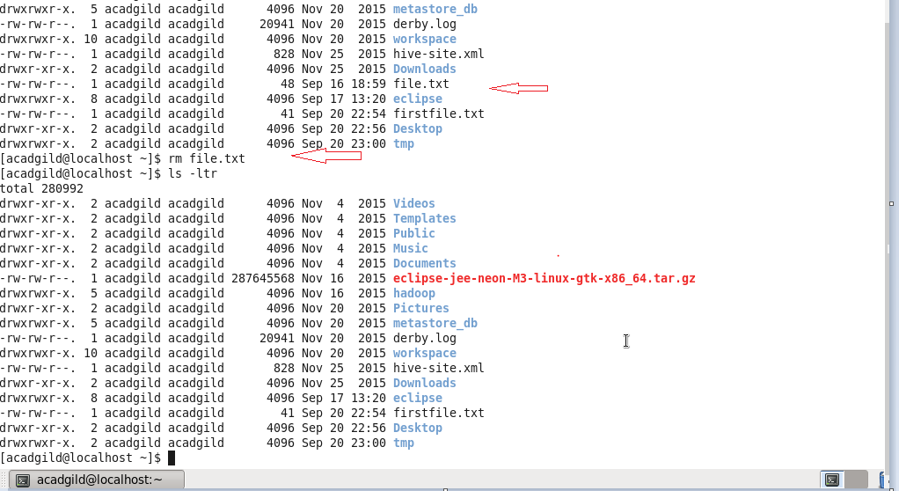

6)ls: The ls command lists all files in the directory that match the name

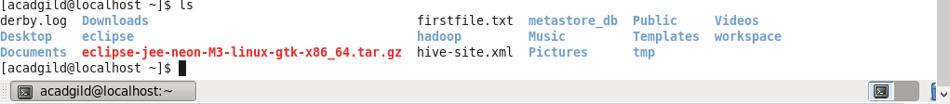

7)Echo: echo is a built-in command in the bash and C shells that writes its arguments to standard output.

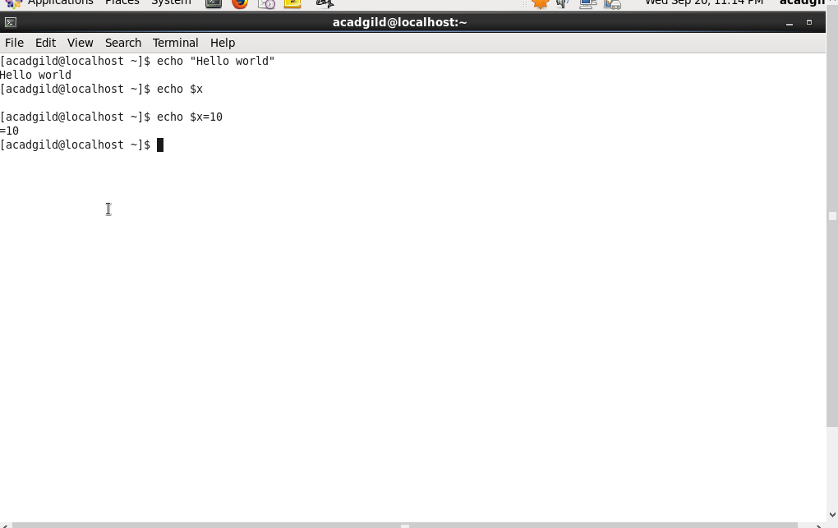

8)Cat: Shows the contents of the file.

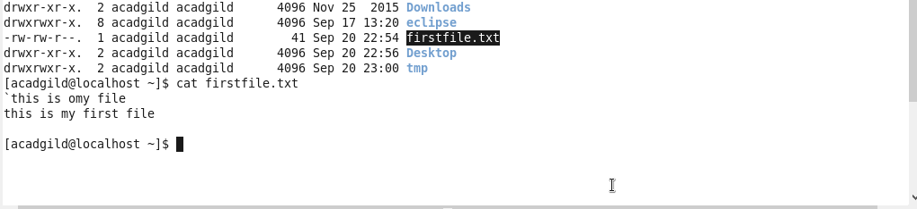

9)Who: Command will show the user details



10)Cd: The cd command is used to change the current directory (i.e., the directory in which the user is currently working) in Linux and other Unix-like operating systems.

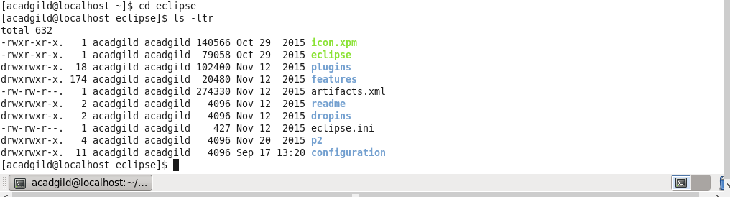

11)Date: UNIX date command examples, syntax and help. Explains how write the date and timeusing a shell prompt.



12)Cal :  The command "cal" displays a calendar.

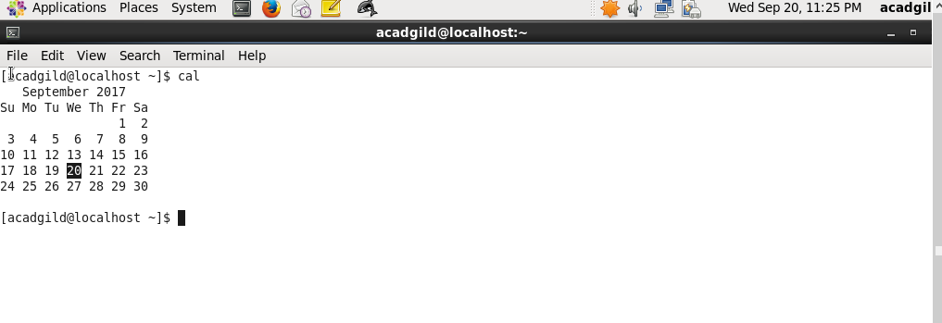

13)Mv : mv command is used to move files and directories

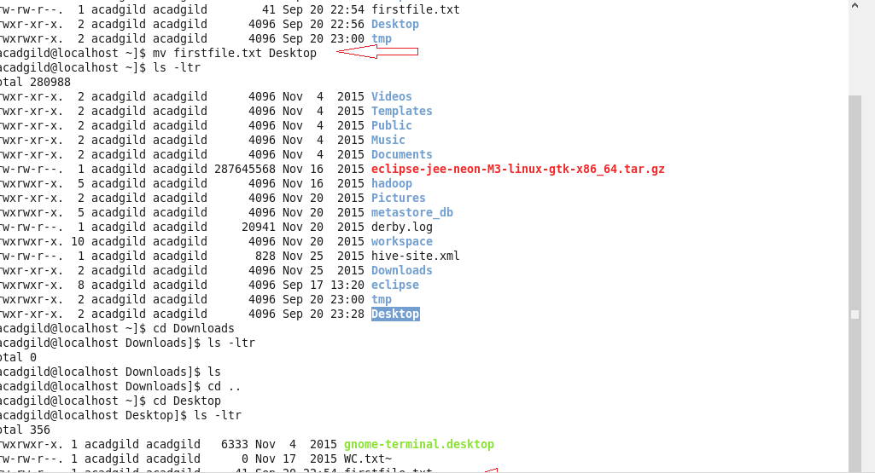

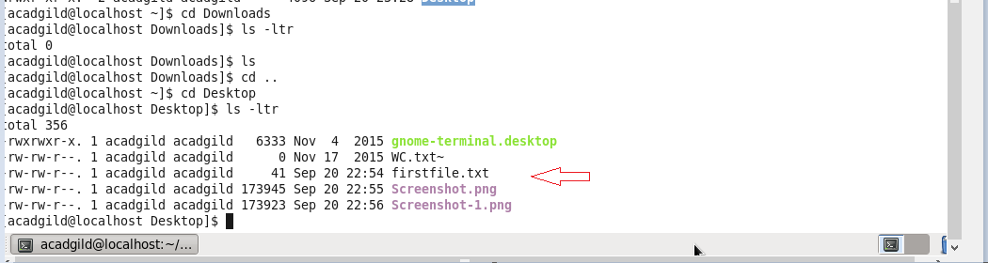

14)Cp: cp is a UNIX command for copying files and directories

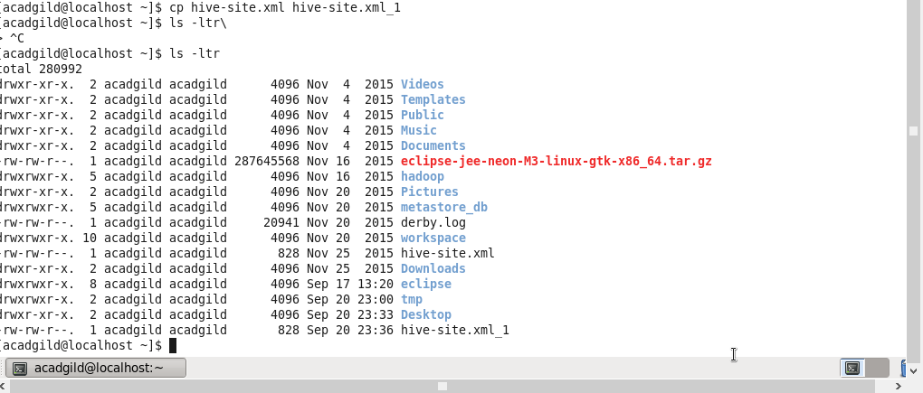

15)Which: which is a Unix command used to identify the location of executables

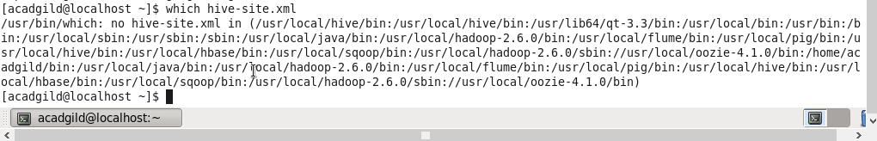

\*\*\*\*\*\*\*\*\*\*\*\*\*\*\*\*\*\*\*\*\*\*\*\*\*\*\*\*\*\*\*\*\*\*END\*\*\*\*\*\*\*\*\*\*\*\*\*\*\*\*\*\*\*\*\*\*\*\*\*\*\*\*\*\*\*\*\*\*\*\*\*\*\*\*\*\*\*\*\*\*\*\*\*\*\*\*\*\*\*\*\*\*\*\*\*\*