**Assignment 7.1**

Created the file **emp_details.txt** and loaded into **/user/acadgild**

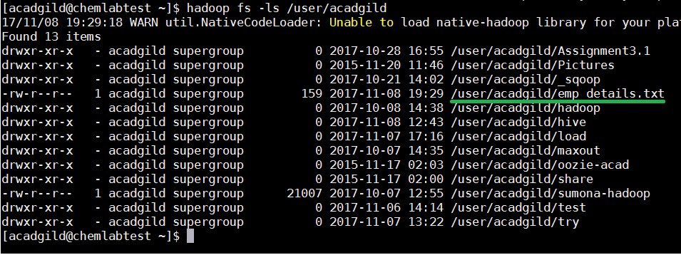

Created the table **emp_details** and loaded the **emp_details.txt** file.

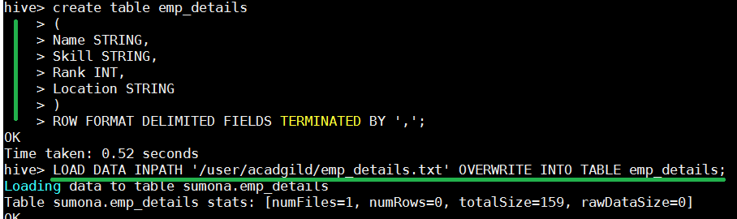

Command to calculate the number of employee’s for each skill:



**Output:**

