Assignment 8.1

Problem Statement 1 :-

Get a list of employees who receive a salary less than 100, compared to their immediate employee with higher salary in the same unit

Solution:-

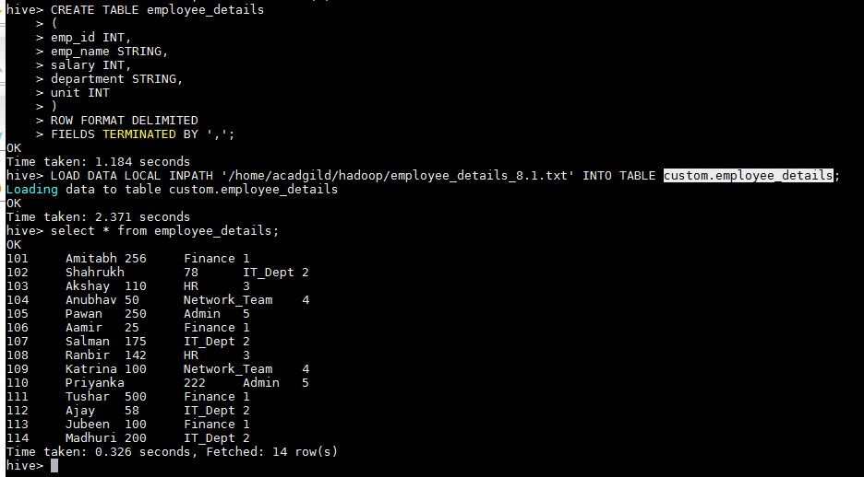

SELECT emp_name,department,salary FROM employee_details where salary <

100 GROUP BY emp_name,department,salary;

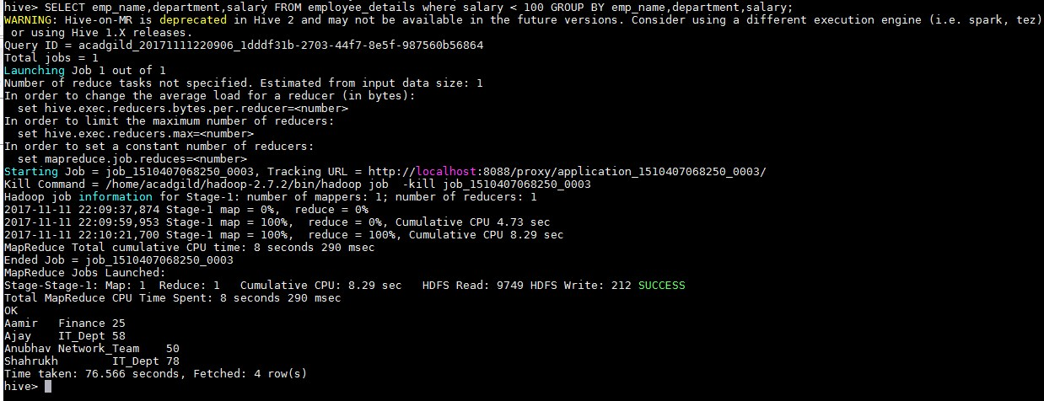

Problem Statement 2 :-

List of all employees who draw higher salary than the average salary of that department

Solution:-

Suppose we want list of all employees who draw higher salary than average salary of Finance department than we ran below command :- select avg(salary) from employee_details where department = 'Finance';

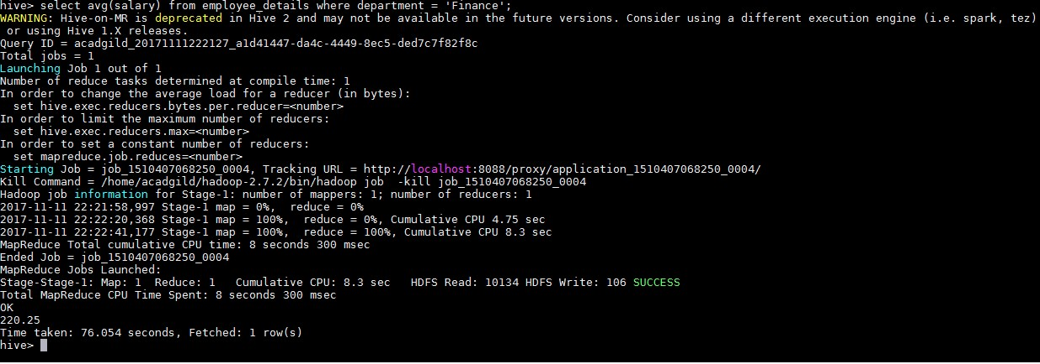

select * from employee_details where department = 'Finance' AND salary > 220.25;

