**ASSIGNMENT 13.1**

***Problem Statement:***

*Createa Scala applicationto findtheGCD of two numbers.Solution:-*

*CD(Greatest Common Divisor)orHCF(Highest CommonFactor)of twonumbersis thelargestnumber thatdividesbothofthem.*

*For example:-36=2 x2x 3x3*

*60=2 x2x 3x5*

*GCD=Mulipicationofcommon factors*

*=2x 2x 3= 12*

*Thus,ScalaApplicationto findGCDof two numbersisas follows:-objectGCD{*

*defgcd(a:Int,b:Int): Int={if(b==0)a elsegcd(b,a%b)*

*}*

*defmain(args: Array[String]){println(gcd(36,60))*

*}*

*}*

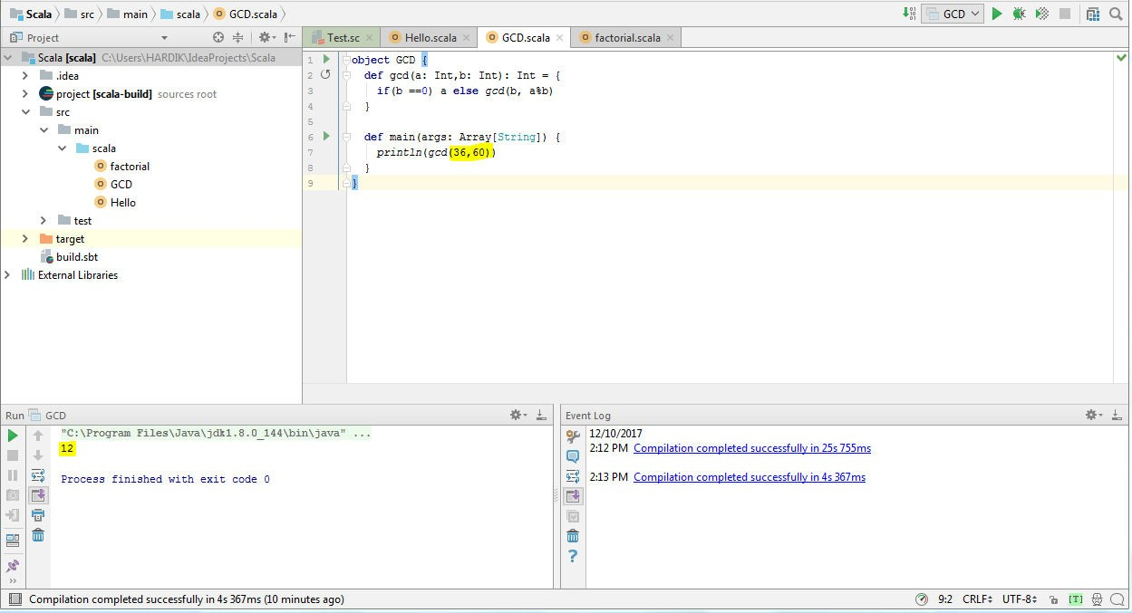

*Thannow trywithothersetofnumbersas 20and 2820=4 x5*

*28=4 x7*

*GCD=4*

