**Problem Statement**

Implement the below blog at your end and send the complete documentation

.

<https://drive.google.com/file/d/0B_Qjau8wv1KoUThzZ24tT1NsZGs/view?usp=sharing>

Question 1 Solution Screen-shot

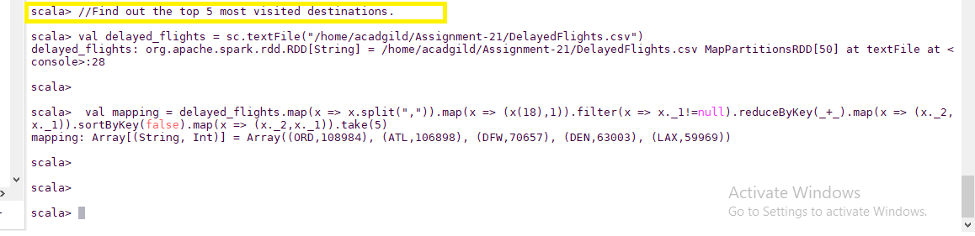

Question 2 Solution Screen-Shot

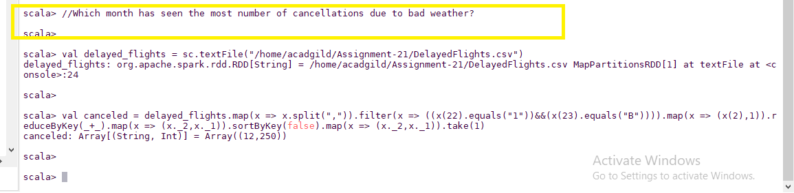

Question 3 Solution Screen-Shot

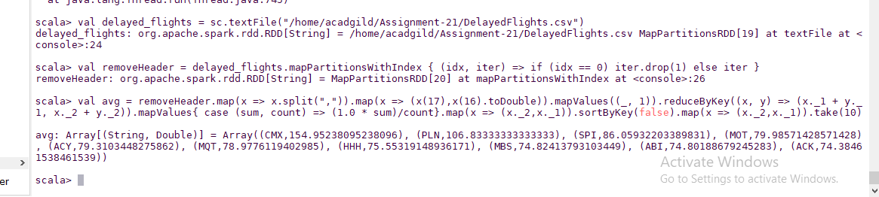

Question 4 Solution Screen-Shot

