**ASSIGNMENT5.1**

**(a) Top 5 employees (employee id and employee name) with highest rating. (In case two**

**employees have same rating, employee with name coming first in dictionary should get preference).**

**Solution:**



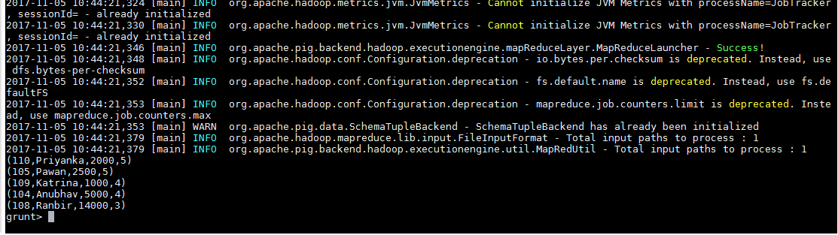

**(b) Top 3 employees (employee id and employee name) with highest salary, whose employee id**

**is an odd number. (In case two employees have same salary, employee with name coming first**

**in dictionary should get preference)**

**Solution:**





**(c) Employee (employee id and employee name) with maximum expense (In case two**

**employees have same expense, employee with name coming first in dictionary should get**

**preference)**

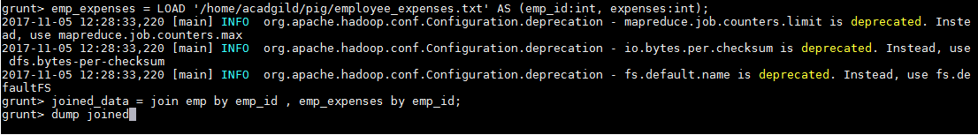











**(d) List of employees (employee id and employee name) having entries in employee_expenses**

**file.**

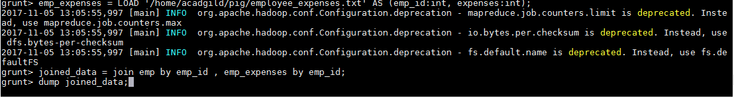

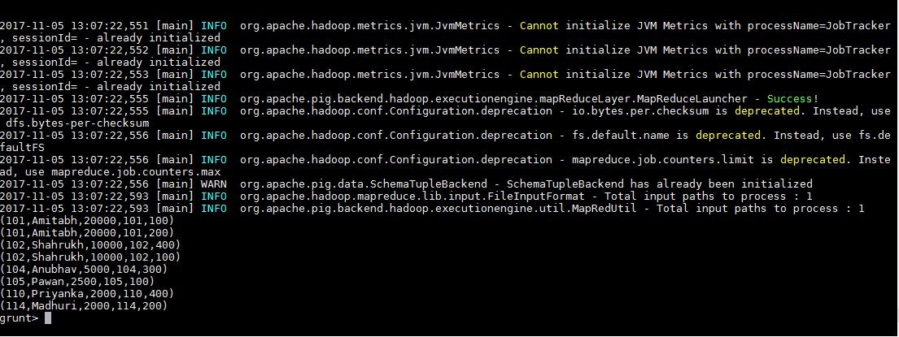

**(e) List of employees (employee id and employee name) having no entry in employee_expenses**

**file.**

