**ASSIGNMENT5.3**

**Ques 1: Find the list of players that have been selected in the qualifying round (DEFENCE>55).**





The dataset is filtered, and hence out of all the 800 Pokémons, only 544 are eligible to take part in the tournament.

#### Ques 2: State the number of players taking part in the competition after getting selected in the qualifying round.



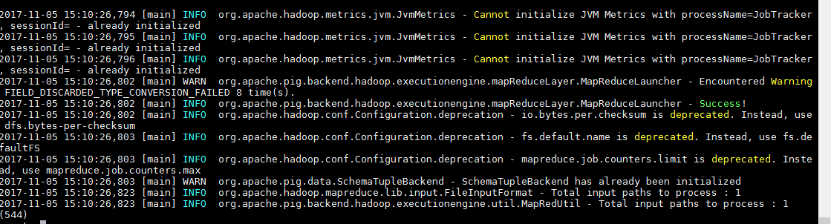

So, All the 544 players taking part will be alphabetically arranged and two teams of 5 Pokémons need to be extracted out randomly from the earlier list.

#### Ques 3: Using random() generate random numbers for each Pokémon on the selected list.



Hence sample for the list after adding random numbers:

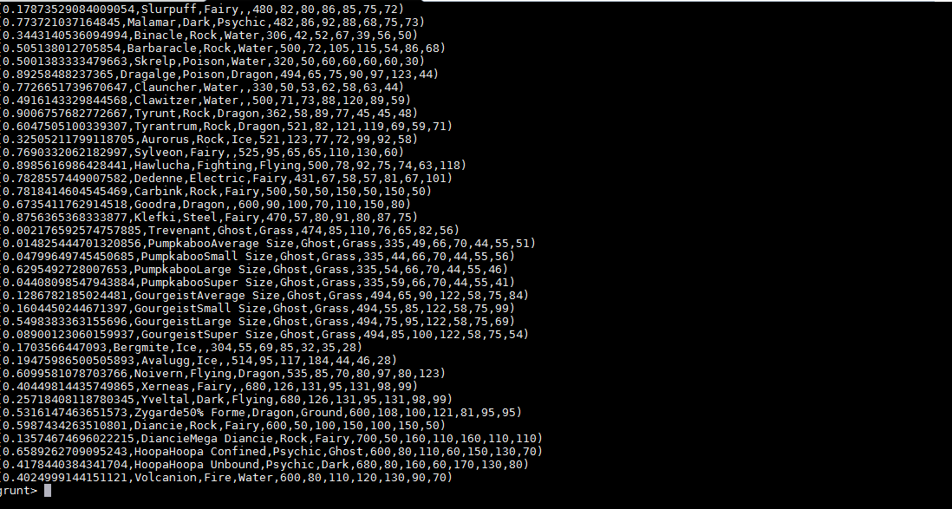

#### Ques 4: Arrange the new list in a descending order according to a column randomly.

**Explanation**: This will give us consequently a layer arranged to pick the random list which 1st player will choose.



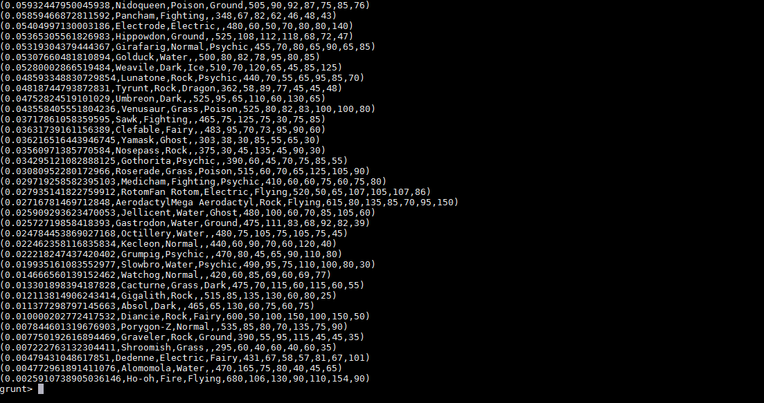

#### Ques 5: Now on a new relation again associate random numbers for each Pokémon and arrange in descending order according to column random.

**Explanation**: We will be repeating above two steps again to form the 2nd list.



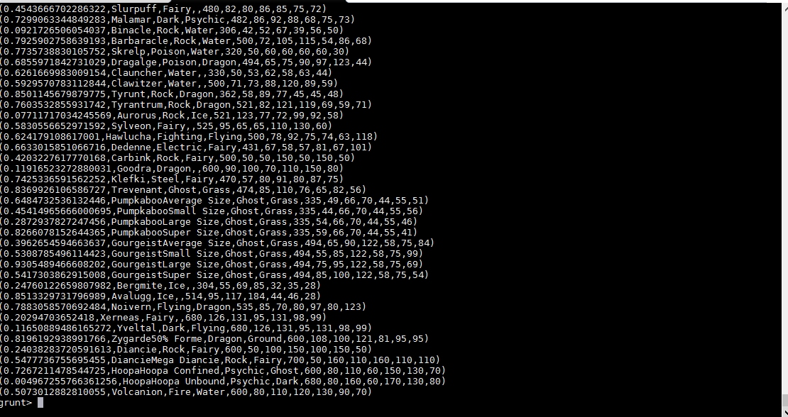



Hence sample for the list.

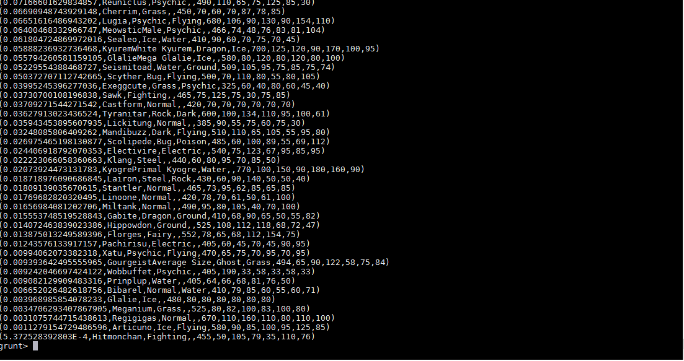

#### Ques: From the two different descending lists of random Pokémons, select the top 5 Pokémons for 2 different players.

**Explanation**:

*Commands*



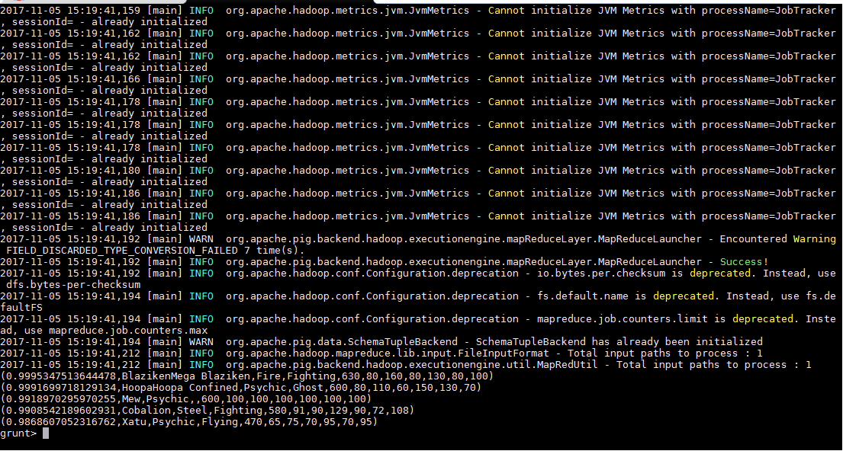



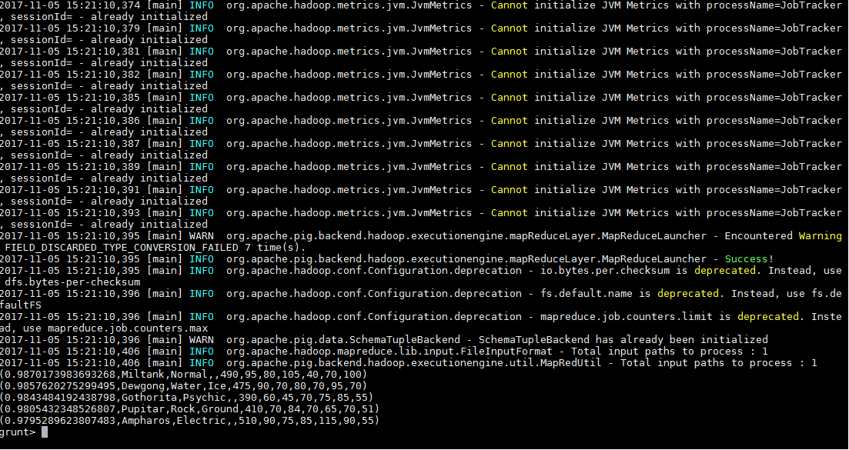

#### Ques: Store the data on a local drive to announce for the final match. By the name player1 and player2 (only show the NAME and HP).

**Explanation**:



