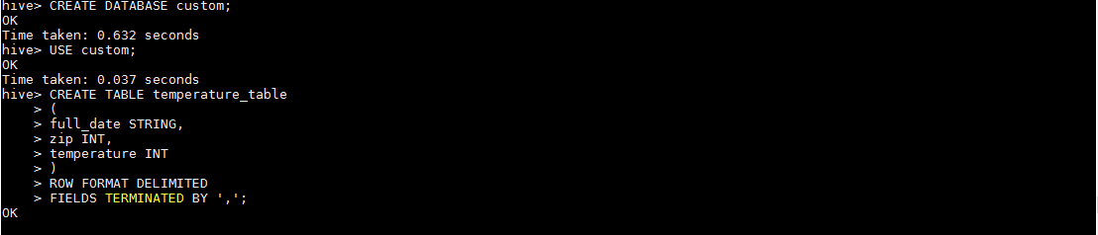

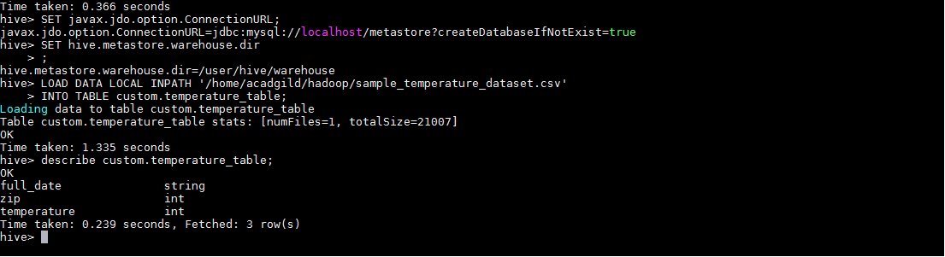

**ASSIGNMENT6.1**

**Problem Statement:**

Create a database named 'custom'.

Create a table named temperature_data inside custom having below fields:

1. date (mm-dd-yyyy) format

2. zip code

3. temperature

The table will be loaded from comma-delimited file.

Load the dataset.txt (which is ',' delimited) in the table.

