**Assignment6.2**

**Problem Statement:**

1. **Fetch date and temperature from temperature_data where zip code is greater than 300000 and less than 399999.**

**Steps**

hive> **select full_date,zip,temperature from saman.temperature_table where zip BETWEEN 300000 and 399999;**

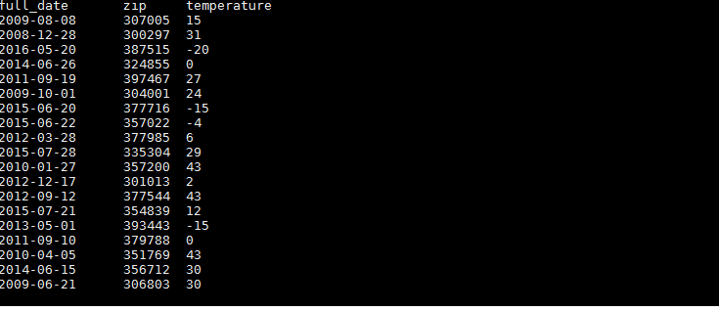

1. **Calculate maximum temperature corresponding to every year from temperature_data table.**

**Steps:**

**hive> select SUBSTR(full_date,-10,4),MAX(temperature) from saman.temperature_table GROUP BY SUBSTR(full_date,-10,4);**

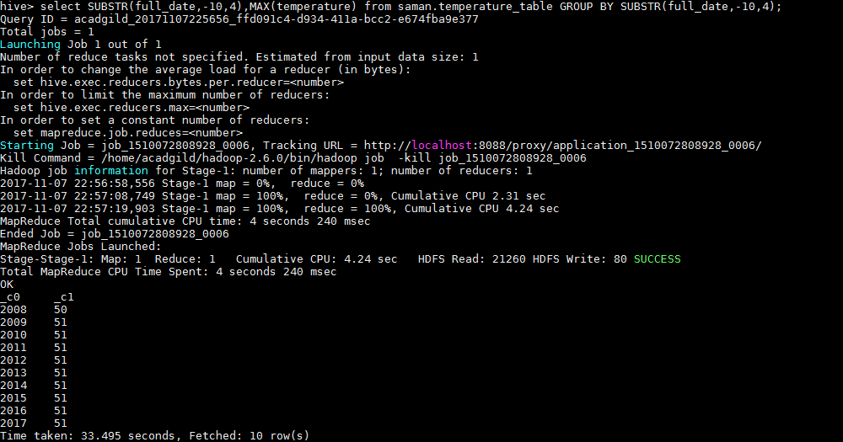

1. **Calculate maximum temperature from temperature_data table corresponding to those years which have at least 2 entries in the table.**

**hive>select SUBSTR(full_date,-10,4),MAX(temperature) from saman.temperature_table GROUP BY SUBSTR(full_date,-10,4);**



1. **Create a view on the top of last query, name it temperature_data_vw.**

**Steps:**

**hive>CREATE VIEW AS temperture_data_vw**

**SELECT * FROM saman.tempearture_table;**

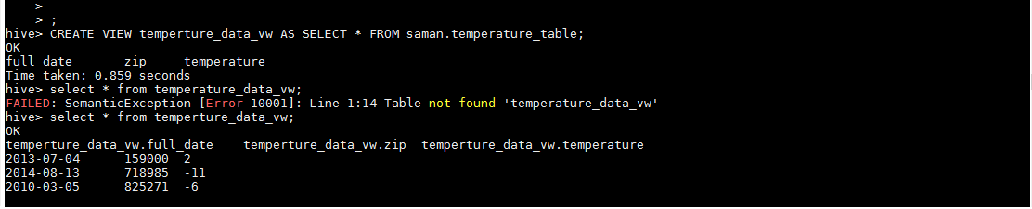

**e)** **Export contents from temperature_data_vw to a file in local file system, such that each**

**file is '|' delimited.**

**Steps:**

**hive> INSERT OVERWRITE LOCAL DIRECTORY'/home/acadgild/hadoop/temperture_data_vw.txt' ROW FORMAT DELIMITED FIELDS TERMINATED BY'|’ SELECT * FROM temperture_data_vw ;**

