**Assignment 7.2**

Loaded the **Olympics_data.csv** into **/user/acadgild**. Created the table **Oylmpics_data** and loaded the **Olympics_data.csv** file in the table.

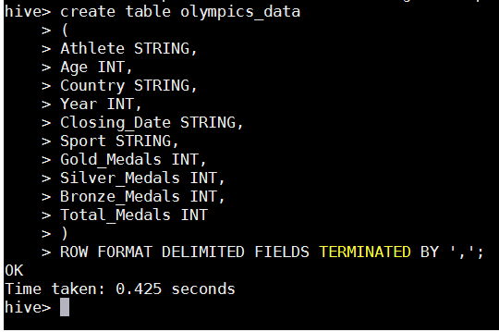

1. Numbers of medals won by each country for Swimming

**Command:**



**Output:**

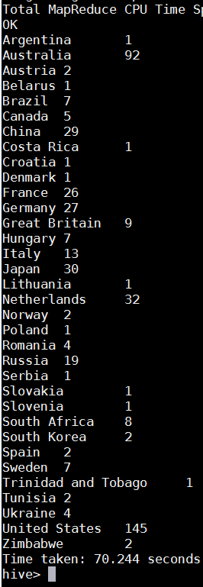

1. No. of medals won by India year wise.

**Command :**

SELECT Year, COUNT(Total_Medals) FROM olympics_data WHERE Country="India" GROUP BY Year;

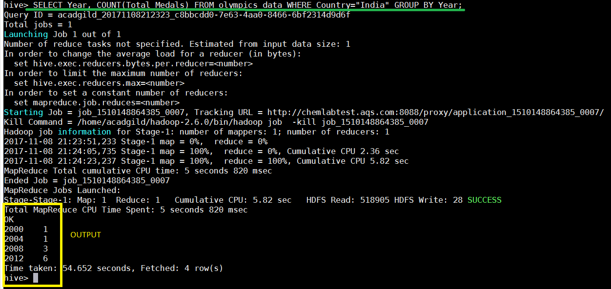

1. Number of medals won by each country

**Command:**



**Output:**

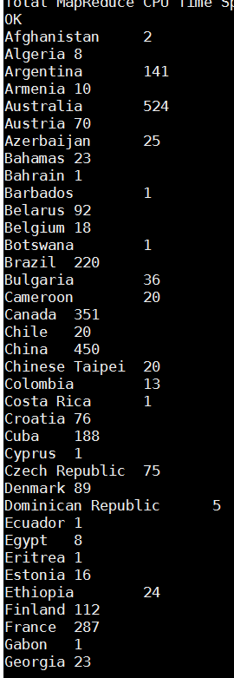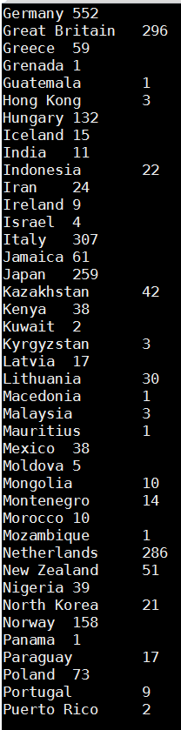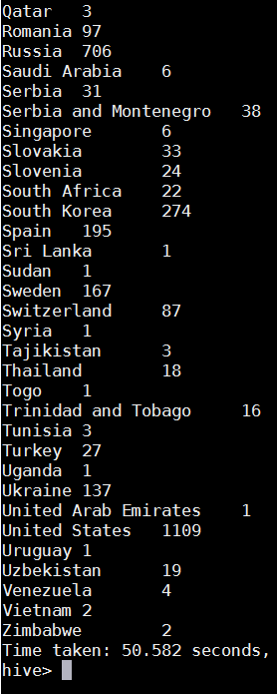

1. Number of Gold medals won by each country

**Command:**



**Output:**

