**Assignment-2.1**

**Task 1**: Check whether /user/acadgild directory exists or not in the HDFS.

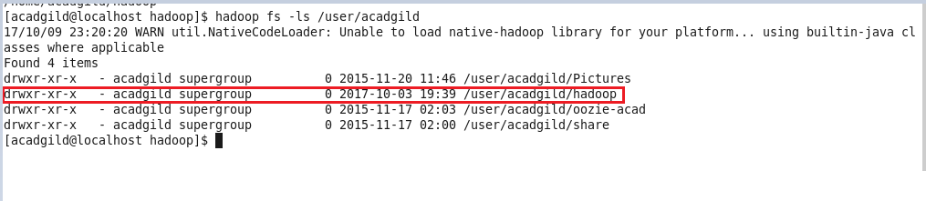

**Task2**: Create a file in HDFS under directory /user/acadgild/hadoop, with name word-count.txt.

Whatever we type on screen should get appended to the file.

