Intelligent Data Architectures
Fall 2026 - Project Specification
An Automated DWH + BI Pipeline based on Data Engineering! - Weightage: 30% + Bonus 3%
Project Overview
This course project integrates Data Warehousing (DWH) and Business Intelligence (BI) into a Data Engineering pipeline for Pharmaceutical Cold Supply Chain – dataset has been provided.
Your job is to architect, implement, and orchestrate an enterprise-level data engineering pipeline using Apache Airflow as the centralized DAG orchestration engine. And this pipeline will primarily implement a DWH+BI infrastructure which will be fully automated – dashboard refreshes should also be shown.
In other words, it is a 360-degree inventory intelligence platform.
The project will be done in 3 phases. You will be given ~10 days for each phase. In each of these phases, you will build and test a unique data mart + its BI dashboard. In the final phase, you will combine all the marts into a Fact Constellation (to solve the inventory management problem).
Datasets
This project builds on the 7-file relational pharmaceutical supply chain dataset (already provided):
Source File (.csv) | Granularity / Primary Key | Domain Description & Analytical Purpose
01_master_data.csv | 1 row = 1 SKU  PK: MedicineID | Master details for 63 medicines across 7 therapeutic categories
02_manufacturing_data.csv | 1 row = 1 Batch  PK: ManufacturingOrderID | 561 production batch records (2023–2025)
03_manufacturer_delivery_data.csv | 1 row = 1 Line Item  PK: ShipmentID + LineNo | 999 shipment lines (897 shipments) from plants to regional warehouses
04_warehouse_data.csv | 1 row = 1 Lot Snapshot  PK: InventorySnapshotID | 112,184 daily inventory snapshots across 6 regional warehouses
05_pharmacy_sales_data.csv | 1 row = 1 Transaction  PK: SalesTransactionID | 500,000 retail, hospital, and e-commerce sales transactions with complete upstream lineage
06_hospital_demand_data.csv | 1 row = 1 Hosp-Med-Mo  PK: HospitalDemandRecordID | 27,216 monthly hospital demand logs across 12 hospitals
07_iot_streaming_data.csv | 1 row = 1 Sensor Reading  PK: SensorReadingID | 293,425 IoT records (temp, humidity, GPS, shock levels, threshold breach flags in storage and shipment).
Core Data Engineering (DE) Requirements of Airflow
Remember: Every phase of project is built on standardized DE capabilities.
I will evaluate you on your ability to automate the following pipeline pillars with Apache Airflow:
- Data Oversampling Layer:
- To simulate a live 24/7 automated pipeline, you need to generate data in each of the 7 source files
- I need to see the DWH and BI dashboards being updated with the newly generated data
- Develop a Python data generator script that oversamples and synthesizes new batch records in each of the 7 source files
- Generate enough data so that each mart and constellation should be refreshed twice over different time periods.
- It is up to you to determine the exact amount of data that should be generated for each refresh for each mart.
- Remember that the new data will be added to the existing data in DWH – don’t think that the DWH will be emptied and new data will pour in – this will defeat the purpose of the DWH which is meant to give you a historical analysis.
- Important: You should model this activity as well on Airflow (although the real data engineering starts with data ingestion)
- Output Required: A 1-2 pager report (PDF) giving the logic of your data generation methodology (why you generated this much data) and the statistics of the data generated (rows etc. and other basic details) [Weightage: 2%]

- Data Ingestion Layer:
- This is the first step in the DE pipeline – you must implement an API for data ingestion.
- You need to ingest the relevant Excel files into a temporary storage - which is typically called the Operational Data Store (ODS) or the staging area.
- For this, use a Python-based automated file-watcher mechanism

- For batch data ingestion, record and observe the following on a dashboard (implement this dashboard in PowerBI/Grafana/Superset) – make any assumptions you want and modify these metrics as you deem fit [Weightage: 2%]:
- Batch Load Duration (Seconds): Total time taken to read, parse, and insert an Excel file into the staging layer.
  - Computation: Timestamp_{end} - Timestamp_{start} per file load script.
- Rows Processed per Batch: The exact record count successfully read and loaded from each Excel file.
  - Computation: len(df) after loading the Pandas dataframe.
- Batch Success Rate (%): Binary indicator of whether the batch job completed without unhandled exceptions.
  - Computation: ({Successful Runs}/{Total Attempted Runs}) \times 100$.
- Recommended Chart: Horizontal Bar Chart displaying Load Duration (seconds) per Excel File Source, allowing students to instantly spot which large file takes the longest to process.

- Below is a sample (but you should only include above or one or more of your choice):
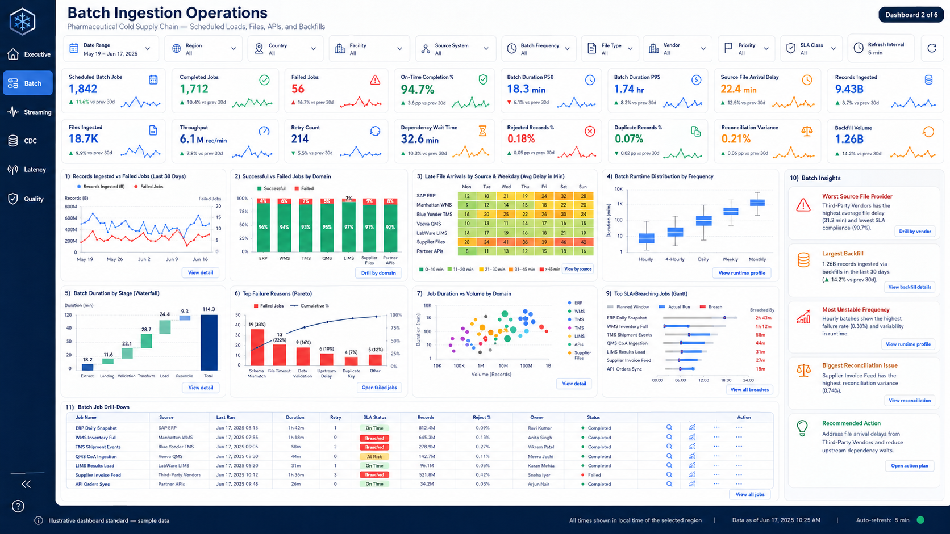

- For streaming data ingestion, record and observe the following on a dashboard (implement this dashboard in PowerBI/Grafana/Superset)- – make any assumptions you want and modify these metrics as you deem fit [Weightage: 2%]:
- Stream Throughput (Events/Sec): Number of records ingested per second during the active simulation window.
- Computation: {Total Records Ingested} / {Total Stream Duration (Seconds)}.
- End-to-End Latency (Seconds): The time lag between a simulated event timestamp and its final commit to the database.
- Computation: Timestamp_db_insert - Timestamp_source_row_creation.
- Malformed / Dropped Record Count: Number of rows rejected due to schema mismatches or null key constraints during stream parsing.
- Computation: Counter incremented in a try-except block during row validation.
- Recommended Chart: Line Chart tracking Stream Throughput (Events per Second) over the course of the simulation run to observe pipeline stability.

- Below is a sample (but you should only include above or one or more of your choice)
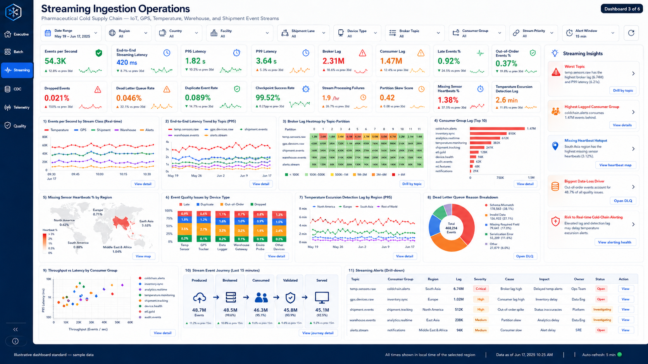

- Storage & Staging Layer:
- This comes after ingestion – ingested data is to be stored in RDBMS – use Postgres
- Measure the following and show it on a dashboard (implement this dashboard in PowerBI/Grafana/Superset)- – make any assumptions you want and modify these metrics as you deem fit [Weightage: 2%]:
- Table Row Count: Total cumulative records stored across dimension and fact tables.
- Computation: SQL SELECT COUNT(*) FROM table_name.
- Storage Footprint (MB): The physical file size of the local database or parquet storage directory.
- Computation: Operating system file size check of Postgres file (os.path.getsize()).
- Date Coverage Span: Validation metric ensuring the 2023–2025 temporal range is fully represented.
- Computation: MAX(date_column) - MIN(date_column) or checking distinct year-month partitions.
- Recommended Chart: Donut Chart or Stacked Bar Chart showing Storage Breakdown (% of total rows or MB) contributed by each of the 7 source domains.

- Below is a sample (but you should only include above or one or more of your choice)

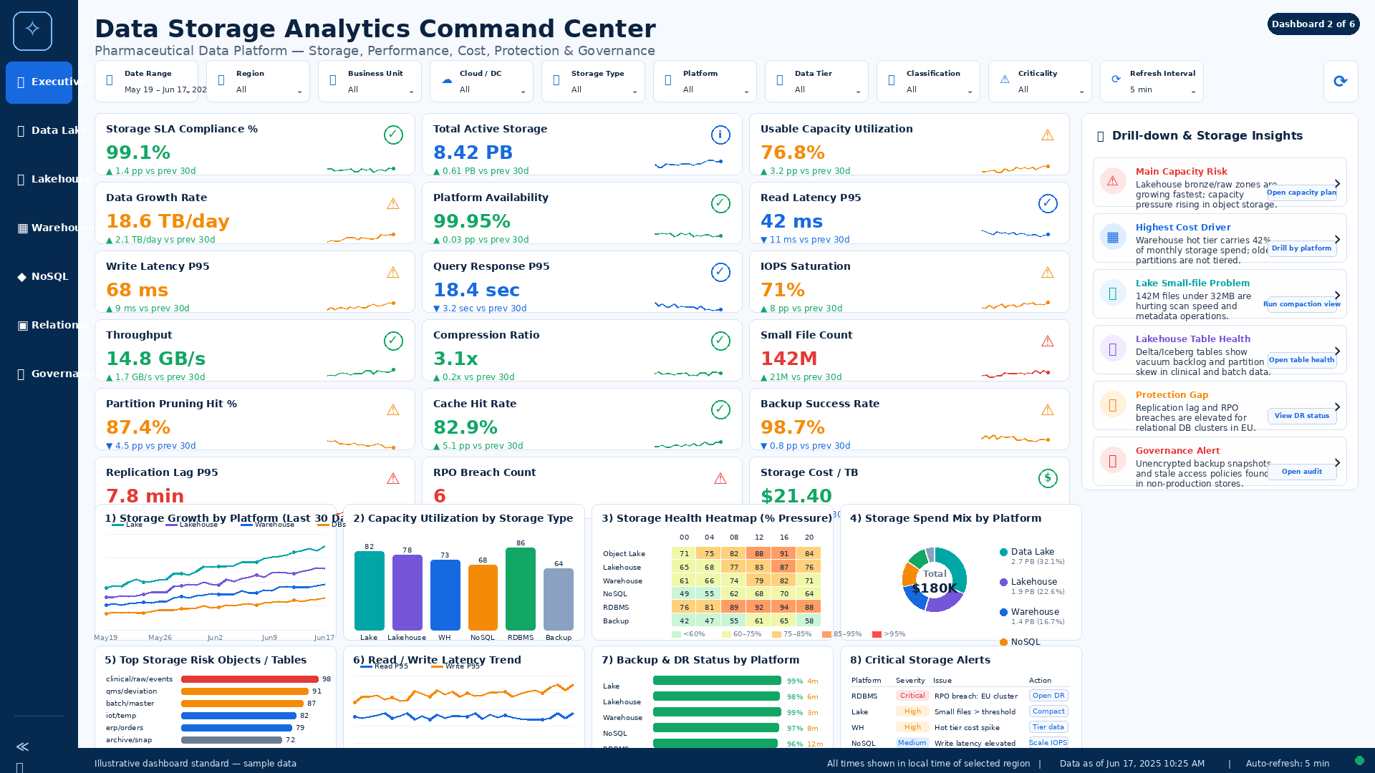

- Transformation & Dimensional Modeling Layer:
- This layer will contain the star schema tables
- It will also transform the data – to do this transformation, you can take help of the staging area in the previous layer
- For data mart implementation, you can use DuckDB (tailored for OLAP)
- Remember to create the star schema/fact constellation tables in this step
- After this, you can transform and load.
- Hint: Automated SQL/dbt transformations within Airflow handling dimensional modeling.
- Remember to cater for all the DWH paraphernalia: Slowly Changing Dimensions, Junk dimensions, role playing dimensions, types of fact tables etc. For the time being, focus on what you have.

- Analytical Query Layer & Query Optimization:
- This layer allows the stakeholders to query the data mart through one or more dimensional queries.
- These queries are written in SQL.
- To speed things up, typically, concepts like OLAP indexing, table partitioning, materialized views, and pre-aggregated summary tables are used.
- These ensure sub-second response times for complex multi-fact queries.
- Measure the following and show it on a dashboard (implement this dashboard in PowerBI/Grafana/Superset)- – make any assumptions you want and modify these metrics as you deem fit [Weightage: 2%]:
- Query Execution Time (Milliseconds/Seconds): Time taken for a specific dashboard visual or underlying SQL query to return results.
- Computation: time.time() wrapper around database query execution functions.
- Daily Active Query Count: Total number of analytical queries executed during user interaction or automated dashboard refreshes.
- Computation: Simple counter incremented every time a BI component fetches data.
- Query Error Rate (%): Percentage of queries failing due to syntax errors, missing columns, or connection timeouts.
- Computation: $(\text{Failed Queries} / \text{Total Executed Queries}) \times 100$.
- Recommended Chart: Column Chart displaying Average Query Execution Time (sec) per Dashboard Widget/KPI Card, helping students identify unoptimized SQL joins or missing indexes.

- Business Intelligence Layer:
- This layer implements the BI Dashboard
- The dashboard and the data mart need to be refreshed at least twice in your demo.
- You can also think about implementing a data lake architecture if you want (medallion).

Marks Breakdown
- Oversampling: 2%
- Batch Ingestion dashboard: 2%
- Streaming Ingestion dashboard: 2%
- Storage dashboard: 2%
- Querying dashboard: 2%
- Excel file Phase 1: 2.5%
- Excel file Phase 2: 2.5%
- Excel file Phase 3: 2.5%
- Transformation and dimensional modeling: 2.5%
- BI: 10%
- Bonus: 3%
- And in the end, when you make your final constellation, I will see whether you have solved the inventory management problem.
Three-Phase Project Execution Plan
Phase 1: Sales & Demand Intelligence (SDI) Data Mart
Milestone 1 Deadline: 11th November 2026 (implement upto Query layer)
Milestone 2 Deadline: 25th November 2026 (complete pipeline with BI and refreshing)
- Data Engineering Tasks (change as you deem fit – you can simplify): Build Airflow ingestion DAGs to extract raw sales and hospital logs; perform data validation (price > 0, valid dates, non-null SKU IDs); load into staging; execute dimensional lookup transformations.
- Potential BI Dashboards (change as you deem fit);
- Hospital Forecast vs. Actual Consumption Ratio and Unfulfilled Demand Analysis.
- Channel Revenue Split & Gross Margin Comparison (Retail vs. Hospital vs. E-commerce).
- Top 10 Fast-moving vs. Slow-moving Cold Chain Medicines by Therapeutic Class.

Phase 2— Inventory, Expiry & Replenishment Data Mart
Milestone 1 Deadline: 5th December (with 2 times refreshing)
Phase Objective: Goal: Eliminate warehouse stockouts, overstocking, and product expiry waste by building the Inventory & Replenishment Data Mart.
- Dataset Scope: Input Datasets: 02_manufacturing_data.csv, 03_manufacturer_delivery_data.csv, 04_warehouse_data.csv (plus conformed Dim_Medicine).
- Data Engineering Tasks (change as you deem fit – you can simplify): Automate daily snapshot extraction in Airflow; calculate dynamic inventory metrics (Stockout Risk, FEFO Compliance %, Days Remaining Shelf Life); partition snapshot facts by SnapshotDate.
- Potential BI Dashboards (change as you deem fit);
- Real-time Regional Warehouse Stockout vs. Overstock Threshold Monitoring.
- Near-Expiry Risk Matrix (Products expiring within 30/60/90 days and Financial At-Risk Value).
- FEFO (First-Expired, First-Out) Compliance Score per Warehouse.

Phase 3: End-to-End Traceability & Cold Chain Performance Data Mart
Milestone Deadline: 14th December (with 2 times refreshing)
Phase Objective: Goal: Ensure strict regulatory compliance, batch cold-chain integrity, and excursion alerting by building the Traceability & IoT Telemetry Data Mart.
- Dataset Scope: Input Datasets: 03_manufacturer_delivery_data.csv, 04_warehouse_data.csv, 07_iot_streaming_data.csv (plus conformed Dim_Medicine, Dim_Vehicle, Dim_Device).
- Data Engineering Tasks (change as you deem fit – you can simplify): Configure micro-batch / high-frequency Airflow DAG execution (every 1–5 minutes) to stream sensor logs; perform dynamic range validation (detecting temp breaches outside medicine allowed limits); aggregate telemetry into hourly thermal exposure tables.
- Potential BI Dashboards (change as you deem fit):
- Live Temperature & Humidity Excursion Heatmaps (Warehouse Zones & In-Transit Vehicles).
- Carrier On-Time In-Full (OTIF) Delivery Performance & Freight Cost Efficiency.
Phase 4 Bonus [4%]: Enterprise Fact Constellation that solves the inventory management problem
Phase Objective: Goal: Unify all three specialized Data Marts into an Enterprise Fact Constellation Architecture
- Data Engineering Tasks: Consolidate Airflow DAGs into a master orchestrated workflow; establish cross-mart dependency sensors; optimize multi-fact join queries; implement SLA monitoring and retry policies.
- 24/7 Real-Time Simulation: Execute a multi-threaded data generator simulating 24/7 real-time operations across manufacturing releases, shipments, warehouse storage snapshots, sales transactions, and IoT streaming.
- Enterprise BI Dashboard: Deploy the unified 360-Degree Inventory Intelligence Dashboard presenting combined supply, demand, stock, and cold-chain risk insights.
- Unified DE Dashboard: Present the complete Data Engineering Observability Dashboard exhibiting real-time health across all pipeline components.
SUBMISSION & GRADING CRITERIA:
1. Each group must maintain a Github profile and maintain everything there including code, Excel files, PPTs, project report, and link to demo – this profile will be made public after my approval
2. Airflow DAG files (.py) must follow modular software design with clean task separation
3. In live running of pipeline, you must demonstrate that dashboards are changing with the new data.
4. The project report must mention all your project assumptions along with the explanations of each dashboard and the story they tell.

