MYSQL Project: Employee Salary Analysis

**1. Table Structure**

CREATE TABLE EmployeeSalary

 (

    EmployeeId INT PRIMARY KEY,

    Name VARCHAR(100),

    Department VARCHAR(50),

    DateOfBirth DATE,

    WorkingDays INT,

    PresentDays INT,

    BasicPay DECIMAL(10,2),

    DA DECIMAL(5,2),

    HRA DECIMAL(5,2),

    MA DECIMAL(10,2),

    TA DECIMAL(10,2),

    TDS DECIMAL(10,2),

    PF DECIMAL(10,2)

);

**2. Insert Sample Data**

INSERT INTO EmployeeSalary VALUES

(101, 'Amit', 'IT', '1990-04-15', 30, 28, 30000, 15, 10, 1000, 1500, 2000, 1800),

(102, 'Neha', 'HR', '1988-09-20', 30, 29, 28000, 12, 8, 1000, 1200, 1800, 1600),

(103, 'Ravi', 'Sales', '1992-01-10', 30, 30, 32000, 18, 12, 1000, 1700,

2200, 1900),

(104, 'Reena', 'Finance', '1985-07-12', 30, 27, 29000, 14, 9, 1000, 1400,

1900, 1700),

(105, 'Deepak', 'IT', '1993-11-25', 30, 26, 31000, 15, 11, 1000, 1600, 2100, 1850);

**3. Retrieving data**

select * from EmployeeSalary;

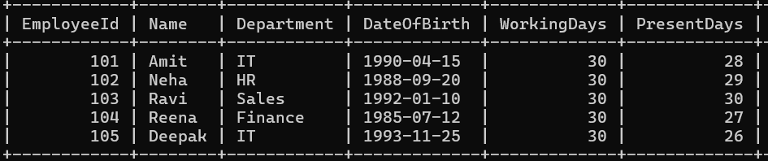

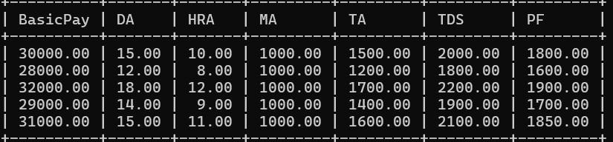

**4. SQL Queries Based on Python Programs**

* Calculate DA Amount

SELECT Name, BasicPay,

(BasicPay * DA / 100) AS DA_Amount

FROM EmployeeSalary;

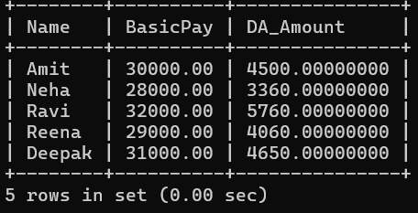

* Calculate Gross Salary

SELECT Name,

(BasicPay + (BasicPay * DA / 100) + (BasicPay * HRA / 100) + MA + TA)

AS GrossSalary

FROM EmployeeSalary;

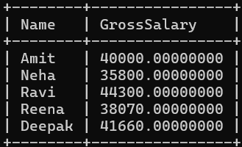

* Calculate Total Deductions (TDS + PF)

SELECT Name,

(TDS + PF) AS TotalDeduction

FROM EmployeeSalary;

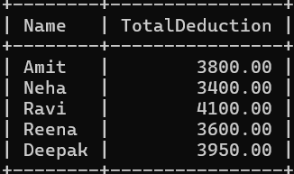

* Calculate Net Salary

SELECT Name,

(BasicPay + (BasicPay * DA / 100) + (BasicPay * HRA / 100) +

MA + TA) - (TDS + PF) AS NetSalary

FROM EmployeeSalary;

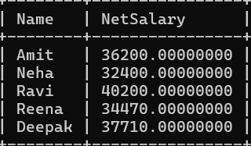

* Calculate Attendance %

SELECT Name,

(PresentDays * 100 / WorkingDays) AS AttendancePercent

FROM EmployeeSalary;

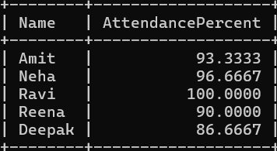

* Employees with Net Salary > 35000

SELECT * FROM

(SELECT Name,

(BasicPay + (BasicPay * DA / 100) + (BasicPay * HRA / 100) + MA + TA) - (TDS + PF) AS NetSalary

FROM EmployeeSalary) AS sub

WHERE NetSalary > 35000;

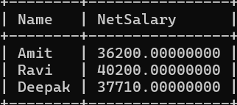

* Count of employees per department

SELECT Department,

COUNT(*) AS EmployeeCount

FROM EmployeeSalary

GROUP BY Department;

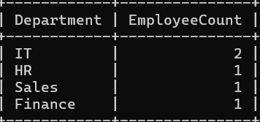

* Department-wise average Net Salary

SELECT Department,

AVG((BasicPay + (BasicPay * DA / 100) + (BasicPay * HRA / 100) + MA + TA) - (TDS + PF))

AS AvgNetSalary

FROM EmployeeSalary

GROUP BY Department;

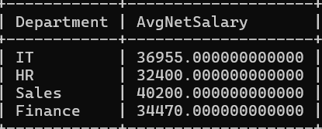

* Employees with Perfect Attendance

SELECT * FROM EmployeeSalary

WHERE WorkingDays = PresentDays;

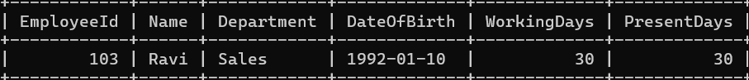

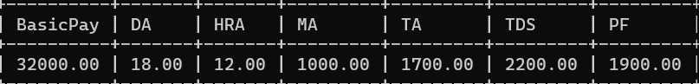

* Find Top 3 Earners

SELECT Name,

(BasicPay + (BasicPay * DA / 100) + (BasicPay * HRA / 100) + MA + TA) - (TDS + PF)

AS NetSalary

FROM EmployeeSalary

ORDER BY NetSalary

DESC LIMIT 3;

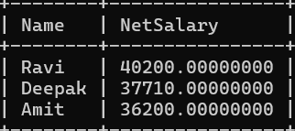

* Add Age Column (in SELECT)

SELECT Name, YEAR(CURDATE()) - YEAR(DateOfBirth) AS Age

FROM EmployeeSalary;

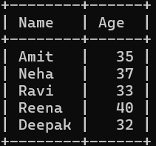

* Department with lowest average deduction

SELECT Department,

AVG(TDS + PF) AS AvgDeduction

FROM EmployeeSalary

GROUP BY Department

ORDER BY AvgDeduction

ASC LIMIT 1;

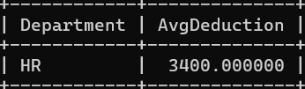

* Employees whose attendance < 90%

SELECT Name

FROM EmployeeSalary

WHERE (PresentDays * 100 / WorkingDays) < 90;



* Employees eligible for bonus (attendance≥ 95%)

SELECT Name

FROM EmployeeSalary

WHERE (PresentDays * 100 / WorkingDays) >= 95;



**5. Advanced SQL and View Creation**

* Department-wise Summary

SELECT Department,

SUM(BasicPay + (BasicPay * DA / 100) + (BasicPay * HRA / 100) + MA +

TA) AS TotalGross,

SUM(TDS + PF) AS TotalDeduction,

AVG((BasicPay + (BasicPay * DA / 100) + (BasicPay * HRA / 100) + MA +

TA) - (TDS + PF)) AS AvgNet

FROM EmployeeSalary

GROUP BY Department;

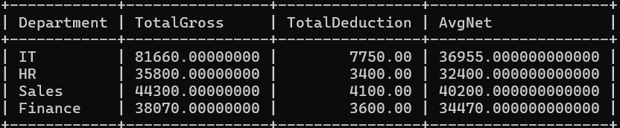

* Create a View for Computed Columns

CREATE VIEW EmployeeSalaryView AS

SELECT *,

(BasicPay + (BasicPay * DA / 100) + (BasicPay * HRA / 100) + MA + TA) AS

GrossSalary,

(BasicPay + (BasicPay * DA / 100) + (BasicPay * HRA / 100) + MA + TA) -

(TDS + PF) AS NetSalary,

(PresentDays * 100 / WorkingDays) AS AttendancePercent

FROM EmployeeSalary;

