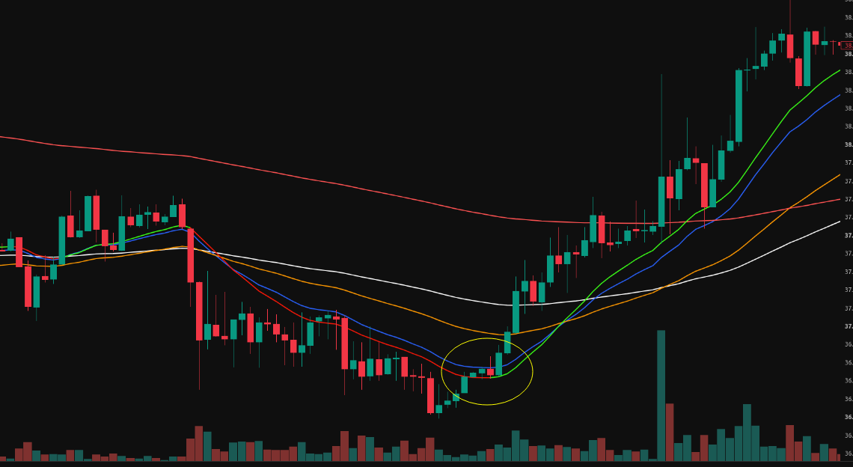

Stuck 4 candles inside EMA20 to kernel Regression

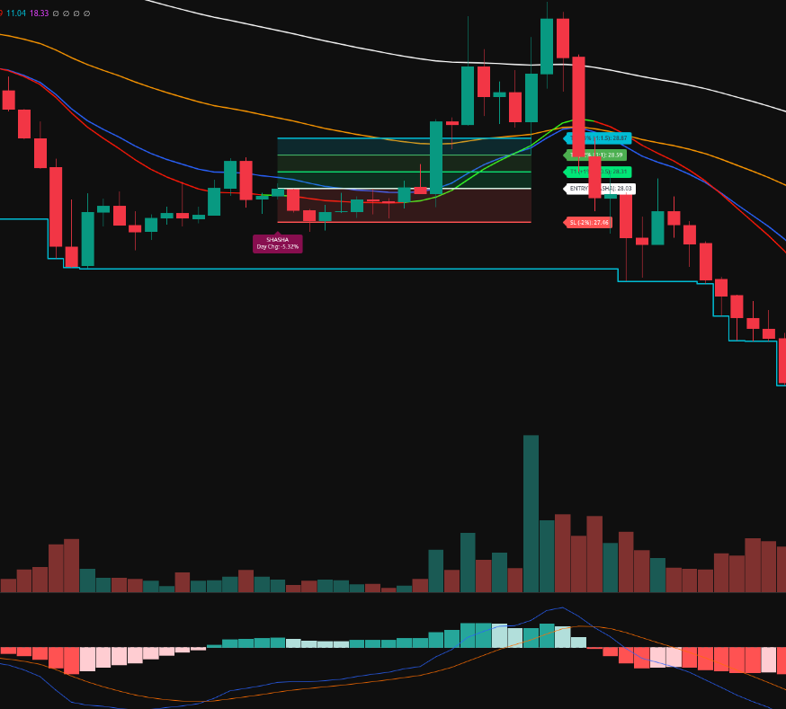
when shasha label candle consolidate between past 6candle we can see good entry without SL?

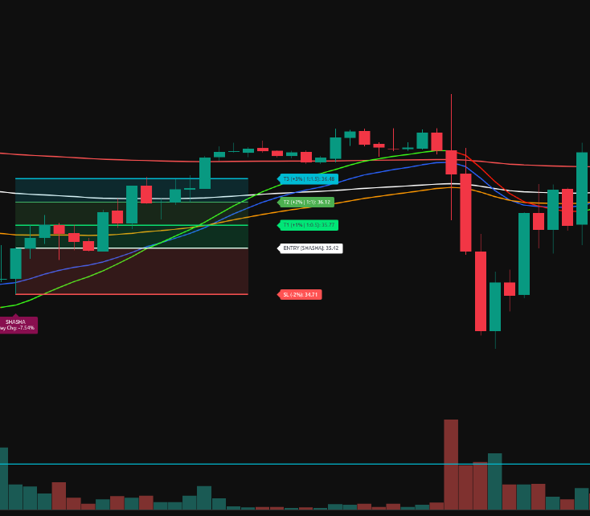
When EMA20> Kernel Regression line, Candle open greater than EMA20 and Kernel regression, Candle High Less than EMA50 and Candle Body Ratio >=75% and consdaite with past 2candles. didnt touch stoploss

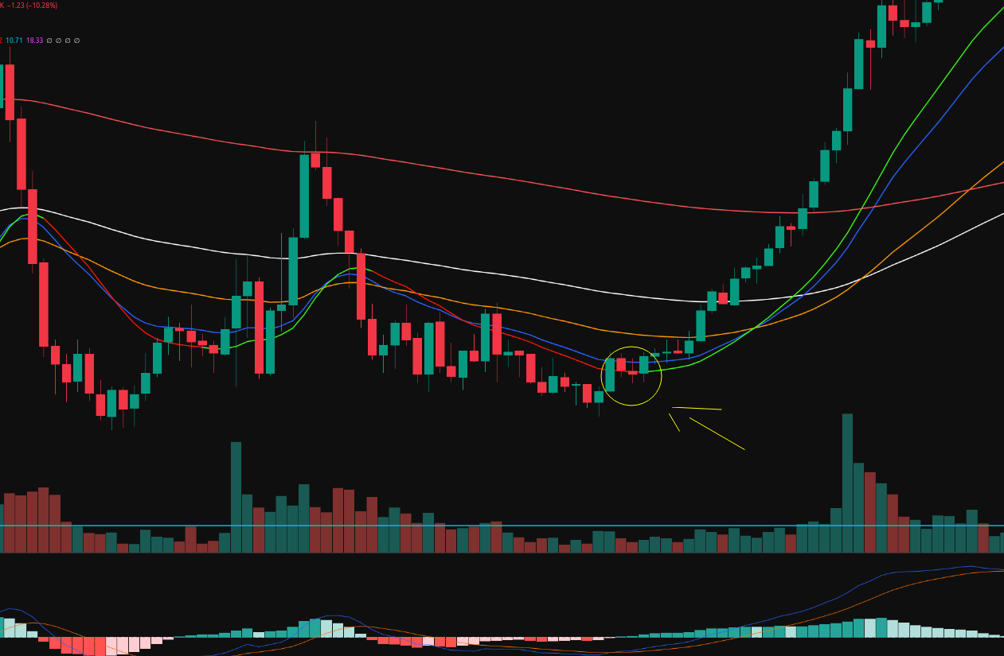
we need to keep moving trailing stoploss..

