Project 7 — Algorithmic Bias Audit and Mitigation
COMPAS Recidivism Risk Model | Fairness Metrics, Mitigation, and Ethical Recommendation
Prepared by Samarah Hiba
Executive finding
Overall accuracy hides subgroup harm. The baseline classifier looks competent at 66.6% accuracy when looking at it superficially, but it creates unequal error rates across racial subgroups (Black Americans vs White Americans). The group-threshold mitigation sharply reduces the equalized-odds gap from 0.290 to 0.040 while keeping accuracy close to the baseline: 65.5%.
Abstract and Roadmap
A criminal-justice risk model can appear to be rather useful based on overall accuracy while producing unequal error rates across racial groups. That matters because a false positive in this setting can label someone as high risk when they may not reoffend, while a false negative can miss someone who does reoffend. This project trains a logistic-regression baseline on COMPAS two-year recidivism data, excludes race from model input, and then uses race only for auditing subgroup outcomes. I used logistic regression because the project was not only about prediction accuracy. It was about auditing fairness. Logistic regression is simple, interpretable, and gives probability scores, which are useful for calibration and threshold adjustment. In general, the audit finds that the baseline predicts high risk for Black-American defendants at about 1.96 times the White high-risk rate.
My workflow was like my previous machine-learning assignments: clean the data, train a classifier, evaluate performance, then interpret the results carefully. The difference here is that the evaluation does not stop at accuracy. I audit fairness metrics, compare subgroup confusion matrices, test mitigation methods, and explain the final ethical tradeoff. Two mitigation methods are tested: reweighting and group-specific thresholds. Reweighting improves recall and slightly reduces high-risk imbalance but does not solve equalized odds. Group thresholds give the strongest result, reducing the equalized-odds gap to 0.040 with small accuracy decrease of the overall model.
Paper roadmap
1. Problem framing and data handling | 2. Baseline model and fairness audit | 3. Mitigation strategies | 4. Calibration trade-off | 5. Ethical recommendation

Core results
Method | Accuracy | Recall | F1 | High-risk ratio | EOdds gap
Baseline LR | 0.666 | 0.562 | 0.613 | 1.959 | 0.290
Reweighted LR | 0.659 | 0.648 | 0.641 | 1.824 | 0.292
Group thresholds | 0.655 | 0.703 | 0.657 | 1.070 | 0.040
The first mitigation strategy I tested was reweighting, which happens before or during training. The idea is to give more representation to underrepresented group-label combinations, so the model does not mostly optimize for the dominant pattern in the data. I like reweighting because it keeps one shared decision rule for everyone, which can be easier to explain ethically than by using specific thresholds based on weights. In the results, accuracy moved from 0.666 to 0.659, so performance only dropped slightly. Recall improved from 0.562 to 0.648, telling us that the model caught more of the positive cases. The high-risk ratio improved from 1.959 times to 1.824 times. The high-risk prediction imbalance improved slightly: Black-American defendants were still labeled high risk more often, but the gap became smaller. However, the equalized odds gap did not improve meaningfully; it stayed around 0.29. This is a useful result, not a failure. It shows that fairness mitigation is not achieved via the flick of the wand. One method may reduce one unfairness while leaving another metric mostly unchanged. That is why I compared more than one mitigation strategy.
Without reweighting, the model sees 100 Black-American recidivated examples but only 20 White recidivated examples, so the Caucasian recidivated pattern may have less influence. So, each White recidivated example might count about 5 times more during training to even out representation.
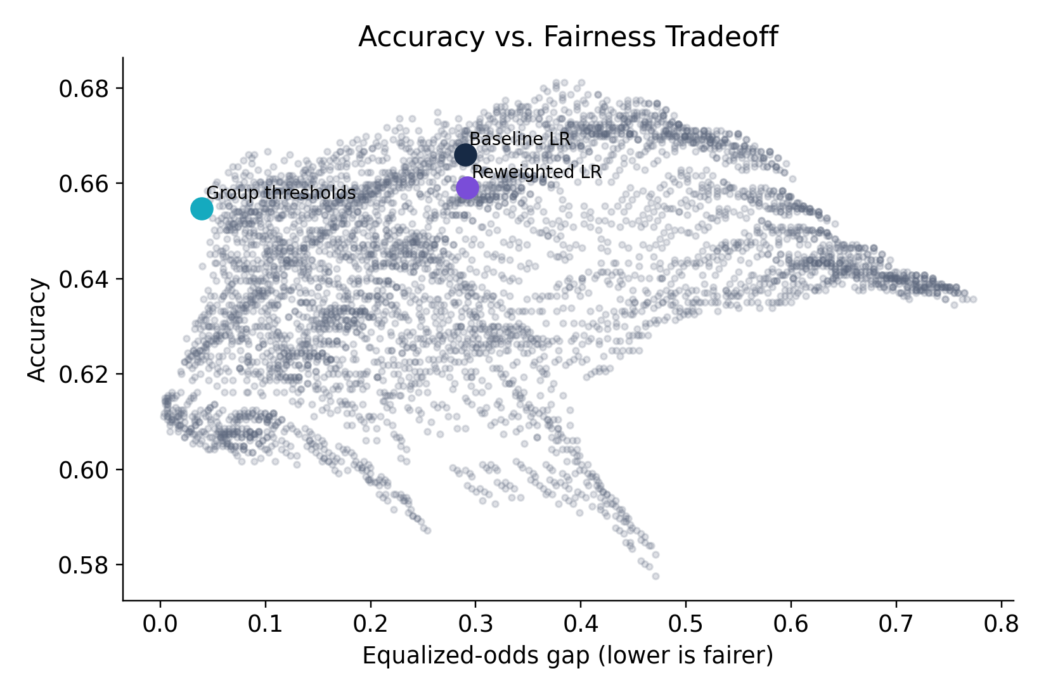
Figure 1. The mitigation choice is a trade-off, not an accuracy-only decision.
The second mitigation strategy was threshold adjustment. Instead of using one universal cutoff of 0.50 for both groups, I searched for group-specific thresholds that reduce the equalized-odds gap while keeping accuracy close to the baseline. The selected thresholds were 0.475 for Black-American defendants and 0.380 for White defendants. This worked much better for equalized odds: the equalized-odds gap dropped from 0.290 to 0.040, while accuracy only decreased from 0.666 to 0.655. So from a model-performance perspective, this is the strongest tradeoff in my experiment. But ethically, this is also the most potentially invasive strategy. Group-aware thresholds mean the system explicitly uses race in the decision rule, even though the goal is to reduce unfair error rates. This will bring controversy to the implementation of this method. My conclusion is that threshold adjustment is strongly effective, but it should be used transparently and with careful monitoring.

Code: SELECTED THRESHOLDS
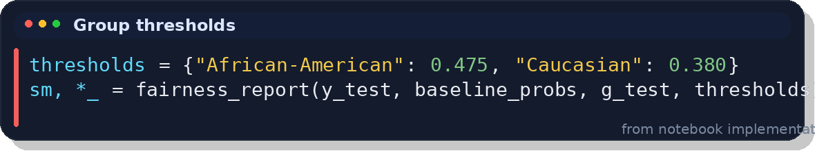
Each dot on the graph represents something like:
AA threshold = 0.45
Caucasian threshold = 0.40
or:
Black American threshold = 0.55
White American threshold = 0.35
For every pair, the code calculated:
- Accuracy: Let’s say the model got about 66.6% of the test cases correct overall. If there were 100 defendants, it correctly classified around 67 of them as either high risk or not high risk.
- TPR gap: TP / TP + FN; Out of all the people who were positive, how many did the model correctly predict as positive?
- FPR gap: FP / FP + TN; Out of all the people who were negative, how many did the model incorrectly predict as positive?
- Equalized-odds gap: It compares both the true positive rate gap and the false positive rate gap between Black-American and Caucasian defendants

1. Problem framing and data handling
Problem. A criminal-justice risk model may sound cool because it sums up many variables into one predicted risk score. The danger is that a model can look decent and highly accurate while producing unequal error rates across racial subgroups. In this project, the true positive class is actual two year recidivism and predicted positive means model “predicted high risk / recidivates within two years,”, negative is “did not recidivate” and the protected attribute used for the audit is race.
Dataset. The analysis uses ProPublica’s COMPAS two-year recidivism dataset, filtered to cases screened within 30 days of arrest, valid recidivism labels, non-ordinary charge degree, non-missing score rows, and the two largest comparison groups: Black-American and White defendants. After cleaning, the analysis uses 5,278 records.
Features. The model uses age, prior count, juvenile felony/misdemeanor/other counts, charge degree, and sex. Race is intentionally excluded as a direct model input; however, this does not guarantee fairness because remaining variables can still act as proxies for unequal historical treatment bias.
Rejected alternatives. I rejected using a deep neural network because the goal is not to max out raw predictive power; it is transparency and a clear and concise fairness audit. Logistic regression is a competent, interpretable baseline for tabular classification and supports clean probability thresholds, calibration analysis, and explicit fairness metrics.
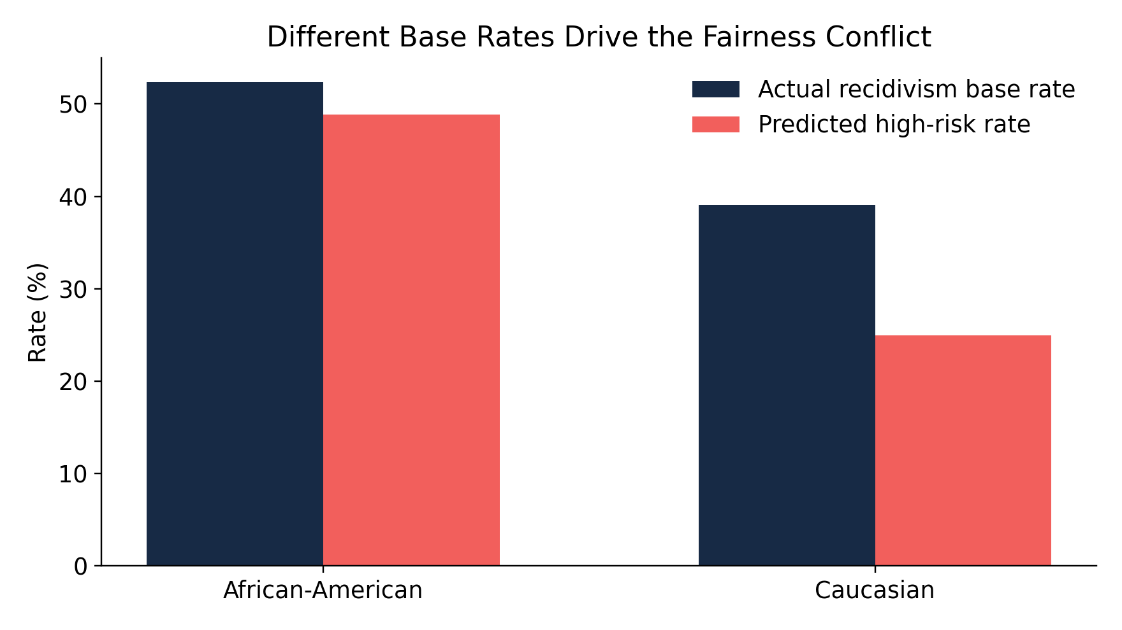
Figure 2. The observed base rate is higher for African-American defendants in this dataset, and the baseline model amplifies this into a much higher predicted high-risk rate.

2. Baseline classifier and fairness audit
Model. The baseline pipeline standardizes numeric features, one-hot encodes categorical features, and trains a logistic-regression classifier. This structure is leakage-free because preprocessing is fit on the training split only through a scikit-learn pipeline. The held-out test split is 30% of the cleaned data.
Overall performance. The baseline achieves 66.6% accuracy, 67.4% precision, 56.2% recall, 61.3% F1, and 72.1% ROC-AUC. These numbers are reasonable enough to be tempting, but they do not answer the fairness question.

Baseline subgroup metrics
Group | n | Base rate | High-risk rate | TPR | FPR | Precision
African-American | 947 | 0.524 | 0.489 | 0.659 | 0.302 | 0.706
Caucasian | 637 | 0.391 | 0.250 | 0.369 | 0.173 | 0.579
Fairness result. The baseline model predicts high risk for Black-American defendants at about 1.96 times the White high-risk rate. The TPR gap is 0.290 and the FPR gap is 0.129 stemming from positive tests distributed to Black Americans the most despite the exclusion of race. This means both “caught recidivists” and “false alarms” are distributed unequally by group. What stands out is the outstandingly high FPR for Black Americans compared to White Americans since false positives can ruin a person’s life easily. But it looks like Black Americans are exposed to this harm the most.
This tells us the model is much more active for one group. It catches more positives, but it also produces more false positives. That is the central tradeoff: the same classifier can look reasonable overall while creating unequal error burdens across groups.

3. Bias mitigation strategies
Mitigation 1: reweighting. Reweighting is a training-time mitigation method that changes how much each group-label cell contributes to the loss. The training data is weighted by group-label cells, so each racial group and outcome combination contributes more evenly to the loss. It is ethically appealing because it does not create separate decision rules at deployment time. In this experiment, it improved the high-risk ratio slightly, but it did not solve equalized odds.

Code:
# Race is not added as a model feature; it is only used to compute training weights.
group_label_cells = race_train.astype(str) + "_" + y_train.astype(str)
weights = compute_sample_weight(
class_weight="balanced",
y=group_label_cells
)
reweighted_lr = LogisticRegression(max_iter=1000)
reweighted_lr.fit(X_train, y_train, sample_weight=weights)
y_pred_rw = reweighted_lr.predict(X_test)
y_prob_rw = reweighted_lr.predict_proba(X_test)[:, 1]
This code gives more training weight to underrepresented race-outcome combinations, while still keeping race out of the actual model features.
Mitigation 2: group-specific thresholds. Threshold adjustment is a postprocessing-stage method. Instead of one 0.50 cutoff, the selected thresholds are 0.475 for Black-American defendants and 0.380 for White defendants. This sharply reduces the equalized-odds gap from 0.290 to 0.040, while accuracy moves from 0.666 to 0.655.
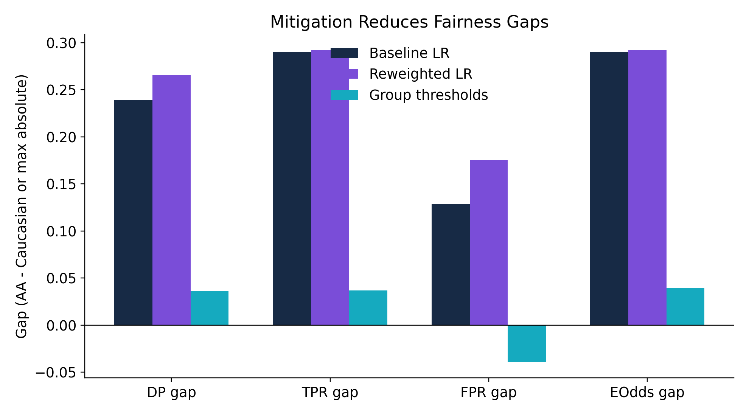
Figure 3. The group-threshold mitigation is the strongest fairness improvement, but the reweighting result is important because it shows that not every technical fairness method fixes every fairness definition.

Threshold subgroup metrics
Group | n | Base rate | High-risk rate | TPR | FPR | Precision
African-American | 947 | 0.524 | 0.551 | 0.716 | 0.370 | 0.680
Caucasian | 637 | 0.391 | 0.515 | 0.679 | 0.410 | 0.515

The goal was not just to maximize accuracy, but to make the model’s error rates more similar across the two racial groups. The high-risk rates became much closer: 55.1% for Black-American defendants and 51.5% for White defendants.
This is a major change from the baseline, where Black-American defendants were predicted high risk at almost twice the Caucasian rate. The most important part is the TPR and FPR comparison. The true positive rate became 0.716 for Black-American defendants and 0.679 for White defendants, so the TPR gap was only 0.037. The false positive rate became 0.370 for Black-American defendants and 0.410 for White defendants, so the FPR gap was 0.040. Since equalized odds looks at both gaps, the final equalized-odds gap was: max(0.037,0.040) = 0.040. This explains why the group-threshold method was the strongest fairness mitigation in the experiment. It made both kinds of errors much more balanced across groups. However, precision still differed: 0.680 for Black-American defendants and 0.515 for White defendants. This happens partly because the base rates are different across the groups. The Black-American group had a higher actual recidivism rate in the dataset, so even after balancing TPR and FPR, the positive predictions had different precision levels. This shows an important fairness trade-off: improving equalized odds does not automatically make every fairness metric equal.
Note: Race is excluded from the baseline model features, but the group-threshold mitigation uses race/group membership during postprocessing to apply different cutoffs
# Evaluate subgroup metrics after applying selected group thresholds
thresholds = {
"African-American": 0.475,
"Caucasian": 0.380
}
y_pred_thresh = np.zeros(len(y_prob_test), dtype=int)
for group, threshold in thresholds.items():
group_mask = race_test == group
y_pred_thresh[group_mask] = (y_prob_test[group_mask] >= threshold).astype(int)
threshold_metrics = group_metrics(
y_true=y_test,
y_pred=y_pred_thresh,
group=race_test
)
threshold_metrics
This code applies a different cutoff to each audited group, then recalculates the subgroup confusion-matrix metrics to check whether TPR and FPR became more balanced.

4. Calibration, equalized odds, and the impossibility tension
Why the conflict appears. The observed recidivism base rate is 0.524 for Black-American defendants and 0.391 for Caucasian defendants, a 0.133 difference. When base rates differ, a calibrated model assigns probabilities that correspond to different observed outcome frequencies by group. Equalized odds, however, requires matching both TPR and FPR across groups. These goals generally cannot both be perfectly satisfied unless base rates are equal or the model is nearly perfect.
Empirical demonstration. The baseline maintains a probability-risk interpretation but fails equalized odds with a 0.290 gap. The group-threshold mitigation nearly equalizes error rates, but it does this by changing decision cutoffs; that improves parity of errors while weakening a single common probability threshold interpretation. The trade-off is visible in the accuracy-vs-fairness plot.
Calibration means the risk score should be meaningful -- for instance, a 70% score should correspond to about a 70% actual recidivism rate. But equalized odds ask for similar true positive and false positive rates across groups. Since the two groups have different base recidivism rates, 0.524 versus 0.391, both fairness goals cannot usually be perfect at the same time. That is why the final recommendation is not just to maximize accuracy. We must choose which fairness goal matters most for the real-world harm and justify that choice.
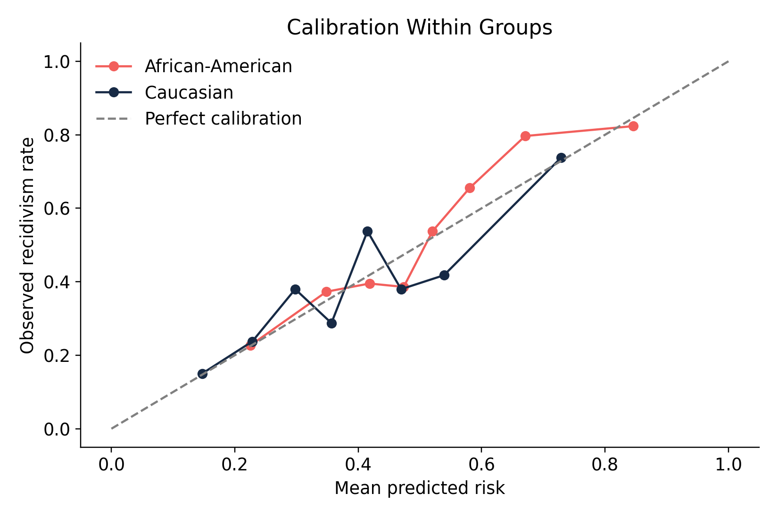
Figure 4. Calibration must be evaluated within groups; a single accuracy value does not show whether predicted probabilities mean the same thing across subgroups.

5. Recommendation and ethical conclusion
Recommendation. The model should not be used as an automated decision-maker. If used at all, it should be limited to decision support with human review, subgroup monitoring, and regular re-audits. The threshold-adjusted model is the best technical choice for reducing error-rate gaps here, but its ethicality depends on whether companies are ok with group-aware thresholds in a legal setting.
Where bias enters. Bias can enter through historical labels, policing patterns, prior-count features, missing-data rules, target definition, and threshold choice. Removing race from the features does not suffice, as the report has proven, because proxies can preserve unequal patterns. The overall accuracy of the model is misleading as it clearly did hide subgroup harm.
Final takeaway. Fairness is not one metric. The best answer is a chosen model setting that you can justify because it clearly explains what fairness problem it reduces and what cost it accepts. I chose the group-threshold model because it sharply reduces unequal error rates across racial groups, while accepting a small decrease in overall accuracy. The final recommendation must justify which fairness goal matters the most.

Glossary
-Precision asks: “When the model predicts high risk, how often is it right?” TP / (TP + FP)
- True Positive (TP): person recidivated, and model predicted high risk.
- Accuracy: The percentage of total predictions the model got correct.
- Recall / True Positive Rate (TPR): Recall asks, “Of all the people who actually reoffended, how many did the model catch?”
Recall = TP / (TP + FN)
- F1 Score: F1 combines precision and recall into one score. It is useful when we care about both catching positives and avoiding too many false alarms.
F1 = 2 * (Precision * Recall) / (Precision + Recall)
- True Negative (TN): The person did not actually recidivate, and the model predicted low risk.
- False Negative (FN): The person actually recidivated, but the model predicted low risk.
- False Positive Rate (FPR): Out of all people who did not actually recidivate, the percentage the model incorrectly labeled high risk.
FPR = FP / (FP + TN)
- Base Rate: The actual outcome rate in a group. In this project, it means the actual recidivism rate for each racial subgroup.
- High-Risk Rate / Selection Rate: The percentage of a group that the model labels as high risk.
- Equalized Odds: A fairness standard that asks whether groups have similar true positive rates and false positive rates.
- Equalized-Odds Gap: The larger difference between the groups’ TPR gap and FPR gap.
Equalized-odds gap = max(|TPR_AA - TPR_Caucasian|, |FPR_AA - FPR_Caucasian|)
- Reweighting: A mitigation method that gives different training weights to group-label combinations so underrepresented combinations contribute more evenly to model training.
- Group-Specific Thresholds: A mitigation method that uses different probability cutoffs for different audited groups to reduce unfair error-rate gaps.
- Calibration: Calibration means predicted probabilities should match real-world outcomes. For example, among people given a 70% risk score, about 70% should actually recidivate.

References
ProPublica COMPAS Analysis GitHub repository, compas-scores-two-years.csv and methodology notebook.
Project Problems & Deliverables I, Project 7 — Algorithmic Bias Audit and Mitigation.
Kleinberg, Mullainathan, and Raghavan (2016), Inherent Trade-Offs in the Fair Determination of Risk Scores.
Hardt, Price, and Srebro (2016), Equality of Opportunity in Supervised Learning.
ProPublica COMPAS two-year recidivism dataset:
https://github.com/propublica/compas-analysis/blob/master/compas-scores-two-years.csv

