

**Assignment 02**

**Web Site: - Fruits Store App Web Site**

**Name: - Udara Samaratunge**

This application Created to maintain small fruits inventory in a shop assume you can enter unit price quantity and application generate Amount and at the end you can generate the Grand total of the application.

**This Application includes following things.**

* 5 images of Fruits
* 1 Ordered and one Unordered List
* 2 Simple animations of the Fruit baskets in the Website
* 1 Table created to handle the inventory – (Each row and internal elements of the row will be generated dynamically through a Java Script
* 1 hyperlink – Regarding the Author and linked to the author’s LinkedIn profile
* 5 JavaScript functions
  + addIndex() – Generate Unique index for the table rows
  + addRow() – Generate Table rows dynamically with Java Script function
  + selectItem() – Table internal fruit selection drop down menu generates
  + getTotal() – Generates the grand total of the inserted fruits for the store
* Made the Web Site Responsive.

Web Site Images contains images folder. Click FruitsStoreApp.html and Java Script file is FruitsStoreApp.js and CSS file is FruitsStoreApp.css resources are as follows.

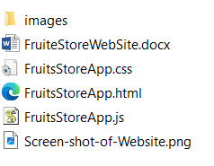

**Screen Shot of the Web Site is follows.**

* You can add Fruits Items by clicking the Button of the below site and it dynamically add the rows.
* In each row you can enter Unit Price and Quantity for the text boxes in the table row and Amount will be added automatically.
* At last you can display Grand total of the items.

