Test Execution Logging Design
Nenad Samardzic
2026-09-25
Table of contents

1. Purpose
This document defines the architecture, format, collection, storage, processing, analysis, and lifecycle of test execution logs generated during System-on-Chip (SoC) validation.
The objectives are:
- complete traceability of every test execution;
- a consistent logging mechanism across different test types;
- correlation between test actions and SoC responses;
- preservation of raw diagnostic information;
- machine-readable data for automated analysis;
- human-readable logs for debugging;
- integration with Continuous Integration and Continuous Delivery (CI/CD) and test reports;
- reproducibility of failures;
- long-term historical analysis and regression detection.
The logging system supports both interactive/local execution and automated CI execution.

2. Scope
The logging architecture covers the complete execution chain.
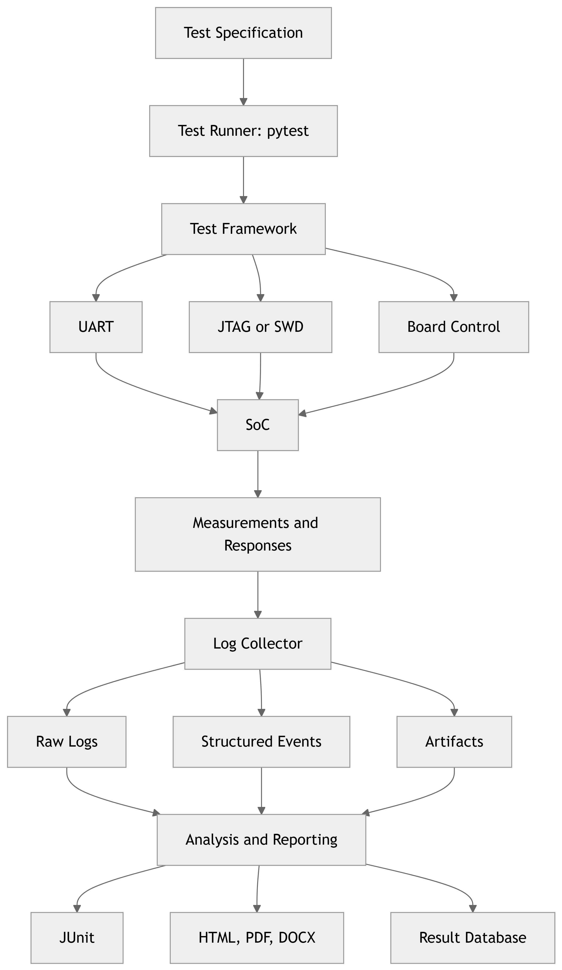
Figure 1: Complete SoC validation execution and logging chain

3. Design Goals
These goals are explicit requirements.

3.1 Functional Requirements
ID | Requirement
LOG-001 | Every test execution shall have a unique Execution ID.
LOG-002 | Every test case shall have a unique Test ID.
LOG-003 | All log entries shall be associated with an Execution ID.
LOG-004 | Logs from different interfaces shall be correlatable.
LOG-005 | Raw interface output shall be preserved.
LOG-006 | Log entries shall contain timestamps.
LOG-007 | Test actions shall be logged.
LOG-008 | Test verdicts shall be logged.
LOG-009 | Failures shall contain sufficient diagnostic information.
LOG-010 | Logs shall be machine-readable.
LOG-011 | Logs shall be human-readable.
LOG-012 | Logs shall be usable outside the CI environment.
LOG-013 | Test artifacts shall be associated with the execution.
LOG-014 | Logging shall have minimal impact on test execution.
LOG-015 | Logs shall support long-term historical analysis.

4. Logging Architecture
The logging system is separated into four logical layers.
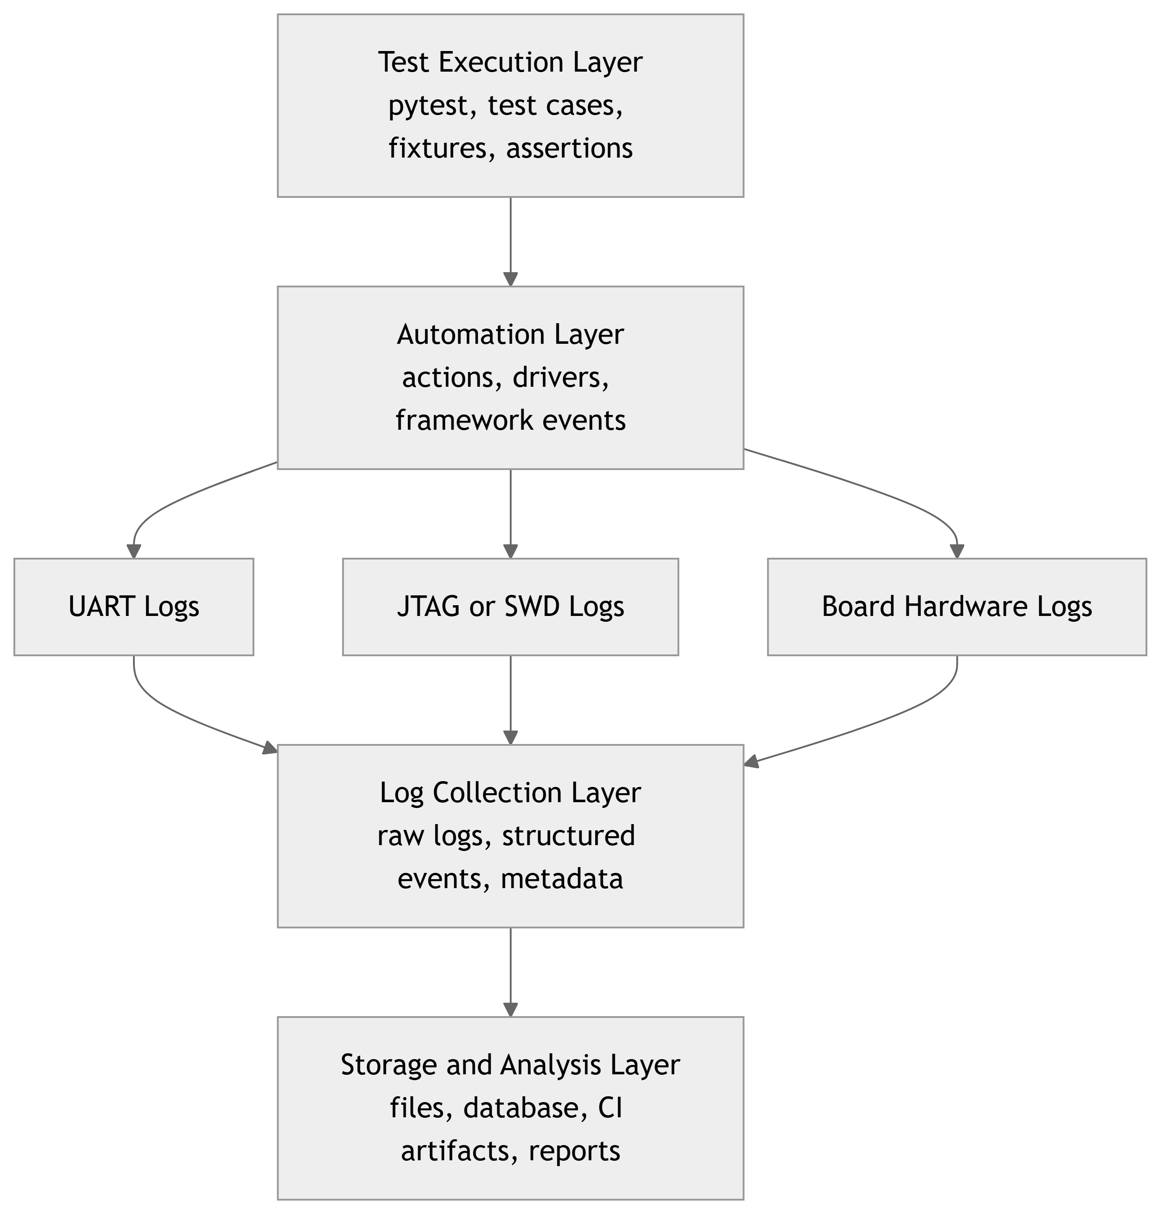
Figure 2: Logical logging architecture
This separation is important because raw logs and interpreted logs are different data products.

5. What Should Be Logged?
Logs are divided into well-defined categories.

5.1 Test Framework Logs
Generated by pytest or the test framework. Typical events are:
TEST_START
TEST_STEP
TEST_PASS
TEST_FAIL
TEST_SKIP
TEST_ERROR
TEST_END
Example:
10:21:15.120 INFO TEST_START
10:21:15.124 INFO test_id=SOC_UART_001
10:21:15.125 INFO step="Reset DUT"
10:21:17.342 INFO step="Wait for boot"
10:21:18.002 INFO step="Send UART command"
10:21:18.103 INFO step="Validate response"
10:21:18.104 INFO TEST_PASS

5.2 Test Action Logs
Every significant action performed by the automation framework is logged, including power control, reset, firmware flashing, interface operations, register access, measurements, and debugger operations.
ACTION
execution_id=EXE-20260918-001
test_id=SOC_UART_001
action=UART_SEND
interface=UART0
data="AT+STATUS"

5.3 SoC Interface Logs

5.3.1 UART
Recommended fields are timestamp, interface, direction, data, and baudrate.
12:31:02.120 UART0 TX "status\r\n"
12:31:02.145 UART0 RX "STATUS: READY\r\n"

5.3.2 SPI
SPI0
TX: 9F 00 00 00
RX: EF 40 18 00

5.3.3 I2C
I2C0
ADDR=0x50
WRITE=00 10
READ=AB CD

5.3.4 JTAG/SWD
Typical events include connect, reset, halt, resume, register read, memory read, and memory write.

5.4 Firmware Logs
Firmware-generated messages are preserved separately from automation logs.
[BOOT] Starting system
[CLK] PLL configured
[MEM] DDR initialization OK
[UART] Driver initialized
[APP] Application started
The source remains explicit:
source = DUT
interface = UART0
Do not merge firmware output into the Python log and discard its origin.

5.5 Hardware and Board Logs
Capture the power-supply state, voltage, current, temperature, reset state, relay state, board-controller messages, power-cycle events, and external instrumentation.
BOARD_POWER_ON
voltage=3.30V
current=142mA
timestamp=2026-09-18T12:31:00.123Z

5.6 Environment Information
Every execution captures the environment in which the test was executed.
execution:
execution_id: EXE-20260918-001
timestamp: 2026-09-18T12:30:00Z
test:
suite: regression
test_id: SOC_UART_001
test_version: abc1234
dut:
device: XYZ123
silicon_revision: B1
serial_number: DUT-00017
board_revision: REV_C
firmware:
version: 2.4.1
git_commit: 8f23ab1
build_id: BUILD-12345
environment:
runner: Jenkins
runner_id: runner-04
python_version: "3.12"
pytest_version: "8.x"
os: Ubuntu 24.04
tools:
debugger: J-Link
debugger_version: x.x.x
This information is critical for failure reproduction.

6. Identification and Correlation

6.1 Execution ID
The Execution ID is the primary correlation mechanism. Example:
EXE-20260918-153045-7F32
Everything generated during one run references the same Execution ID.
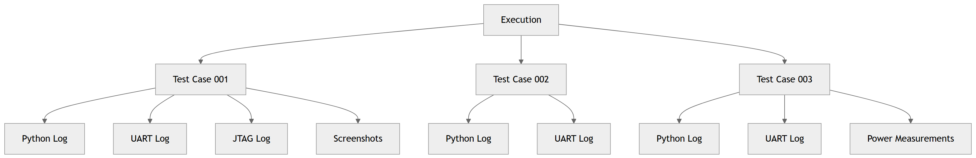
Figure 3: Execution-level artifact hierarchy

6.2 Test ID
Each test has a stable identifier, for example:
SOC-BOOT-001
SOC-UART-001
SOC-SPI-014
SOC-INT-023
SOC-PWR-007
Do not use only the Python function name. Associate a stable logical ID with the test:
@pytest.mark.test_id("SOC-UART-001")
def test_uart_command():
...

6.3 Step ID
Complex tests use explicit step identifiers.
TEST: SOC-UART-001
STEP-001 Power on DUT
STEP-002 Flash firmware
STEP-003 Reset DUT
STEP-004 Wait for boot
STEP-005 Send command
STEP-006 Validate response
STEP-007 Power off DUT
A precise failure record is:
test_id=SOC-UART-001
step_id=STEP-005
status=FAILED

6.4 Correlation ID
For complex operations, use an additional correlation_id to group low-level events that belong to one high-level action.
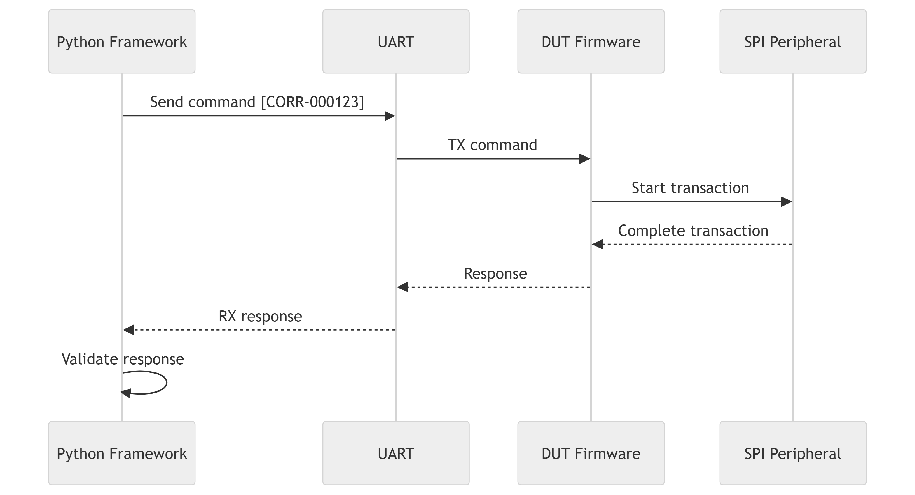
Figure 4: Correlation of one high-level operation across log sources

7. Log Entry Structure
The canonical machine-readable format is JSON Lines (JSONL). One event corresponds to one JSON object.
{
"timestamp": "2026-09-18T12:31:02.120Z",
"execution_id": "EXE-20260918-001",
"test_id": "SOC-UART-001",
"source": "test_framework",
"level": "INFO",
"event": "TEST_START",
"message": "UART test started"
}
{
"timestamp": "2026-09-18T12:31:05.120Z",
"execution_id": "EXE-20260918-001",
"test_id": "SOC-UART-001",
"source": "uart",
"interface": "UART0",
"direction": "TX",
"event": "DATA",
"data": "status\\r\\n"
}

7.1 Recommended Event Schema
Mandatory fields:
Field | Description
timestamp | Event timestamp in Coordinated Universal Time (UTC).
execution_id | Unique execution identifier.
source | Component that generated the event.
level | Event severity.
event | Event type.
Contextual fields:
Field | Description
test_id | Test-case identifier.
step_id | Test-step identifier.
correlation_id | Operation correlation identifier.
interface | DUT interface.
dut_id | DUT identifier.
board_id | Board identifier.
message | Human-readable description.
data | Raw or structured event data.

8. Log Levels
Level | Purpose
TRACE | Extremely detailed diagnostic information.
DEBUG | Developer and debugging information.
INFO | Normal execution information.
WARNING | Unexpected but non-fatal condition.
ERROR | Test or framework error.
CRITICAL | Infrastructure or system failure.
INFO Flashing firmware
INFO Firmware flash completed
DEBUG Waiting for boot message
INFO DUT boot completed
WARNING Boot took longer than expected
ERROR UART response timeout

9. Raw and Processed Logs
Architectural rule: Never destroy the raw evidence.
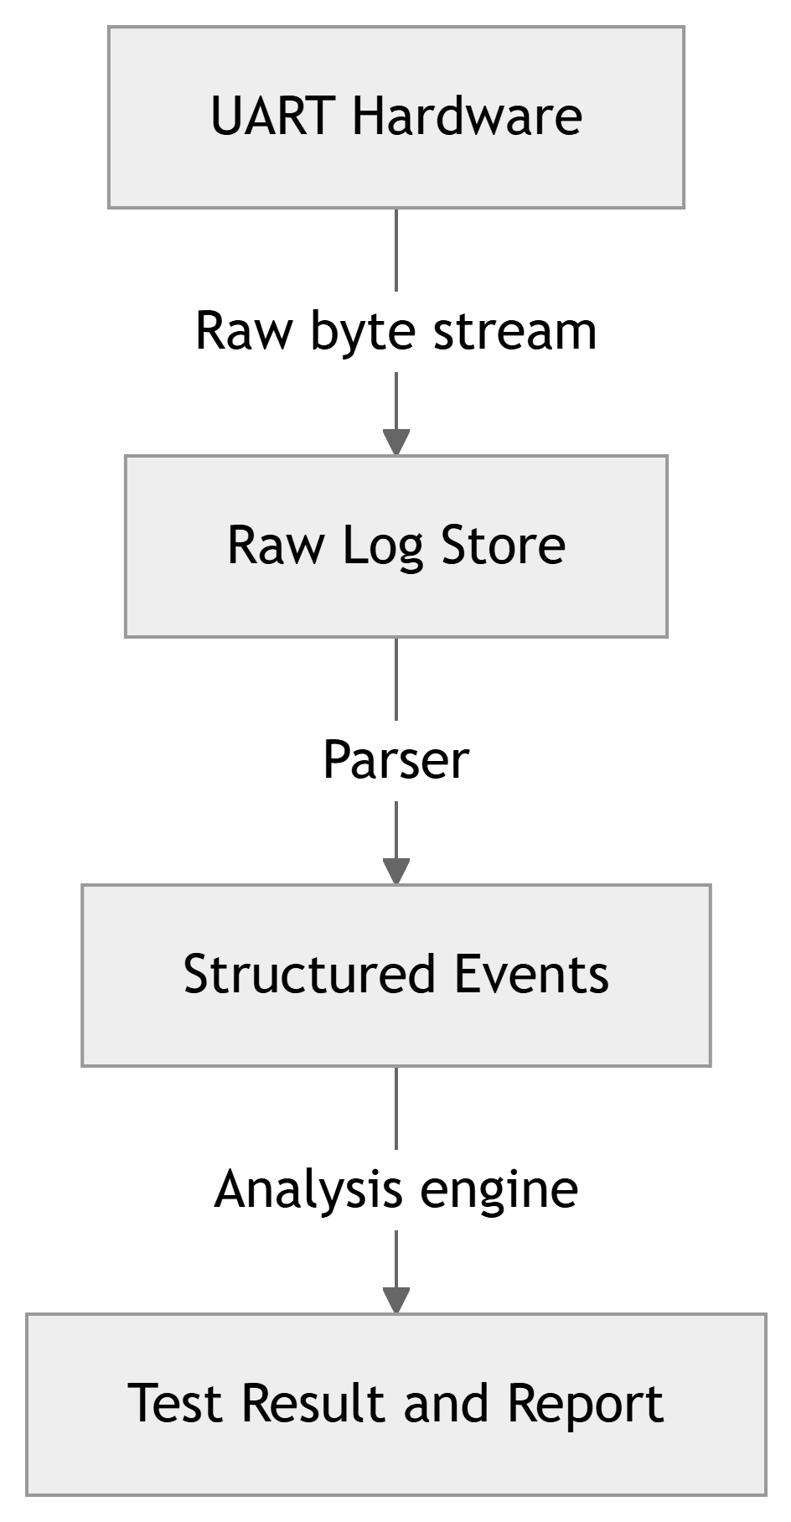
Figure 5: Raw-to-processed logging flow
If the parser has a defect, raw logs can be reprocessed. If only parsed output is stored, the original evidence is lost.

10. Storage Architecture
For the initial implementation, a filesystem-based artifact structure is sufficient. A centralized logging platform is introduced only when log volume and search requirements justify it.
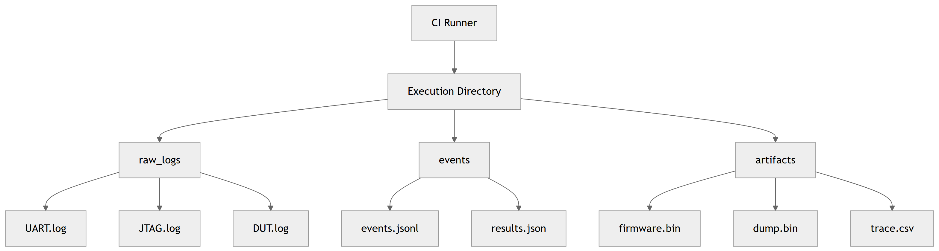
Figure 6: Initial CI storage architecture

10.1 Recommended Execution Directory Structure
EXE-20260918-001/
├── execution.json
├── metadata.json
├── result.json
├── logs/
│ ├── framework/framework.log
│ ├── dut/uart0.log
│ ├── dut/uart1.log
│ ├── debug/jtag.log
│ └── board/board-controller.log
├── events/events.jsonl
├── measurements/
│ ├── power.csv
│ ├── temperature.csv
│ └── performance.csv
├── dumps/
│ ├── memory.bin
│ └── registers.json
├── reports/
│ ├── junit.xml
│ └── report.html
└── artifacts/firmware.bin

10.2 Long-Term Storage
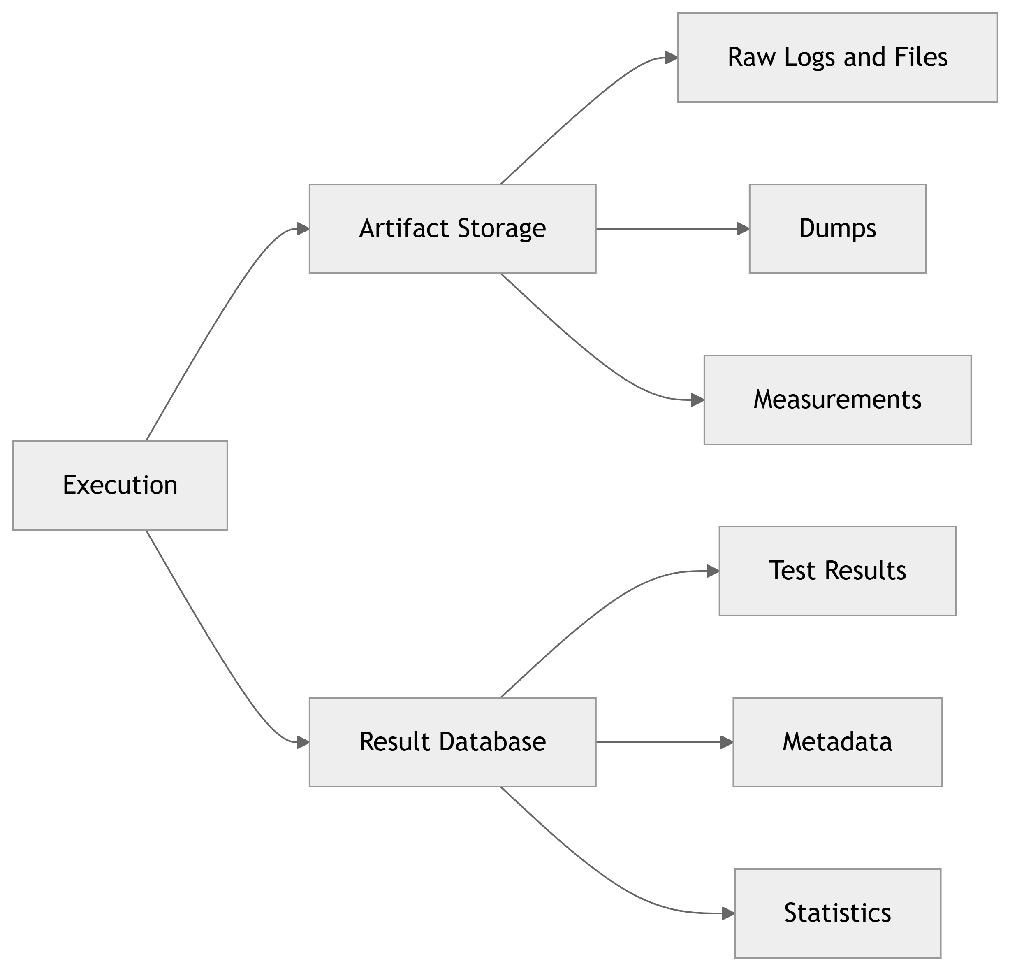
Figure 7: Separation of large artifacts and searchable metadata
Large raw UART and JTAG logs normally remain in artifact storage rather than being stored directly in a relational database.

11. Database Model
A simple relational model can be used initially.
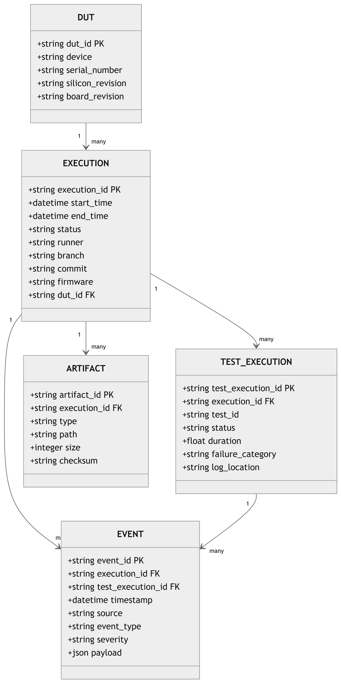
Figure 8: Proposed logging database model

12. Failure Classification
Results contain more than a simple PASS or FAIL verdict.
TEST_FAILURE
ASSERTION_FAILURE
TIMEOUT
UART_FAILURE
JTAG_FAILURE
FLASH_FAILURE
BOOT_FAILURE
DUT_CRASH
DUT_HANG
POWER_FAILURE
COMMUNICATION_FAILURE
INFRASTRUCTURE_FAILURE
ENVIRONMENT_FAILURE
UNKNOWN

13. Failure Analysis Pipeline
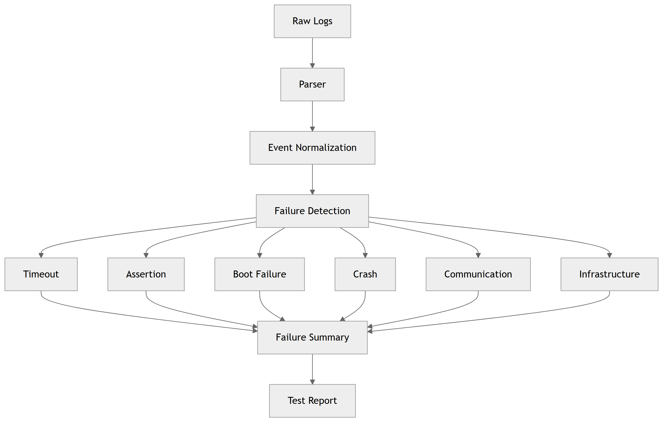
Figure 9: Automated failure-analysis pipeline
A failure report includes the test identifier, expected and observed behavior, DUT state, last DUT message, likely failure category, and links to supporting artifacts.

14. Test Step Event Example
{
"timestamp": "2026-09-18T12:31:05.120Z",
"execution_id": "EXE-20260918-001",
"test_id": "SOC-UART-001",
"step_id": "STEP-005",
"source": "test_framework",
"level": "INFO",
"event": "STEP_START",
"message": "Send UART command"
}

15. CI Integration
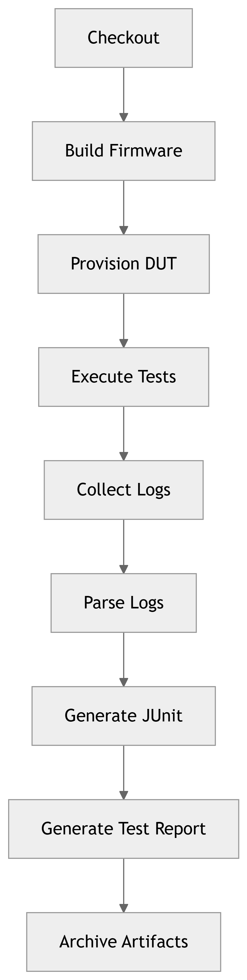
Figure 10: CI logging and reporting pipeline
JUnit XML is the standard CI test-result interface, while JSONL and raw logs retain the detailed SoC diagnostic information.

16. Reporting
Execution logging and report generation remain separate concerns.
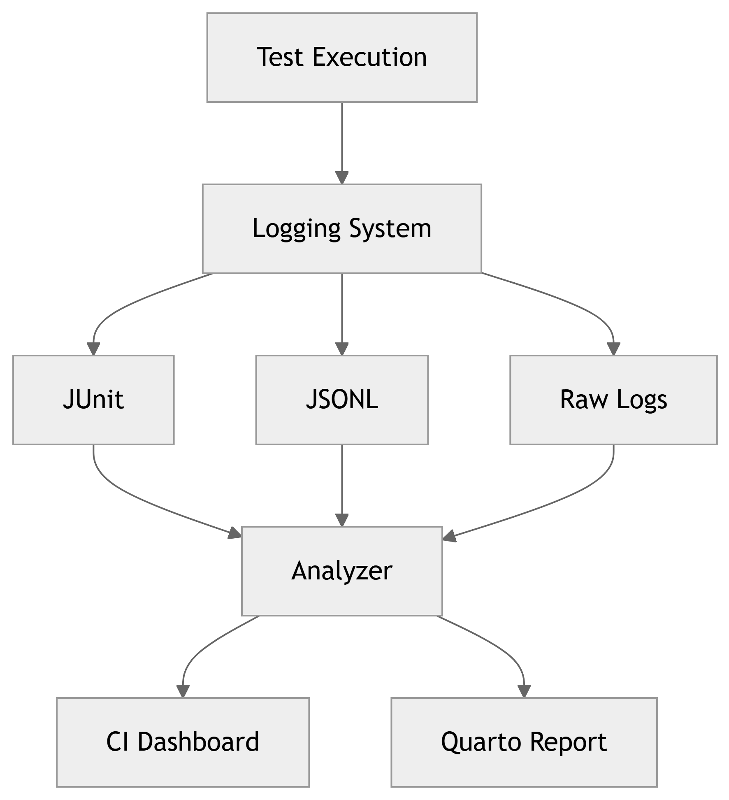
Figure 11: Separation of logging and reporting
Reports support execution summaries, verdict counts, failure categories, failed-test details, duration, DUT information, firmware and commit information, and links to raw evidence.

17. Retention Policy
Example retention values must be confirmed with the project.
Artifact | Example Retention
Test-result metadata | 1 to 2 years
Failed-test logs | 1 year
Successful raw logs | 30 to 90 days
Firmware and build metadata | 1 to 2 years
Crash dumps | 1 year
Regression reports | 1 to 2 years
Debug traces | 30 days
The policy also defines maximum log size, compression, archive format, deletion policy, ownership, and storage limits.

18. Log Rotation
Long-running tests can generate large logs. Rotation can be triggered by file size, elapsed time, test execution, or DUT reboot.
uart.log
uart.log.001
uart.log.002
uart.log.003
uart.log.current
Example configurable policy:
Maximum file size: 100 MB
Compression: gzip

19. Logging Performance
Logging must not materially influence the behavior being tested. Use asynchronous processing, buffering, batching, measurable overhead, and source-specific controls for high-volume logging.
LOG_LEVEL=ERROR
may be suitable for a performance-sensitive test, while:
LOG_LEVEL=TRACE
may be used during debugging.

20. Security and Sensitive Data
The logging design defines what may be written to logs. Credentials, tokens, private keys, production secrets, customer information, and proprietary information require protection or masking.
username=test_user
password=********
token=********
Sensitive information is not written to raw logs unless explicitly required and appropriately protected.

21. Configuration
Logging is configurable without modifying test implementation.
logging:
level: INFO
outputs:
console: true
file: true
json: true
interfaces:
uart:
enabled: true
raw: true
jtag:
enabled: true
rotation:
max_size_mb: 100
compression: true

22. Recommended Initial Architecture
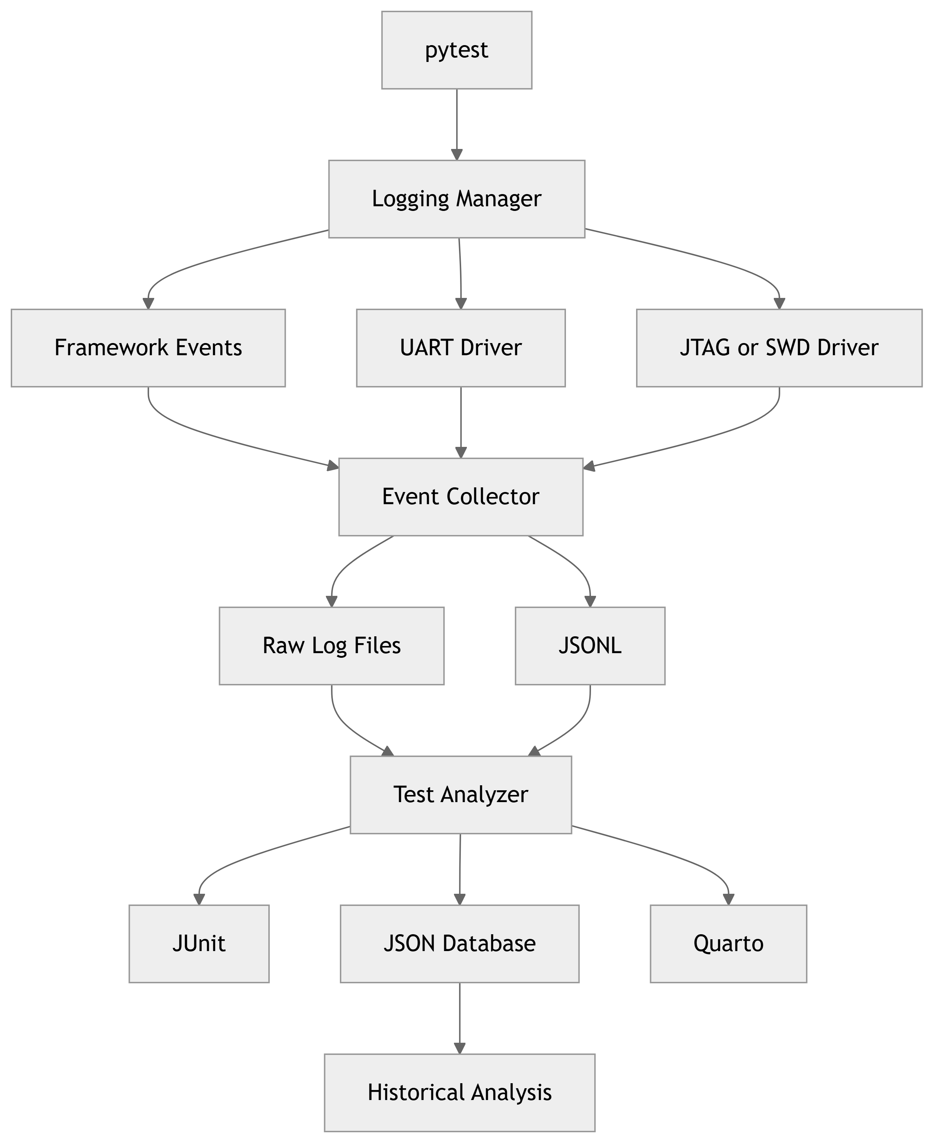
Figure 12: Recommended initial Python and pytest logging architecture

23. Recommended Technology Choices
Component | Initial Choice
Test framework | pytest
Logging API | Python logging plus custom structured logger
Canonical event format | JSONL
Raw interface logs | Plain text or binary, as appropriate
Test result | JUnit XML
Metadata | JSON
Measurements | CSV or JSON
Local storage | Filesystem
CI storage | Jenkins or GitLab artifacts
Historical data | PostgreSQL or SQLite initially
Reporting | Quarto
Analysis | Python and pandas
Visualization | Quarto and Plotly
Compression | gzip or zstd

24. Key Design Principles

24.1 Preserve Raw Evidence
Raw evidence shall never be destroyed as a result of log processing. Raw logs remain available after parsing and analysis.

24.2 Every Event Must Be Traceable
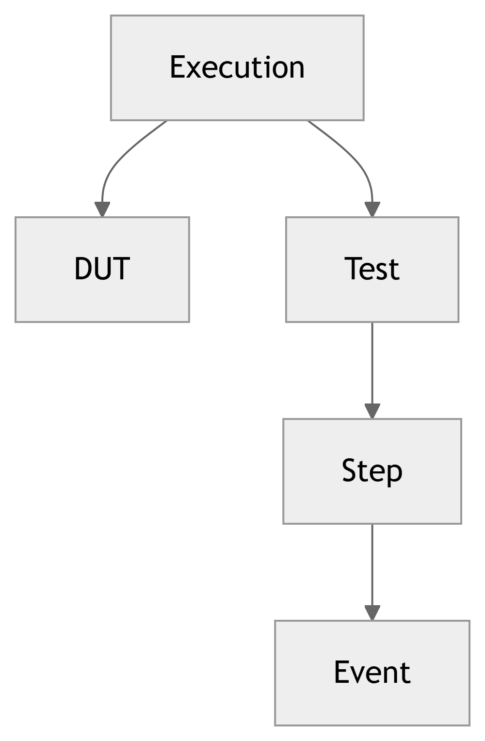
Figure 13: Required event traceability hierarchy

24.3 Test Results and Logs Are Different
A test result answers: Did the test pass or fail?
A log answers: What happened during execution?
The two are linked but are not the same data product.

24.4 Logs Must Support Failure Reconstruction
The stored information must allow failure reconstruction without access to the original test-runner session.

24.5 Logging Must Be Configurable
At minimum, support ERROR, WARNING, INFO, DEBUG, and TRACE, together with source-specific configuration.

24.6 Logging Must Be Low Overhead
Logging must not materially alter timing-sensitive, performance-sensitive, or power-sensitive SoC validation behavior.

25. Final Architectural Principle
A test execution log shall contain sufficient information to reconstruct and diagnose the execution without requiring access to the original test-runner session.
The supporting principle is:
Raw evidence shall be preserved independently from processed and analyzed results.
Together, these principles drive event structure, correlation identifiers, storage, retention, analysis, and reporting.

26. Rendering
Place my_template.docx in the same directory as this .qmd file, then render all configured formats:
quarto render test_execution_logging.qmd
Quarto creates HTML, DOCX, and PDF outputs. PDF output requires a supported TeX installation. Mermaid diagrams are authored as Quarto Mermaid cells and are rendered rather than shown as raw diagram text.

