Quarto DOCX Examples
  - Tables, Code Blocks, Schemas and Diagrams
Example Document
Table of contents

Introduction
This document demonstrates several Quarto features that work well when the primary output is a Microsoft Word (.docx) document.
The examples deliberately avoid Jupyter, Python, and notebook execution. Code blocks are rendered as source code rather than executed.

Tables

Table 1 — Test Execution Summary
Table 1: Test execution summary
Test Suite | Tests | Passed | Failed | Pass Rate
Smoke | 25 | 24 | 1 | 96%
Regression | 120 | 115 | 5 | 95.8%
Integration | 48 | 46 | 2 | 95.8%
Performance | 12 | 11 | 1 | 91.7%

The table above can be referenced as Table Table 1.

Table 2 — Configuration Matrix
Table 2: Environment configuration matrix
Parameter | Development | Test | Production
Logging | DEBUG | INFO | WARN
Database | SQLite | PostgreSQL | PostgreSQL
API Endpoint | Local | Test server | Production
Retries | 1 | 3 | 5

Code Blocks

Option 1 — Plain Code Block
A simple fenced code block is the most portable option for DOCX output.
TestExecution
├── Initialize
├── Execute tests
├── Collect results
└── Generate report

Option 2 — Language-Specific Code Block
A language can be specified to enable syntax highlighting.
#!/bin/bash
echo "Starting test execution"
./run_tests.sh \
--suite regression \
--log-level INFO \
--output results/
The code is displayed in the document; it is not executed by Quarto.

Option 3 — Code Block with Caption and Reference
A code block can have a caption and identifier.
test_execution:
environment: test
suite: regression
retries: 3
logging:
level: INFO
output: results/execution.log
: Example test execution configuration {#lst-config}
The configuration shown in Listing ?@lst-config is suitable for a simple execution-control file.

Schemas and Diagrams

Example 1 — Mermaid Flowchart
Mermaid can be used for a process flow.
flowchart TD
A[Start Test Execution] --> B[Load Configuration]
B --> C[Initialize Environment]
C --> D[Execute Tests]
D --> E[Collect Results]
E --> F[Generate Report]
F --> G[Finish]

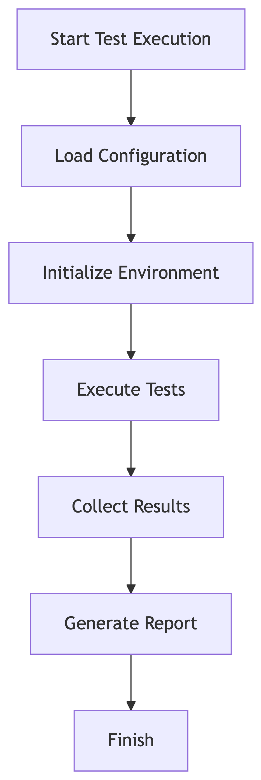

: Test execution flow {#fig-flow}
The flow in Figure ?@fig-flow illustrates the high-level execution lifecycle.

Example 2 — Mermaid Sequence Diagram
A sequence diagram is useful for showing interactions between components.
sequenceDiagram
participant Runner
participant DUT as Device Under Test
participant Logger
participant Reporter
Runner->>DUT: Start test
DUT-->>Runner: Test result
Runner->>Logger: Write execution event
Logger-->>Runner: Event stored
Runner->>Reporter: Generate report
Reporter-->>Runner: Report ready

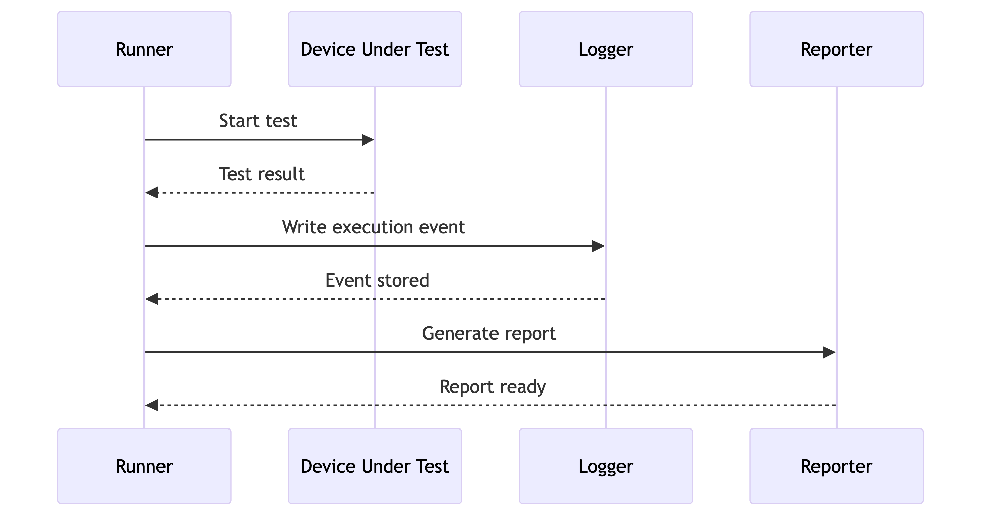

: Test execution interaction sequence {#fig-sequence}

Example 3 — Mermaid Entity Relationship Diagram
An ER diagram can describe the logical data model.
erDiagram
TEST_RUN ||--o{ TEST_CASE : contains
TEST_CASE ||--o{ TEST_RESULT : produces
TEST_RUN ||--|| EXECUTION_ENVIRONMENT : uses
TEST_RUN {
string run_id
datetime started_at
string status
}
TEST_CASE {
string test_id
string name
string suite
}
TEST_RESULT {
string result_id
string status
string log_reference
}
EXECUTION_ENVIRONMENT {
string environment_id
string name
string version
}

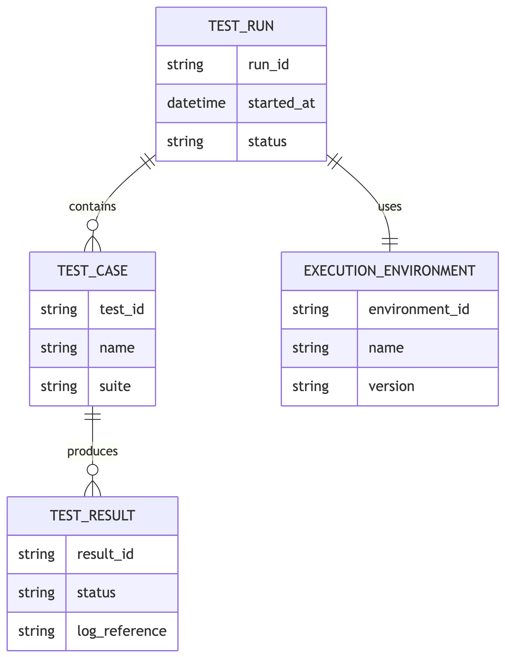

: Logical test execution data model {#fig-er}

Example 4 — Mermaid State Diagram
State diagrams are useful when an object or execution moves through well-defined states.
stateDiagram-v2
[*] --> Created
Created --> Queued
Queued --> Running
Running --> Passed
Running --> Failed
Running --> Aborted
Failed --> Retrying
Retrying --> Running
Passed --> Completed
Aborted --> Completed
Completed --> [*]

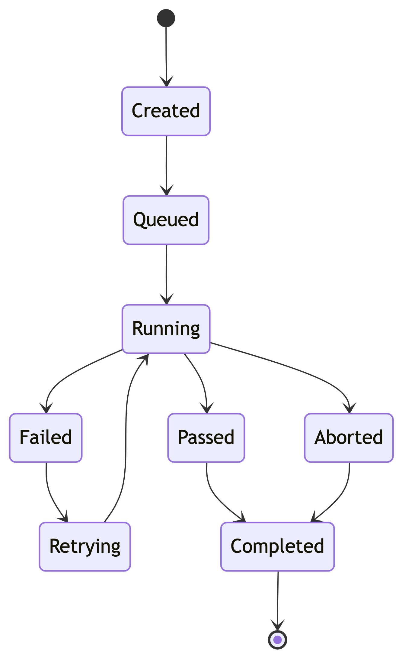

: Test run state lifecycle {#fig-state}

Example 5 — Mermaid Class Diagram
A class diagram can document the structure of a test automation model.
classDiagram
class TestRun {
+String runId
+DateTime startedAt
+String status
+start()
+finish()
}
class TestCase {
+String testId
+String name
+execute()
}
class TestResult {
+String status
+String message
+String logPath
}
TestRun "1" --> "*" TestCase : executes
TestCase "1" --> "*" TestResult : produces

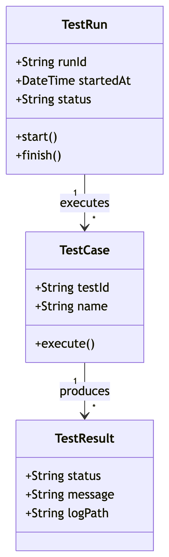

: Test automation object model {#fig-class}

DOCX Notes
The examples in this document are intentionally based on features that can be processed without Jupyter.
For a DOCX-oriented Quarto project, a typical command is:
quarto render examples.qmd --to docx
If Mermaid rendering is unavailable in the local Quarto installation, install or enable the Mermaid rendering support appropriate for the Quarto version being used.

Summary
This example contains:
- Two different table layouts.
- Three different code-block approaches.
- Five different schema/diagram examples:
  - Flowchart
  - Sequence diagram
  - Entity-relationship diagram
  - State diagram
  - Class diagram
The document is designed as a starting point for a larger DOCX-based technical document.

