Quarto DOCX — Tables, Code Blocks, and Mermaid Diagrams
  - DOCX-compatible technical document examples
Example
Table of contents

Purpose
This document demonstrates Quarto features intended for Microsoft Word (.docx) output.
It intentionally does not use Jupyter, notebooks, or Python execution.
The document contains:
- two different tables;
- three different code-block approaches;
- five Mermaid diagrams;
- Mermaid diagrams configured to render as graphical figures rather than appearing as Mermaid source code in the final document.

Tables

Test Execution Summary
Table 1: Test execution summary
Test Suite | Tests | Passed | Failed | Pass Rate
Smoke | 25 | 24 | 1 | 96.0%
Regression | 120 | 115 | 5 | 95.8%
Integration | 48 | 46 | 2 | 95.8%
Performance | 12 | 11 | 1 | 91.7%

Table Table 1 shows a typical test execution summary.

Configuration Matrix
Table 2: Environment configuration matrix
Parameter | Development | Test | Production
Logging | DEBUG | INFO | WARN
Database | SQLite | PostgreSQL | PostgreSQL
Retries | 1 | 3 | 5
Report Format | HTML | DOCX | DOCX/PDF

Table Table 2 demonstrates a second table layout with multiple environment columns.

Code Blocks

Option 1 — Plain Text
The simplest option is a normal fenced code block.
TestExecution
|
+-- Initialize
|
+-- Execute tests
|
+-- Collect results
|
+-- Generate report
This option requires no syntax highlighting and is highly portable to DOCX.

Option 2 — Language-Specific Code
A language identifier can be used to provide syntax highlighting.
#!/bin/bash
echo "Starting test execution"
./run_tests.sh \
--suite regression \
--log-level INFO \
--output results/
The code is displayed in the document. It is not executed by Quarto.

Option 3 — Captioned and Referenced Code
A code block can have a caption and identifier.
test_execution:
environment: test
suite: regression
retries: 3
logging:
level: INFO
output: results/execution.log
: Example execution configuration {#lst-config}
Listing ?@lst-config demonstrates how a code block can be referenced from normal document text.

Mermaid Diagrams
The following diagrams use Quarto’s Mermaid integration.
For DOCX output, the diagrams are intended to be rendered as graphical figures and inserted into the generated Word document.
No Jupyter kernel is required.

Example 1 — Flowchart
flowchart TD
A[Start Test Execution] --> B[Load Configuration]
B --> C[Initialize Environment]
C --> D[Execute Tests]
D --> E[Collect Results]
E --> F[Generate Report]
F --> G[Finish]
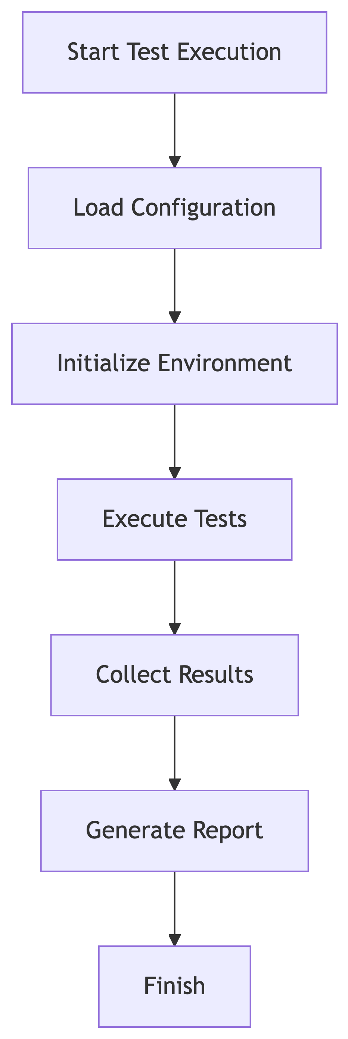
Figure 1: Test execution flow
Figure Figure 1 shows the overall execution flow.

Example 2 — Sequence Diagram
sequenceDiagram
participant Runner
participant DUT as Device Under Test
participant Logger
participant Reporter
Runner->>DUT: Start test
DUT-->>Runner: Test result
Runner->>Logger: Write execution event
Logger-->>Runner: Event stored
Runner->>Reporter: Generate report
Reporter-->>Runner: Report ready
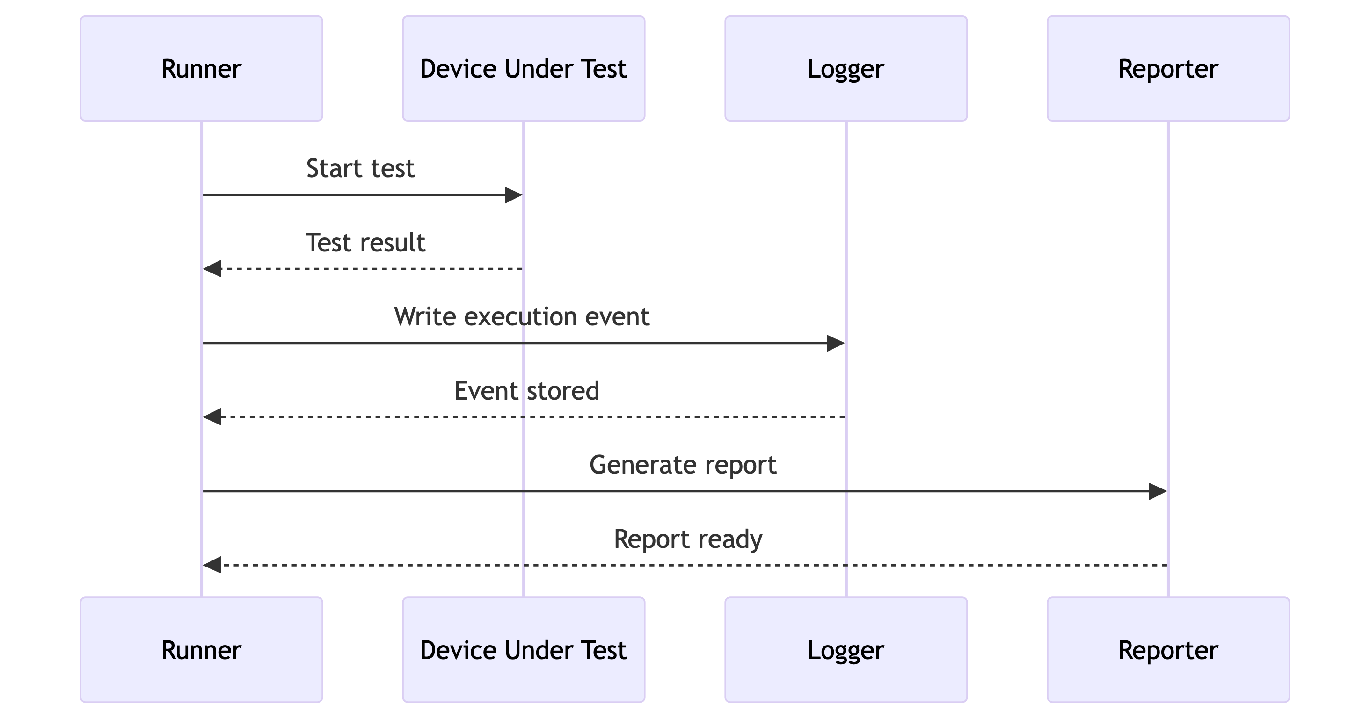
Figure 2: Test execution interaction sequence
Figure Figure 2 shows the interaction between the test runner, device under test, logger, and reporting component.

Example 3 — Entity Relationship Diagram
erDiagram
TEST_RUN ||--o{ TEST_CASE : contains
TEST_CASE ||--o{ TEST_RESULT : produces
TEST_RUN ||--|| EXECUTION_ENVIRONMENT : uses
TEST_RUN {
string run_id
datetime started_at
string status
}
TEST_CASE {
string test_id
string name
string suite
}
TEST_RESULT {
string result_id
string status
string log_reference
}
EXECUTION_ENVIRONMENT {
string environment_id
string name
string version
}
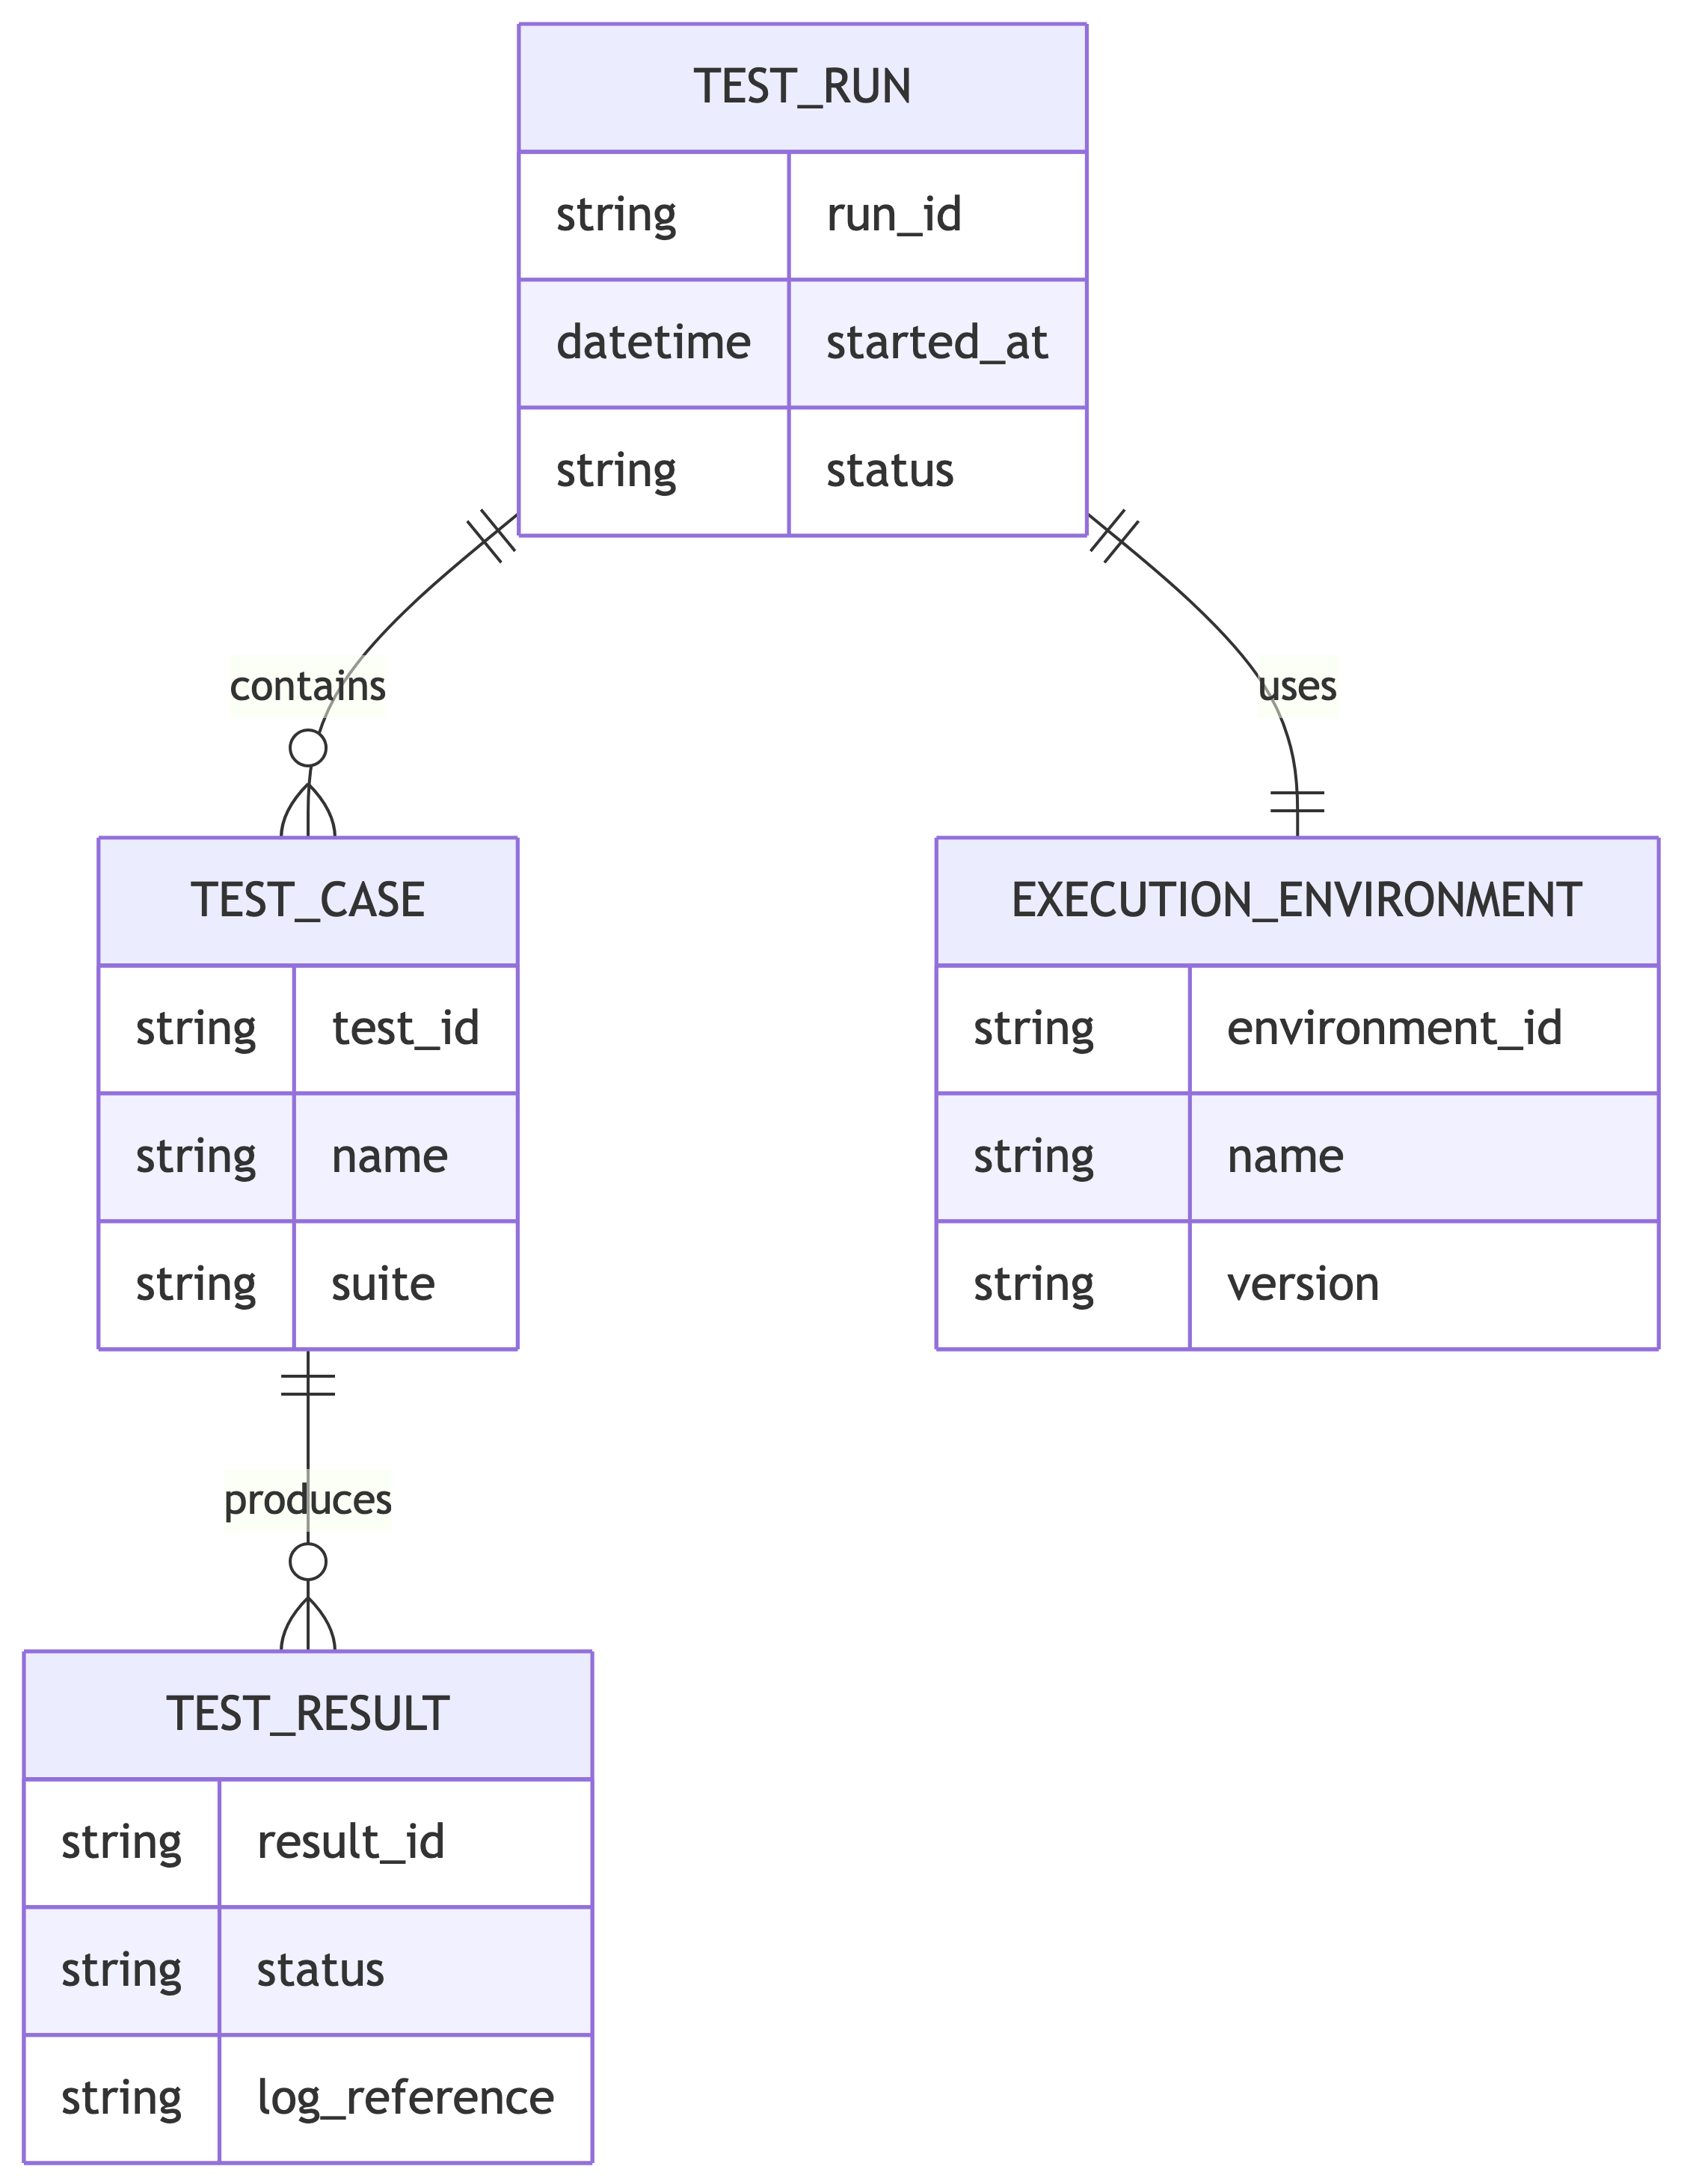
Figure 3: Logical test execution data model
Figure Figure 3 demonstrates a logical data schema.

Example 4 — State Diagram
stateDiagram-v2
[*] --> Created
Created --> Queued
Queued --> Running
Running --> Passed
Running --> Failed
Running --> Aborted
Failed --> Retrying
Retrying --> Running
Passed --> Completed
Aborted --> Completed
Completed --> [*]
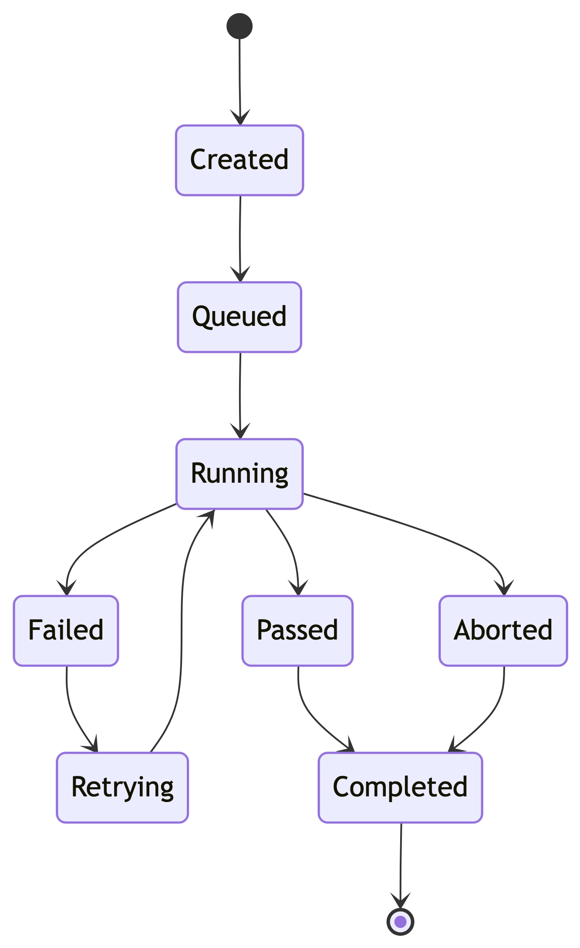
Figure 4: Test run state lifecycle
Figure Figure 4 shows the lifecycle of an individual test run.

Example 5 — Class Diagram
classDiagram
class TestRun {
+String runId
+DateTime startedAt
+String status
+start()
+finish()
}
class TestCase {
+String testId
+String name
+execute()
}
class TestResult {
+String status
+String message
+String logPath
}
TestRun "1" --> "*" TestCase : executes
TestCase "1" --> "*" TestResult : produces
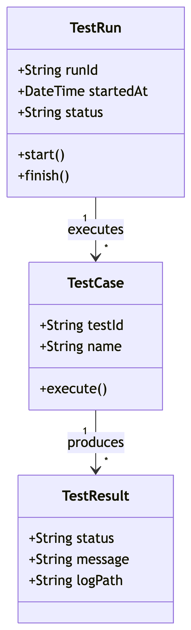
Figure 5: Test automation object model
Figure Figure 5 documents the main test automation objects and their relationships.

Mermaid and DOCX Rendering
The Mermaid blocks above are not ordinary code blocks. They are Quarto diagram blocks:
```{mermaid}
...
Quarto processes these diagrams during rendering.
For a DOCX target, the desired result is:
```text
QMD source
|
v
Quarto
|
+--> Mermaid source
|
v
Rendered diagram
|
v
Graphical figure
|
v
Microsoft Word DOCX
The Mermaid source therefore does not need to be supported natively by Microsoft Word.

Recommended Render Command
Render the document with:
quarto render quarto_docx_examples.qmd --to docx
The resulting .docx should contain the Mermaid diagrams as graphical figures.

Summary
This document provides a DOCX-oriented example containing:
Requirement | Included
Table 1 | Yes
Table 2 | Yes
Code block option 1 | Plain text
Code block option 2 | Language-specific
Code block option 3 | Captioned/referenced
Mermaid diagram 1 | Flowchart
Mermaid diagram 2 | Sequence diagram
Mermaid diagram 3 | ER diagram
Mermaid diagram 4 | State diagram
Mermaid diagram 5 | Class diagram
Jupyter required | No
Mermaid intended as graphical figure in DOCX | Yes

