**Model View Controller**

**Summary:**

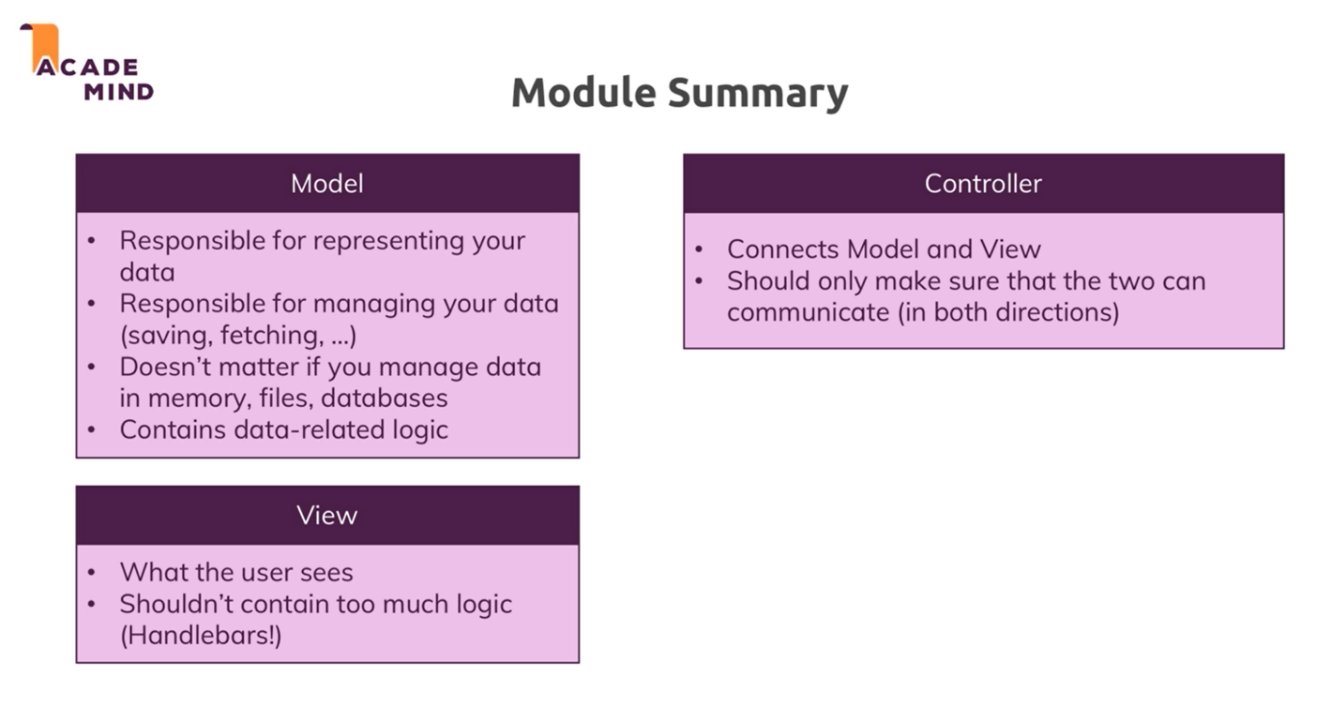

1. **What is MVC?**a. it is Separation of Concerns. Making sure that different part of code to do different part and if something breaks, we know which part is responsible for it.   
   b. It has 3 components: models, views & controllers.  
   c. models: it is responsible for representing data in your code and allow you to work with data. eg. save, fetch, etc.  
   d. views: it is responsible for rendering right content in html documents and sending back to user. It is decoupled from your application code.  
   e. controllers: it is a connecting layer between models and views. It contains ‘in-between’ logic.it also contains routes. It is split across middleware functions.