**SQL – Introduction**

**Table of Content:**

* **Different kind of Databases**
* **Using SQL in a node.js app**

1. **Choosing a Database**goal is to store data and make is easily accessible and fastly available.   
   2 types of databases:  
      
   SQL Database (eg. MySql):  
   a. it thinks in tables and in each table, there are fields (called as column) and data (called as records) which is rows in our table.  
   b. in SQL database we can relate tables with each other.  
   c. Core SQL Database characteristics are:  
    A. they have very strong data schema. So that for each table we can clearly define type (look like) of data store in each column. All data entered should fit with the rules.  
    B. (Data relation) we relate our data in 3 different relations:  
    1-to-1, 1-to-many, many-to-many. Tables are connected  
   d. Query are imp part of sql. Query are the command use to communicate with database.  
   eg.   
   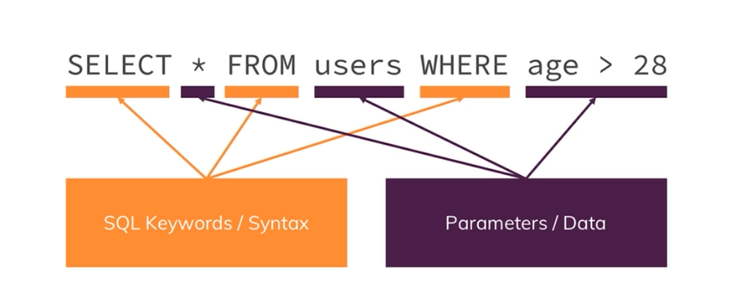  
     
   NoSQL Database (eg. MongoBD)  
   a. NoSql means it does not follow approach of sql database. (it does not have schema and relation)  
   b. Tables are called Collection and collection contain documents.  
   c. NoSQL is Schemaless means it’s okay to don’t have some fields and it’s okay to have some addition fields as compare to other documents.  
   (we can have different structure of documents in a collection)  
   d. in this we don’t have relation intend we duplicate data.  
   e. NoSQL characteristics:  
    A. No Data Schema  
    B. No Data Relations (no/few connections)
2. **Horizontal vs Vertical Scaling**there are 2 approaches to scale our database:  
     
   Horizontal Scaling  
   a. in this we add more servers and connect them with our database and split our data accordingly.  
   b. we need some process which runs queries on all of them and merge them which is not easy todo but this good way to scale.  
     
   Vertical Scaling  
   a. in this we make our old server stronger by adding more cpu power or memory.  
   b. but there is some limit we can’t fit infinite cpu power into a single machine.
3. **SQL vs NoSQL**SQL where data is not change frequently and data have relations  
   NoSQL where data changes frequently  
   