**NoSql**

**Table of Content**

* What is MongoDB
* Using the MongoDB Driver in Node.js Apps

1. **What is MongoDB**a. MongoDB is a company which has product called mongoDB which is a Database.  
   b. it can store large amount of data and it is highly scalable.   
   c. It store data in collection. Collection contains many documents in a JSON format.  
   d. No Schema, No/few relations. Data Duplication.  
   e. Relations – Options  
   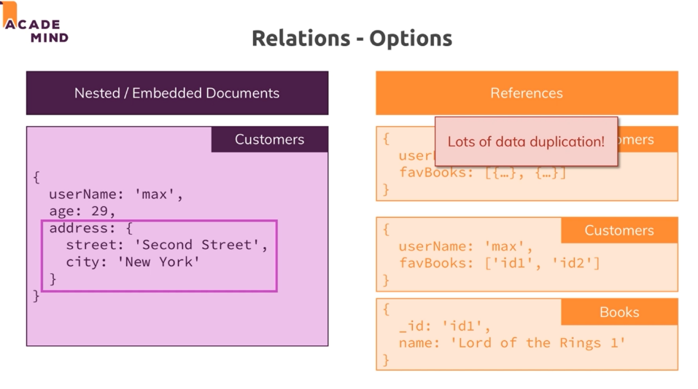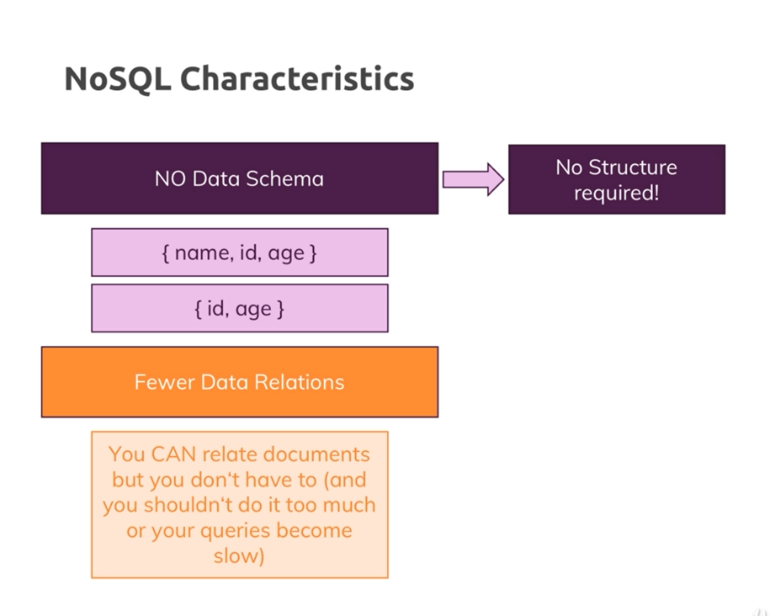
2. **Setting mongodb**a. Create a db in mongodb (shop) and create an admin if not created.  
   b. Copy the link of database   
   c. to connect we node application:  
    A. install mongodb package.  
    B. in database.js file import mongodb package  
    const mongodb = require('mongodb');  
    C. create a client to connect we database  
    const MongoClient = mongodb.MongoClient;  
    D. create a connection using  
    MongoClient.connect(<DB-LINK>);  
    and pass copied link as parameter. Also replace <password> with our password. This will return a client object through which we can connect to our database.  
    E. in then() block we get a client object to connect we db use  
    client.db();  
   d. for each query creating a connection is not a correct way, we save the database connection object in a variable and return that.
3. **Adding Data to DB**a. to query we need to import database object from database.js file  
    const getDb = require('../util/database').getDb;  
   b. to add single data  
    db.collection('products').insertOne({});
4. **Fetching Data to DB**a. to fetch all data of the collection  
    db.collection('products').find().toArray()  
   find() return a cursor object  
   b. to fetch single document from the collection  
    db.collection('products').find({ _id: new mongodb.ObjectId(productId) }).next()  
   in mongodb id is stored as ObjectId and key name of id is _id
5. **Edit Data in DB**a. we can update one or many object one using updateOne() or updateMany()  
     
   db.collection('products').updateOne({ _id: new mongodb.ObjectId(this._id) }, { $set: this })
6. **Delete Data from DB**to delete data we use,  
   db.collection('products').deleteOne({ _id: new mongodb.ObjectId(this._id)})