**Dynamic Routes & Advanced Models**

**Table of content:**

* Passing Route Params
* Using Query Params
* Enhance out Models

**Summary:**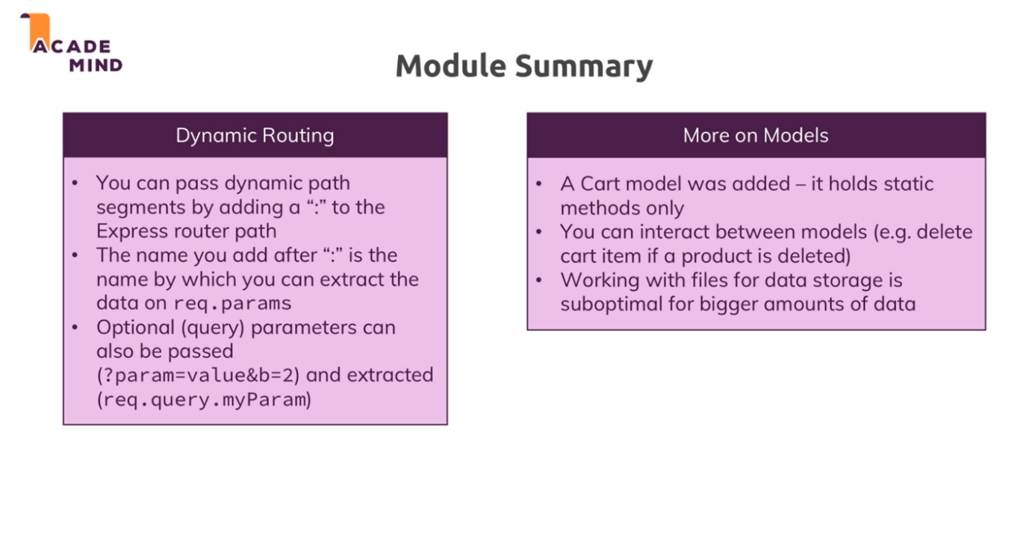

1. **Passing & Extracting Product ID to the path**a. to pass id, we have to pass id in the URL  
   eg. <a href=’/products/<%=product.id%>’> Detail </a>  
   b. to extract that we have to use : in get() (: means anything/ dnamic segment) of route  
   eg. router.get(‘/product/:productId’, controller);  
   in this id we have passed is store in productId.   
     
   now if we want to call /product/delete route we have write this middleware above /product/:productId route middleware reason :productId will store anything after /product/   
   (remember top to down)  
     
   above process is for get() as in post() we can pass it in req body.  
     
   we can pass data in include() as 2nd parameter  
   eg: include(‘../add-to-cart.ejs’, {product: product});
2. **Query Params**a. query params are the data which given in url (data is always in String)  
   eg. /admin/edit-product/12345?edit=true&title=new  
   edit is key and data is true.  
   b. to get this type of data we use query property of request obj.  
   eg. const editMode = req.query.edit