CoverageIQ
An Evidence-Grounded Insurance Policy Intelligence System
Project Synopsis — Recommendation • Summarization • Grounded Query Retrieval • Verification

1. Project Overview
ClauseGuard is an evidence-grounded intelligence system for insurance policy documents, covering three end-user capabilities on a single shared knowledge base: (a) policy recommendation from user profile and requirements, (b) grounded policy summarization, and (c) evidence-grounded question answering with page/section citations. All three pipelines converge on a common Grounded LLM stage followed by a dedicated Evaluator Agent that verifies evidence support, contradiction, citation accuracy and completeness before any answer is released.
A user uploads or selects a policy PDF, which is ingested, OCR'd where needed, structured into sections/clauses/tables, semantically chunked, and embedded into a shared knowledge base (PostgreSQL + pgvector). From there, the user can ask ClauseGuard to recommend a policy, summarize a policy, or answer a specific coverage question — each request is routed through its own pipeline but validated by the same verification layer.
Core Research Claim
A shared, verifiable knowledge base with pipeline-specific retrieval (hard filtering + ML ranking for recommendation, grounded clause retrieval for summarization, hybrid retrieval + reranking for query answering) combined with a single independent Evaluator Agent produces more accurate, better-grounded, and safer insurance guidance than an ungated single-pass RAG system. A closed-loop retry (re-retrieve / re-rank / re-answer) is triggered whenever the Evaluator Agent fails a response.

2. Objectives
- Build a reliable ingestion pipeline for insurance policy documents (Car | Health | Life | Term), including OCR for scanned pages.
- Preserve policy structure — sections, clauses, page numbers, conditions, exclusions, definitions — in a shared relational + vector knowledge base.
- Recommend suitable policies using hard eligibility/budget/type filtering followed by ML-based ranking (LightGBM / XGBoost).
- Summarize a selected policy into key points/details using grounded clause retrieval and LLM summarization.
- Answer free-form coverage questions using hybrid retrieval (vector + BM25) and cross-encoder reranking.
- Route every pipeline's output through a single Grounded LLM and an independent Evaluator Agent before it reaches the user.
- Automatically re-retrieve, re-rank, or re-answer when the Evaluator Agent fails a response, instead of returning an ungrounded answer.
- Quantify performance per pipeline (ranking quality, summarization faithfulness, retrieval/answer accuracy) with reproducible metrics.

3. Scope (Phase 1)
Area | Phase-1 Decision | Reason
Policy types | Health primary; Car/Life/Term supported by the same ingestion pipeline | Ingestion and knowledge-base layers are policy-type agnostic; deep evaluation stays focused on health.
Pipelines in scope | Recommendation, Summarization, and Query Retrieval — all three are Phase-1 deliverables | The shared knowledge base and Evaluator Agent make all three pipelines low-marginal-cost once built.
Documents | 5–10 policies, at least one full family per type used in demos | Keeps structural validation and manual annotation feasible.
Recommendation ranking | Pretrained-feature ML ranker (LightGBM/XGBoost) over hard-filtered candidates | Avoids collecting large-scale preference data; ranking model can be retrained later.
LLM fine-tuning | None in MVP | Avoids high data/compute cost before baseline evidence exists.
Vector index | Exact search (no ANN) | Few-thousand-vector scale does not justify approximate-index complexity.

Not a Legal Coverage Determination
ClauseGuard is an information-retrieval, summarization and interpretation aid. It reports what is supported by the supplied policy text and is not a substitute for the insurer, claims department, broker, or a legally binding policy interpretation.

4. System Architecture and Workflow
The pipeline has one offline ingestion stage feeding a shared knowledge base, three parallel online pipelines (Recommendation, Summarization, Query Retrieval), a shared Grounded LLM stage, and a dedicated Evaluator Agent with a closed retry loop.
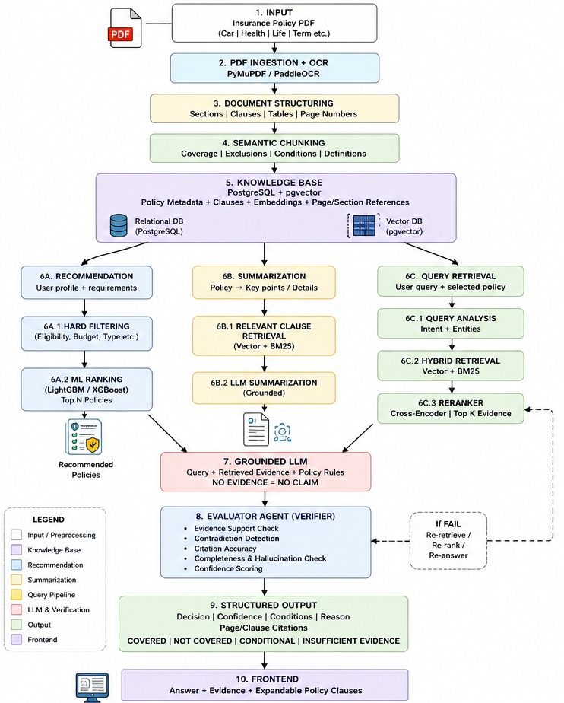
Ingestion and structuring (Steps 1–5)
- Extract digital text and page boundaries with PyMuPDF; use PaddleOCR for scanned/image-only pages, retaining page identifiers for traceability.
- Detect section headings, clause numbering and tables (Document Structuring), then chunk within logical policy sections — coverage, exclusions, conditions, definitions (Semantic Chunking).
- Store policy metadata and clause records in PostgreSQL, and clause embeddings in pgvector — a single shared Knowledge Base feeding all three downstream pipelines.

5. The Three Pipelines

5.1 Recommendation Pipeline (6A)
- Input: user profile and requirements (eligibility, budget, policy type, coverage needs).
- 6A.1 Hard Filtering — deterministic rules eliminate ineligible policies (eligibility, budget ceiling, policy type).
- 6A.2 ML Ranking — a LightGBM/XGBoost ranker scores the remaining candidates and returns the Top N policies.
- Output: a ranked, explainable list of recommended policies.

5.2 Summarization Pipeline (6B)
- 6B.1 Relevant Clause Retrieval — hybrid vector + BM25 search pulls the clauses that matter for a policy-level summary (coverage, exclusions, conditions, definitions).
- 6B.2 LLM Summarization — a grounded LLM call turns retrieved clauses into a structured, cited summary of key points and details.

5.3 Query Retrieval Pipeline (6C)
- 6C.1 Query Analysis — identify intent and entities (event/cause, requested benefit, key conditions) from the user's free-form question.
- 6C.2 Hybrid Retrieval — BM25 + exact vector search run in parallel; BM25 protects exact legal terms, vectors capture semantic matches.
- 6C.3 Reranker — a cross-encoder scores query-clause pairs and keeps the strongest Top K evidence.
All three pipelines converge on the shared Grounded LLM stage (Step 7).

6. Grounded LLM and Evaluator Agent (Verification Loop)
Step 7 — Grounded LLM: generates an answer, summary, or recommendation rationale strictly from the retrieved evidence and policy rules for that pipeline. No evidence retrieved means no claim is made (“NO EVIDENCE = NO CLAIM”).
Step 8 — Evaluator Agent (Verifier): an independent secondary model checks the Grounded LLM's output against the retrieved evidence before release.
- Evidence Support Check — does the response actually follow from the retrieved clauses?
- Contradiction Detection — does any retrieved clause contradict the response?
- Citation Accuracy — do the cited page/section/clause references actually exist and match?
- Completeness and Hallucination Check — does the response omit a material exclusion/condition, or state anything not grounded in evidence?
- Confidence Scoring — assigns a HIGH/MEDIUM/LOW status bucket to the final output.
Retry loop: if the Evaluator Agent fails a response, the system automatically re-retrieves, re-ranks, or re-answers (looping back into 6C.2/6C.3) rather than returning an unverified result. A response is released to the user only after it passes verification or the retry budget is exhausted, in which case the system returns INSUFFICIENT EVIDENCE / CONFLICTING EVIDENCE instead of guessing.

7. Deterministic Decision Rules
For the Query Retrieval pipeline, the MVP uses reproducible categorical outcomes rather than an uncalibrated numeric confidence score:
Condition | Decision | Status
Valid citation + evidence contradicts claim + no unresolved exception | NOT COVERED | HIGH
Valid citation + evidence supports claim + conditions satisfied | COVERED | HIGH
Support exists but an exception remains unresolved | CONDITIONAL | MEDIUM
Evaluator fails after full retry budget, no decisive signal | INSUFFICIENT EVIDENCE | LOW
Support and contradiction both remain after retry | CONFLICTING EVIDENCE | LOW
Citation cannot be verified against source | INSUFFICIENT EVIDENCE | LOW

8. Models and Technology Stack

8.1 Models
Component | MVP Status | Role
PyMuPDF + PaddleOCR | Pre-built | Text extraction and OCR.
Embedding model (BGE-M3) | Pretrained | Semantic representation for vector retrieval.
BM25 | No training | Exact lexical retrieval for legal/insurance phrases.
LightGBM / XGBoost ranker | Trained on hard-filtered candidate features | Recommendation ranking (6A.2).
Cross-encoder reranker | Pretrained | Higher-precision ranking than raw vector similarity (6C.3).
Grounded LLM | Pretrained, API-hosted | Shared reasoning/generation stage for all three pipelines (Step 7).
Evaluator Agent (LLM) | Pretrained, independent secondary model | Evidence support, contradiction, citation and completeness checks (Step 8).
Pydantic + rule engine | No training | Schema validation and deterministic decision gate.
Principle: a model is not trained simply because the architecture has a slot for one. Only the recommendation ranker is trained in the MVP; every other component is pretrained unless a benchmark shows a measurable need for domain adaptation.

8.2 Technology Stack
Layer | Technology | Use
Frontend | React / Next.js | Upload, policy selection, recommendation UI, summary view, query UI, evidence/citation display.
Backend | Python + FastAPI | API orchestration, three-pipeline routing, model calls, validation.
PDF processing | PyMuPDF | Text, page and document metadata extraction.
OCR | PaddleOCR | Scanned policy text extraction.
Relational DB | PostgreSQL | Policy metadata, clauses, user profiles, evaluation records.
Vector DB | pgvector (exact search) | Semantic retrieval at MVP corpus size.
Lexical search | BM25 | Exact terminology retrieval.
Recommendation ranking | LightGBM / XGBoost | Top-N policy ranking after hard filtering.
Reranking | Pretrained cross-encoder | Query-pipeline candidate relevance ranking.
LLM | Primary API-hosted instruction LLM | Grounded generation shared across pipelines.
Evaluator | Independent, smaller secondary LLM | Verification agent (Step 8).
Validation | Pydantic + Python rules | Structured output and deterministic decision gate.
Deployment | Docker | Reproducible service packaging.

9. Data, Annotation and Evaluation
Dataset | Target Size | Purpose
Policy corpus | 5–10 policies across types | Shared ingestion and retrieval corpus for all pipelines.
Recommendation profiles | 30–50 synthetic user profiles | Evaluate hard filtering and ranking quality.
Summarization reference set | 10–15 policy summaries | Faithfulness/completeness evaluation of 6B output.
Query benchmark | 100–200 queries | End-to-end evaluation of the query pipeline (30% independently reviewed).

Pipeline | Key Metrics
Recommendation (6A) | Precision@N, NDCG, filter correctness rate
Summarization (6B) | Faithfulness (% claims grounded in source), coverage of key clauses, ROUGE vs. reference
Query Retrieval (6C) | Recall@5/@10, MRR, Answer Accuracy, Macro F1 across decision labels
Evaluator Agent (Step 8) | % responses correctly flagged as fail, retry success rate, false-pass rate
Citation (all pipelines) | % valid page/section/clause citations
Latency | p50 / p95 end-to-end latency per pipeline (target p95 ≤ 8s for query, ≤ 12s for summarization)
Results are reported with 95% bootstrap confidence intervals; differences are interpreted cautiously when intervals overlap or the sample is small.

10. Progressive Ablation Study
The ablation study isolates the value of each verification component in the Query Retrieval pipeline:
Configuration | Components | Question It Answers
A. Baseline RAG | Vector retrieval + LLM | How does a simple semantic RAG system perform?
B. Hybrid | BM25 + exact vector + LLM | Does lexical + semantic retrieval improve recall?
C. + Reranker | Hybrid + cross-encoder | Does reranking improve top-k evidence quality?
D. + Evaluator Agent (no retry) | Previous + verification, single pass | Does verification alone catch ungrounded answers?
E. Full system | D + closed retry loop (re-retrieve/re-rank/re-answer) | Does the retry loop recover failed responses instead of just flagging them?

11. Privacy and Security
- Store only the minimum personal information needed for recommendation profiles and the demo; separate user identifiers from policy content where practical.
- Keep temporary OCR/PDF artifacts in controlled storage and delete them once processing is complete.
- Do not train the recommendation ranker or any other model on private user-uploaded documents without explicit permission.
- Use access controls for stored policies and secrets for API credentials.
- Display a clear disclaimer on every pipeline's output that ClauseGuard provides policy-text interpretation, not a binding claims or purchase decision.

12. Limitations and Future Work
- Generalization across many insurers and highly variable layouts is not claimed in Phase 1.
- The recommendation ranker is trained on a small synthetic profile set; real user-preference data collection is future work.
- Summarization faithfulness evaluation uses a small reference set; scaling it is future work.
- The retry loop has a fixed budget in the MVP; adaptive retry policies are future work.
- At larger corpus sizes, approximate vector search (e.g., HNSW) can be benchmarked against exact search.
- Calibrated numeric confidence (using held-out data and Expected Calibration Error) is future work.

13. Expected Outcome
The Phase-1 deliverable is a single shared-knowledge-base system, ClauseGuard, that recommends, summarizes, and answers questions about insurance policies through three dedicated pipelines, all gated by one Grounded LLM stage and one independent Evaluator Agent with a closed-loop retry mechanism — measured through pipeline-specific metrics and a progressive ablation study of the verification layer.

14. Final System Output Schema
{ pipeline: RECOMMENDATION | SUMMARIZATION | QUERY, decision: COVERED | NOT_COVERED | CONDITIONAL | INSUFFICIENT_EVIDENCE | CONFLICTING_EVIDENCE | N_A, confidence_bucket: HIGH | MEDIUM | LOW, reason: string, conditions: [string], citations: [{page, section, clause_id}], supporting_evidence: [clause_id], contradicting_evidence: [clause_id], evaluator_status: PASS | REVIEW | FAIL, retry_count: integer }

