**RADIANT ACADEMY J.H.S.**

Sector 115, Noida

**COMPUTER PRACTICAL FILE**

**(Computer Science File)**

Submitted to :

Mr. Vimal Bhardwaj

Computer Science

Submitted by :

Samar Kumar

XII Science

1. **Write a program calculates the volume and surface area of a sphere.**

pi = 3.14

r = int(input("Enter radius of sphere : "))

s = 4*pi*r**2

v = (4*pi*r**3)/3

print('Surface area : ',s,'\n Volume : ', v)

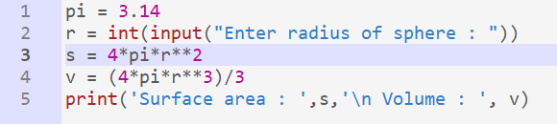

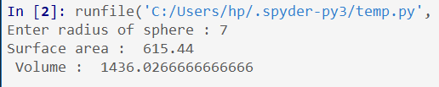

1. **Complete the following function that adds up all the positive values in a list of integer. def sum_positive_integers(a):**

a = [6, 20, 24, -32, -10, 100]

def sum_positive_integers(a):

sum = 0

for i in a:

if i > 0:

sum += i

return sum

print(sum_positive_integers(a))

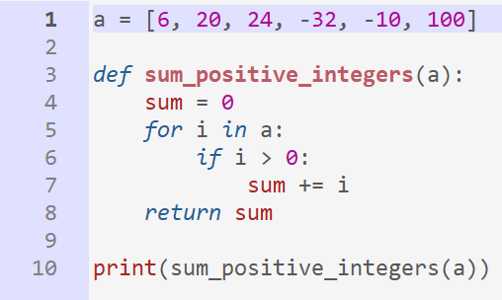

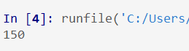

1. **Write a function in Python to display the elements of list thrice if it is a number and display the element terminated with ‘#’ if it is not a number. i.e if the content of list is as follows : List = [‘41’ , ‘DROND’ , ‘GIRIRAJ’ , ‘13’ , ‘ZARA’] The output should be 414141 DROND# GIRIRAJ# 131313 ZARA#**

L = ['41' , 'SAMAR', 'FERALICK', '10', 'IIT', '20']

def fu(a):

for i in a:

if i.isdigit():

print(i*3)

else :

print(i + '#')

fu(L)

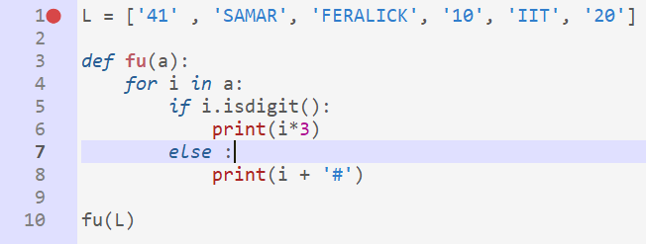

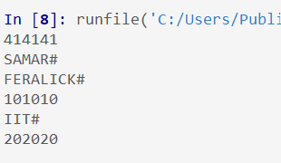

1. **Write a program simulates the rolling of a die. (Using randrange() function of random library.**

import random as r

for i in range(6):

n = int(1 + r.random()*6)

print(n)

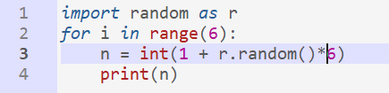

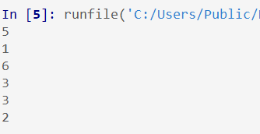

1. **Write a program to read a text file line by line and display each word separated by a #**

file = open('file.txt', 'r')

lines = file.readlines()

for i in lines:

words = i.split( )

print()

for word in words:

print(word + '#', end=' ')

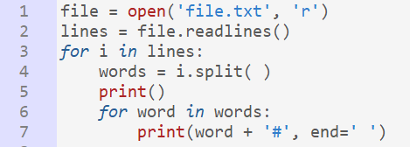

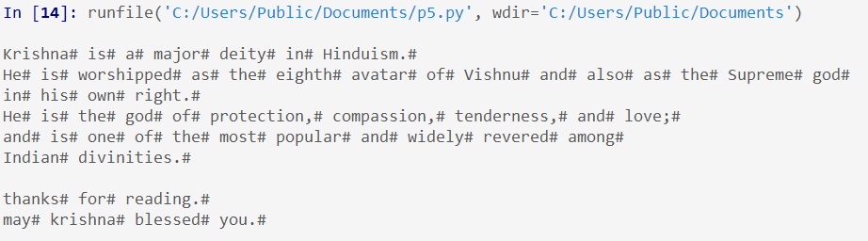

1. **Write different functions to count the number of (1) words (2) Lines (3) spaces (4) digits in “Introduction.txt” file.**

file = open('introduction.txt', 'r')

linesC = 0

wordsC = 0

spaceC = 0

digitC = 0

lines = file.readlines()

linesC += len(lines)

for i in lines:

spaceC += i.count(' ')

words = i.split( )

for word in words:

if word.isalpha():

wordsC += 1

elif word.isdigit():

digitC += 1

print('Number of : \n 1) lines : ', linesC,'\n 2) words : ',

wordsC,'\n 3) space : ', spaceC,'\n 4) digit : ', digitC)

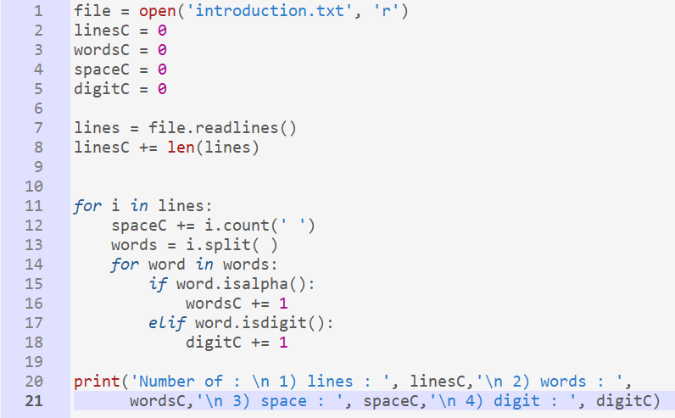

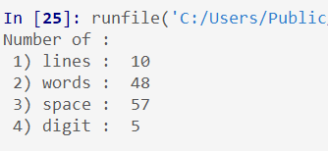

1. **Write a program to read a text file and display the number of vowels, consonants, uppercase and lowercase letters in the file**

file = open('file.txt', 'r')

vowel = 0

consonant = 0

upper = 0

lower = 0

vowels = ['a','e','i','o','u','A','E','I','O','U']

lines = file.readlines()

for i in lines:

words = i.split( )

for word in words:

if word.isalpha():

for letter in word:

if letter in vowels:

vowel += 1

else:

consonant += 1

if letter.isupper():

upper += 1

else:

lower += 1

print('Number of : \n 1) vowel : ', vowel,'\n 2) consonant : ',

consonant,'\n 3) uppercase : ', upper,'\n 4) lowercase : ', lower)

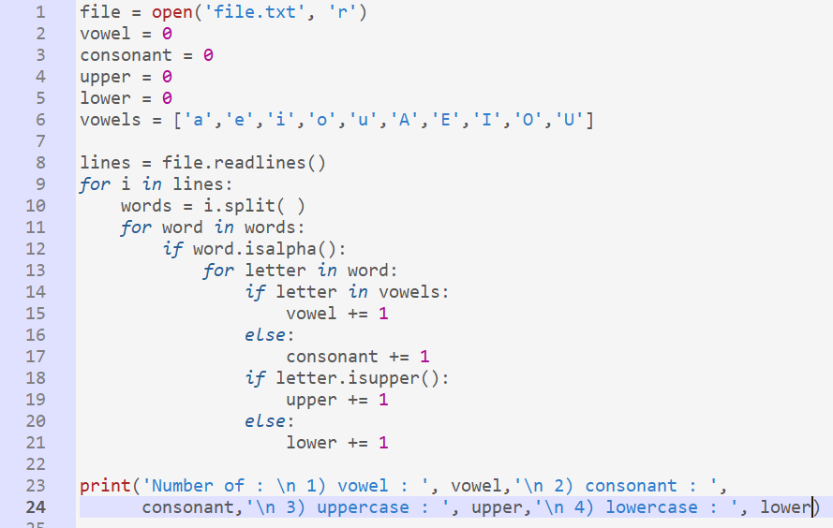

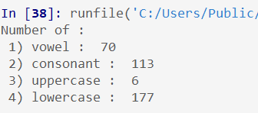

1. **Write a function word_z_s() to count the words starting with “Z” or “S”. (applicable for lower case also)**

a = 'samar kumar zuper man'

def word_z_s(a):

c = ['z','s','Z','S']

count = 0

word = a.split(' ')

for i in word:

if i[0] in c:

count += 1

return count

print(word_z_s(a))

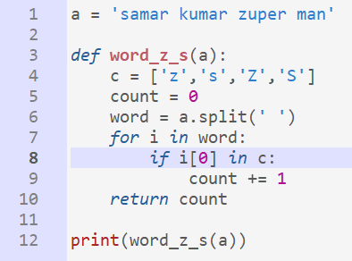

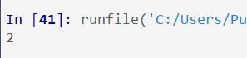

1. **Write a function display_me_my() that will count the no of “me” or “my” words present in text file “story.txt**

def display_me_my(a):

w = ['me','Me','mE','ME','MY','my','My','mY']

count = 0

file = open(a, 'r')

lines = file.readlines()

for i in lines:

words = i.split(' ')

for word in words:

if word in w:

count += 1

return count

print('the number of me or my in the file is :', display_me_my('story.txt'))

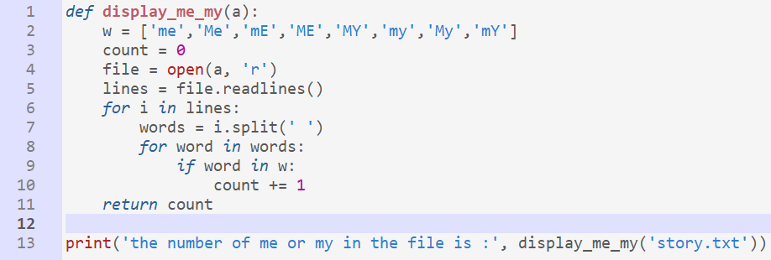

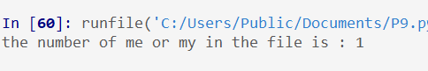

1. **Write a program to find all the words in the file “Allwords.txt” that contains vowels and write those words in “vowels.txt” file.**

file = open('Allwords.txt', 'r')

newFile = open('vowels.txt', 'w')

lines = file.readlines()

v = ['a','e','i','o','u','A','E','I','O','U']

for i in lines:

words = i.split(' ')

for word in words:

for letter in word:

if letter in v:

newFile.write(word + " ")

break

file.close()

newFile.close()

new_file = open('vowels.txt', 'r')

read = new_file.read()

print(read)

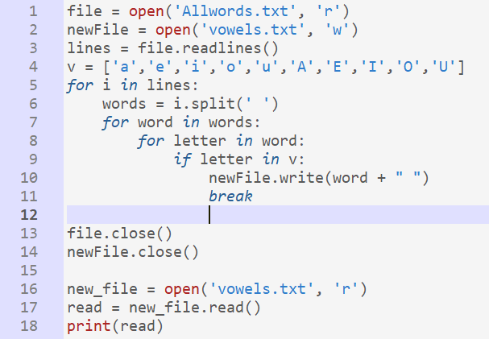

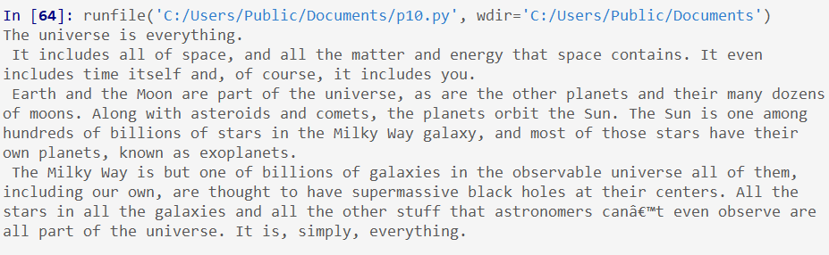

1. **Write functions to create a binary file named ”student.dat” with Roll_No and Name i.e. [Roll_No, Name] and read the Binary file “student.dat” to display data on the screen.**

rec = []

n = int(input('Enter number of students : '))

def student():

file = open("student.txt", 'w')

for i in range(n):

rol = int(input('Enter your roll number : '))

name = input('Enter your roll number : ')

rec = [str(rol) + ' , ', name, '\n']

print(rec)

file.writelines(rec)

file.close()

def display_data():

a = open('student.txt', 'r')

read = a.read()

print(read)

student()

display_data()

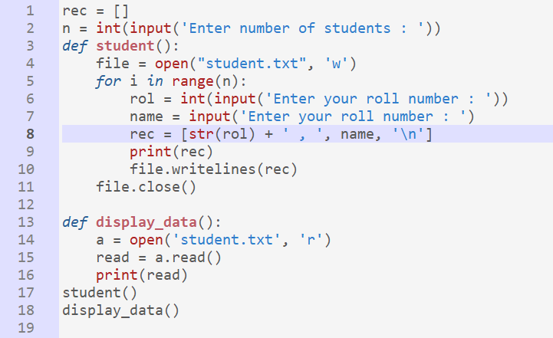

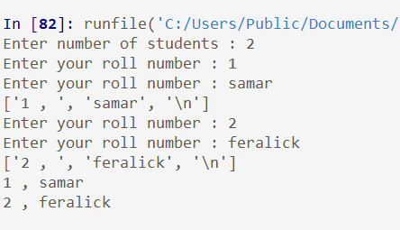

1. **Write a function to create a binary file with Roll_No, Name.Search for a given roll no. and display the name , If not found display appropriate message.**

Problem in concept

**16.Display the details of all the employees who are getting a salary of more than 35000**

Select * from employee where salary > 35000;

**17. Display the details of all the employees whose salary is between 32000 and 38000. (Using BETWEEN operator)**

Select * from employee where salary between 32000 and 38000;

**18. Display the details of all the employees in the descending order of their names.**

Select * from employee order by name desc;

**19. Increase salary by 5000 of those employees whose grade is ‘A’.**

Update employee set salary = salary + 5000 where grade = A;

**20. Display the name of the department and the name of the corresponding HOD for all the departments.**

Select Dname, name from department D, Employee E where D.dept = E.dept;

**21. Display name,dept of employees working in North zone.**

Select name, dept from employee where zone = north