**RADIANT ACADEMY J.H.S.**

Sector 115, Noida

**Computer Science File**

**(Term I + Term II)**

Submitted to :

Ms. Deepika Aggarwal

Computer Science

Submitted by :

Samar Kumar

XI Science

Roll no. - 30

|  |  |  |
| --- | --- | --- |
|  | **Radiant Academy J.H.S. Class-11th**  **Subject: Computer Science Term -1+Term 2**  **Practical File-Python**  **\*\*\*\*\*\*\*\*\*\*\*\*\*\*\*\*\*\*\*\*\*\*\*\*\*\*\*\*\*\*\*\*\*\*\*\*\*\*\*\*\*\*\*\*\*\*\*\*\*\*\*\*\*\*\*\*\*\*\*\*\*\***  **\*\*\*\*\*\*\*\*\*\*\*\*\*\*\*** |  |
|  | **Programs** | **Date** |
| **1.** | **Write a program to calculate total and average of marks by inputting marks through keyboard in five subjects and print it student is pass or fail and display grade accordingly. Criteria: >= 75 Grade ‘A’ , >=65 and <75 Grade ‘B’, >= 50 and**  **<65 Grade ‘C’, >= 33 and <50 Grade ‘D’ , <33 Grade ‘E’** |  |
| **2.** | **Write a program that accepts radius of circle then print area of circle.** |  |
| **3.** | **Write a program asks for height in centimeters and then converts your height to**  **feet and inches** |  |
| **4.** | **Write a program to obtain principal ,rate of interest and time from user and**  **compute simple interest and compound interest.** |  |
| **5.** | **Write a program to read three numbers in three variables and swap first two**  **variable with the sum of first and second , second and third number respectively.** |  |
| **6.** | **Write a program to find the sum of even number and odd numbers for first 20**  **natural numbers.** |  |
| **7.** | **Write a program to determine whether a no is a perfect , Armstrong or a**  **palindrome.** |  |
| **8.** | **Input a number and check if the no. is prime or composite no.** |  |
| **9.** | **Write a program to print every integer between 1 and n divisible by m . Also**  **report whether the number that is divisible by m is even or odd** |  |
| **10.** | **Write a program to find largest number of a list of numbers entered through**  **keyboard.** |  |
| **11.** | **Write a program to print the sum of 12 + 32 +52+ +n2** |  |
| **12.** | **Program to print series**  **A \***  **A B * \***  **A B C * * \***  **A B C D * * * \***  **A B C D E * * * * \*** |  |
| **14** | **Compute the greatest common divisor and least common multiple of two**  **integers.** |  |
| **15.** | **Write a program to find sum of digits of a number.** |  |
| **16.** | **Write a program to find the factorial of a given number.** |  |
| **17.** | **Write a proram to print febnocci series for first 10 element. 0 1 1 2 3 5 8 13 21 34** |  |
| **18.** | **Write a program to count total number of vowels ,consonants ,uppercase and**  **lowercase letters in a string.** |  |

|  |  |  |
| --- | --- | --- |
| **19.** | **Write a program to check whether the string is palindrome or not. You can**  **change the case of characters in a string.** |  |
| **20.** | **Write a program to count total number of words in a string.** |  |
| **21.** | **Write a program to input string or line through keyboard and then count specified character in string or line. Print the total number of occurrence of**  **specified character.** |  |
|  | **Term 2** |  |
| **22.** | **Write a program to find the largest/smallest no in a list/tuple** |  |
| **23.** | **Write a menu driven program for a list**   1. **Find Mean** 2. **Find Mode** 3. **Find Median** 4. **Exit** |  |
| **24.** | **Write a menu driven program for list**   1. **Append** 2. **Delete** 3. **Search** 4. **Exit** |  |
| **25.** | **Write a program to input a list/tuple of elements search for a given element in**  **the list/tuple** |  |
| **26.** | **Input a list of numbers and find smallest and largest no from the list.** |  |
| **27.** | **Input a list of numbers and swap elements at the even location with the**  **elements at the odd location.** |  |
| **28.** | **Write a program in Python to display the elements of list thrice if it is a number**  **and display the element terminated with ‘#’ if it is not a number.**  **i.e if the content of list is as follows :**  **List = [‘41’ , ‘DROND’ , ‘GIRIRAJ’ , ‘13’ , ‘ZARA’]**  **The output should be**  **414141**  **DROND# GIRIRAJ# 131313**  **ZARA#** |  |
| **29.** | **Write a program to store student’s information like admission number , roll**  **number, name and marks in a dictionary and display information on the basis of**  **admission number.** |  |
| **30.** | **Write a program to input total number of sections and stream name in class 11**  **and display all information on the output screen .** |  |
| **31.** | **Write a python script to concatenate two dictionaries to create a new one.** |  |

**No. 1**

**# Write a program to calculate total and average of marks by inputting marks through keyboard in five subjects and print it student is pass or fail and display grade accordingly.**#This program provide you complete analyses of your test.

print("This program provide you complete analyses of your test.")

subject1= float(input(" Enter your marks in Subject 1 :"))

subject2= float(input(" Enter your marks in Subject 2 :"))

subject2= float(input(" Enter your marks in Subject 3 :"))

subject4 = float(input(" Enter your marks in Subject 4 :"))

subject5 = float(input(" Enter your marks in Subject 5 :"))

total = subject1+ subject2+ subject2+ subject4 + subject5

max = float(input(" Enter maximum marks :"))

average = total/5

if average > max :

print("Not valid. It is a case of extraordinary as your total marks is greater than allowed.")

else :

p = (total * 100)/(max * 5)

print("Your Total marks is ",total,"Out of ", max * 5)

print("Average marks : ", average)

print("You secured : ", p,"%" )

if p >= 75 :

print("Your result : Grade A \nGreat!" )

elif p >= 65 and p< 75 :

print("Your result : Grade B \nNice!", )

elif p >= 50 and p< 65 :

print("Your result : Grade C \nGood!")

elif p >= 33 and p < 50:

print("Your result : Grade D \nNeed hard word!")

else :

print("Your result : Grade E \nBetter do next time!")

OUTPUT

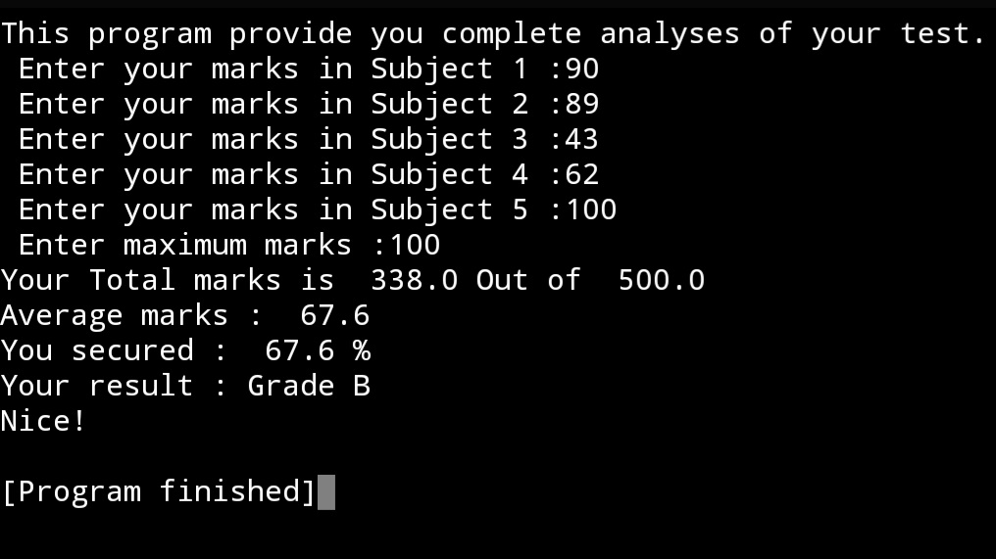

**No. 2**

**#Write a program that accepts radius of circle then print area of circle.**

import math

radius = float(input(" Enter the radius of circle : "))

print(" The area of circle is", math.pi * (radius ** 2))

OUTPUT

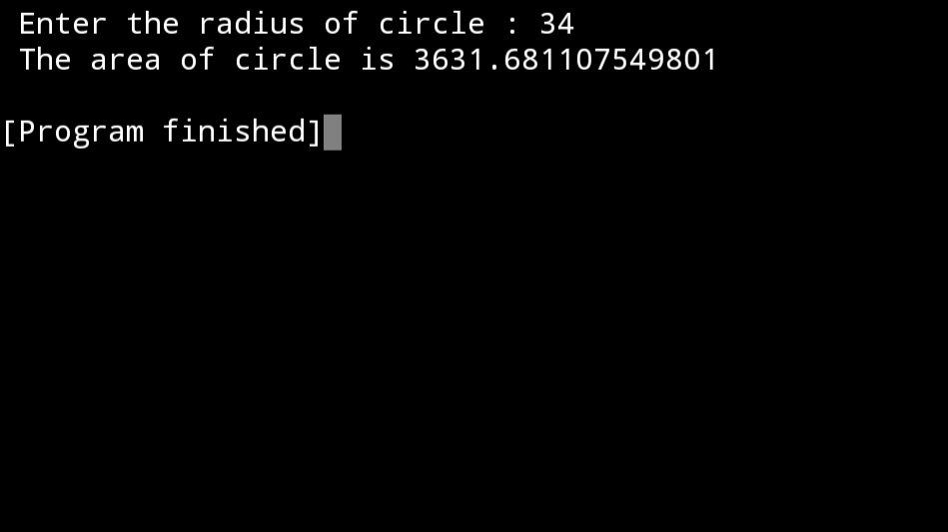

**No. 3**

**#Write a program asks for height in centimeters and then converts your height to feet and inches**

height = float(input(" Enter your height in cm ( if you know ! ) : "))

inch = height/2.54

feet = inch//12

inches = round(inch - (feet * 12))

print("Your height is", feet , "Feet and",inches , "inches")

OUTPUT

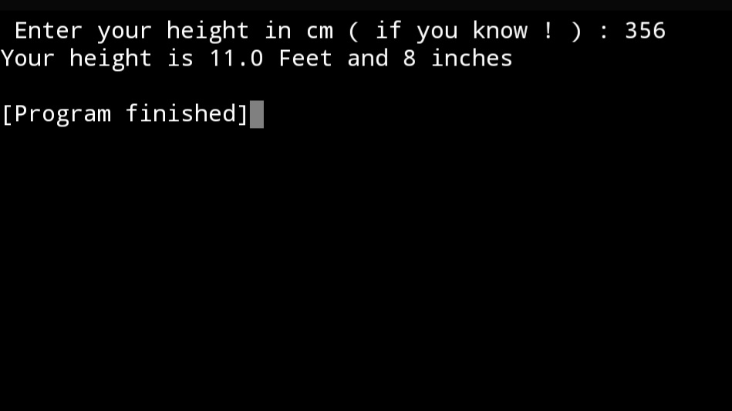

**No.4**

**#Write a program to obtain principal ,rate of interest and time from user and compute simple interest and compound interest**

principle = float(input("Enter the principal amount ( in Rs. ) :"))

rate = float(input("Enter the rate of floaterest per month ( in % ) :"))

time = float(input("Enter the time ( in years ) :"))

simpleInterest = ( principle * rate * time ) // 100

print('Simple intrest of', principle, ', at the rate of', rate, 'for', time, 'years is - ', simpleInterest)

compoundInterest = (principle*(1 + (rate/100)) ** time) - principle

print('whereas compund interest is', compoundInterest)

if compoundInterest > simpleInterest:

print('\nInvestment in Compound interest is beneficial.')

else:

print('\nInvestment in Simple interest is beneficial.')

i = 0

while i < 1000:

compoundInterest = (principle*(1 + (rate/100)) ** i) - principle

if compoundInterest > (principle * i):

print('\nAfter', i, 'year, your earned compound interest will be more than you would have accumulated by collecting', principle, 'ruppes every years for', i, 'years')

break

i += 1

OUTPUT

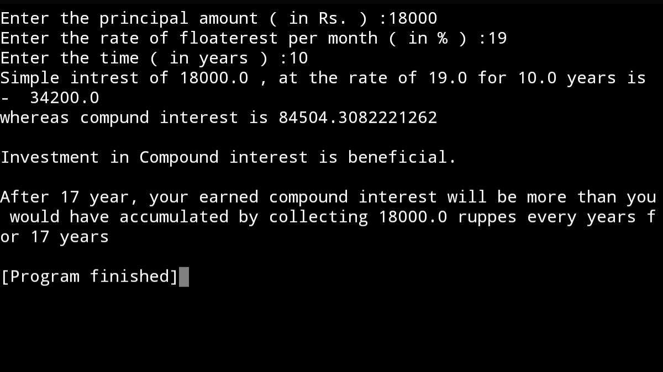

**No.5**

**#Write a program to read three numbers in three variables and swap first two variable with the sum of first and second , second and third number respectively**

a = int(input("Enter a number : "))

b = int(input("Enter another number : "))

c = int(input("Enter once again : "))

a = a+b

b = b+c

print(a)

print(b)

OUTPUT

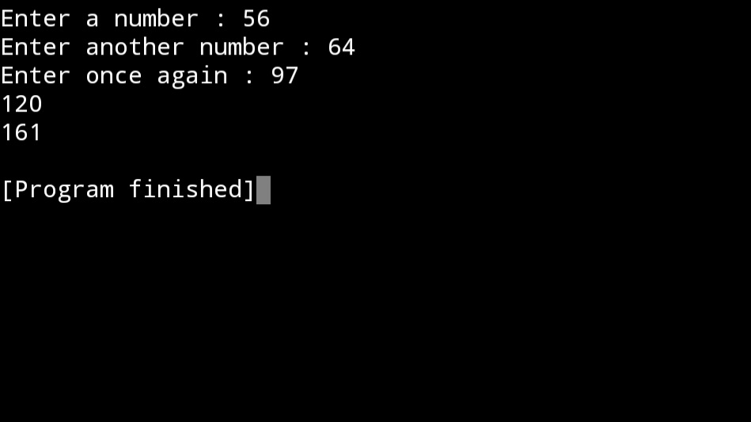

**No.6**

**#Write a program to find the sum of even number and odd numbers for first 20 natural numbers.**

sum = 0

for n in range(2,21,2):

sum += n

print("Sum of first 20 even natural numbers is",sum)

sum = 0

for n in range(1,20,2):

sum += n

print("Sum of first 20 odd natural numbers is",sum)

OUTPUT

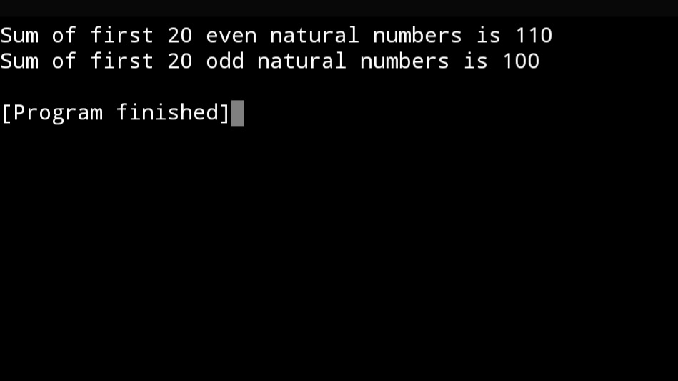

**No.7**

**#Write a program to determine whether a no is a perfect , Armstrong or a palindrome**.

n = int(input("Enter Any Number:"))

print('\n\nChecking whether the number is palindrome...')

number = n

a = 0

while(n>0):

r = n % 10

a *= 10

a += r

n = n // 10

if(number == a):

print("The number",number,"is a Palindrome!")

else:

print("The number",number,"is not a Palindrome!")

'''xxxxxxxxxxxxxxxxxxxxxxxxxxxxxxxxxxxxxxxxxxxxx'''

print('\n\nChecking wether the number is Perfect Number...')

sum = 0

for i in range(1, number):

if (number % i == 0):

sum = sum + i

if (sum == number):

print("The number",number,"is a Perfect number!")

else:

print("The number",number,"is not a Perfect number!")

'''xxxxxxxxxxxxxxxxxxxxxxxxxxxxxxxxxxxxxxxxxxxxx'''

print('\n\nChecking wether the number is an Armstrong Number...')

sum = 0

n = number

while n != 0:

a = n % 10

sum = sum + (a**3)

n = n//10

if (sum == number):

print("The number", number, "is an Armstrong number!")

else:

print("The number", number, "is not an Armstrong number!")

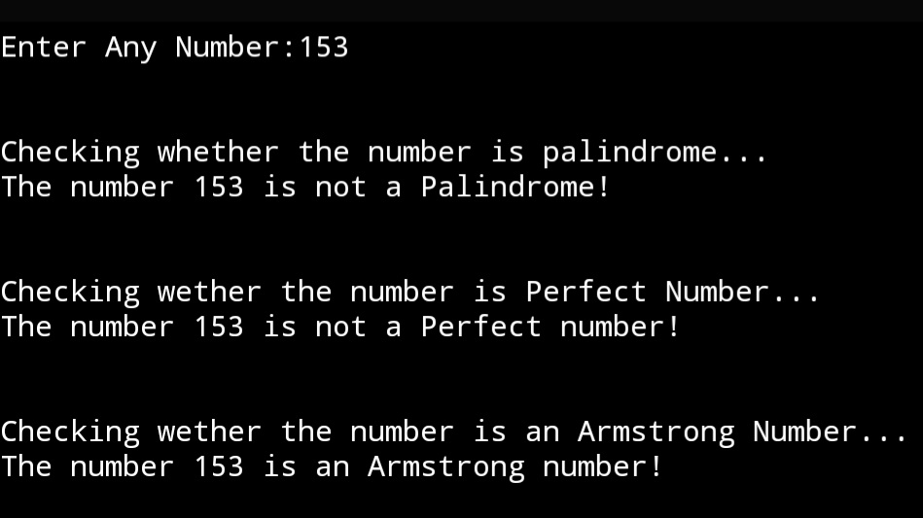

OUTPUT

**No.8**

**#Input a number and check if the number is prime or composite number.**n = int(input("Enter any number to check whether it is prime or composite :"))

point = 0

for i in range(2, n//2 + 1):

if n % i == 0 :

point = 1

break

if point == 1:

print("The number",n, "is a composite number!")

else:

print("The number",n,"is a prime number!")

OUTPUT

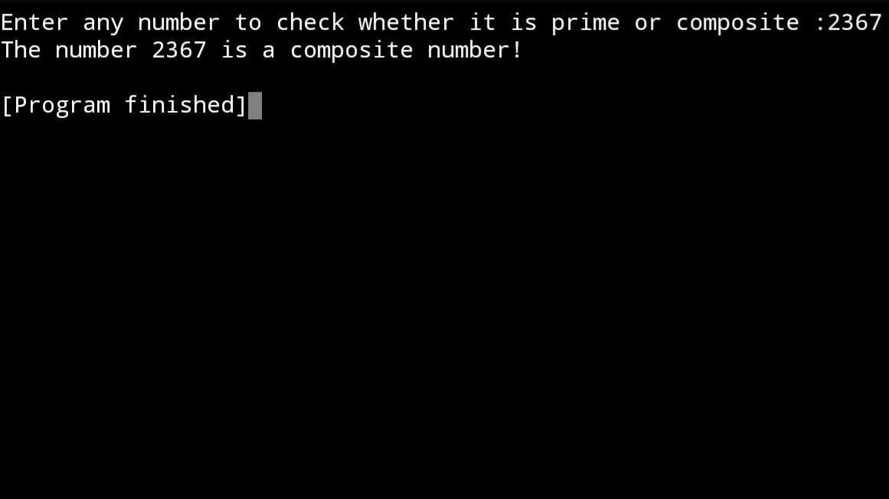

**No.9**

**#Write a program to print the sum of 1^2 + 3^2 +5^2+……………+n^2**

n = int(input("Enter a number : "))

sum = 0

for i in range( 1 , n + 1 , 2 ):

sum = sum + ( i ** 2 )

print("The sum is ",sum)

OUTPUT

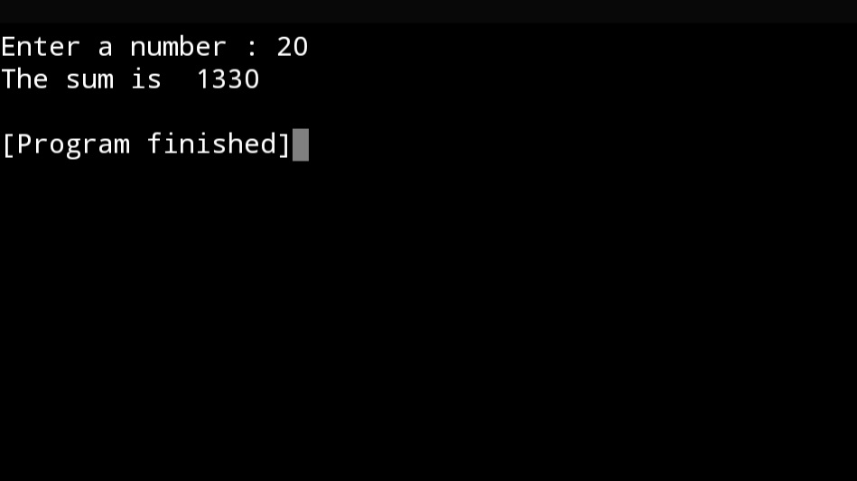

**No.10**

**#Write a Program to print series**

**A \***

**A B * \***

**A B C * * \***

**A B C D * * * \***

**A B C D E * * * * \***

**for** i **in** range(1,6):  
 **for** j **in** range(0,i):  
 print("*", end=" ")  
 print("")  
  
**for** x **in** range(1, 6):  
 **for** y **in** range(65, 65+x):  
 a = chr(y)  
 print(a, end=" ")  
 print("")

OUTPUT

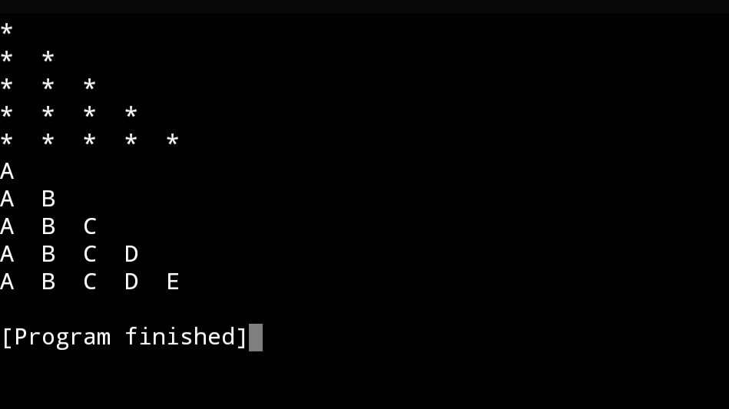

**No.11**

**#Write a program to find sum of digits of a number.**sum = 0

n = int(input("Enter a number:"))

while n != 0:

a = n % 10

sum += a

n = n//10

print(sum)

OUTPUT

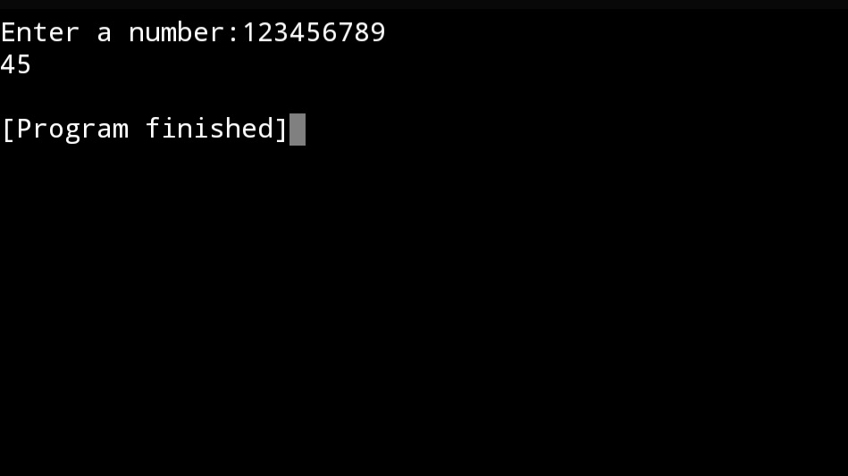

**No.12**

**#Write a program to find the factorial of a given number.**  
factorial = 1

n = int(input("Enter the number to find factorial:"))

for i in range(n,0,-1):

factorial *= i

print('Factorial', n, 'is', factorial)

OUTPUT

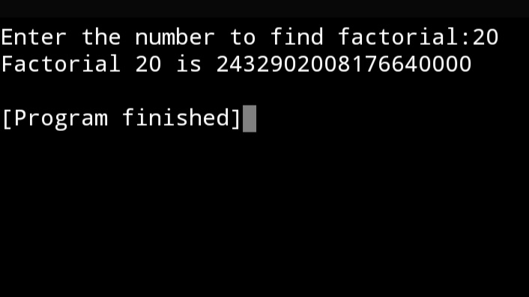

**No.13**

**#Write a program to print Fibonacci series for first 10 element. 0 1 1 2 3 5 8 13 21 34**  
print('This program gives first 10 Fibonacci numbers.\n')

a = 0

b = 1

print(a, end = ",")

print(b, end = ",")

for i in range(3, 11) :

c = a + b

print(c, end=",")

a , b = b , c

OUTPUT

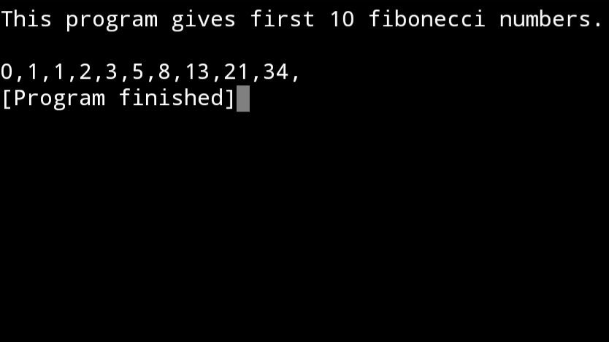

**No.14**

**#Write a program to count total number of vowels, consonants, uppercase and lowercase letters in a string.**

str = input("Enter the string :")

vowels = ["a","e","i","o","u","A",'E', 'I','O',"U"]

consonants = ['b', 'c', 'd', 'f', 'g', 'h', 'j', 'k', 'l', 'm', 'n', 'p', 'q', 'r', 's', 't', 'v', 'w', 'x', 'y', 'z', 'B', 'C', 'D', 'F', 'G', 'H', 'J', 'K', 'L', 'M', 'N', 'P', 'Q', 'R', 'S', 'T', 'U', 'V', 'W', 'X', 'Y', 'Z']

vow = 0

cons = 0

upr = 0

lwr = 0

for i in str :

if i in vowels:

vow += 1

if i in consonants :

cons += 1

#else : continue

for x in str:

if x.isupper() :

upr += 1

if x.islower():

lwr += 1

print('The number of vowels are', vow)

print('The number of consonants are', cons)

print('The number of upper case letters are', upr)

print('The number of lower case letters are', lwr)

OUTPUT

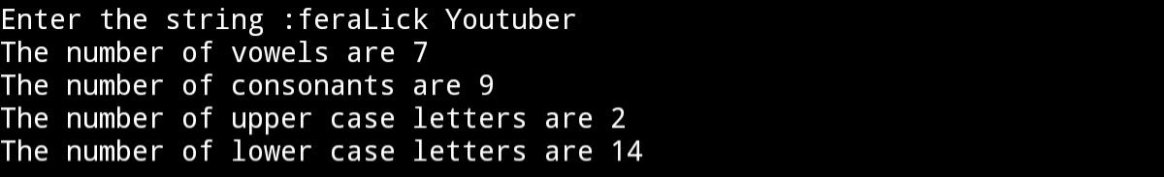

**No.15**

**#Write a program to check whether the stringing is palindrome or not. You can change the case of characters in a stringing.**

string = input("Enter the stringing : ")

if string == string[ : : -1 ]:

print("This string is PALINDROME !")

else :

print(“No, this is not PALINDROME !”)

OUTPUT



**No.16**

**#Write a program to count total number of words in a string**

str = input("Enter the string : ")

lst = str.split()

print("The number of words in the strings are :", len(lst))

OUTPUT



**No.17**

**# Write a program to input string or line through keyboard and then count specified character in string. Print the total number of occurrence of specified character.**

str = input("Enter the string: ")

subStr = input("Enter the substring to be search :")

a = str.count(subStr)

print("The substring :", subStr, ", occurred", a, "times")

OUTPUT

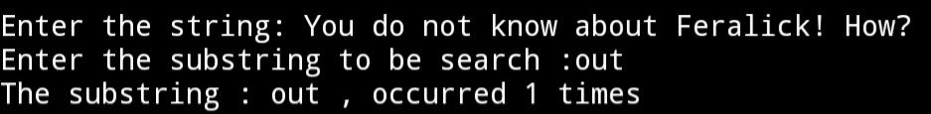

**No.18**

#Write a program to find the largest/smallest no. in a list/tuple

num = eval(input("Enter numbers : "))

print('The largest number in the sequence is', max(num))

print('The smallest number in the sequence is', min(num))

OUTPUT

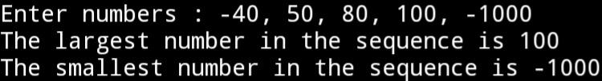

**No.19**

**'''NO.19**

**Write a menu driven program for a list**

**1. Find Mode**

**2. Find Median**

**3. Find Mean**

**4. Exit**

**'''**

**import statistics**

**nums = eval(input("Enter the numbers : "))**

**while True:**

**print('''**

**1. Find Mode**

**2. Find Median**

**3. Find Mean**

**4. Exit**

**''')**

**select = int(input("Enter your select : "))**

**if select == 1 :**

**print('The Mode is', statistics.mode(nums))**

**elif select == 2 :**

**print('The Median is',statistics.median(nums))**

**elif select ==3 :**

**print('The Mean is',statistics.mean(nums))**

**else :**

**break**

OUTPUT

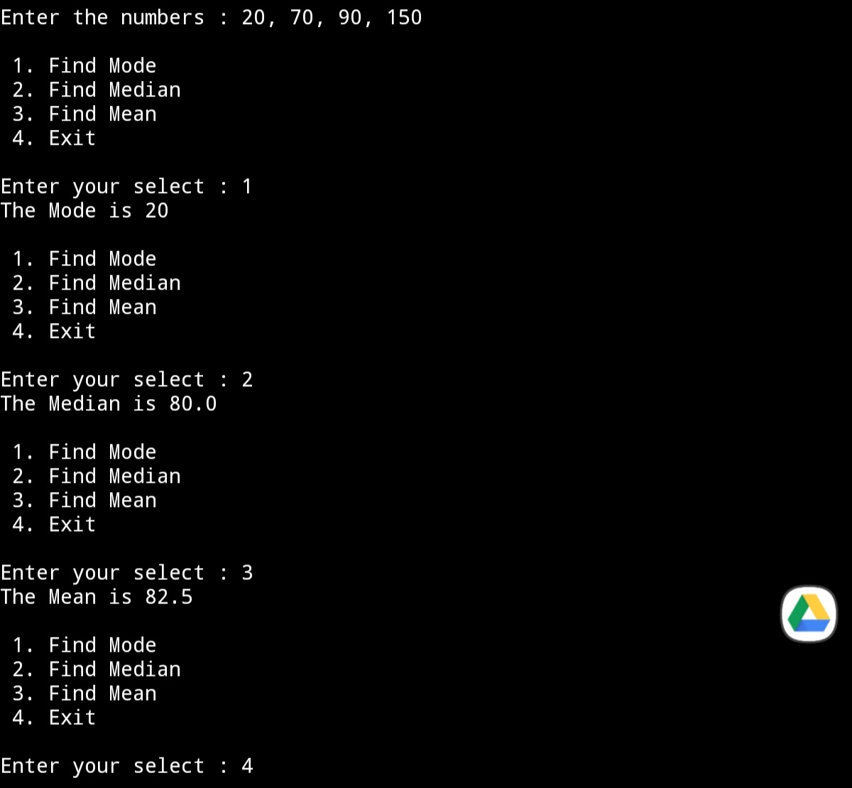

**No.12**

**'''Write a menu driven program for a list to:**

**1. Append**

**2. Delete**

**3. Search**

**4. Exit**

**'''**

**nums = list(eval(input("Enter the numbers : ")))**

**while True:**

**print('''**

**1. Append**

**2. Delete**

**3. Search**

**4. Exit**

**''')**

**select = int(input("Enter your select : "))**

**if select == 1 :**

**x = int(input("The number to be appended :"))**

**nums.append(x)**

**print('The required list :',nums)**

**elif select == 2 :**

**x = int(input("The number to be deleted :"))**

**nums.remove(x)**

**print('The required list:', nums)**

**elif select == 3 :**

**x = int(input("The number to be searched :"))**

**y = nums.index(x)**

**print('The item ', x, 'is in ', (y + 1), 'place')**

**else :**

**break**

OUTPUT

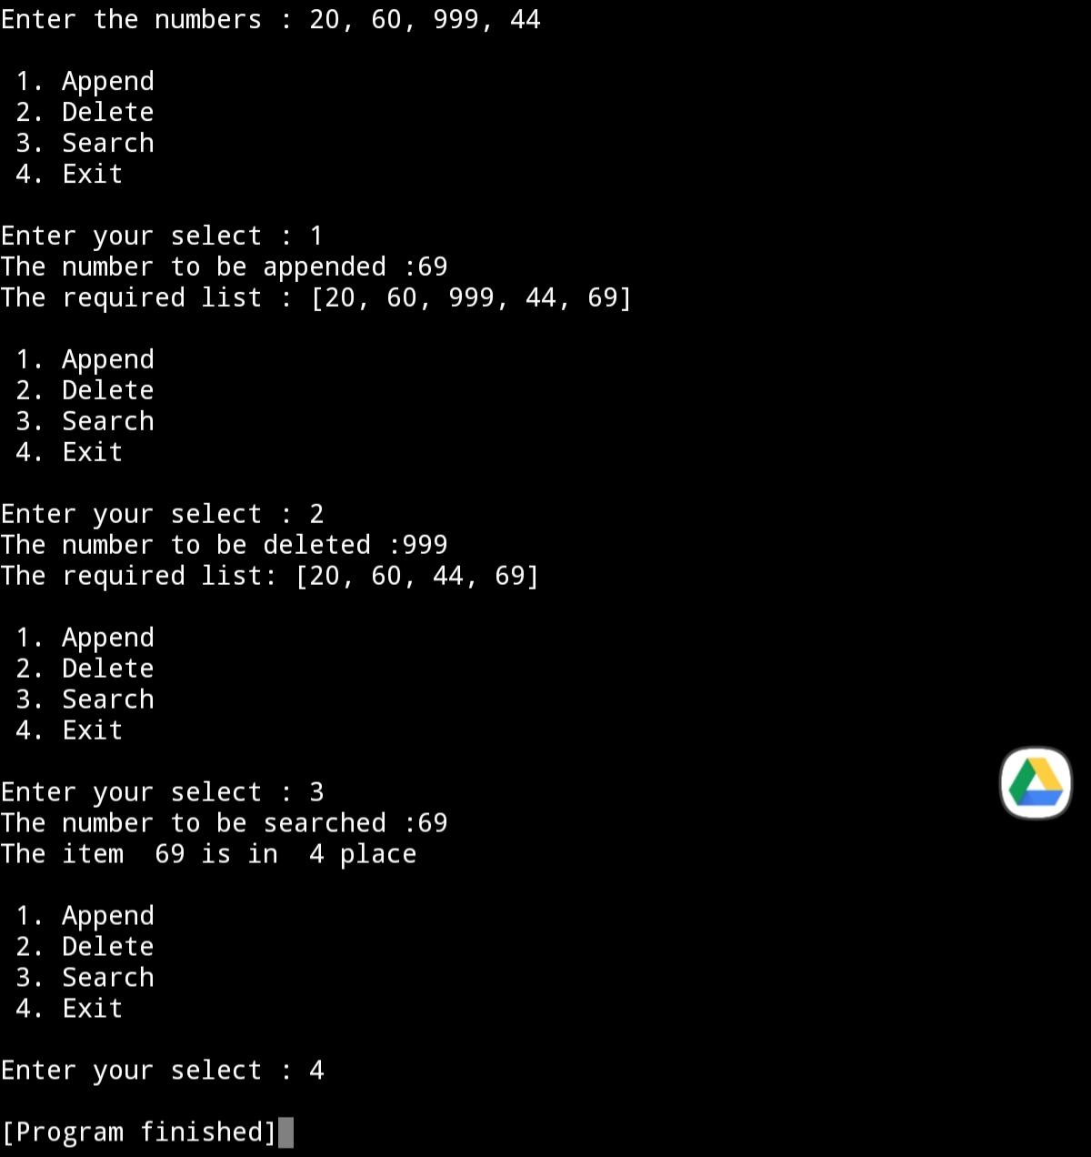

**No.12**

**#NO.21**

**'''#Write a program to input a list/tuple of elements**

**earch for a given element in the list/tuple**

**'''**

**nums = list(eval(input("Enter the numbers : ")))**

**a = int(input("The number to be searched :"))**

**b= (nums.index(a)**

**1)**

**print('The item ', a, 'is at ', b, 'place')**

OUTPUT

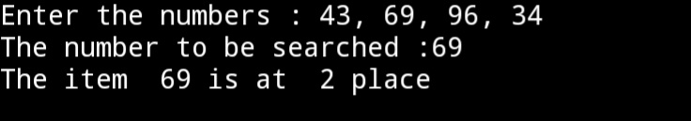

**#NO.22**

**'''#Input a list of numbers and swap elements at the**

**ven location with the elements at the odd location.'''**

**nums = list(eval(input("Enter the numbers : ")))**

**for i in range(0, (len(nums)),2):**

**nums[i],nums[(i + 1)] = nums[ i+ 1],nums[i]**

**print(nums)**

OUTPUT

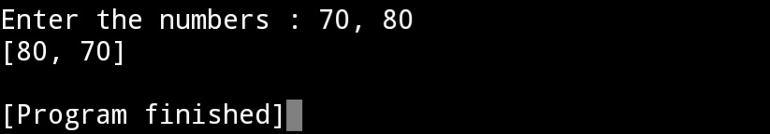

**No.12**

**#Write**  
#NO.23

'''#Write a program in Python to display the elements of

ist thrice if it is a number and display the element

erminated with ‘#’ if it is not a number. i.e if the content of list is as follows :

'''

list = ['69', 'FERALICK', 'YOUTUBER', 'HARI BOL', 'HARE KRISHNA']

for x in list:

if x.isdigit():

print(x * 3)

else:

print(x + '#')

OUTPUT

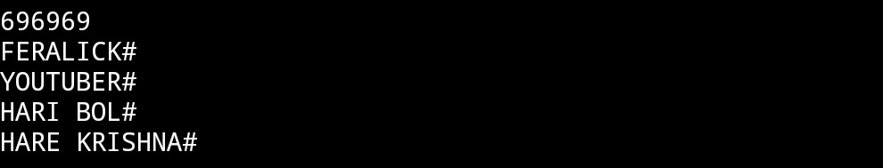

**No.12**

**#Write**  
#No.24

'''Write a program to store student's information like admission number , roll number, name and marks in a dictionary and display information on the basis of admission number.'''

D1 = {}

D2 = {}

s = int(input('Enter the no. of students : '))

for i in range(s):

add = input("Enter the Admission no.:")

roll = int(input('Enter the roll no. : '))

name = input('Enter the name : ')

marks = int(input("Enter the marks : "))

D1[add] = roll

D2[name] = marks

l1 = list(D1.keys())

l2 = list(D1.values())

l3 = list(D2.keys())

l4 = list(D2.values())

for x in range(len(l1)):

print('Addmission no.:', l1[x],' Roll no.: ', l2[x],'Name : ', l3[x], 'Marks: ', l4[x] )

OUTPUT

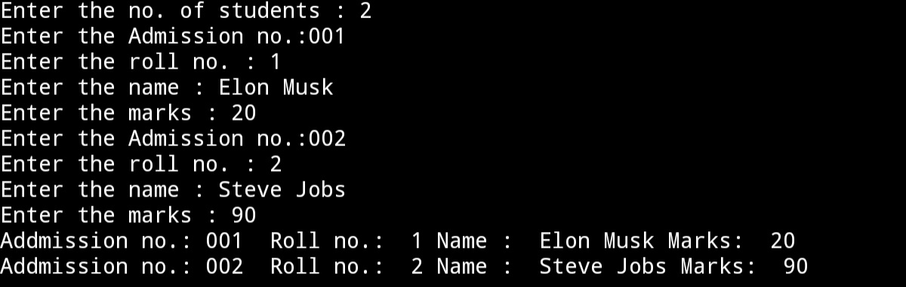

**No.12**

**#Write**  
#NO.25

'''Write a program to input total number of sections and stream name in class 11 and display all information on the output screen .'''

D1 = {}

s = int(input('Enter the no. of sections : '))

for i in range(s):

sec = input("Enter the section no.:")

stream = input('Enter the stream name : ')

D1[sec] = stream

l1 = list(D1.keys())

l2 = list(D1.values())

for x in range(len(l1)):

print('Section no.:', l1[x],', Stream Name : ', l2[x],)

OUTPUT

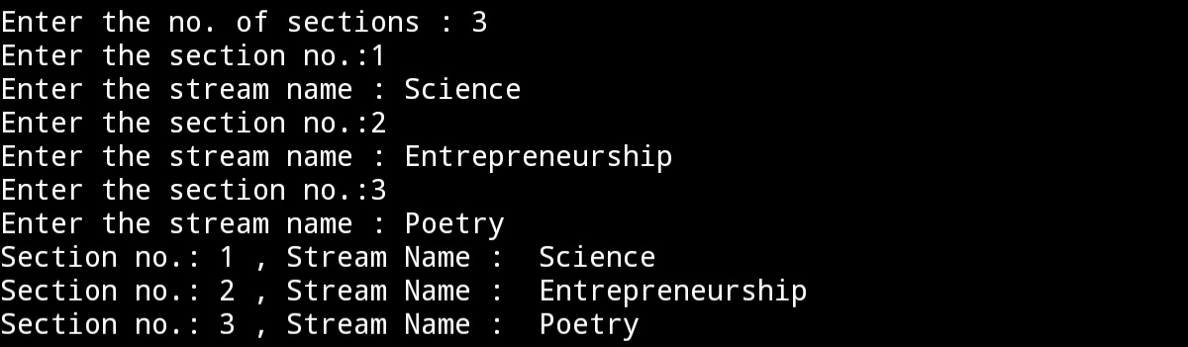

**No.12**

**#Write**  
#NO.26

#Write a python script to concatenate two dictionaries to create a new one.

D1 = {'Elon Musk' : 32, 'Steve Jobs' : 69}

D2 = {'Feralick' : 55, 'Unicorn' : 77}

D1.update(D2)

print(D1)

OUTPUT

