CAP776: PROGRAMMING IN PYTHON
MINOR PROJECT #1 REPORT
MY DATA, MY STORY
Personal Activity Intelligence Report

Student Details | Info
Student Name | Samarpreet Singh
Registration / Roll No. | 12601472 / 30
Program / Section | MCA / D1P2633
Activity Recording Period | 13 August 2026 to 21 September 2026
Date of Report Generation | 27-09-2026

1. Activity Data Summary
Particular | Value
Expected number of days | 40
Valid days recorded | 40
Missing days | 0
Invalid / excluded records | 0
Average Sleep/day | 365.75 min/day
Average Fitness/day | 32.12 min/day
Average Study/day | 68.78 min/day
Average Coding/day | 56.88 min/day
Average Class/day | 257.38 min/day
Average Other Activities/day | 119.72 min/day
Average Free / Unaccounted Time/day | 539.38 min/day

2. Index Values
Index Name | Acronym | Formula | Value to Enter
Personal Activity Index | PAI | PAI = 0.15(TPI) + 0.20(AAI) + 0.15(PhAI) + 0.20(SRI) + 0.15(TUI) + 0.10(EI) + 0.05(DCI) | 292.11
Tech Productivity | TPI | TPI = Average(Coding Time per valid recorded day) | 56.88 min/day
Academic Activity | AAI | AAI = Average(Study Time + Class Time per valid recorded day) | 326.15 min/day
Physical Activity | PhAI | PhAI = Average(Fitness Time per valid recorded day) | 32.12 min/day
Sleep & Recovery | SRI | SRI = Average(Sleep Time per valid recorded day) | 365.75 min/day
Activity Balance | ABI | ABI = Average(Free / Unaccounted Time per valid recorded day) | 539.38 min/day
Time Utilization | TUI | TUI = Average(Total Tracked Time per valid recorded day) | 900.62 min/day
Experience Index | EI | EI = Average of daily (Feeling Score + Satisfaction Score + Energy Score) / 3 | 2.87 / 5
Data Continuity Index | DCI | DCI = (Valid Recorded Days / Expected Days) × 100 | 100.00 %
Formula references: All time values are taken directly from the activity record and averaged across valid recorded days. Feeling, Satisfaction and Energy are scored using the prescribed 5/4/3/2/1, 5/4/3/2/1 and 3/2/1 scales respectively. PAI uses the predefined weights shown above. DCI rewards complete and continuous recording from 13 August 2026.

3. Key Findings from My Data
No. | Correlation/Observation | Evidence from my data
1 | Sleep ↔ Energy | r = -0.25, a weak negative relationship. Sleep duration alone could not predict my energy level.
2 | Study ↔ Satisfaction | r = -0.18, negligible. Study time did not have a strong direct relationship with satisfaction.
3 | Coding ↔ Energy | r = 0.04, negligible. Coding time and Energy level has almost negligible relationship.
4 | Total Tracked Time ↔ Energy | r = -0.59, a moderate negative relationship and the strongest signal in my data. Longer, fuller days consistently came with lower energy.
5 | Class Time ↔ Satisfaction | r = -0.47, a moderate negative relationship. Heavily scheduled class days were my least satisfying days.

4. Findings About Myself (100–200 words)
Write about what your activity data revealed about your habits, priorities, consistency, balance, academic/technical engagement, and the relationship between activities and your reported experience.
During these 40 days (13 August – 21 September 2026), I had no invalid records and recorded every day, giving my Data Continuity Index as 100%. My routine was mainly academic: my Academic Activity Index average was 326.15 minutes per day (made up of 257.38 minutes of classes and 68.78 minutes of self-study), and on top of that I spent 56.88 minutes a day on coding. Fitness was only 32.12 minutes and sleep was 365.75 minutes, or about six hours and six minutes. Overall, I tracked 900.62 minutes of each day and left 539.38 minutes untracked (that is 37%, the biggest weakness). All three of the required relationships were actually weak: Sleep and Energy r = −0.25, Study and Satisfaction r = −0.18 and Coding and Energy r = 0.04. With 40 days a correlation needs to reach about 0.31 to mean much, and none of these did. The two I chose myself were stronger: Total Tracked Time and Energy r = −0.59 and Class Time and Satisfaction r = −0.47 –. These results describe patterns in my records and do not establish cause and effect. The unaccounted-time figure is a remainder and may include meals, travel, chores, breaks and rest.

5. Areas and Ways to Improve My Lifestyle (100–200 words)
Identify the areas you would like to improve and describe specific, realistic ways in which you intend to improve them based on the evidence from your data.
My intent is to improve the quality of my sleep, my fitness, my coding, and my tracking. My sleep is at 365.75 minutes, or just about six hours and six minutes, so I'll set a regular bedtime and wake-up time and seek to work my way up to seven hours. My fitness is at 32.12 minutes, so I'll plan a minimum of thirty minutes five days a week rather than wing it. My strongest result is Total Tracked Time versus Energy (r = −0.59), so more hours isn't the fix. Class Time versus Satisfaction (r = −0.47) tells me my busiest class days are my least satisfying days, so I'll limit how busy I allow days to be, subdivide the 326.15 minutes of academic work into smaller chunks interspersed with breaks, and provide a buffer for long classes. I also want to bring my coding up to a dedicated hour per day instead of 56.88 minutes. Lastly, 539.38 minutes is a chunk of my day that I'm not tracking, so I'll log that time and spend some of it resting and planning.

6. Student Declaration
I confirm that the values entered in this report have been generated from my submitted activity data using my Python program and that the report represents my own analysis.
Student Name | Signature | Date
Samarpreet Singh | 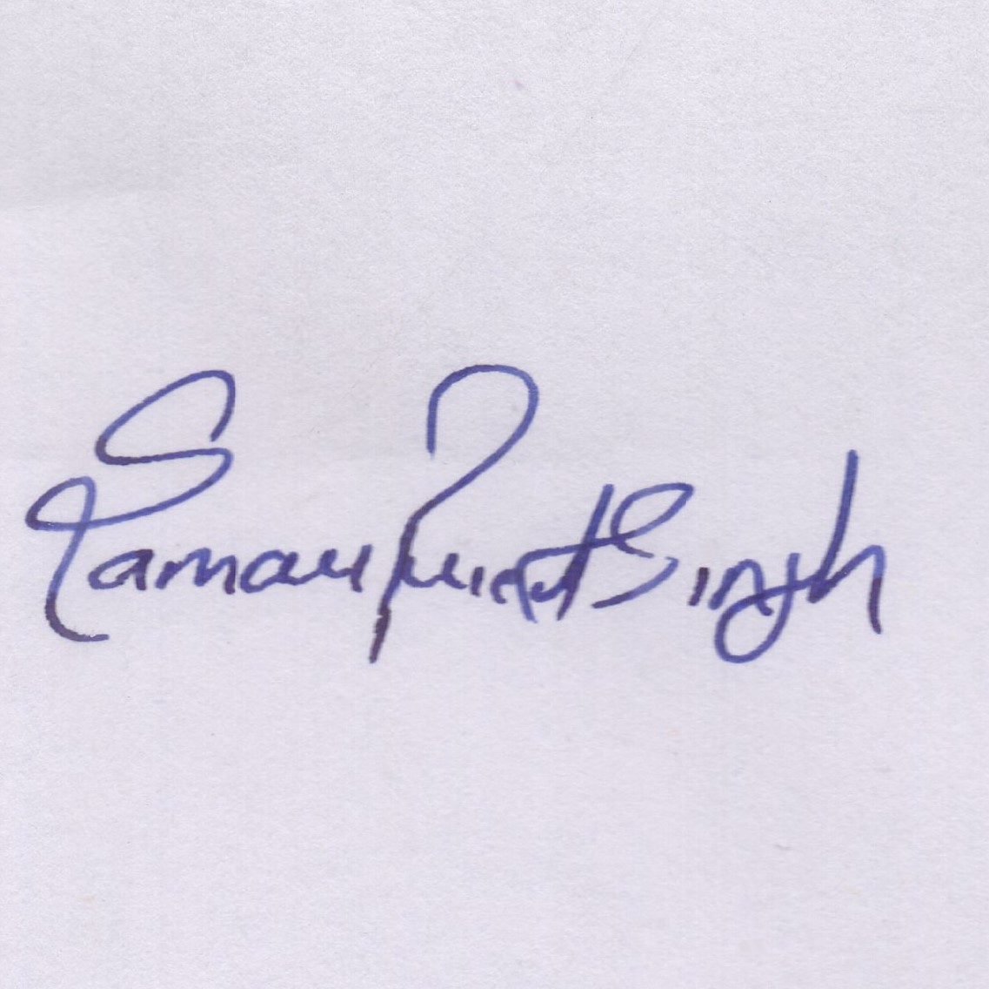 | 10-10-2026

