CAP776: PROGRAMMING IN PYTHON
MINOR PROJECT #1 REPORT
MY DATA, MY STORY
Personal Activity Intelligence Report

Student Details | Info
Student Name | Samarpreet Singh
Registration / Roll No. | 12601472 / 30
Program / Section | MCA / D1P2633
Activity Recording Period | 13 August 2026 to 20 September 2026
Date of Report Generation | 27-09-2026

1. Activity Data Summary
Particular | Value
Expected number of days | 39
Valid days recorded | 39
Missing days | 0
Invalid / excluded records | 0
Average Sleep/day | 364.36 min/day
Average Fitness/day | 32.18 min/day
Average Study/day | 69.00 min/day
Average Coding/day | 55.26 min/day
Average Class/day | 256.28 min/day
Average Other Activities/day | 121.92 min/day
Average Free / Unaccounted Time/day | 541.00 min/day

2. Index Values
Enter the final value generated by your Python program. The activity indicators are based on simple averages across valid recorded days. PAI is calculated using the predefined weights shown below.
Index Name | Acronym | Formula | Value to Enter
Personal Activity Index | PAI | PAI = 0.15(TPI) + 0.20(AAI) + 0.15(PhAI) + 0.20(SRI) + 0.15(TUI) + 0.10(EI) + 0.05(DCI) | 291.18
Tech Productivity | TPI | TPI = Average(Coding Time per valid recorded day) | 55.26 min/day
Academic Activity | AAI | AAI = Average(Study Time + Class Time per valid recorded day) | 325.28 min/day
Physical Activity | PhAI | PhAI = Average(Fitness Time per valid recorded day) | 32.18 min/day
Sleep & Recovery | SRI | SRI = Average(Sleep Time per valid recorded day) | 364.36 min/day
Activity Balance | ABI | ABI = Average(Free / Unaccounted Time per valid recorded day) | 541.00 min/day
Time Utilization | TUI | TUI = Average(Total Tracked Time per valid recorded day) | 899.00 min/day
Experience Index | EI | EI = Average of daily (Feeling Score + Satisfaction Score + Energy Score) / 3 | 2.86 / 5
Data Continuity Index | DCI | DCI = (Valid Recorded Days / Expected Days) × 100 | 100.00 %
Formula references: All time values are taken directly from the activity record and averaged across valid recorded days. Feeling, Satisfaction and Energy are scored using the prescribed 5/4/3/2/1, 5/4/3/2/1 and 3/2/1 scales respectively. PAI uses the predefined weights shown above. DCI rewards complete and continuous recording from 13 August 2026.

3. Key Findings from My Data
No. | Correlation/Observation | Evidence from my data
1 | Sleep ↔ Energy | r = -0.26, a weak negative relationship. Sleep duration alone could not predict my energy level.
2 | Study ↔ Satisfaction | r = -0.18, negligible. Study time did not have a strong direct relationship with satisfaction.
3 | Coding ↔ Energy | r = 0.05, negligible. Coding time and Energy level has almost negligible relationship.
4 | Total Tracked Time ↔ Energy | r = -0.61, a moderate negative relationship and the strongest signal in my data. Longer, fuller days consistently came with lower energy.
5 | Class Time ↔ Satisfaction | r = -0.48, a moderate negative relationship. Heavily scheduled class days were my least satisfying days.
6 | Free Time ↔ Feeling | r = 0.53, a moderate positive relationship. Days with more free time were the days I felt best.

4. Findings About Myself (100–200 words)
Write about what your activity data revealed about your habits, priorities, consistency, balance, academic/technical engagement, and the relationship between activities and your reported experience.
During this 39-day record period, I was able to maintain complete consistency as I recorded all 39 days from 13 august to 20 September 2026 with no invalid entries. My routine was mainly focused on academics: As my academic activity index was 325.28 minutes per day including 256.28 minutes of classes and 69 minutes of self-study. I also spent 55.26 minute per day on coding, Showing regular technical engagement alongside my coursework. My average time for fitness was 32.18 minutes while my average for sleep was 364.36 minutes. High track 899 minutes per day in total and still had around 541 minutes of my free time. The three required relationships were all weak, but the extra relationships I tested were much clearer. Total Tracked Time and Energy gave r = -0.61, Class Time and Satisfaction gave r = -0.48, and Free Time and Feeling gave r = 0.53. Together these show that my experience was driven by my total daily workload rather than by any single activity. The longer and more heavily scheduled my day was, the lower my energy and satisfaction, while days with more free time felt noticeably better. My Experience Index of 2.86 out of 5 reflects this moderate overall experience.

5. Areas and Ways to Improve My Lifestyle (100–200 words)
Identify the areas you would like to improve and describe specific, realistic ways in which you intend to improve them based on the evidence from your data.
I want to improve my routine of sleep, physical activity and my focused work. My sleep averaged 364.36 minutes, which is about six hours and four minutes per day, so I will fix a regular bedtime and wake-up time and move gradually towards at least seven hours. My fitness average was 32.18 minutes, so I will schedule at least 30 minutes of exercise on five days every week instead of leaving it to chance. The strongest evidence in my data is the negative relationship between Total Tracked Time and Energy (r = -0.61), so simply adding more hours is not the answer. Instead I will cap my heaviest days, divide my 325.28 minutes of academic work into shorter planned sessions with proper breaks, and protect recovery time when classes are long. I also want to improve my coding practice from 55.26 minutes to focused one hour on most of the days. Then finally I want to use part of my 541 minutes of free time for rest, hobbies and planning so that my routine remains balanced.

6. Student Declaration
I confirm that the values entered in this report have been generated from my submitted activity data using my Python program and that the report represents my own analysis.
Student Name | Signature | Date
Samarpreet Singh | 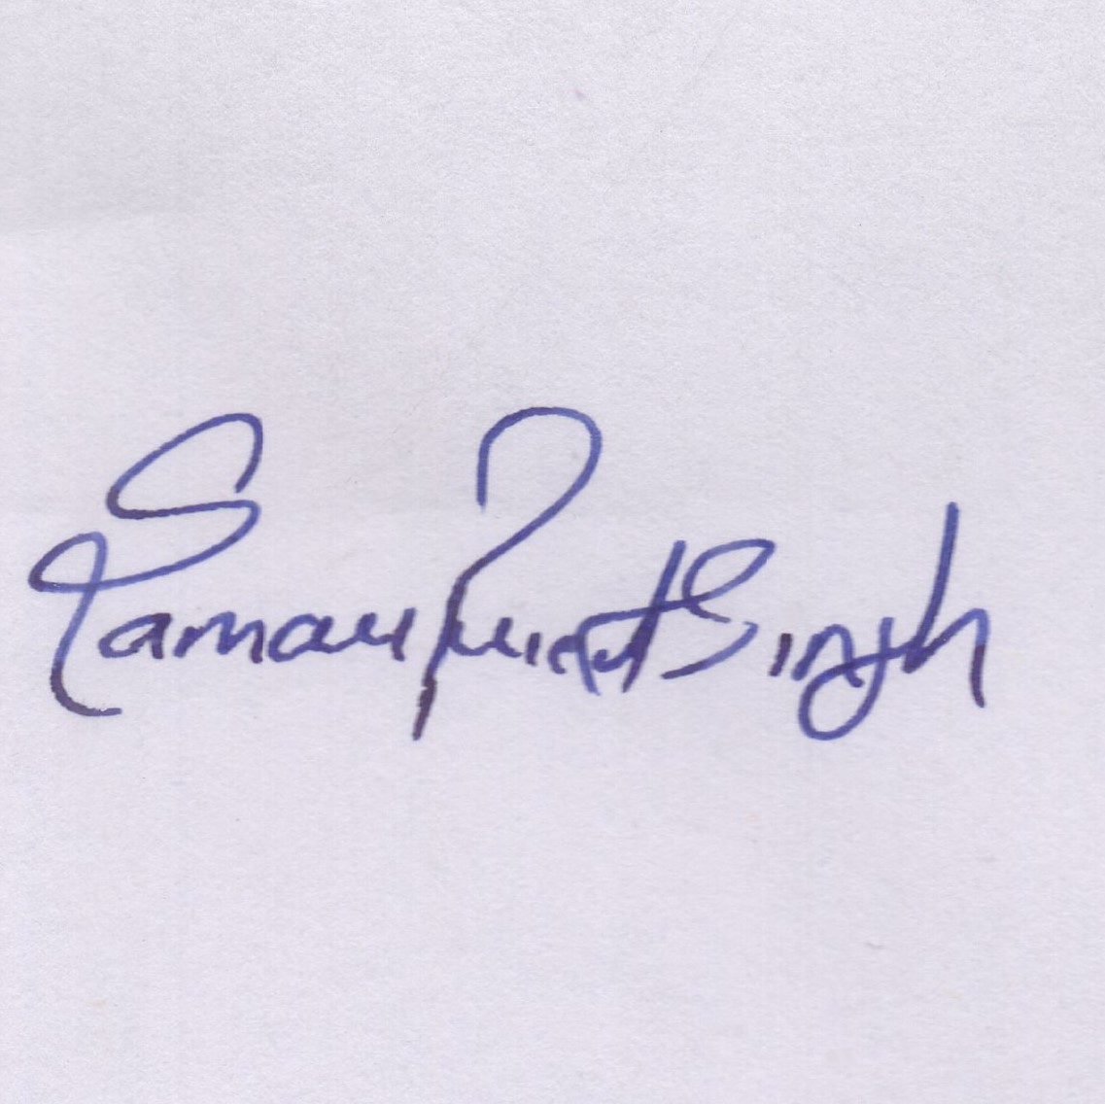 | 30-09-2026

