**ECE216, Experiment 01**

**ECE, University of Toronto**

# Introduction to Simulink

Bruno Korst - bkf@comm.utoronto.ca, David Ding - davidy.ding@mail.utoronto.ca

|  |  |  |
| --- | --- | --- |
| • Name: | Lab Date: |  |
| • Student No.: | Day of the week: | Time: |
| • Name: | TA Signature: |  |
| • Student No.: | Grade: |  |

**1. Matlab Exercises**

## 1.1 Creating and Plotting a Sinusoid

a. Re-write the program to plot three periods of your 1KHz sine wave. (0.5pt)

T=1;

Fs = 48000;

N = T*Fs;

t = 0 : 1/Fs : T;

Fn = 1000;

y = sin(Fn*2*pi*t);

plot(t,y);

axis([0 3*48/48000 -1 1])

## 1.2 Listening to a Sine Wave

1. Play the program and hear the 1KHz sine wave.

T=1;

Fs = 48000;

N = T*Fs;

t = 0 : 1/Fs : T;

Fn = 1000;

y = sin(Fn*2*pi*t);

sound(2*y,Fs);

%db change = 20log(v2/v1) = 6.02

1. Change the frequency to 500Hz and play it again.
2. Now change it to hear 2KHz and play it again.
3. Now change back to 10KHz and explain what you have observed/heard. (1.0pts)

Very shrill sound.

1. As you doubled the voltage, what is the change in dB of the signal as measured at the load? Note that the dB you are calculating does not represent sound pressure; you are only comparing voltages. (0.5pts)

Db change = 20log(v2/v1) = 6.02

## 1.3 Audio Signal Processing

1. What is the duration of the guitar signal in seconds? (1.0pts)

length guitar = 4593084

fs = 44100

duration = number of samples / sampling frequency = 4593084/44100 =

104.2 sec = 1min 44 sec

1. Play the combined bass, drums, and guitar sound and have TA sign below (1.0pts)
2. Synthesize gradual increase of guitar volume with bass and drums volume staying constant, and have TA sign below

(1.0pts)

**Introduction to Simulink — 2/2**

**2. Simulink**

## 2.1 First Simulink Model

a. Show the TA a clear 1KHz sine wave with 1/48000 sampling time displayed on your Simulink scope. (1.0pts)

## 2.2 The Four Operations

### 2.2.1 Adding and Subtracting a Constant to/from Sinusoid

a. Show the TA a positive DC shift of 2 on your Simulink scope. (1.0pt)

w/shift

w/ no shift

### 2.2.2 Gain

a. Apply a 10dB gain to your sine wave and show it to the TA on the Simulink scope. (1.0pt)

### 2.2.4 Operating on Two Sines

a. Show to the TA on your Simulink scope the resulting addition of 2 sinusoids: a 1Vp, 1KHz and a Vp, 2KHz. Use the slider gain blocks to assign the magnitudes for the 2 sinusoids. (1.0pt)

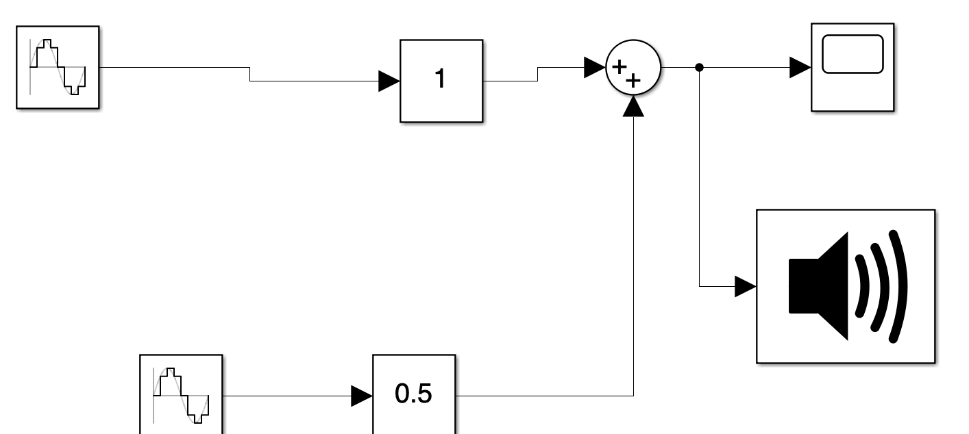

### 2.2.5 Multiplying Two Sines

a. Show to the TA your working (and sounding) model that multiplies two sinusoids: a 31.25Hz and a 500Hz, both with amplitude 1. (1.0pt)

