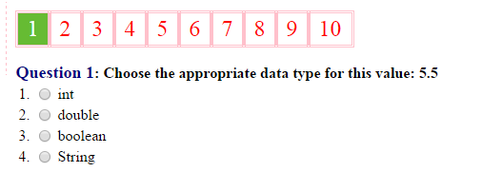 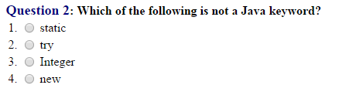 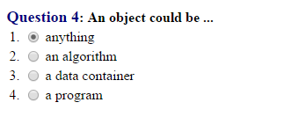 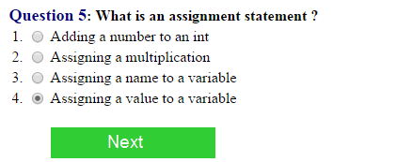 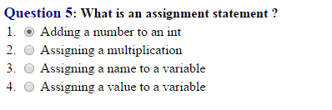 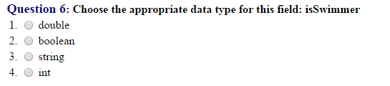 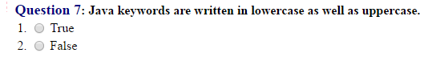 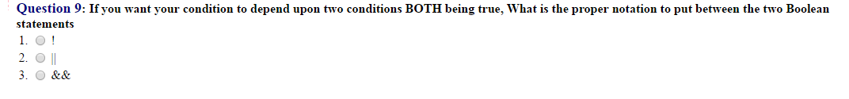





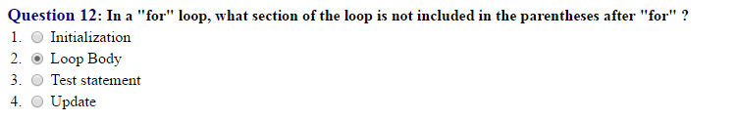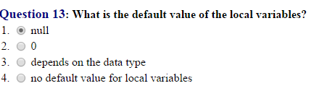

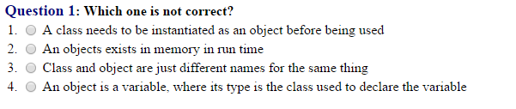 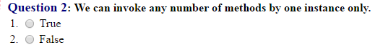 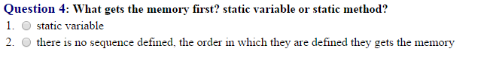 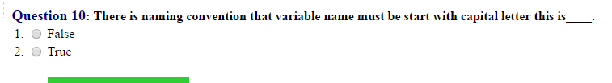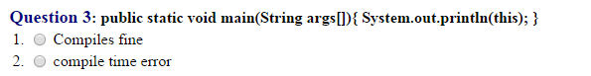

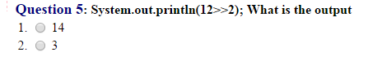

================

[**https://www.4tests.com/exam/java-programmer/6/**](https://www.4tests.com/exam/java-programmer/6/)

[**https://www.tutorialspoint.com/java/java_online_test.htm**](https://www.tutorialspoint.com/java/java_online_test.htm)

The && and || operators "short-circuit", meaning they don't evaluate the right hand side if it isn't necessary. The & and | operators, when used as logical operators, always evaluate both sides.