

**Distributed Systems (2019)**

**Assignment 2 - REST API**

Train Ticket Reservation System

Report

Batch: SE - Weekend

**3rd Year – 1st Semester**

**IT16170162 - T. M. Guruge**

**Table of Contents**

1. Introduction........................................................................................................................3
2. High Level Architecture………………......................................................................................5

2.1. Component diagram…………….…………………………….……………………………....….…………….5

2.2. Overall system architecture.………………………………………………………………………………….6

3. Rest APIs…………………………………………………………………………………………………………….………….7

3.1. Railway………………………………………………………………………………………………………………….7

3.2. Users……………………………………………………………………………….…………………………………….9

3.3. Payment……………………………………………………………………………….……………………………….9

3.4. Register…………………………………………………………………………………………………………………9

3.5. Login…………………………………………………………………………………………….……………………....9

3.6. Gov (dummy government service) ……………………………………………………………….…….10

4. Workflow………………………………………………………………………………….………………………………….11

4.1. System Workflow.....................................................................................................11

4.2. System Workflow Scenario......................................................................................13

5. Authentication and Security Mechanism……………………………………………………………………….21

6. Appendix………...................................................................................................................24

6.1. Front-end (Client side) ............................................................................................24

6.2. Back-end (Server side) .............................................................................................55

6.3. WSO2 EI (Enterprise Integration – ESB) ……………………………………………………………….71

7. Known Issues…………………………………………………………………………………………………………………76

8. GitHub Repository…………………………………………………………………………………………………………77

1. **Introduction**

This is the report of the “Train Ticket Reservation System” web application, in which front end (client side) is developed using React JS and back end (server side) is developed using Node JS and Express JS. This web application use MongoDB as the database, which is a cross-platform document-oriented database.

In this web application users can provide the start and the destination locations, train, class, time, ticket quantity and the date of booking. Users can pay using credit/debit cards or by mobile phone, in which the amount is added to the mobile bill. If the user chooses card payment, the confirmed booking details will send to the email of the user by using “nodemailer” email service. If user chooses mobile payment the booking details will send to the entered mobile number using “Twilio” mobile service.

In the web application booking page, when user select a start location (which contains all the stations of all routes), the destination locations are filtered according to the route of the selected station.

If the user is a government employee, they can have special discounts in this web application. Once user gave their NIC when registering, that NIC is validated using government web service to ensure that user is eligible to have discounts. NIC is optional and if user enter a NIC, then only it will be validated using government web service.

Following are sample text emails and text messages sent using previously mentioned services,

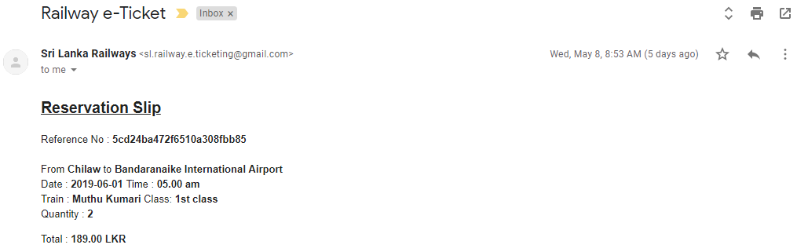

Fig 1:   Email sent using “nodemailer”

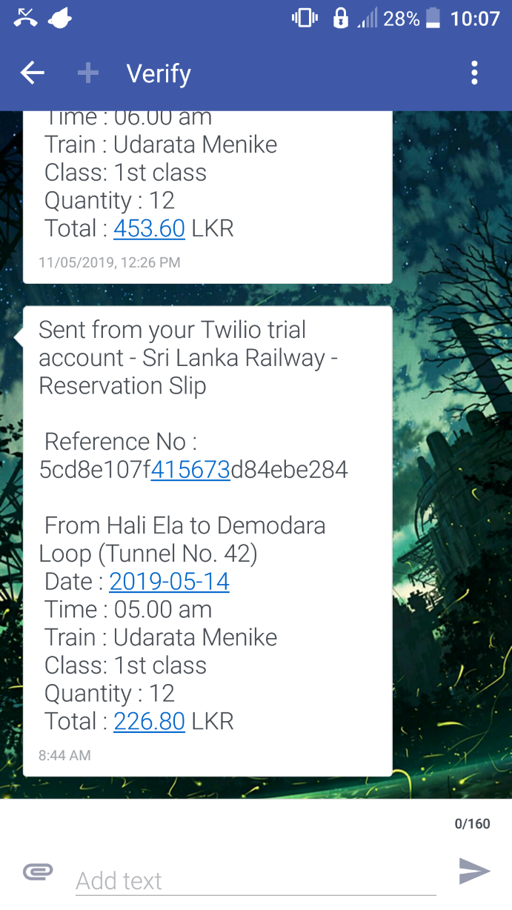

Fig 2:   Text message sent using “Twilio”

1. **High Level Architectural Diagrams**

Front end of the web application is developed using React.js, backend is developed using Node.js and Express.js, MongoDB database is connected to the back end and the front end and the back end communicates with WSO2 EI, which is a comprehensive integration solution that enables communication among various, disparate applications.

**2.1. Component Diagram**

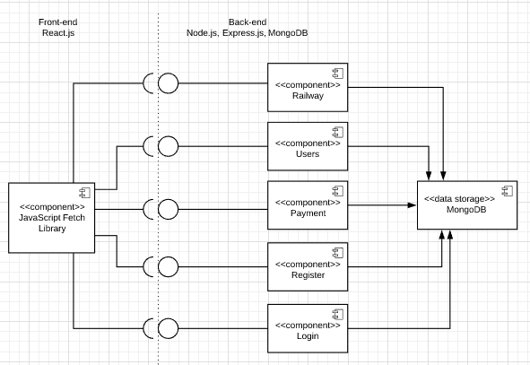

Fig 3: component diagram

**2.2. Overall System Architecture**

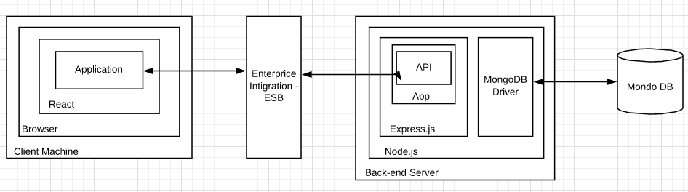

Fig 4: overall system architecture

1. **Rest APIs**

Following are the REST endpoints deployed in the back-end.

**3.1. Railway**

1. ***/railway/routes***

This is a GET endpoint which returns an array of routes which includes route name and the array of stations in that route.

1. ***/railway/route/{id}***

This is a GET endpoint which has a path parameter of route id. It returns all the stations for a given route id.

1. ***/railway/trains***

This is a GET endpoint which returns array of all the trains in the database.

1. ***/railway/trains/{route}***

This is a GET endpoint which has a path parameter of route id. It returns array of all the trains which are running on the specified route.

1. ***/railway/classes***

This is a GET endpoint which returns array of all the train classes available in the database.

1. ***/railway/schedules***

This is a GET endpoint which returns array of all the train schedules available in the database.

1. ***/railway/reservations***

This endpoint support both GET and POST requests. If it is a GET request it returns all the reservations in the database. If it is a POST request it creates a new reservation according to the data in request body and save it in the database. After the new reservation saving it send email or a text message (according to the payment method, card payment - email, mobile payment - text message). Sample email and text messages are shown in Fig 1 and Fig 2 in introduction section.

1. ***/railway/reservations/{user}***

This is a GET endpoint which contains path parameter of user id. It returns an array of all the reservations of the specified user.

1. ***/railway/reservations/{id}***

This is a DELETE endpoint, which delete the specified reservation (reservation id) in the request path parameter.

1. ***/railway/contact***

This is a POST endpoint, which used to process customer support requests. In this service it saves the support information given by the customer (email, phone, message, etc.) and send the confirmation details in email to both railway customer support team and to the customer.

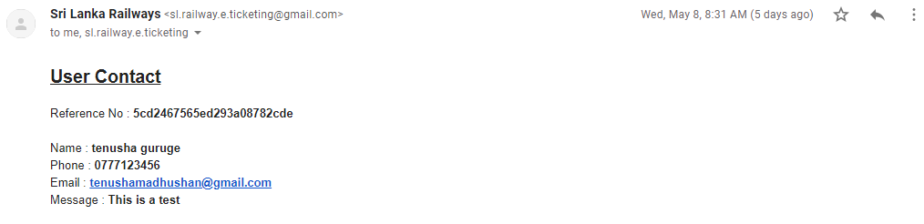

Fig 5: sample email sent by contact service

**3.2. Users**

1. ***/users/{id}***

This endpoint supports PUT requests. User id should be specified in path parameter and the new user data should be send along with request body will be updated in the database.

**3.3. Payment**

Payment services are dummy web services which are used to represent the payment gateway.

1. ***/payment/card***

This is a POST endpoint, which validate the credit/debit card details and the payment amount send inside request body and send the validation status in response.

1. ***/payment/phone***

This is a POST endpoint, which validate the mobile phone details and the payment amount send inside request body and send the validation status in response.

**3.4. Register**

1. ***/Register***

This is a POST endpoint. It reads the new user details send inside the request body and save them in the database.

**3.5. Login**

1. ***/login***

This is a POST endpoint. It reads the username and password sent inside request body and validate them with values in the database and send the validation status in response.

**3.6. Gov**

This is a dummy government service which used to validate whether the user is a government employee or not.

1. ***/gov/employee/{nic}***

This is a GET endpoint, which accept the NIC number as a path parameter. It checks whether there is any employee with that NIC and validate. The validation status will be sent back in the response.

1. **Workflow**

Following system workflow diagrams and system workflow scenario will help to get a better understanding on how the system works.

**4.1. System Workflow**

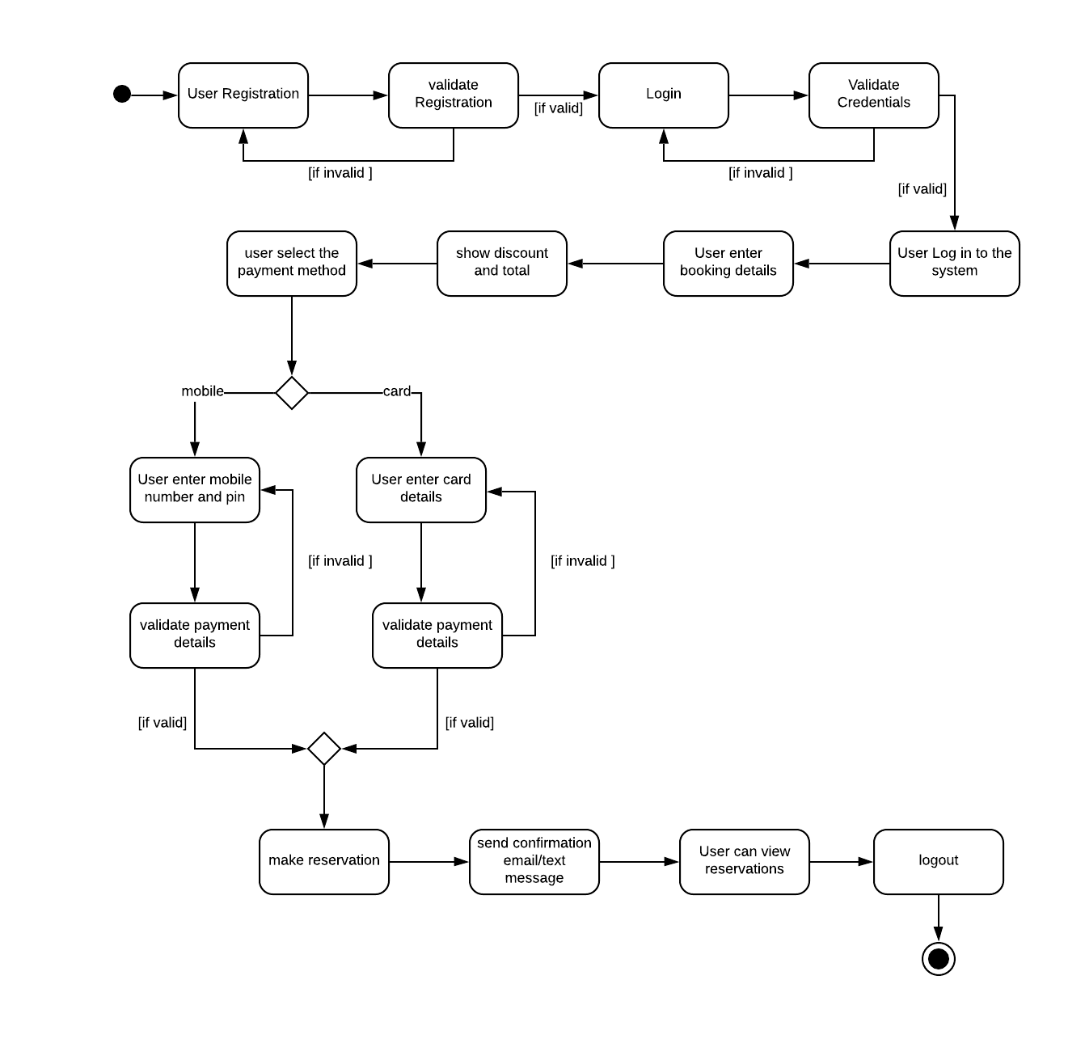

Fig 6: user make reservation

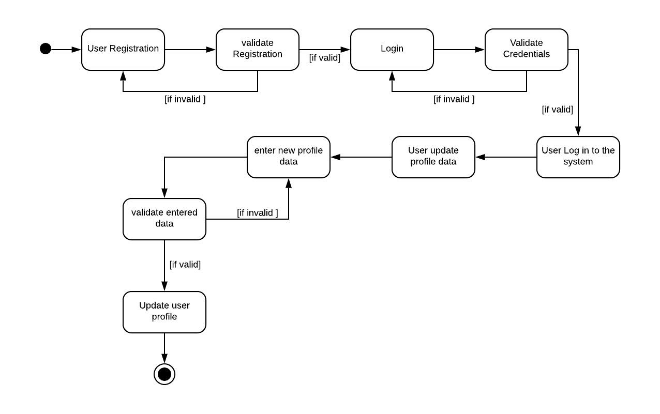

Fig 7: user update profile data

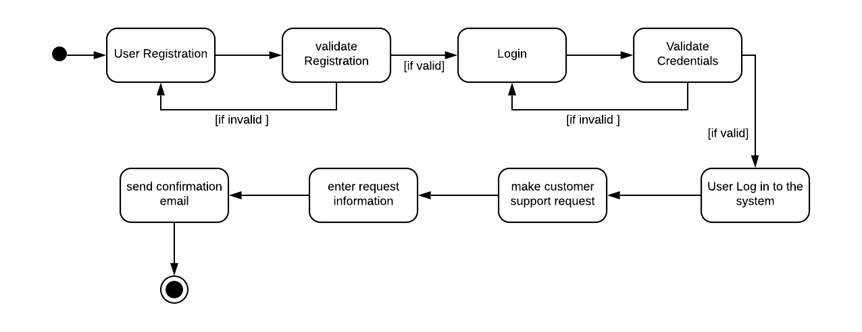

Fig 8: user make customer support request

**4.2. System Workflow Scenario**

The figure below shows the landing page of the web application. Any user can fill the reservation details in the form and view the cost of tickets, but if user want to make a reservation user should login first.

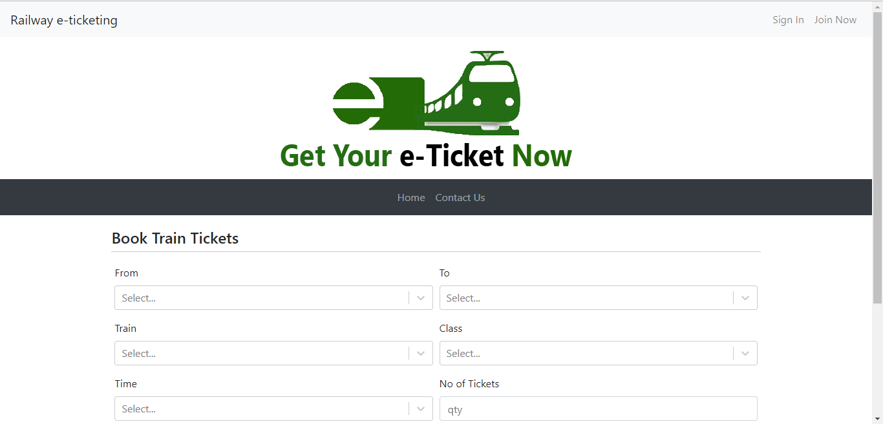

Fig 9: landing page

Firstly, user have to fill the “From” station, then the “To” stations are filtered according to the route of the selected “From” station. Once user filled the form, they can view the cost of tickets.

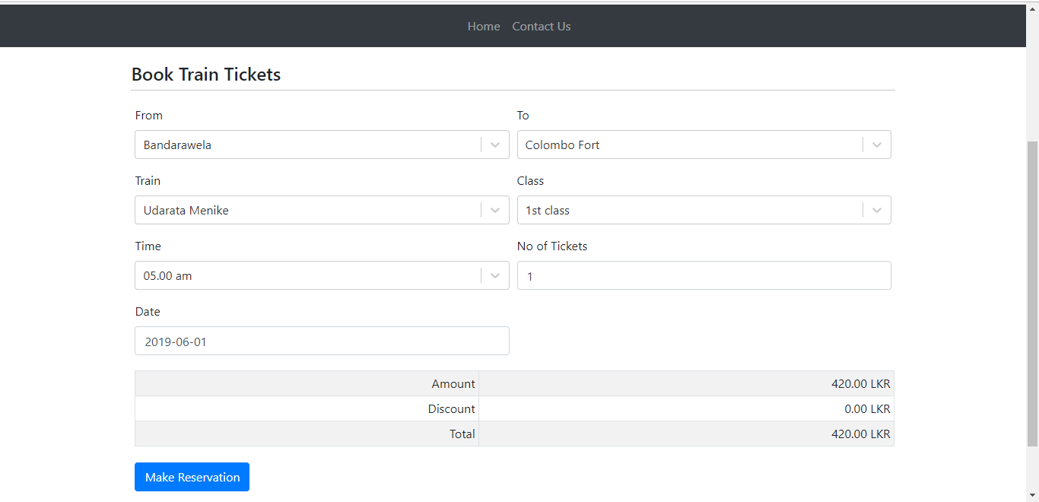

Fig 10: user enter booking details

If user need to make a reservation, user need to login first. If user is not registered before, they can register their account first.

Users can click join now link in navigation bar and enter their details in the modal shown after clicking the link. NIC field is optional and if you enter a NIC it will be validated using government service to ensure that user is eligible to discounts.

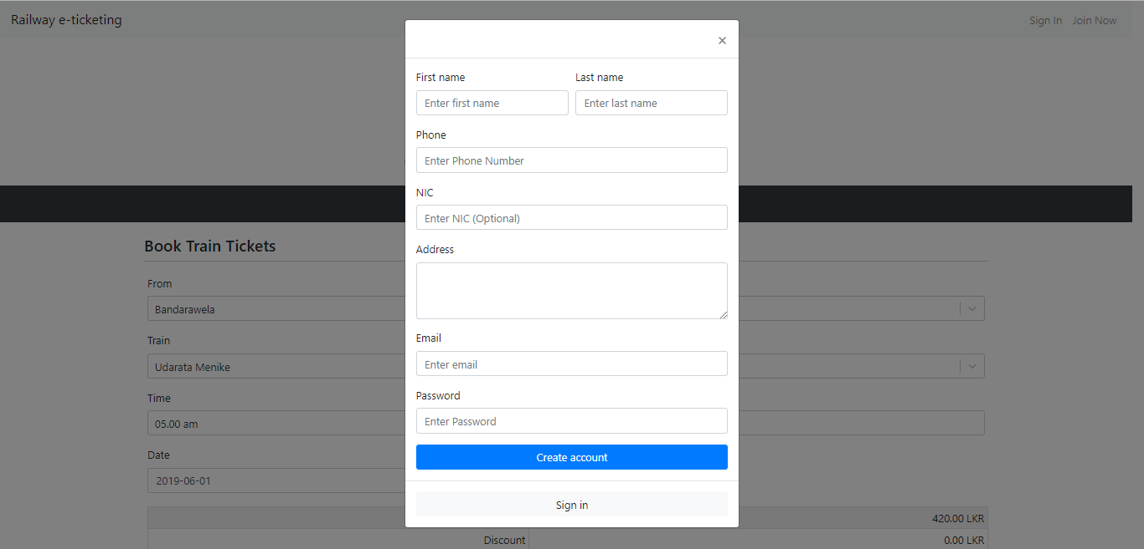

Fig 11: register modal

Once user has successfully register user can login to the system and make reservations.

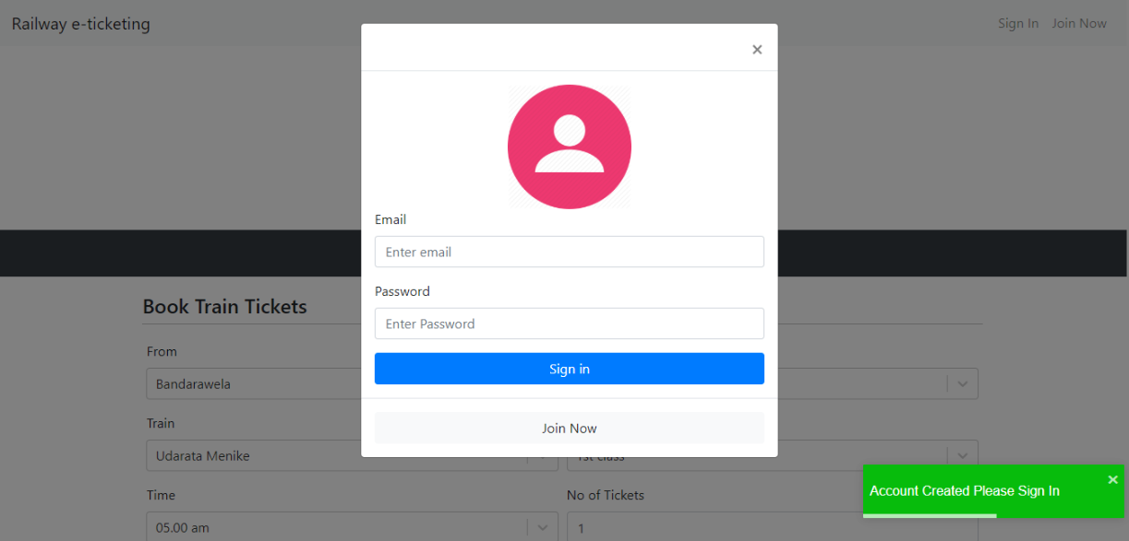L

Fig 12: login modal

Once user login successfully the navigation bar will change and show user’s first name in dropdown and the “My Reservations” link. The user data will be saved in local storage until they sign out.

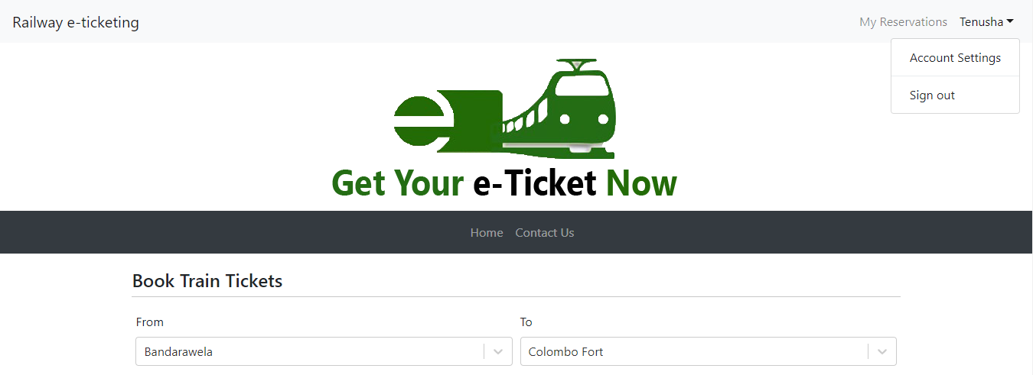

Fig 13: logged user

If the user is a government employee, user is eligible for 10% discount and the discount amount is shown.

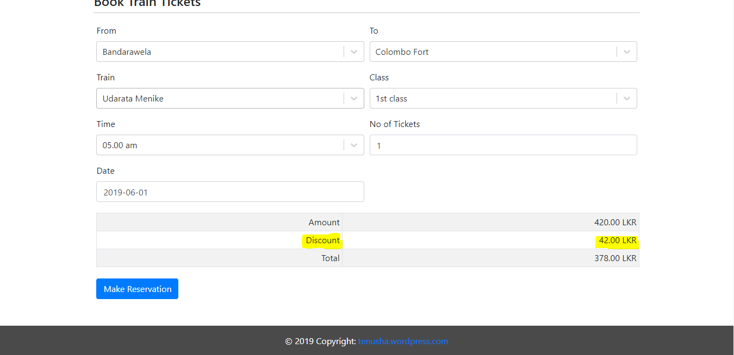

Fig 14: gov employees can have discounts

Then user can click “Make Reservation” button in the bottom of the form and the user will directed to “Payment” page. Only logged in users are allowed in payment page, otherwise they are asked to login.

In the payment page it shows the amount and user can select a payment method (card or phone).

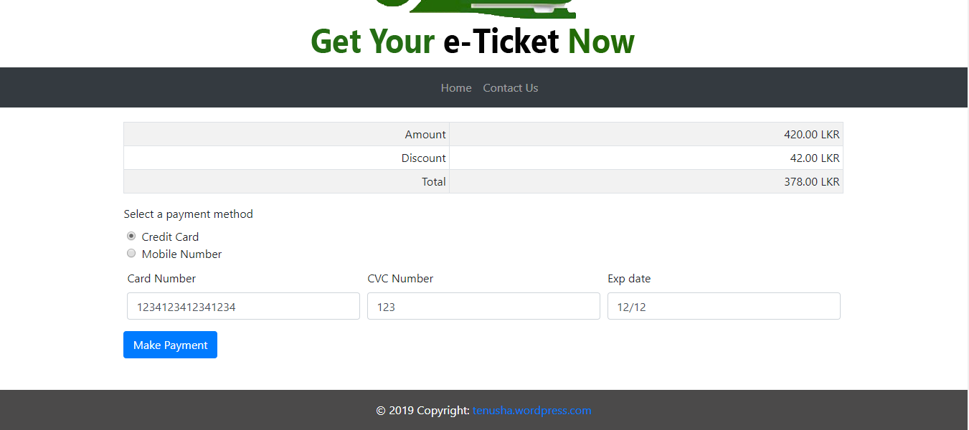

Fig 15: user select card payment

When user select mobile payment, the user’s mobile number (entered when registering) will be auto filled, but user can change it if they want to make the payment with different mobile number.

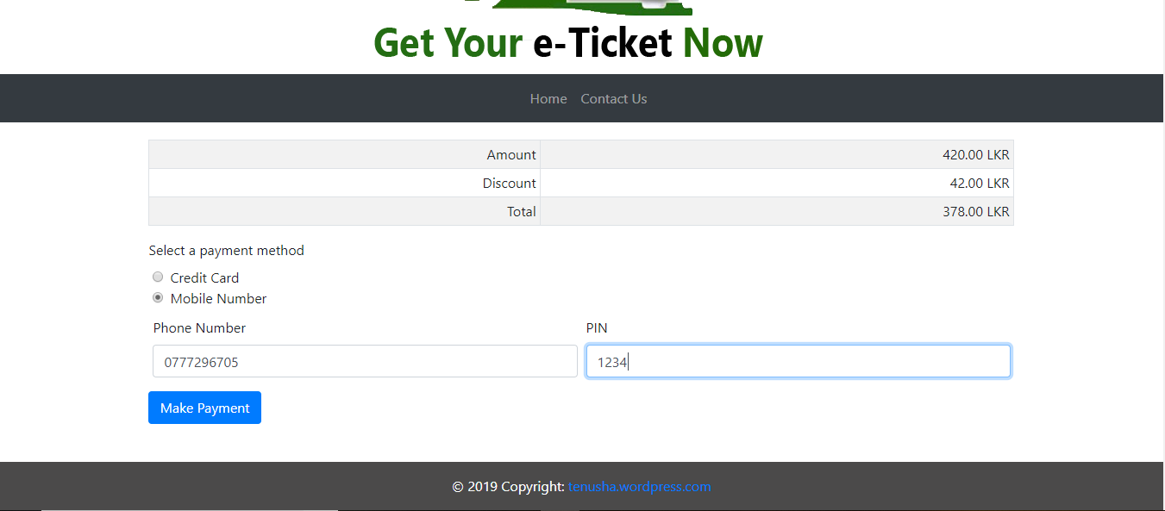

Fig 16: user select mobile payment

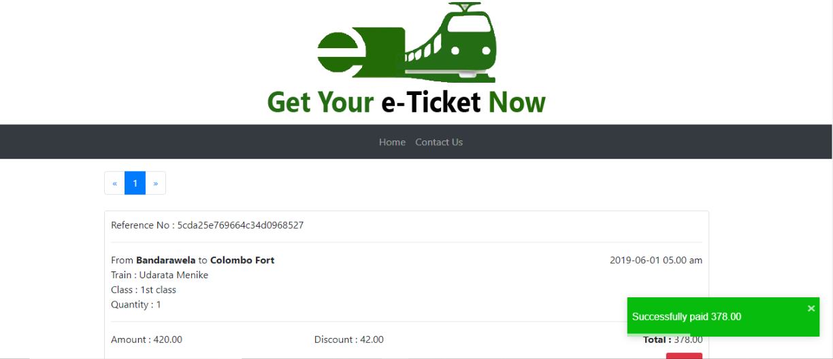Once user enter valid payment details, the reservation will be made and user will be directed to “My reservation” page, in where user can view all their previous reservations and new reservations.

Fig 17: my reservations page

If user select card payment, an email will be sent to their email address. If user select mobile payment, a text message will be sent to the given mobile number.

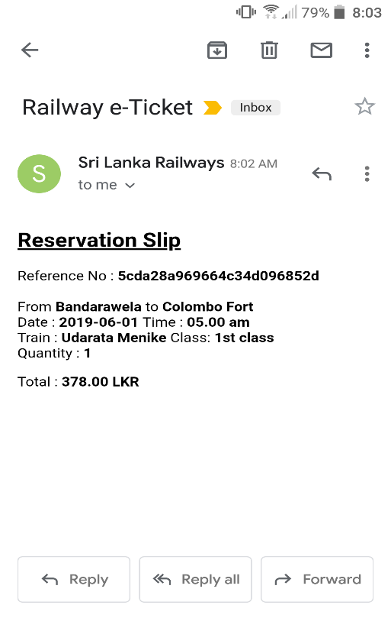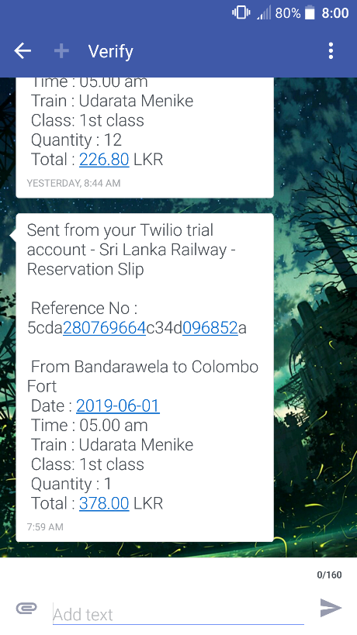

Fig 18: email sent for card payment (left), text message sent for mobile payment (right)

Users can cancel the reservation by clicking the cancel button in the reservations shown in the “My Reservations” page. User will be asked confirmation after clicking the cancel button.

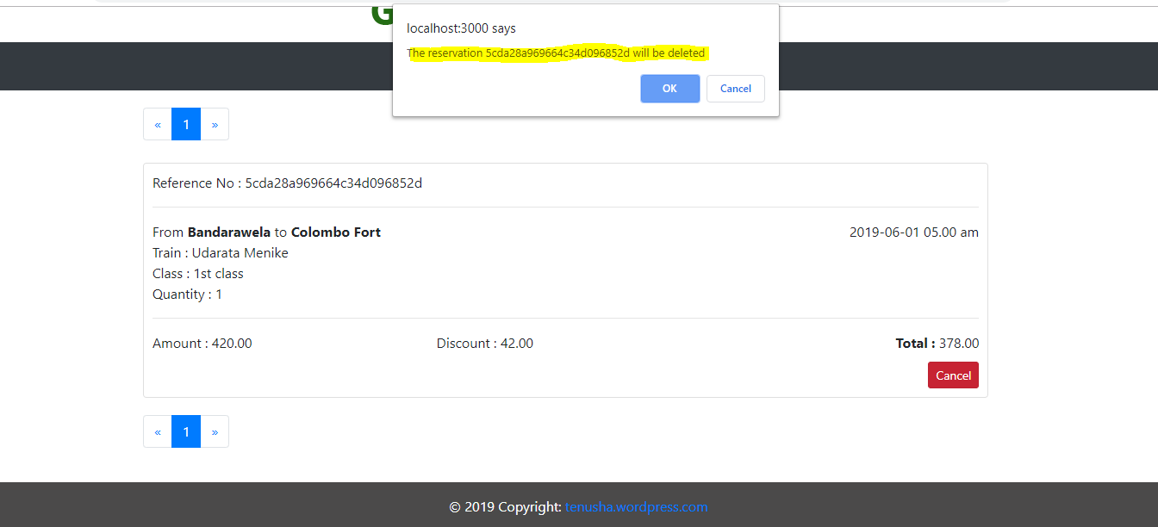

Fig 19: cancel reservation

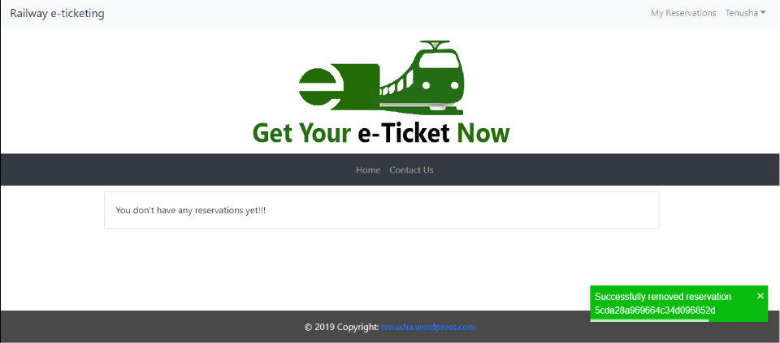

Fig 20: cancel reservation confirmation

Users can edit their profile through the link in the navigation bar.

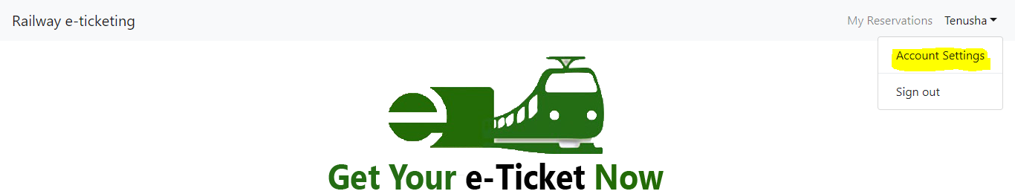

Fig 21: change profile data

Users cannot change the username (email).

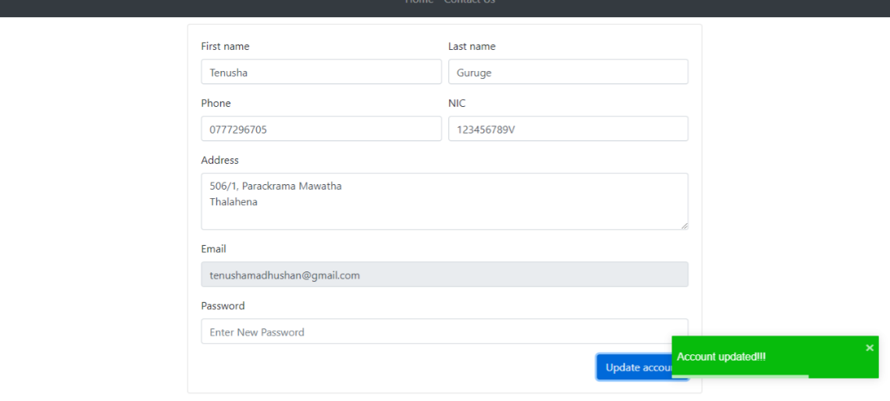

Fig 22: successfully change profile data

Users can view contact details from “Contact Us” page or they can send a message to support team regarding any of their issues. Once user send support request an email will send to both the user and the support team.

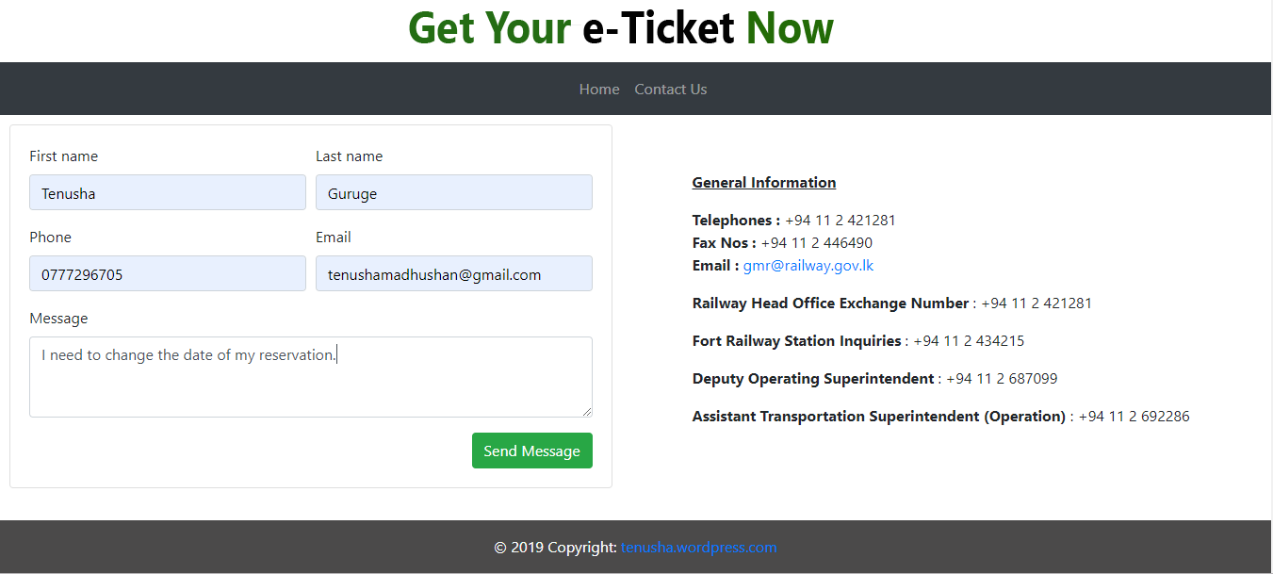

Fig 23: contact us page

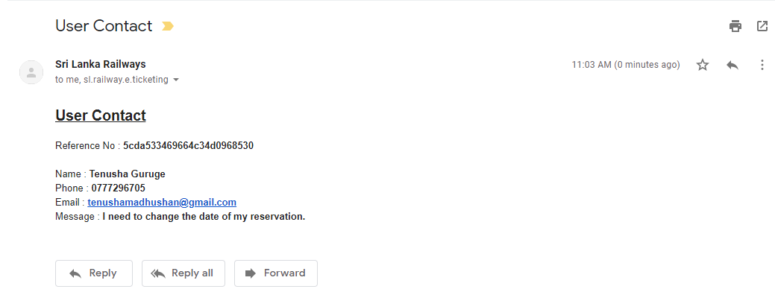

Fig 24: confirmation of support request

1. **Authentication and Security Mechanism**

When saving user passwords, it saves the hash value generated by the JavaScript function rather than saving the plane text password.

Following is the JavaScript function used to generate hash code for a given string.

export function getHash(str) {

let hash = 0

for (let i = 0; i < str.length; i++) {

hash += Math.pow(str.charCodeAt(i) * 31, str.length - i)

hash = hash & hash // Convert to 32bit integer

}

return hash

};

Following is a user document saved in MongoDB with hashed password.

{

"_id" : ObjectId("5cda20be69664c34d0968526"),

"fname" : "Tenusha",

"lname" : "Guruge",

"phone" : "0777296705",

"nic" : "123456789V",

"address" : "506/1, Parackrama Mawatha\nThalahena",

"email" : "tenushamadhushan@gmail.com",

"password" : "-1144286319",

"discount" : true,

"__v" : 0

}

In the front end only one account can be created with one email address.

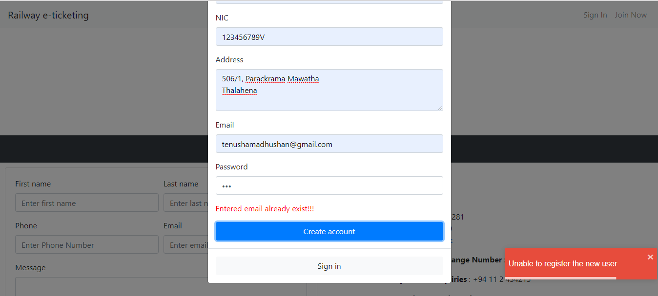

Fig 25: cannot register two accounts with same email

When users are login entered username and password will send to the back end for the validation. When sending data to back end the password will be hashed before sending.

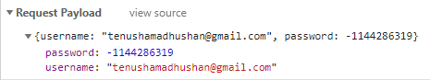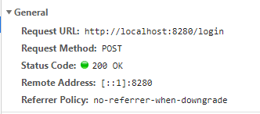

Fig 26: login POST request

With only valid username (previously registered) and valid password, Users can login to the system. If a user tries to access a page like “Payment” it will automatically redirect the user to the landing page of the web application. This redirection is handled using ReactJS lifecycle methods ( componentWillUpdate(), componentDidMount() ).

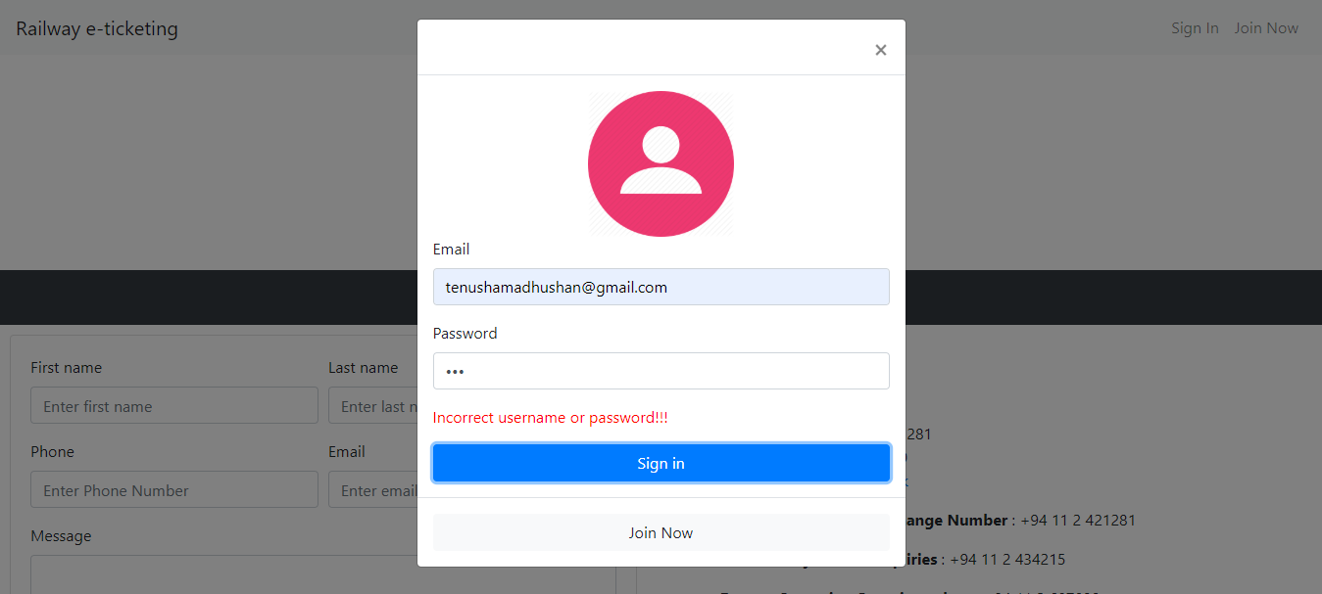

Fig 27: cannot login with invalid credentials

1. **Appendix**

**6.1. Front-End (ReactJS)**

Following figure shows the folder structure of the web (front-end) component.

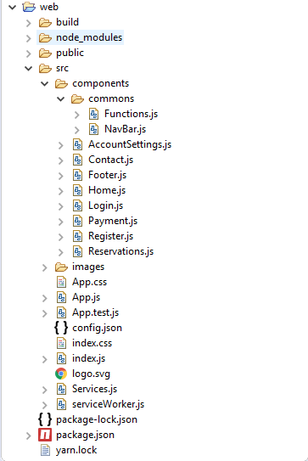

Fig 28: front-end folder structure

* **Config file (/web/src/config.json)**

This is where the configs of web application are stored. The "baseUrl" is where the back-end services deployed. In this case I have given the URL of WSO2 EI API base URL. If you have the WSO2 server in a separate location, you have to simply change the URL in the config file and deploy the application.

{

"baseUrl": *"http://localhost:8280"*

}

* **Index component (/web/src/index.js)**

**import** React from 'react';

**import** ReactDOM from 'react-dom';

**import** './index.css';

**import** App from './App';

**import** * as serviceWorker from './serviceWorker';

ReactDOM.render(<App />, document.getElementById('root'));

// If you want your app to work offline and load faster, you can change

// unregister() to register() below. Note this comes with some pitfalls.

// Learn more about service workers: https://bit.ly/CRA-PWA

serviceWorker.unregister();

* **App component (/web/src/App.js)**

**import** React, { Component, Suspense } from 'react'

**import** 'bootstrap/dist/css/bootstrap.min.css'

**import** 'react-toastify/dist/ReactToastify.css'

**import** 'react-datepicker/dist/react-datepicker.css'

**import** './App.css'

**import** { BrowserRouter as Router, Route, Switch } from 'react-router-dom'

**import** { ToastContainer } from 'react-toastify'

**import** NavBar from './components/commons/NavBar'

**import** Login from './components/Login'

**import** Register from './components/Register'

**import** Home from './components/Home'

**import** Contact from './components/Contact'

**import** Reservations from './components/Reservations'

**import** Payment from './components/Payment'

**import** AccountSettings from './components/AccountSettings'

**import** Footer from './components/Footer'

**class** App **extends** Component {

constructor(props, context) {

**super**(props, context)

**this**.state = {

showLogin: **false**,

showRegister: **false**

}

**this**.config = {

selected: 'home'

}

**this**.baseState = **this**.state

}

handleChange = obj => {

**if** (obj **instanceof** Object) {

**this**.setState({ ...obj })

}

}

handleLogout = () => {

**this**.setState(**this**.baseState)

localStorage.clear()

}

handleLoginShow = () => {

**this**.setState({ showLogin: **true** })

}

handleLoginClose = () => {

**this**.setState({ showLogin: **false** })

}

handleRegisterShow = () => {

**this**.setState({ showRegister: **true** })

}

handleRegisterClose = () => {

**this**.setState({ showRegister: **false** })

}

render() {

**return** (

<>

<div className="main-container">

<NavBar

handleLoginShow={**this**.handleLoginShow}

handleRegisterShow={**this**.handleRegisterShow}

logout={**this**.handleLogout}

{...**this**.state}

/>

<Login

showLogin={**this**.state.showLogin}

handleShow={**this**.handleLoginShow}

handleClose={**this**.handleLoginClose}

handleRegisterShow={**this**.handleRegisterShow}

/>

<Register

showRegister={**this**.state.showRegister}

handleShow={**this**.handleRegisterShow}

handleClose={**this**.handleRegisterClose}

handleLoginShow={**this**.handleLoginShow}

/>

<Router>

<Suspense fallback={<div>Loading...</div>}>

<Switch>

<Route exact path="/" component={Home} />

<Route path="/contact" component={Contact} />

<Route path="/reservations" component={Reservations} />

<Route path="/payment" component={Payment} />

<Route path="/account" component={AccountSettings} />

</Switch>

</Suspense>

</Router>

</div>

<Footer />

<ToastContainer

autoClose={3000}

position="bottom-right"

/>

</>

);

}

}

**export** **default** App;

* **Styles (/web/src/App.css)**

*.App* {

text-align: *center*;

}

*.App-logo* {

animation: *App-logo-spin* *infinite* *20s* *linear*;

height: *40vmin*;

pointer-events: *none*;

}

*.App-header* {

background-color: *#282c34*;

min-height: *100vh*;

display: *flex*;

flex-direction: *column*;

align-items: *center*;

justify-content: *center*;

font-size: *calc(10px* + *2vmin)*;

color: *white*;

}

*.App-link* {

color: *#61dafb*;

}

*.react-datepicker-wrapper***,** *.react-datepicker__input-container* {

display: *block*;

}

**body** {

height: *100%*;

position: *relative*;

}

* {

box-sizing: *border-box*;

}

\**:before***,**

\**:after* {

box-sizing: *border-box*;

}

*.main-container* {

min-height: *100vh*; /* will cover the 100% of viewport */

overflow: *hidden*;

display: *block*;

position: *relative*;

padding-bottom: *80px*; /* height of your footer */

}

@**keyframes** **App-logo-spin** {

from {

transform: *rotate(0deg)*;

}

**to** {

transform: *rotate(360deg)*;

}

}

* **Login component (/web/src/components/Login.js)**

**import** React, { Component } from 'react'

**import** { Modal, Button, Form, Image, Row } from 'react-bootstrap'

**import** { login } from '../Services'

**import** { getHash } from './commons/Functions'

**class** Login **extends** Component {

constructor(props, context) {

**super**(props, context)

**this**.state = {

// validated: false,

modalShowErr: **false**,

modalErrMsg: "Incorrect username or password!!!",

username: "",

password: ""

}

**this**.baseState = **this**.state

}

componentWillUnmount() {

**this**.setState(**this**.baseState)

}

handleChange = type => event => {

**let** value = event;

**if** (event.target) {

value = event.target.value;

}

**this**.setState({ [type]: value })

}

handleSubmit = event => {

**this**.setState({ modalShowErr: **false** })

**const** form = event.currentTarget

**if** (form.checkValidity() === **true**) {

login({ username: **this**.state.username, password: getHash(**this**.state.password) })

.then(res => {

localStorage.setItem('user', JSON.stringify(res))

**this**.props.handleClose()

})

.**catch**(err => {

console.log(err)

**this**.setState({ modalShowErr: **true** })

})

}

event.preventDefault()

event.stopPropagation()

}

joinClick = () => {

**this**.props.handleClose()

**this**.props.handleRegisterShow()

}

render() {

**return** (

<Modal show={**this**.props.showLogin} onHide={**this**.props.handleClose}>

<Form onSubmit={e => **this**.handleSubmit(e)}>

<Modal.Header closeButton>

</Modal.Header>

<Modal.Body>

<Row style={{ alignItems: 'center', justifyContent: 'center' }}>

<Image src={require("../images/login.png")} width='30%' />

</Row>

<Form.Group controlId="formBasicEmail">

<Form.Label>Email</Form.Label>

<Form.Control required type="username" placeholder="Enter email" onChange={**this**.handleChange('username')} />

</Form.Group>

<Form.Group controlId="formBasicPassword">

<Form.Label>Password</Form.Label>

<Form.Control required type="password" placeholder="Enter Password" onChange={**this**.handleChange('password')} />

</Form.Group>

{**this**.state.modalShowErr && <p style={{ color: 'red' }}>{**this**.state.modalErrMsg}</p>}

<Button variant="primary" type="submit" block>

Sign **in**

</Button>

</Modal.Body>

<Modal.Footer>

<Button variant="light" block onClick={**this**.joinClick}>

Join Now

</Button>

</Modal.Footer>

</Form>

</Modal>

);

}

}

**export** **default** Login;

* **Register component (/web/src/components/Register.js)**

**import** React, { Component } from 'react'

**import** { Modal, Button, Form, Col } from 'react-bootstrap'

**import** { register } from '../Services'

**import** { toast } from 'react-toastify'

**import** { getHash } from './commons/Functions'

**class** Register **extends** Component {

constructor(props, context) {

**super**(props, context)

**this**.state = {

// validated: false,

modalShowErr: **false**,

modalErrMsg: "Entered email already exist!!!",

}

**this**.baseState = **this**.state

}

componentWillUnmount() {

**this**.setState(**this**.baseState)

}

handleChange = type => event => {

**let** value = event

**if** (event.target) {

value = event.target.value

}

**this**.setState({ [type]: value })

}

handleSubmit = event => {

**this**.setState({ modalShowErr: **false** })

**const** form = event.currentTarget

**if** (form.checkValidity() === **true**) {

**var** body = { ...**this**.state, password: getHash(**this**.state.password) }

register(body)

.then(res => {

toast.success("Account Created Please Sign In")

**this**.loginClick()

})

.**catch**(err => {

**if** (err.then && **typeof** err.then === 'function') {

err.then(e => {

toast.error("Unable to register the new user")

**if** (e.exist) {

**this**.setState({ modalShowErr: **true** })

}

})

} **else** {

console.log(err)

}

})

}

// this.setState({ validated: true })

event.preventDefault()

event.stopPropagation()

}

loginClick = () => {

**this**.props.handleClose()

**this**.props.handleLoginShow()

}

render() {

**return** (

<Modal show={**this**.props.showRegister} onHide={**this**.props.handleClose}>

<Form onSubmit={e => **this**.handleSubmit(e)}>

<Modal.Header closeButton>

</Modal.Header>

<Modal.Body>

<Form.Row>

<Form.Group as={Col} controlId="formGridFName">

<Form.Label>First name</Form.Label>

<Form.Control required type="username" placeholder="Enter first name" onChange={**this**.handleChange('fname')} />

</Form.Group>

<Form.Group as={Col} controlId="formGridLName">

<Form.Label>Last name</Form.Label>

<Form.Control required type="username" placeholder="Enter last name" onChange={**this**.handleChange('lname')} />

</Form.Group>

</Form.Row>

<Form.Group controlId="formGridPhone">

<Form.Label>Phone</Form.Label>

<Form.Control required type="username" placeholder="Enter Phone Number" onChange={**this**.handleChange('phone')} />

</Form.Group>

<Form.Group controlId="formGridNIC">

<Form.Label>NIC</Form.Label>

<Form.Control type="username" placeholder="Enter NIC (Optional)" onChange={**this**.handleChange('nic')} />

</Form.Group>

<Form.Group controlId="controlTextarea1">

<Form.Label>Address</Form.Label>

<Form.Control required as="textarea" rows="3" onChange={**this**.handleChange('address')} />

</Form.Group>

<Form.Group controlId="formGridEmail">

<Form.Label>Email</Form.Label>

<Form.Control required type="email" placeholder="Enter email" onChange={**this**.handleChange('email')} />

</Form.Group>

<Form.Group controlId="formBasicPassword">

<Form.Label>Password</Form.Label>

<Form.Control required type="password" placeholder="Enter Password" onChange={**this**.handleChange('password')} />

</Form.Group>

{**this**.state.modalShowErr && <p style={{ color: 'red' }}>{**this**.state.modalErrMsg}</p>}

<Button variant="primary" type="submit" block>

Create account

</Button>

</Modal.Body>

<Modal.Footer>

<Button variant="light" block onClick={**this**.loginClick}>

Sign **in**

</Button>

</Modal.Footer>

</Form>

</Modal >

)

}

}

**export** **default** Register;

* **Navigation Bar (/web/src/components/commons/NavBar.js)**

**import** React, { Component } from 'react'

**import** { Navbar, Nav, NavDropdown, Image, Row } from 'react-bootstrap'

**class** NavBar **extends** Component {

render() {

**var** user = localStorage.getItem('user')

**if** (user) {

user = JSON.parse(user)

}

**return** (

<>

<Navbar bg="light" expand="sm">

<Navbar.Brand href="/">

Railway e-ticketing

</Navbar.Brand>

<Navbar.Toggle aria-controls="basic-navbar-nav" />

<Navbar.Collapse id="basic-navbar-nav">

<Nav className="ml-auto">

{user ?

<>

<Nav.Link href="/reservations" >My Reservations</Nav.Link>

<NavDropdown title={user.fname} id="nav-dropdown" alignRight>

<NavDropdown.Item href="/account">Account Settings</NavDropdown.Item>

<NavDropdown.Divider />

<NavDropdown.Item onClick={**this**.props.logout}>Sign out</NavDropdown.Item>

</NavDropdown>

</>

:

<>

<Nav.Link href="" onClick={**this**.props.handleLoginShow}>Sign In</Nav.Link>

<Nav.Link href="" onClick={**this**.props.handleRegisterShow}>Join Now</Nav.Link>

</>

}

</Nav>

</Navbar.Collapse>

</Navbar>

<Row style={{ alignItems: 'center', justifyContent: 'center', width: '100%' }}>

<div >

<Image src={require("../../images/railway.png")} />

</div>

</Row>

<Navbar style={{ justifyContent: 'space-between' }} bg="dark" variant="dark" expand="sm">

<Navbar.Brand href="/"></Navbar.Brand>

<Navbar.Toggle aria-controls="basic-navbar-nav" />

<Navbar.Collapse id="basic-navbar-nav" data-collapsed="false">

<Nav className="mx-auto">

<Nav.Link href="/" >{'Home'}</Nav.Link>

<Nav.Link href="/contact">{'Contact Us'}</Nav.Link>

</Nav>

</Navbar.Collapse>

</Navbar>

</>

);

}

}

**export** **default** NavBar;

* **Services component (/web/src /Services.js)**

All the functions of service calls to the back-end are stored in this component

**import** config from './config.json'

**const** baseUrl = config.baseUrl

**export** **function** login(body) {

**return** callPost(baseUrl + '/login', body);

}

**export** **function** register(body) {

**return** callPost(baseUrl + '/register', body);

}

**export** **function** routes() {

**return** callGet(baseUrl + '/railway/routes');

}

**export** **function** route(station) {

**return** callGet(baseUrl + '/railway/route/' + station);

}

**export** **function** trains() {

**return** callGet(baseUrl + '/railway/trains/');

}

**export** **function** trainsByRoute(route) {

**return** callGet(baseUrl + '/railway/trains/' + route);

}

**export** **function** classes() {

**return** callGet(baseUrl + '/railway/classes/');

}

**export** **function** schedules() {

**return** callGet(baseUrl + '/railway/schedules/');

}

**export** **function** validateCard(body) {

**return** callPost(baseUrl + '/payment/card', body);

}

**export** **function** validatePhone(body) {

**return** callPost(baseUrl + '/payment/phone', body);

}

**export** **function** makeReservation(body) {

**return** callPost(baseUrl + '/railway/reservations', body);

}

**export** **function** getReservations(user) {

**return** callGet(baseUrl + '/railway/reservations/' + user);

}

**export** **function** deleteReservation(id) {

**return** callDelete(baseUrl + '/railway/reservations/' + id);

}

**export** **function** updateAccount(body, id) {

**return** callPut(baseUrl + '/users/' + id, body)

}

**export** **function** contact(body) {

**return** callPost(baseUrl + '/railway/contact', body);

}

**const** callGet = (url) => {

**return** fetch(url).then(handleres);

}

**const** callPost = (url, body) => {

**return** fetch(url, {

method: 'POST',

body: JSON.stringify(body),

headers: { "Content-Type": "application/json" }

}).then(handleres);

}

**const** callPut = (url, body) => {

**return** fetch(url, {

method: 'PUT',

body: JSON.stringify(body),

headers: { "Content-Type": "application/json" }

}).then(handleres);

}

**const** callDelete = (url) => {

**return** fetch(url, {

method: 'DELETE'

}).then(handleres);

}

**const** handleres = (res) => {

**if** (res.ok) {

**return** res.json();

}

**else** {

**if** (res.status === 404) {

**return** Promise.reject();

} **else** {

**throw** res.json();

}

}

}

* **Home component (/web/src/components/Register.js)**

**import** React, { Component } from 'react'

**import** { routes, route, trainsByRoute, classes, schedules } from '../Services'

**import** { Button, Form, Col, Row, Table } from 'react-bootstrap'

**import** Select from 'react-select'

**import** DatePicker from "react-datepicker"

**import** moment from 'moment'

**class** Home **extends** Component {

constructor(props) {

**super**(props);

**this**.state = {

fromOptions: [],

toOptions: [],

trains: [],

errMsg: 'Please fill all the fields!!!',

showErr: **false**,

};

}

componentDidMount() {

**var** options = []

routes()

.then(res => {

res.map((item, i) => {

**return** item.route.map((station, i) => {

**return** options.push({ value: station.name, label: station.name, route: item._id, id: i, fair: station.fair })

})

})

**this**.setState({ fromOptions: options })

})

.**catch**(err => {

console.log(err)

})

classes()

.then(res => {

**var** classes = []

res.map((trainClass, i) => {

**return** classes.push({ value: trainClass.name, label: trainClass.name, id: trainClass._id, fairRatio: trainClass.fairRatio })

})

**this**.setState({ classes: classes })

})

.**catch**(err => {

console.log(err)

})

schedules()

.then(res => {

**var** schedules = []

res.map((schedule, i) => {

**return** schedules.push({ value: schedule.time, label: schedule.time, id: schedule._id })

})

**this**.setState({ schedules: schedules })

})

.**catch**(err => {

console.log(err)

})

}

handleChange = type => selectedOption => {

**this**.setState({ [type]: selectedOption }, () => {

**this**.calculateFair()

});

**if** (type === 'from') {

**this**.setState({ to: '', train: '' })

route(selectedOption.route)

.then(res => {

**var** options = [];

res.route.map((station, i) => {

**return** options.push({ value: station.name, label: station.name, route: res._id, id: i, fair: station.fair })

})

**this**.setState({ toOptions: options })

})

.**catch**(err => {

console.log(err)

})

trainsByRoute(selectedOption.route)

.then(res => {

**var** options = [];

res.map((train, i) => {

**return** options.push({ value: train.name, label: train.name, id: train._id })

})

**this**.setState({ trains: options })

})

.**catch**(err => {

console.log(err)

})

}

}

handleQtyChange = () => event => {

**this**.setState({ qty: event.target.value }, () => **this**.calculateFair())

}

calculateFair = () => {

**var** user = localStorage.getItem('user')

**if** (user) {

user = JSON.parse(user)

}

**if** (**this**.state.to && **this**.state.from && **this**.state.trainClass && **this**.state.qty) {

**var** amount = Math.abs(**this**.state.to.fair - **this**.state.from.fair) * **this**.state.trainClass.fairRatio * **this**.state.qty

amount = amount.toFixed(2)

**var** discount = (user && user.discount ? 0.1 * amount : 0).toFixed(2)

**var** total = (amount - discount).toFixed(2)

**this**.setState({ amount: amount, discount: discount, total: total })

}

}

handleSubmit = event => {

**this**.setState({ showErr: **false** })

**const** state = **this**.state

**var** user = localStorage.getItem('user')

**if** (!user) {

alert("Please Sign In Before Make a Reservation!!!")

**this**.props.history.push('/')

} **else** **if** (state.from && state.to && state.train && state.trainClass && state.time && state.qty && state.date) {

**this**.props.history.push("/payment", { ...**this**.state })

} **else** {

**this**.setState({ showErr: **true** })

}

event.preventDefault()

event.stopPropagation()

}

handleDateChange = dt => {

**const** date = moment(dt).format('YYYY-MM-DD')

**this**.setState({ date: date })

}

render() {

**return** (

<Form style={{ padding: 20 }} onSubmit={(e) => **this**.handleSubmit(e)}>

<Row style={{ alignItems: 'center', justifyContent: 'center' }}>

<Form.Row style={{ width: '75%', borderBottom: '1px solid rgb(200,200,200)', marginBottom: 20 }}>

<h4>Book Train Tickets</h4>

</Form.Row>

<Form.Row style={{ width: '75%' }}>

<Form.Group as={Col} controlId="from">

<Form.Label>From</Form.Label>

<Select options={**this**.state.fromOptions} onChange={**this**.handleChange("from")} />

</Form.Group>

<Form.Group as={Col} controlId="to">

<Form.Label>To</Form.Label>

<Select options={**this**.state.toOptions} onChange={**this**.handleChange("to")} value={**this**.state.to} />

</Form.Group>

</Form.Row>

<Form.Row style={{ width: '75%' }}>

<Form.Group as={Col} controlId="from">

<Form.Label>Train</Form.Label>

<Select options={**this**.state.trains} onChange={**this**.handleChange("train")} value={**this**.state.train} />

</Form.Group>

<Form.Group as={Col} controlId="to">

<Form.Label>Class</Form.Label>

<Select options={**this**.state.classes} onChange={**this**.handleChange("trainClass")} value={**this**.state.trainClass} />

</Form.Group>

</Form.Row>

<Form.Row style={{ width: '75%' }}>

<Form.Group as={Col} controlId="from">

<Form.Label>Time</Form.Label>

<Select options={**this**.state.schedules} onChange={**this**.handleChange("time")} value={**this**.state.time} />

</Form.Group>

<Form.Group as={Col} controlId="formGridEmail">

<Form.Label>No **of** Tickets</Form.Label>

<Form.Control placeholder="qty" onChange={**this**.handleQtyChange()} />

</Form.Group>

</Form.Row>

<Form.Row style={{ width: '75%', paddingBottom: 20 }}>

<Col md={6} lg={6} xl={6}>

<Form.Label>Date</Form.Label>

<DatePicker

className="form-control"

onChange={**this**.handleDateChange}

minDate={**new** Date()}

value={**this**.state.date}

placeholderText="YYYY-MM-DD"

/>

</Col>

</Form.Row>

<Form.Row style={{ width: '75%', paddingLeft: 5, align: 'right' }}>

{**this**.state.amount &&

<Table striped bordered hover size="sm">

<tbody>

<tr>

<td align='right'>Amount</td>

<td align='right'>{**this**.state.amount} LKR</td>

</tr>

<tr>

<td align='right'>Discount</td>

<td align='right'>{**this**.state.discount} LKR</td>

</tr>

<tr>

<td align='right'>Total</td>

<td align='right'>{**this**.state.total} LKR</td>

</tr>

</tbody>

</Table>

}

</Form.Row>

<Form.Row style={{ width: '75%' }}>

{**this**.state.showErr && <p style={{ color: 'red' }}>{**this**.state.errMsg}</p>}

</Form.Row>

<Form.Row style={{ width: '75%', padding: 5 }}>

<Button variant="primary" type="submit">

Make Reservation

</Button>

</Form.Row>

</Row>

</Form >

);

}

}

**export** **default** Home;

* **Payment component (/web/src/components/Payment.js)**

**import** React, { Component } from 'react'

**import** { Table, Row, Form, Col, Button } from 'react-bootstrap'

**import** { validateCard, validatePhone, makeReservation } from '../Services'

**import** { toast } from 'react-toastify'

**class** Payment **extends** Component {

constructor(props) {

**super**(props);

**this**.state = {

checked: 'card',

errMsg: 'Please fill all the fields!!!',

showPaymentErr: **false**,

validateErrMsg: 'Entered data not valid!!!',

showValidateErr: **false**,

cardNo: '',

cvc: '',

exp: '',

phoneNo: '',

pin: ''

};

}

componentDidMount() {

**if** (**this**.props.location) {

**this**.setState({ ...**this**.props.location.state })

}

**var** user = localStorage.getItem('user')

**if** (user) {

**this**.setState({ phoneNo: JSON.parse(user).phone })

}

}

componentWillUpdate() {

**var** user = localStorage.getItem('user')

**if** (!user) {

**this**.props.history.push('/')

}

}

handleChange = type => event => {

**var** value = event.target.value

**if** (type === 'card' || type === 'phone') {

**this**.setState({ checked: type })

} **else** {

**this**.setState({ [type]: value })

}

}

handleSubmit = async event => {

event.preventDefault()

event.stopPropagation()

**this**.setState({ showPaymentErr: **false**, showValidateErr: **false** })

**const** state = **this**.state;

**if** (state.checked === 'card') {

**if** (state.cardNo && state.cvc && state.exp) {

validateCard({ card: state.cardNo, cvc: state.cvc, exp: state.exp, total: state.total })

.then(res => {

**if** (res.validated) {

**this**.createReservation({ card: state.cardNo })

} **else** {

**this**.setState({ showValidateErr: **true** })

}

})

.**catch**(err => {

console.log(err)

})

} **else** {

**this**.setState({ showPaymentErr: **true** })

}

}

**if** (state.checked === 'phone') {

**if** (state.phoneNo && state.pin) {

validatePhone({ phone: state.phoneNo, pin: state.pin, total: state.total })

.then(res => {

**if** (res.validated) {

**this**.createReservation({ phone: state.phoneNo })

} **else** {

**this**.setState({ showValidateErr: **true** })

}

})

.**catch**(err => {

console.log(err)

})

} **else** {

**this**.setState({ showPaymentErr: **true** })

}

}

}

createReservation = (paymentMethod) => {

**const** state = **this**.state

**var** user = localStorage.getItem('user')

**if** (user) {

user = JSON.parse(user)

**const** reservation = {

...paymentMethod,

user: user._id,

email: user.email,

from: state.from.value,

to: state.to.value,

train: state.train.value,

trainClass: state.trainClass.value,

time: state.time.value,

qty: state.qty,

date: state.date,

amount: state.amount,

discount: state.discount,

total: state.total

}

makeReservation(reservation)

.then(res => {

toast.success("Successfully paid " + reservation.total)

**this**.props.history.push('/reservations')

})

.**catch**(err => {

console.log(err)

})

}

}

render() {

**return** (

<Form style={{ padding: 20 }} onSubmit={(e) => **this**.handleSubmit(e)}>

<Row style={{ alignItems: 'center', justifyContent: 'center' }}>

<Form.Row style={{ width: '75%' }}>

<Table striped bordered hover size="sm">

<tbody>

<tr>

<td align='right'>Amount</td>

<td align='right'>{**this**.state.amount} LKR</td>

</tr>

<tr>

<td align='right'>Discount</td>

<td align='right'>{**this**.state.discount} LKR</td>

</tr>

<tr>

<td align='right'>Total</td>

<td align='right'>{**this**.state.total} LKR</td>

</tr>

</tbody>

</Table>

</Form.Row>

<Form.Row style={{ width: '75%' }}>

<Form.Label as="legend">

Select a payment method

</Form.Label>

</Form.Row>

<Form.Row style={{ width: '75%', paddingBottom: 10 }}>

<Col>

<Form.Check

type="radio"

label="Credit Card"

name="formHorizontalRadios"

id="formHorizontalRadios1"

defaultChecked

onChange={**this**.handleChange('card')}

/>

<Form.Check

type="radio"

label="Mobile Number"

name="formHorizontalRadios"

id="formHorizontalRadios2"

onChange={**this**.handleChange('phone')}

/>

</Col>

</Form.Row>

{**this**.state.checked === 'card' &&

<Form.Row style={{ width: '75%' }}>

<Form.Group as={Col} controlId="cardNo">

<Form.Label>Card Number</Form.Label>

<Form.Control placeholder="card number" onChange={**this**.handleChange('cardNo')} value={**this**.state.cardNo} />

</Form.Group>

<Form.Group as={Col} controlId="cvc">

<Form.Label>CVC Number</Form.Label>

<Form.Control placeholder="CVC" onChange={**this**.handleChange('cvc')} value={**this**.state.cvc} />

</Form.Group>

<Form.Group as={Col} controlId="exp">

<Form.Label>Exp date</Form.Label>

<Form.Control placeholder="dd/mm" onChange={**this**.handleChange('exp')} value={**this**.state.exp} />

</Form.Group>

</Form.Row>

}

{**this**.state.checked === 'phone' &&

<Form.Row style={{ width: '75%' }}>

<Form.Group as={Col} controlId="phoneNo">

<Form.Label>Phone Number</Form.Label>

<Form.Control placeholder="Phone number" onChange={**this**.handleChange('phoneNo')} value={**this**.state.phoneNo} />

</Form.Group>

<Form.Group as={Col} controlId="pin">

<Form.Label>PIN</Form.Label>

<Form.Control placeholder="PIN" onChange={**this**.handleChange('pin')} value={**this**.state.pin} />

</Form.Group>

</Form.Row>

}

<Form.Row style={{ width: '75%' }}>

{**this**.state.showPaymentErr && <p style={{ color: 'red' }}>{**this**.state.errMsg}</p>}

{**this**.state.showValidateErr && <p style={{ color: 'red' }}>{**this**.state.validateErrMsg}</p>}

</Form.Row>

<Form.Row style={{ width: '75%' }}>

<Button variant="primary" type="submit">

Make Payment

</Button>

</Form.Row>

</Row>

</Form>

)

}

}

**export** **default** Payment

* **Reservations Component (/web/src/components/Reservations.js)**

**import** React, { Component } from 'react';

**import** { Row, Col, Button, Card, Pagination } from 'react-bootstrap'

**import** { getReservations, deleteReservation } from '../Services'

**import** { toast } from 'react-toastify'

**class** Reservations **extends** Component {

constructor(props) {

**super**(props);

**this**.state = {

reservations: [],

items: [],

offset: 1,

lastPage: 1,

paginateItems: []

};

}

componentDidMount() {

**this**.updateReservations()

}

componentWillUpdate() {

**var** user = localStorage.getItem('user')

**if** (!user) {

**this**.props.history.push('/')

}

}

updateReservations = () => {

**var** user = localStorage.getItem('user')

**if** (!user) {

**this**.props.history.push('/')

} **else** {

user = JSON.parse(user)

getReservations(user._id)

.then(res => {

**this**.setState({ reservations: res }, () => **this**.paginateReservations())

})

.**catch**(err => {

console.log(err)

})

}

}

cancelReservation = id => {

**var** c = window.confirm("The reservation " + id + " will be deleted")

**if** (c) {

deleteReservation(id)

.then(res => {

toast.success("Successfully removed reservation " + id)

**this**.updateReservations()

})

.**catch**(err => {

console.log(err)

})

}

}

paginateReservations = () => {

**let** items = [];

**const** offset = (**this**.state.offset - 1) * 5

**for** (**let** number = offset; number < offset + 5; number++) {

**const** reservation = **this**.state.reservations[number]

**if** (reservation) {

items.push(

<Row style={{ width: '75%' }} key={number}>

<Col>

<Card style={{ padding: 10, marginTop: 10 }}>

<Row>

<Col>Reference No : {reservation._id}</Col>

</Row>

<hr />

<Row>

<Col>From <b>{reservation.from}</b> to <b>{reservation.to}</b></Col>

<Col align='right'>{reservation.date} {reservation.time}</Col>

</Row>

<Row>

<Col>Train : {reservation.train}</Col>

</Row>

<Row>

<Col>Class : {reservation.trainClass}</Col>

</Row>

<Row>

<Col>Quantity : {reservation.qty}</Col>

</Row>

<hr />

<Row>

<Col>Amount : {reservation.amount.toFixed(2)}</Col>

<Col>Discount : {reservation.discount.toFixed(2)}</Col>

<Col align='right'><b>Total :</b> {reservation.total.toFixed(2)}</Col>

</Row>

<Row>

<Col style={{ paddingTop: 10 }} align='right'>

<Button variant="danger" size="sm" onClick={() => **this**.cancelReservation(reservation._id)}>Cancel</Button>

</Col>

</Row>

</Card>

</Col>

</Row>

)

}

}

**let** paginateItems = [];

**const** lastPage = Math.ceil(**this**.state.reservations.length / 5)

**for** (**let** number = 1; number <= lastPage; number++) {

paginateItems.push(

<Pagination.Item key={number} active={number === **this**.state.offset} onClick={() => **this**.pageChange(number)}>

{number}

</Pagination.Item>,

);

}

**this**.setState({ paginateItems: paginateItems, items: items, lastPage: lastPage })

}

pageChange = n => {

console.log(n)

**this**.setState({ offset: n }, () => **this**.paginateReservations())

}

render() {

**return** (

<Row style={{ alignItems: 'center', justifyContent: 'center', width: '100%' }}>

{**this**.state.reservations.length <= 0 &&

<Row style={{ width: '75%', padding: 10 }}>

<Col>

<Card>

<Card.Body>You don't have any reservations yet!!!</Card.Body>

</Card>

</Col>

</Row>

}

{**this**.state.reservations.length > 0 &&

<>

<Row style={{ width: '75%', paddingTop: 20, paddingLeft: 15 }}>

<Pagination>

<Pagination.First onClick={() => **this**.pageChange(1)} />

{**this**.state.paginateItems}

<Pagination.Last onClick={() => **this**.pageChange(**this**.state.lastPage)} />

</Pagination>

</Row>

{**this**.state.items.map((reservation, i) => {

**return** (

reservation

)

})}

<Row style={{ width: '75%', paddingTop: 20, paddingLeft: 15 }}>

<Pagination>

<Pagination.First onClick={() => **this**.pageChange(1)} />

{**this**.state.paginateItems}

<Pagination.Last onClick={() => **this**.pageChange(**this**.state.lastPage)} />

</Pagination>

</Row>

</>

}

</Row>

);

}

}

**export** **default** Reservations;

* **Contact component (/web/src/components/Contact.js)**

**import** React, { Component } from 'react';

**import** { Col, Button, Form, Card, Row } from 'react-bootstrap'

**import** { contact } from '../Services'

**import** { toast } from 'react-toastify'

**class** Contact **extends** Component {

constructor(props) {

**super**(props);

**this**.state = {

fname: '',

lname: '',

phone: '',

email: '',

message: ''

};

**this**.baseState = **this**.state

}

handleChange = type => event => {

**let** value = event

**if** (event.target) {

value = event.target.value

}

**this**.setState({ [type]: value })

}

handleSubmit = event => {

event.preventDefault()

event.stopPropagation()

contact(**this**.state)

.then(res => {

toast.success("Your message has been sent..")

**this**.setState({ ...**this**.baseState })

})

.**catch**(err => {

console.log(err)

})

}

render() {

**return** (

<Row style={{ alignItems: 'center', justifyContent: 'center' }}>

<Col>

<Card style={{ padding: 20, margin: 10 }}>

<Form onSubmit={e => **this**.handleSubmit(e)}>

<Form.Row>

<Form.Group as={Col} controlId="formGridFName">

<Form.Label>First name</Form.Label>

<Form.Control required type="username" placeholder="Enter first name" onChange={**this**.handleChange('fname')} value={**this**.state.fname} />

</Form.Group>

<Form.Group as={Col} controlId="formGridLName">

<Form.Label>Last name</Form.Label>

<Form.Control required type="username" placeholder="Enter last name" onChange={**this**.handleChange('lname')} value={**this**.state.lname} />

</Form.Group>

</Form.Row>

<Form.Row>

<Form.Group as={Col} controlId="formGridPhone">

<Form.Label>Phone</Form.Label>

<Form.Control type="username" placeholder="Enter Phone Number" onChange={**this**.handleChange('phone')} value={**this**.state.phone} />

</Form.Group>

<Form.Group as={Col} controlId="formGridEmail">

<Form.Label>Email</Form.Label>

<Form.Control required type="email" placeholder="Enter email" onChange={**this**.handleChange('email')} value={**this**.state.email} />

</Form.Group>

</Form.Row>

<Form.Group controlId="controlTextarea1">

<Form.Label>Message</Form.Label>

<Form.Control required as="textarea" rows="3" onChange={**this**.handleChange('message')} value={**this**.state.message} />

</Form.Group>

<Col style={{ paddingRight: 0 }} align='right'>

<Button variant="success" type="submit">

Send Message

</Button>

</Col>

</Form>

</Card>

</Col>

<Col>

<Row style={{ alignItems: 'center', justifyContent: 'center', margin: 30 }}>

<Col>

<div id="page">

<p><strong><span style={{ textDecoration: 'underline' }}>General Information</span></strong></p>

<p><strong>Telephones : </strong>+94 11 2 421281 <br /><strong>Fax Nos : </strong>+94 11 2 446490<br /><strong>Email : </strong>

<a href="mailto:gmr@railway.gov.lk">gmr@railway.gov.lk</a>

<span style={{ display: 'none' }}>This e-mail address is being **protected** from spambots. You need JavaScript enabled to view it

</span>

</p>

<p><strong>Railway Head Office Exchange Number</strong> : +94 11 2 421281</p>

<p><strong>Fort Railway Station Inquiries</strong> : +94 11 2 434215</p>

<p><strong>Deputy Operating Superintendent</strong> : +94 11 2 687099</p>

<p className="MsoNormal"><strong>Assistant Transportation Superintendent (Operation)</strong> : +94 11 2 692286</p>

</div>

</Col>

</Row>

</Col>

</Row>

);

}

}

**export** **default** Contact;

* **Account Settings component (/web/src/components/AccountSettings.js)**

**import** React, { Component } from 'react'

**import** { Col, Button, Form, Card, Row } from 'react-bootstrap'

**import** { updateAccount } from '../Services'

**import** { toast } from 'react-toastify'

**import** { getHash } from './commons/Functions'

**class** AccountSettings **extends** Component {

constructor(props, context) {

**super**(props, context)

**this**.state = {

fname: '',

lname: '',

phone: '',

nic: '',

email: '',

address: ''

}

**this**.baseState = **this**.state

}

componentDidMount() {

**var** user = localStorage.getItem('user')

**if** (user) {

user = JSON.parse(user)

**this**.setState({

fname: user.fname,

lname: user.lname,

phone: user.phone,

nic: user.nic || '',

email: user.email,

address: user.address

})

}

}

componentWillUpdate() {

**var** user = localStorage.getItem('user')

**if** (!user) {

**this**.props.history.push('/')

}

}

handleChange = type => event => {

**let** value = event

**if** (event.target) {

value = event.target.value

}

**this**.setState({ [type]: value })

}

handleSubmit = event => {

**const** form = event.currentTarget

**const** id = JSON.parse(localStorage.getItem('user'))._id

**if** (form.checkValidity() === **true**) {

**var** body = { ...**this**.state }

**if** (**this**.state.password) {

body = { ...body, password: getHash(**this**.state.password) }

}

updateAccount(body, id)

.then(res => {

toast.success("Account updated!!!")

localStorage.setItem('user', JSON.stringify(res))

})

.**catch**(err => {

toast.error("Unable to update new data!!!")

})

}

event.preventDefault()

event.stopPropagation()

}

render() {

**return** (

<Row style={{ alignItems: 'center', justifyContent: 'center' }}>

<Row style={{ width: '60%', padding: 10 }}>

<Col>

<Card style={{ padding: 20 }}>

<Form onSubmit={e => **this**.handleSubmit(e)}>

<Form.Row>

<Form.Group as={Col} controlId="formGridFName">

<Form.Label>First name</Form.Label>

<Form.Control required type="username" placeholder="Enter first name" onChange={**this**.handleChange('fname')} value={**this**.state.fname} />

</Form.Group>

<Form.Group as={Col} controlId="formGridLName">

<Form.Label>Last name</Form.Label>

<Form.Control required type="username" placeholder="Enter last name" onChange={**this**.handleChange('lname')} value={**this**.state.lname} />

</Form.Group>

</Form.Row>

<Form.Row>

<Form.Group as={Col} controlId="formGridPhone">

<Form.Label>Phone</Form.Label>

<Form.Control required type="username" placeholder="Enter Phone Number" onChange={**this**.handleChange('phone')} value={**this**.state.phone} />

</Form.Group>

<Form.Group as={Col} controlId="formGridNIC">

<Form.Label>NIC</Form.Label>

<Form.Control type="username" placeholder="Enter NIC" onChange={**this**.handleChange('nic')} value={**this**.state.nic} />

</Form.Group>

</Form.Row>

<Form.Group controlId="controlTextarea1">

<Form.Label>Address</Form.Label>

<Form.Control required as="textarea" rows="3" onChange={**this**.handleChange('address')} value={**this**.state.address} />

</Form.Group>

<Form.Group controlId="formGridEmail">

<Form.Label>Email</Form.Label>

<Form.Control required type="email" placeholder="Enter email" onChange={**this**.handleChange('email')} value={**this**.state.email} disabled />

</Form.Group>

<Form.Group controlId="formBasicPassword">

<Form.Label>Password</Form.Label>

<Form.Control type="password" placeholder="Enter New Password" onChange={**this**.handleChange('password')} />

</Form.Group>

<Col style={{ paddingRight: 0 }} align='right'>

<Button variant="primary" type="submit">

Update account

</Button>

</Col>

</Form>

</Card>

</Col>

</Row>

</Row>

)

}

}

**export** **default** AccountSettings

* **Common functions (/web/src/components/commons/Functions.js)**

**export** **function** getHash(str) {

**let** hash = 0

**for** (**let** i = 0; i < str.length; i++) {

hash += Math.pow(str.charCodeAt(i) * 31, str.length - i)

hash = hash & hash // Convert to 32bit integer

}

**return** hash

};

* **Footer component (/web/src/components/Footer.js)**

**import** React, { Component } from 'react'

**class** Footer **extends** Component {

render() {

**return** (

<footer className="page-footer font-small" style={{ backgroundColor: '#4B4A4A', color: 'white', position: 'absolute', bottom: 0, width: '100%' }}>

<div className="footer-copyright text-center py-3">© 2019 Copyright:

<a href="https://tenusha.wordpress.com"> tenusha.wordpress.com</a>

</div>

</footer>

)

}

}

**export** **default** Footer

**6.2. Back-End (NodeJS, ExpressJS, MongoDB)**

Following figure shows the folder structure of the services (back-end) component.

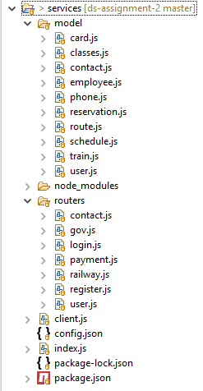

Fig 29: back-end folder structure

* **Config file (/services/config.json)**

This is where all the configs of the back-end are stored.

{

"mongoDB": *"mongodb://localhost/railway"*,

"govAPI": *"http://localhost:3001/gov/employee/"*,

"emailClient": {

"host": *"smtp.gmail.com"*,

"email": *"sl.railway.e.ticketing@gmail.com"*,

"auth": {

"user": *"sl.railway.e.ticketing@gmail.com"*,

"pass": *"railway@123"*

}

},

"messageClient": {

"accountSid": *"AC86b7448c3ed5e78b18f44d5e84fbdcb1"*,

"authToken": *"fee993da9d4cafa918929607a8b37827"*,

"phoneNo": *"+18504040553"*

}

}

It contains the URL of government service to validate NIC of users, email client information and the configs of Twilio text message service. If you want to use a premium Twilio account, you only have to change the configs in this file.

* **Index component (/services/index.js)**

'use strict'

**const** express = require('express')

**const** app = express()

**const** config = require('./config.json')

**const** login = require('./routers/login')

**const** register = require('./routers/register')

**const** railway = require('./routers/railway')

**const** payment = require('./routers/payment')

**const** gov = require('./routers/gov')

**const** user = require('./routers/user')

**const** contact = require('./routers/contact')

**const** mongoose = require('mongoose')

mongoose.connect(config.mongoDB, { useNewUrlParser: **true** }, **function** (err) {

**if** (err) **throw** err

console.log('mongo db connected')

}).**catch**(err => console.log(err))

app.use(express.json());

app.use(**function** (req, res, next) {

res.header("Access-Control-Allow-Origin", "*");

res.header("Access-Control-Allow-Headers", "Origin, X-Requested-With, Content-Type, Accept");

res.header("Access-Control-Allow-Methods", "GET, POST, OPTIONS, PUT, DELETE");

next();

});

app.use(login)

app.use(register)

app.use(railway)

app.use(payment)

app.use(gov)

app.use(user)

app.use(contact)

app.listen(3001, err => {

**if** (err) {

console.error(err)

**return**

}

console.log('app listening on port 3001')

});

* **Client component (/services/Client.js)**

This is where all the connections to the outside network are stored. (government service, email service and Twilio text message service)

**const** fetch = require("node-fetch")

**const** nodemailer = require('nodemailer')

**const** config = require('./config.json')

**const** twilio = require('twilio')(config.messageClient.accountSid, config.messageClient.authToken);

module.exports = {

validateNIC: **function** (nic) {

**return** fetch(config.govAPI + nic)

.then(handleErrors)

.then(res => res.json())

.then(data => {

**return** data.validated

})

.**catch**(err => {

console.log(err)

})

},

sendEmail: async **function** (body) {

**const** emailConfig = config.emailClient

**const** transporter = nodemailer.createTransport({

host: emailConfig.host,

port: 465,

secure: **true**,

auth: emailConfig.auth

});

**var** mailOptions = {

from: '"Sri Lanka Railways"' + emailConfig.email,

to: body.email,

subject: body.subject,

html: body.html

};

transporter.sendMail(mailOptions, **function** (error, info) {

**if** (error) {

console.log(error)

} **else** {

console.log('Email sent: ' + info.response);

}

});

},

sendTextMessage: async **function** (body) {

**var** to = body.phone

**if** (to.startsWith("0")) {

to = to.replace("0", "+94")

}

twilio.messages

.create({

body: "Sri Lanka Railway - Reservation Slip \n\n Reference No : " + body.reservationID + " \n\n From " + body.from + " to " + body.to + " \n Date : " + body.date + " \n Time : " + body.time + " \n Train : " + body.train + " \n Class: " + body.trainClass + " \n Quantity : " + body.qty + " \n Total : " + body.total + " LKR",

from: config.messageClient.phoneNo,

to: to

})

.then(message => console.log(message.sid))

.**catch**(err => console.log(err))

}

}

handleErrors = response => {

**if** (!response.ok) {

**throw** **new** Error("Request failed " + response.statusText)

}

**return** response

}

* **Railway services (/services/routers/railway.js)**

**const** express = require('express')

**const** router = express.Router()

**const** routeModel = require('../model/route')

**const** trainModel = require('../model/train')

**const** classModel = require('../model/classes')

**const** scheduleModel = require('../model/schedule')

**const** reservationModel = require('../model/reservation')

**const** client = require('../client')

router.get('/railway/routes', async (req, res) => {

**try** {

**const** result = await routeModel.find()

res.status(200).json(result)

} **catch** (err) {

res.status(500).json(err)

}

});

router.get('/railway/route/:id', async (req, res) => {

**try** {

**const** result = await routeModel.findOne({ '_id': req.params.id })

res.status(200).json(result)

} **catch** (err) {

res.status(500).json(err)

}

});

router.get('/railway/trains', async (req, res) => {

**try** {

**const** result = await trainModel.find()

res.status(200).json(result)

} **catch** (err) {

res.status(500).json(err)

}

});

router.get('/railway/trains/:route', async (req, res) => {

**try** {

**const** route = await routeModel.findOne({ '_id': req.params.route })

**const** result = await trainModel.find({ route: route.name })

res.status(200).json(result)

} **catch** (err) {

res.status(500).json(err)

}

});

router.get('/railway/classes', async (req, res) => {

**try** {

**const** result = await classModel.find()

res.status(200).json(result)

} **catch** (err) {

res.status(500).json(err)

}

});

router.get('/railway/schedules', async (req, res) => {

**try** {

**const** result = await scheduleModel.find()

res.status(200).json(result)

} **catch** (err) {

res.status(500).json(err)

}

});

router.post('/railway/reservations', async (req, res) => {

**try** {

**const** body = req.body

**var** reservation = **new** reservationModel(body)

**var** result = await reservation.save()

**if** (body.phone) {

client.sendTextMessage({ ...body, reservationID: result._id })

} **else** **if** (body.card) {

**const** html = '<h2><u>Reservation Slip</u></h2><p>Reference No : <b> ' + result._id + ' </b><br><br>From <b> ' + body.from + ' </b> to <b> ' + body.to + ' </b><br>' + 'Date :<b> ' + body.date + ' </b> Time :<b> ' + body.time + ' </b><br>Train : <b>' + body.train + ' </b> Class: <b> ' + body.trainClass + ' </b><br>Quantity : <b> ' + body.qty + ' </b></p><p>Total : <b> ' + body.total + ' LKR</b></p> '

client.sendEmail({ ...body, html: html, subject: 'Railway e-Ticket' })

}

res.status(200).json(result)

}

**catch** (err) {

res.status(500).json(err)

}

});

router.get('/railway/reservations', async (req, res) => {

**try** {

**const** result = await reservationModel.find()

res.status(200).json(result)

} **catch** (err) {

res.status(500).json(err)

}

});

router.get('/railway/reservations/:user', async (req, res) => {

**try** {

**const** result = await reservationModel.find({ user: req.params.user })

res.status(200).json(result)

} **catch** (err) {

res.status(500).json(err)

}

});

router.**delete**('/railway/reservations/:id', async (req, res) => {

**try** {

**const** result = await reservationModel.deleteOne({ _id: req.params.id }).exec()

res.status(200).json(result)

} **catch** (err) {

res.status(500).json(err)

}

});

module.exports = router

* **Register service (/services/routers/register.js)**

**const** express = require('express')

**const** router = express.Router()

**const** UserModel = require('../model/user')

**const** client = require('../client')

router.post('/register', async (req, res) => {

**const** body = req.body

**const** email = body.email

**var** exist = ""

**try** {

await UserModel.findOne({ email: email }, (err, val) => {

**if** (err) {

console.log(err);

} **else** {

exist = val

}

});

**if** (exist) {

res.status(409).json({ exist: **true** })

} **else** {

**const** discount = await client.validateNIC(body.nic)

**var** user = **new** UserModel({ ...body, discount: discount })

**var** result = await user.save()

res.status(200).json(result)

}

} **catch** (err) {

res.status(500).json(err)

}

});

module.exports = router

* **User service (/services/routers/user.js)**

**const** express = require('express')

**const** router = express.Router()

**const** UserModel = require('../model/user')

**const** client = require('../client')

router.put('/users/:id', async (req, res) => {

**const** body = req.body

**try** {

**var** user = await UserModel.findById(req.params.id).exec()

**const** discount = body.nic ? await client.validateNIC(body.nic) : **false**

user.set({ ...body, discount: discount })

**var** result = await user.save()

res.status(200).json(result)

} **catch** (err) {

res.status(500).json(err)

}

});

module.exports = router

* **Login service (/services/routers/login.js)**

**const** express = require('express')

**const** router = express.Router()

**const** UserModel = require('../model/user')

router.post('/login', (req, res) => {

**const** body = req.body

**const** username = body.username

**const** password = body.password

**try** {

UserModel.findOne({ email: username, password: password }, (err, val) => {

**if** (err) {

console.log(err);

} **else** {

**if** (val) {

res.status(200).json(val)

} **else** {

res.status(401).json("unauthorized")

}

}

});

} **catch** (err) {

res.status(500).json(err)

}

});

module.exports = router

* **Payment service (/services/routers/payment.js)**

**const** express = require('express')

**const** router = express.Router()

**const** CardModel = require('../model/card')

**const** PhoneModel = require('../model/phone')

router.post('/payment/card', (req, res) => {

**const** body = req.body

**try** {

CardModel.findOne({ card: body.card, cvc: body.cvc, exp: body.exp }, (err, val) => {

**if** (err) {

console.log(err);

res.status(500).json(err)

} **else** **if** (!val) {

res.status(200).json({ validated: **false** })

} **else** {

console.log(req.body.total + " paid")

res.status(200).json({ validated: **true** })

}

});

} **catch** (err) {

res.status(500).json(err)

}

});

router.post('/payment/phone', (req, res) => {

**const** body = req.body

**try** {

PhoneModel.findOne({ phone: body.phone, pin: body.pin }, (err, val) => {

**if** (err) {

console.log(err);

res.status(500).json(err)

} **else** **if** (!val) {

res.status(200).json({ validated: **false** })

} **else** {

console.log(req.body.total + " paid")

res.status(200).json({ validated: **true** })

}

});

} **catch** (err) {

res.status(500).json(err)

}

});

module.exports = router

* **Contact service (/services/routers/contact.js)**

**const** express = require('express')

**const** router = express.Router()

**const** contactModel = require('../model/contact')

**const** client = require('../client')

router.post('/railway/contact', async (req, res) => {

**try** {

**const** body = req.body

**var** contact = **new** contactModel(body)

**var** result = await contact.save()

**const** phone = body.phone ? 'Phone :<b> ' + body.phone + ' </b><br> ' : ''

**const** html = '<h2><u>User Contact</u></h2><p>Reference No : <b> ' + result._id + ' </b><br><br>Name : <b> ' + body.fname + ' ' + body.lname + ' </b><br> ' + phone + ' Email :<b> ' + body.email + ' </b><br>Message : <b>' + body.message + ' </b></p> '

client.sendEmail({ ...body, html: html, subject: 'User Contact', email: body.email + ', sl.railway.e.ticketing@gmail.com' })

res.status(200).json(result)

} **catch** (err) {

res.status(500).json(err)

}

});

module.exports = router

* **Government service (/services/routers/gov.js)**

**const** express = require('express')

**const** router = express.Router()

**const** employeeModel = require('../model/employee')

router.get('/gov/employee/:nic', (req, res) => {

**try** {

employeeModel.findOne({ nic: req.params.nic }, (err, val) => {

**if** (err) {

console.log(err);

} **else** {

**if** (val) {

res.status(200).json({ validated: **true** })

} **else** {

res.status(200).json({ validated: **false** })

}

}

});

} **catch** (err) {

res.status(500).json(err)

}

});

module.exports = router

* **User DB Schema (/services/model/user.js)**

**const** mongoose = require('mongoose')

**const** userSchema = mongoose.Schema({

fname: {

type: String,

required: **true**,

},

lname: {

type: String,

required: **true**,

},

phone: {

type: String,

required: **true**,

},

nic: {

type: String

},

address: {

type: String,

required: **true**,

},

email: {

type: String,

required: **true**,

},

password: {

type: String,

required: **true**,

},

discount: {

type: Boolean,

required: **true**

}

})

**const** user = module.exports = mongoose.model('User', userSchema)

* **Train DB Schema (/services/model/train.js)**

**const** mongoose = require('mongoose')

**const** trainSchema = mongoose.Schema({

name: {

type: String,

required: **true**,

},

route: {

type: String,

required: **true**,

}

})

**const** train = module.exports = mongoose.model('Train', trainSchema)

* **Schedule DB Schema (/services/model/schedule.js)**

**const** mongoose = require('mongoose')

**const** scheduleSchema = mongoose.Schema({

time: {

type: String,

required: **true**,

}

})

**const** schedule = module.exports = mongoose.model('Schedule', scheduleSchema)

* **Route DB Schema (/services/model/route.js)**

**const** mongoose = require('mongoose')

**const** routeSchema = mongoose.Schema({

name: {

type: String,

required: **true**,

},

route: [

{

name: {

type: String,

required: **true**,

},

fair: {

type: Number,

required: **true**,

}

}

]

})

**const** route = module.exports = mongoose.model('Route', routeSchema)

* **Reservation DB Schema (/services/model/reservation.js)**

**const** mongoose = require('mongoose')

**const** reservationSchema = mongoose.Schema({

user: {

type: String,

required: **true**,

},

from: {

type: String,

required: **true**,

},

to: {

type: String,

required: **true**,

},

train: {

type: String,

required: **true**,

},

trainClass: {

type: String,

required: **true**,

},

time: {

type: String,

required: **true**,

},

qty: {

type: Number,

required: **true**,

},

date: {

type: String,

required: **true**,

},

amount: {

type: Number,

required: **true**,

},

discount: {

type: Number,

required: **true**,

},

total: {

type: Number,

required: **true**,

},

card:{

type: String

},

phone:{

type: String

},

email:{

type: String

}

})

**const** reservation = module.exports = mongoose.model('Reservation', reservationSchema)

* **Phone DB Schema (/services/model/phone.js)**

**const** mongoose = require('mongoose')

**const** phoneSchema = mongoose.Schema({

phone: {

type: String,

required: **true**,

},

pin: {

type: String,

required: **true**,

}

})

**const** phone = module.exports = mongoose.model('Phone', phoneSchema)

* **Employee DB Schema (/services/model/employee.js)**

**const** mongoose = require('mongoose')

**const** employeeSchema = mongoose.Schema({

firstName: {

type: 'String'

},

lastName: {

type: 'String'

},

nic: {

type: 'String'

},

address: {

type: [

'Mixed'

]

}

})

**const** employee = module.exports = mongoose.model('Employee', employeeSchema)

* **Contact DB Schema (/services/model/contact.js)**

**const** mongoose = require('mongoose')

**const** contactSchema = mongoose.Schema({

fname: {

type: String,

required: **true**,

},

lname: {

type: String,

required: **true**,

},

phone: {

type: String,

},

email: {

type: String,

required: **true**,

},

message: {

type: String,

required: **true**,

}

})

**const** contact = module.exports = mongoose.model('Contact', contactSchema)

* **Classes DB Schema (/services/model/classes.js)**

**const** mongoose = require('mongoose')

**const** classSchema = mongoose.Schema({

name: {

type: String,

required: **true**,

},

fairRatio: {

type: Number,

required: **true**,

}

})

**const** trainClass = module.exports = mongoose.model('Class', classSchema)

* **Card DB Schema (/services/model/card.js)**

**const** mongoose = require('mongoose')

**const** cardSchema = mongoose.Schema({

card: {

type: String,

required: **true**,

},

cvc: {

type: String,

required: **true**,

},

exp: {

type: String,

required: **true**,

}

})

**const** card = module.exports = mongoose.model('Card', cardSchema)

**6.3. WSO2 EI (Enterprise Integration – ESB)**

Following figure shows the project structure of the Enterprise Integration.

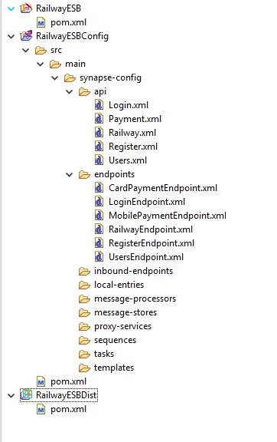

Fig 30: WSO2 -EI project structure

* **Payment API (/wso2-ei/RailwayESBConfig/src/main/synapse-config/api/Payment.xml)**

<?xml version=*"1.0"* encoding=*"UTF-8"*?>

<api context=*"/payment"* name=*"Payment"* xmlns=*"http://ws.apache.org/ns/synapse"*>

<resource methods=*"OPTIONS POST"* protocol=*"http"* uri-template=*"/{method}"*>

<inSequence>

<property action=*"remove"* name=*"REST_URL_POSTFIX"* scope=*"axis2"*/>

<switch source=*"get-property('uri.var.method')"*>

<case regex=*"phone"*>

<send>

<endpoint key=*"MobilePaymentEndpoint"*/>

</send>

</case>

<case regex=*"card"*>

<send>

<endpoint key=*"CardPaymentEndpoint"*/>

</send>

</case>

<default/>

</switch>

</inSequence>

<outSequence>

<respond/>

</outSequence>

<faultSequence/>

</resource>

</api>

* **CardPayment Endpoint**

**(/wso2-ei/RailwayESBConfig/src/main/synapse-config/endpoints/CardPaymentEndpoint.xml)**

<?xml version=*"1.0"* encoding=*"UTF-8"*?>

<endpoint name=*"CardPaymentEndpoint"* xmlns=*"http://ws.apache.org/ns/synapse"*>

<http uri-template=*"http://localhost:3001/payment/card"*/>

</endpoint>

* **MobilePayment Endpoint**

**(/wso2-ei/RailwayESBConfig/src/main/synapse-config/endpoints/MobilePaymentEndpoint.xml)**

<?xml version=*"1.0"* encoding=*"UTF-8"*?>

<endpoint name=*"MobilePaymentEndpoint"* xmlns=*"http://ws.apache.org/ns/synapse"*>

<http uri-template=*"http://localhost:3001/payment/phone"*/>

</endpoint>

* **Login API (/wso2-ei/RailwayESBConfig/src/main/synapse-config/api/Login.xml)**

<?xml version=*"1.0"* encoding=*"UTF-8"*?>

<api context=*"/login"* name=*"Login"* xmlns=*"http://ws.apache.org/ns/synapse"*>

<resource methods=*"OPTIONS POST"* protocol=*"http"*>

<inSequence>

<send>

<endpoint key=*"LoginEndpoint"*/>

</send>

</inSequence>

<outSequence>

<respond/>

</outSequence>

<faultSequence/>

</resource>

</api>

* **Login Endpoint**

**(/wso2-ei/RailwayESBConfig/src/main/synapse-config/endpoints/LoginEndpoint.xml)**

<?xml version=*"1.0"* encoding=*"UTF-8"*?>

<endpoint name=*"LoginEndpoint"* xmlns=*"http://ws.apache.org/ns/synapse"*>

<http uri-template=*"http://localhost:3001/login"*/>

</endpoint>

* **Railway API (/wso2-ei/RailwayESBConfig/src/main/synapse-config/api/Railway.xml)**

<?xml version=*"1.0"* encoding=*"UTF-8"*?>

<api context=*"/railway"* name=*"Railway"* xmlns=*"http://ws.apache.org/ns/synapse"*>

<resource methods=*"DELETE OPTIONS POST PUT GET"* protocol=*"http"*>

<inSequence>

<send>

<endpoint key=*"RailwayEndpoint"*/>

</send>

</inSequence>

<outSequence>

<respond/>

</outSequence>

<faultSequence/>

</resource>

</api>

* **Railway Endpoint**

**(/wso2-ei/RailwayESBConfig/src/main/synapse-config/endpoints/RailwayEndpoint.xml)**

<?xml version=*"1.0"* encoding=*"UTF-8"*?>

<endpoint name=*"RailwayEndpoint"* xmlns=*"http://ws.apache.org/ns/synapse"*>

<http uri-template=*"http://localhost:3001/railway"*/>

</endpoint>

* **Register API (/wso2-ei/RailwayESBConfig/src/main/synapse-config/api/Register.xml)**

<?xml version=*"1.0"* encoding=*"UTF-8"*?>

<api context=*"/register"* name=*"Register"* xmlns=*"http://ws.apache.org/ns/synapse"*>

<resource methods=*"OPTIONS POST"* protocol=*"http"*>

<inSequence>

<send>

<endpoint key=*"RegisterEndpoint"*/>

</send>

</inSequence>

<outSequence>

<respond/>

</outSequence>

<faultSequence/>

</resource>

</api>

* **Register Endpoint**

**(/wso2-ei/RailwayESBConfig/src/main/synapse-config/endpoints/RegisterEndpoint.xml)**

<?xml version=*"1.0"* encoding=*"UTF-8"*?>

<endpoint name=*"RegisterEndpoint"* xmlns=*"http://ws.apache.org/ns/synapse"*>

<http uri-template=*"http://localhost:3001/register"*/>

</endpoint>

* **Users API (/wso2-ei/RailwayESBConfig/src/main/synapse-config/api/Users.xml)**

<?xml version=*"1.0"* encoding=*"UTF-8"*?>

<api context=*"/users"* name=*"Users"* xmlns=*"http://ws.apache.org/ns/synapse"*>

<resource methods=*"DELETE OPTIONS POST PUT GET"* protocol=*"http"* uri-template=*"/{id}"*>

<inSequence>

<log>

<property expression=*"fn:concat('User ID - ',get-property('uri.var.id'))"* name=*"text"*/>

</log>

<send>

<endpoint key=*"UsersEndpoint"*/>

</send>

</inSequence>

<outSequence>

<respond/>

</outSequence>

<faultSequence/>

</resource>

</api>

* **Users Endpoint**

**(/wso2-ei/RailwayESBConfig/src/main/synapse-config/endpoints/UsersEndpoint.xml)**

<?xml version=*"1.0"* encoding=*"UTF-8"*?>

<endpoint name=*"UsersEndpoint"* xmlns=*"http://ws.apache.org/ns/synapse"*>

<http uri-template=*"http://localhost:3001/users"*/>

</endpoint>

1. **Known Issues**

* **Antivirus software block the “nodemailer” email service in back-end.**

If you are getting an error like below, it’s not a fault of the back-end services. It occur because some virus guard applications block “nodemailer” email service.

{ Error: self signed certificate in certificate chain

at TLSSocket.<anonymous> (_tls_wrap.js:1105:38)

at emitNone (events.js:106:13)

at TLSSocket.emit (events.js:208:7)

at TLSSocket._finishInit (_tls_wrap.js:639:8)

at TLSWrap.ssl.onhandshakedone (_tls_wrap.js:469:38) code: 'ESOCKET',

command: 'CONN' }

This is a common problem with Avast antivirus, this problem will not occur in ESET and Kaspersky.

I have also asked the problem in [https://stackoverflow.com](https://stackoverflow.com/). They also suggest to disable the virus guard when running the back-end services.

If you are getting some error like this, please disable the virus guard and try again. Anyway, the reservation process will not abort even if the error occurred.

* **“Twilio” free message service will not allow to sent messages to unverified mobile numbers.**

If you are getting an error like below, it occurs because I’m using Twilio free trial and the entered mobile number should be validated through Twilio dashboard before send messages to that number. If you have paid Twilio account please add account details in back-end “config.json” file.

{ [Error: The number +94777123456 is unverified. Trial accounts cannot send messages to unverified numbers; verify +94777123456 at twilio.com/user/account/phone-numbers/verified, or purchase a Twilio number to send messages to unverified numbers.]

status: 400,

message: 'The number +94777123456 is unverified. Trial accounts cannot send messages to unverified numbers; verify +94777123456 at twilio.com/user/account/phone-numbers/verified, or purchase a Twilio number to send messages to unverified numbers.',

code: 21608,

moreInfo: 'https://www.twilio.com/docs/errors/21608',

detail: undefined }

1. **GitHub Repository**

<https://github.com/tenusha/ds-assignment-2>