**15. Implement navigation using reactrouter**

Add React Router=• To add React Router in your application, run this in the terminal from the root directoryof the application: **npm i -D react-router-dom**

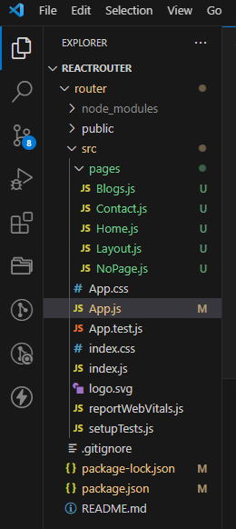

**E:\reactrouter\router\src\App.js**

// App.js

import React from "react";

import ReactDOM from "react-dom/client";

import { BrowserRouter, Routes, Route } from "react-router-dom";

import Layout from "./pages/Layout";

import Home from "./pages/Home";

import Blogs from "./pages/Blogs";

import Contact from "./pages/Contact";

import NoPage from "./pages/NoPage";

function App() {

return (

<BrowserRouter>

<Routes>

<Route path="/" element={<Layout />}>

<Route index element={<Home />} />

<Route path="blogs" element={<Blogs />} />

<Route path="contact" element={<Contact />} />

<Route path="*" element={<NoPage />} />

</Route>

</Routes>

</BrowserRouter>

);}

export default App;

**E:\reactrouter\router\src\pages\Blogs.js**

// Blogs.js

import React from "react";

const Blogs = () => {

return <h1>Blog Articles</h1>;

};

export default Blogs;

**E:\reactrouter\router\src\pages\Contact.js**

// Contact.js

import React from "react";

const Contact = () => {

return <h1>Contact Me</h1>;

};export default Contact;

**E:\reactrouter\router\src\pages\Home.js**

/ Home.js

import React from "react";

const Home = () => {

return <h1>Home</h1>;

};export default Home;

**E:\reactrouter\router\src\pages\Layout.js**

// Layout.js

import React from "react";

import { Outlet, Link } from "react-router-dom";

const Layout = () => {

return (

<><nav><ul><li>

<Link to="/">Home</Link>

</li>

<li>

<Link to="blogs">Blogs</Link>

</li>

<li>

<Link to="contact">Contact</Link>

</li> </ul></nav>

<Outlet /></>

);};

export default Layout;

**E:\reactrouter\router\src\pages\NoPage.js**

// NoPage.js

import React from "react";

const NoPage = () => {

return <h1>404</h1>;

};

export default NoPage;

**OUTPUT**

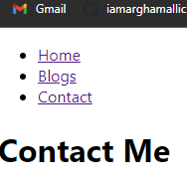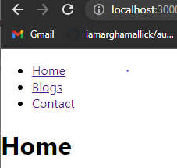

**14. Demonstaration of React-context**.

1. Create a React app.

2. Create new folder components

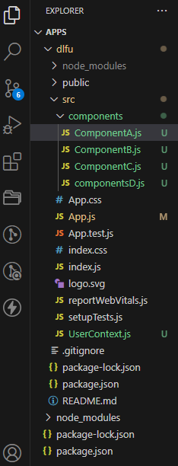

**E:\apps\dlfu\src\components\ComponentA.js**

import React, { Component } from 'react';

import ComponentB from './ComponentB';

class ComponentA extends Component {

render() {

return <ComponentB />;

}}

export default ComponentA;

**E:\apps\dlfu\src\components\ComponentB.js**

import React, { Component } from 'react';

import ComponentC from './ComponentC';

class ComponentB extends Component {

render() {

return <ComponentC />;

}}

export default ComponentB;

**E:\apps\dlfu\src\components\ComponentC.js**

import React, { Component } from 'react';

import { UserConsumer } from '../UserContext';

class ComponentC extends Component {

render() {

return (

<UserConsumer>

{username => {

return <div>Hello {username}</div>;

}}

</UserConsumer>

);}}

export default ComponentC;

**create a new file userContext.js in src folder**

**E:\apps\dlfu\src\UserContext.js**

import React from 'react'**;**

const UserContext = React.createContext();

const UserProvider = UserContext.Provider;

const UserConsumer = UserContext.Consumer;

export { UserProvider, UserConsumer }

**E:\apps\dlfu\src\App.js**

import React, { Component } from 'react';

import './App.css';

import { UserProvider } from './UserContext';

import ComponentC from './components/ComponentC';

class App extends Component {

render() {

return (

<div className="App">

<UserProvider value="Irfan">

<ComponentC />

</UserProvider>

</div>

); }}

export default App;

**Editing The ComponentC.js the program**

**E:\apps\dlfu\src\components\ComponentC.js**

import React, { Component } from 'react';

class ComponentC extends Component {

render() {

return (

<div>

hello all of you iam samarth

</div>

);}}

export default ComponentC;

**OUTPUT:**

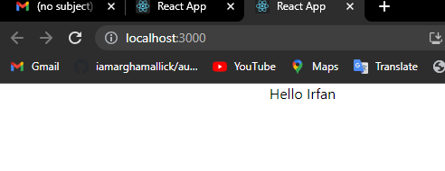

**Edit the component**

