
Report on Mini Project
Responsive Resume Builder with Live Preview and PDFGeneration
Course Code: CS2211-1
Course Name:Internet & Web Programming
Semester: VI SEM Section: C

Submitted To:
Ms. ANUPAMA H C
Department of Computer Science and Engineering

Submitted By:
RANJAN NNM24CS514
SAMARTH VENKAPPA PATIL NNM24CS515

Sign of course instructor
ABSTRACT
The Responsive Resume Builder is a web-based application developed using HTML, CSS, and JavaScript to simplify the process of creating professional resumes. The system enables users to input their personal and professional information through an interactive and user-friendly form interface. As users enter their details, the resume preview is dynamically updated in real time using DOM manipulation techniques, allowing them to instantly visualize the final layout.
The application is designed with a responsive layout to ensure compatibility across various devices such as desktops, tablets, and smartphones. It incorporates modern UI design principles to provide a clean, structured, and professional resume format. The system also includes a profile photo upload feature and dynamic addition of skills and projects, enhancing customization and flexibility.
One of the key features of the application is the integration of the html2pdf.js library, which allows users to generate and download their resumes in a properly formatted PDF file. This eliminates the need for additional software or advanced formatting knowledge.
The project demonstrates practical implementation of front-end web technologies, event handling, real-time data binding, file handling using the FileReader API, and client-side PDF generation. Overall, the Responsive Resume Builder provides an efficient, accessible, and user-friendly solution for creating professional resumes without requiring technical expertise.

TABLE OF CONTENTS

Title Page…………………………………………………………………………………………………………………………1
Abstract…………………………………………………………………………………………………………………………..2
Table of Contents…………………………………………………………………………………………………………….3 Introduction…………………………………………………………………………………………………………………….4
Problem Statement…………………………………………………………………………..................................5 Objectives………………………………………………………………………………………………………………………..6
Hardware/Software Requirement……………………………………………………………………………………7 Methodology…………………………………………………………………………………………………………………8-9
Implementation………….………………………………………………………………………………………………….10
Results………………………………………………………………………………………………………………………11-12
Conclusion …………………………………………………………………………………………………………………….13
References………………………………………………………………………...…………………………………………..14

INTRODUCTION

In today’s competitive job market, a well-structured and professionally designed resume plays a crucial role in securing employment opportunities. A resume serves as the first impression for recruiters and employers, highlighting an individual’s skills, education, experience, and achievements. However, many individuals face difficulties in creating properly formatted resumes due to a lack of technical knowledge and design skills. Traditional tools such as word processors require manual formatting, alignment adjustments, and layout customization, which can be time-consuming and confusing for beginners.
To address this issue, a web-based Responsive Resume Builder has been developed. This system simplifies the resume creation process by providing a user-friendly interface where users can enter their personal and professional details through structured input fields. The application automatically organizes and formats the entered data into a clean and professional resume layout.
The system uses HTML for structuring content, CSS for styling and responsive design, and JavaScript for dynamic functionality. Through real-time DOM manipulation, the resume preview updates instantly as the user types, allowing users to see immediate changes without refreshing the page. Additionally, the application integrates client-side PDF generation, enabling users to download their resumes in a ready-to-use format.
The Responsive Resume Builder is designed to work across different devices, including desktops, tablets, and smartphones, ensuring accessibility and usability. By combining simplicity, responsiveness, and modern web technologies, this project provides an efficient and practical solution for creating professional resumes quickly and easily.

PROBLEM STATEMENT
In today’s digital and highly competitive job market, a professionally designed resume is essential for securing employment opportunities. A resume acts as a formal representation of an individual’s qualifications, skills, and experience. However, many students and job seekers face significant challenges while creating resumes due to limited knowledge of formatting standards, layout design, and document structuring.
Traditional tools such as word processors require manual alignment, spacing adjustments, font selection, and layout formatting. This process can be time-consuming and confusing, especially for users without technical or design expertise. Even small formatting mistakes can make a resume look unprofessional and reduce its effectiveness.
Furthermore, many available resume creation tools are either complex, require paid subscriptions, or demand account registration. This creates accessibility barriers for students and entry-level candidates who need a quick and simple solution. There is also a lack of tools that provide real-time preview functionality, making it difficult for users to visualize the final resume while entering their details.
The Responsive Resume Builder is developed to address these challenges by providing a dynamic, responsive, and easy-to-use platform for creating professional resumes without requiring technical knowledge.

OBJECTIVES

The main objective of the Responsive Resume Builder project is to design and develop a dynamic web-based application that simplifies the process of creating professional resumes using modern front-end technologies. The technical objectives of the project are as follows:
- To design a structured and semantic user interface using HTML to collect personal and professional information from users.
- To implement responsive and modern UI styling using CSS, ensuring compatibility across multiple screen sizes and devices (desktop, tablet, and mobile).
- To develop dynamic real-time data binding between form inputs and resume preview using JavaScript and DOM manipulation techniques.
- To implement event handling mechanisms that update resume content instantly without page reload.
- To integrate the FileReader API for uploading and previewing profile images dynamically.
- To implement dynamic list management for adding, editing, and deleting skills and projects using JavaScript.
- To integrate the html2pdf.js library for client-side PDF generation of the formatted resume layout.
- To ensure that the generated PDF maintains layout consistency, formatting structure, and color design.
- To enhance user experience through clean layout design, structured sections, and intuitive navigation.
- To demonstrate practical implementation of front-end web development concepts including:
- DOM Manipulation
- Event Listeners
- Client-side Rendering
- Responsive Web Design

HARDWARE / SOFTWARE Requirements

Hardware Requirements
The hardware requirements for developing and running the Responsive Resume Builder are minimal, as it is a lightweight web-based application.
- Processor: Intel Core i3 or higheR
- RAM: Minimum 4 GB (8 GB recommended)
- Hard Disk: 500 MB free storage space
- Display: 1366 × 768 resolution or higher
- Input Devices: Keyboard and Mouse
- Internet Connection: Required for loading external libraries (CDN)
Since the application runs in a web browser, no high-end hardware configuration is required.
Software Requirements
The following software components are required for development and execution:
Development Environment:
- Operating System: Windows 10 / Windows 11 / Linux / macOS
- Code Editor: Visual Studio Code (VS Code) or any text editor
- Web Browser: Google Chrome / Microsoft Edge / Mozilla Firefox
Technologies Used:
- HTML5 – For structuring the web pages
- CSS3 – For styling and responsive layout design
- JavaScript (ES6) – For dynamic functionality and DOM manipulation
- html2pdf.js Library – For generating downloadable PDF resumes
- Font Awesome (CDN) – For icons

METHODOLOGY
The development of the Responsive Resume Builder followed a structured, systematic, and modular approach to ensure proper functionality, maintainability, and user-friendly design. The project was developed using a front-end oriented methodology, focusing on client-side technologies to create a lightweight and efficient web application. A step-by-step development process was adopted, starting from requirement gathering to final testing and validation.
The methodology emphasizes clear planning, modular design, dynamic implementation, and responsive layout development. Each module of the system was designed and implemented independently and then integrated to ensure smooth interaction between components. The approach ensured that the application remained scalable, easy to modify, and efficient in performance.
The development process also incorporated modern web development practices such as semantic HTML structuring, CSS-based responsive design principles, JavaScript-based DOM manipulation, and event-driven programming. Continuous testing was performed during development to identify and correct errors related to layout alignment, dynamic data rendering, and PDF generation.

IMPLEMENTATION
The Responsive Resume Builder is developed using HTML, CSS, and JavaScript to create a dynamic and user-friendly web application.
The HTML structure is divided into two main sections: Form section for collecting user input
Preview section for displaying the resume
· CSS is used to design a clean and responsive interface with proper layout, colors, and spacing.
·JavaScript is used to add interactivity by applying event listeners to input fields.
·The user input is instantly reflected in the preview section using DOM manipulation techniques.
·Dynamic addition of skills and projects is implemented using reusable functions, allowing multiple entries efficiently.
· The application includes an image upload feature using the FileReader API to display a profile photo in the resume.
·The html2pdf.js library is integrated to convert the resume into a downloadable PDF file.
·The system provides a real-time preview and practical functionality for creating professional resumes.

OUTPUT

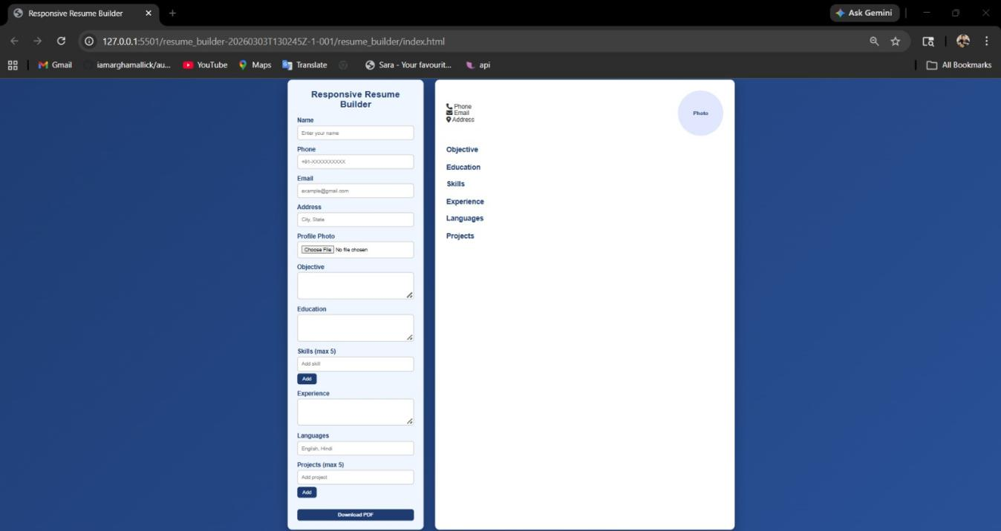
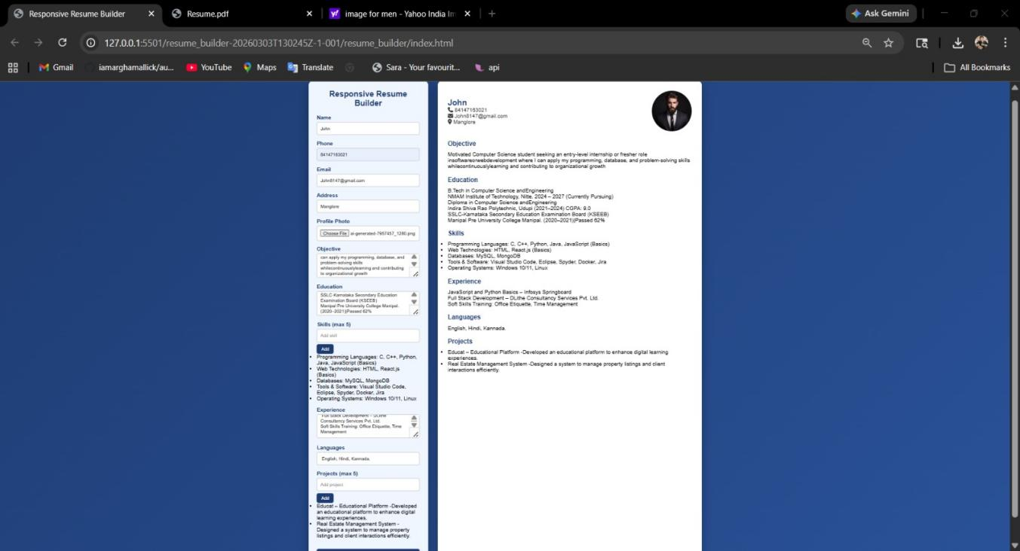
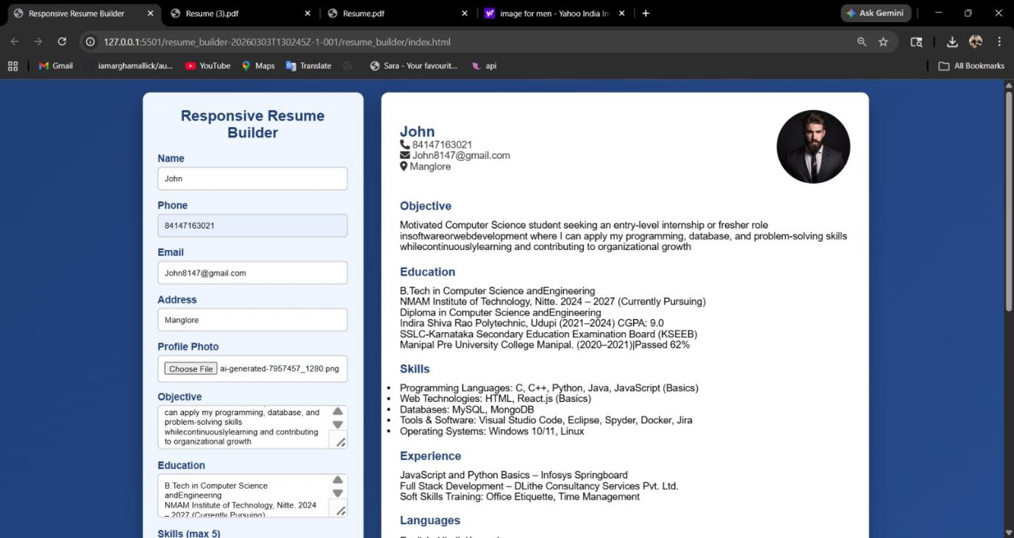
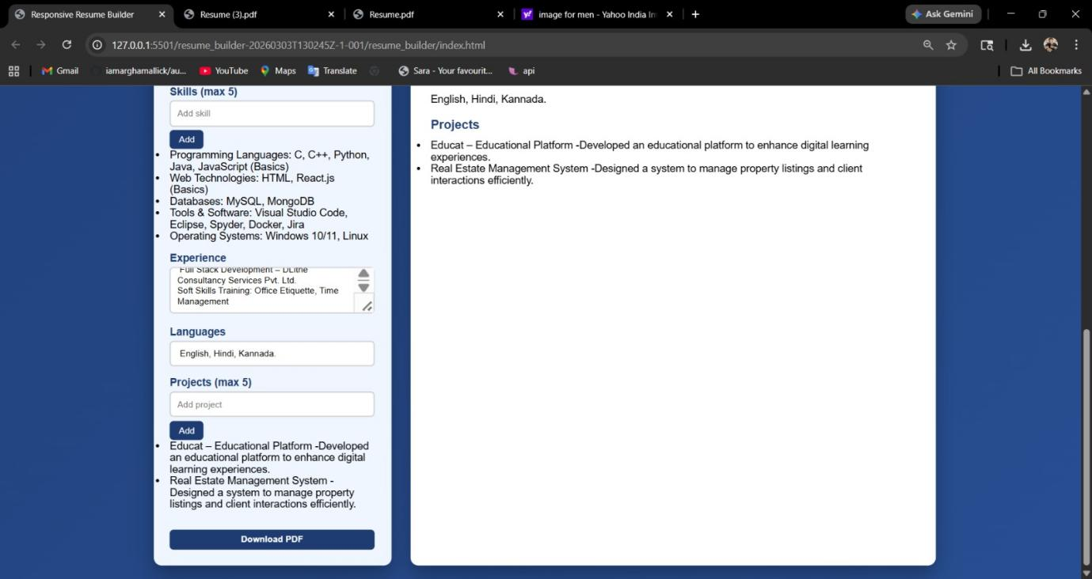

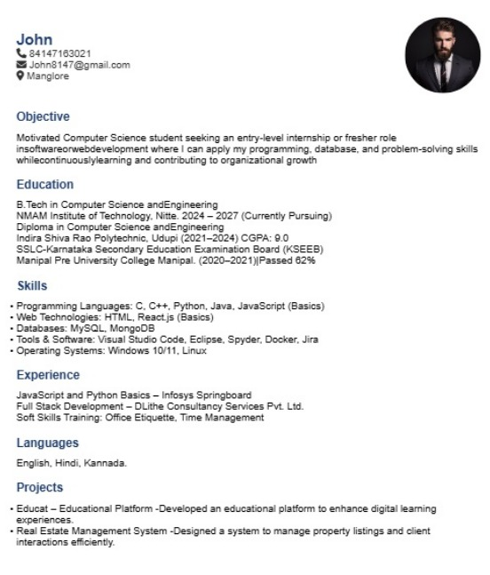

CONCLUSION
· The Responsive Resume Builder successfully provides a simple and efficient way to create professional resumes.
· The application offers real-time preview functionality, improving user experience and ease of use.
· It allows users to input, edit, and organize their details in a structured format.
· The integration of PDF generation makes the application practical for real-world job applications.
· The use of HTML, CSS, and JavaScript demonstrates effective implementation of front-end development concepts.
· The project helps in understanding DOM manipulation, event handling, and dynamic content updates.
· Overall, the system achieves its objective of simplifying the resume creation process in a user-friendly manner.
REFERENCES
· W3Schools, HTML, CSS and JavaScript Tutorials, Available at: https://www.w3schools.com/
· MDN Web Docs, JavaScript DOM Manipulation, Available at: https://developer.mozilla.org/
· html2pdf.js Documentation, HTML to PDF Conversion Library, Available at: https://ekoopmans.github.io/html2pdf.js/
· GeeksforGeeks, Web Development Concepts, Available at: https://www.geeksforgeeks.org/
· Stack Overflow, Programming Help and Discussions, Available at: https://stackoverflow.com/
· Font Awesome, Icons and UI Resources, Available at: https://fontawesome.com/
· ChatGPT, AI-based assistance for coding and project development, OpenAI, Available at: https://chat.openai.com/

