Customer Data Analysis
Shopping Mall Transactions – Istanbul (2021–2023)
PRDA – 04: Customer Data Analysis
Insights Narrative & Analysis Report
Prepared by: Samarth Kawade

Table of Contents
Table of Contents
1. Introduction
1.1 Dataset Summary
1.2 Dashboard Overview
2. Gender-Wise Analysis
2.1 Shopping Distribution by Gender
2.2 Product Quantity Sold by Gender
2.3 Revenue Generated by Gender
2.4 Category Distribution Relative to Gender
3. Age Group Analysis
3.1 Shopping Distribution by Age Group
3.2 Product Quantity Sold by Age Group
3.3 Revenue Generated by Age Group
3.4 Category Distribution Relative to Age Group
4. Category Analysis
4.1 Revenue and Quantity by Category
4.2 Category Distribution Relative to Other Columns
5. Payment Method Analysis
5.1 Distribution of Payment Methods
5.2 Relationship Between Payment Method and Other Columns
6. Key Insights
7. Recommendations / Suggestions to the Company
7.1 Target the Female 31–45 Segment
7.2 Promote Digital Payments
7.3 Expand Technology Inventory
7.4 Engage Senior Customers (60+)
7.5 Focus Investment on Mall of Istanbul
7.6 Boost Food & Beverage Sales
8. Conclusion

1. Introduction
This report presents a detailed analysis of customer shopping behavior across 10 shopping malls in Istanbul between 2021 and 2023. The dataset captures invoice-level transaction details including customer demographics (age, gender), purchase category, quantity, price, payment method, invoice date, and shopping mall location.
The objective of this analysis is to understand shopping patterns across gender and age segments, evaluate category-wise performance, study payment method preferences, and translate these findings into actionable business recommendations. The analysis was performed and visualized using Microsoft Power BI, with the dashboard organized into six interactive pages: Overview, Gender, Age, Category, Payments, and Insights.

1.1 Dataset Summary
Metric | Value
Total Transactions | 99,000 (99K)
Total Quantity Sold | 299,000 units (299K)
Total Revenue | ₺252 Million
Average Order Value | ₺2,530
Shopping Malls Covered | 10
Time Period | 2021 – 2023 (2023 data: Jan–Mar only)

1.2 Dashboard Overview
The Overview page of the Power BI dashboard serves as the landing view, summarizing total transactions, quantity, revenue, and average order value, alongside revenue breakdowns by category and shopping mall, and transaction trends by year and month.
Clothing leads as the top revenue category (45.33% share), Mall of Istanbul and Kanyon are the highest-revenue malls (₺51M each), and transaction volume was highest in 2022, with January seeing the strongest monthly activity before tapering through the rest of the year.
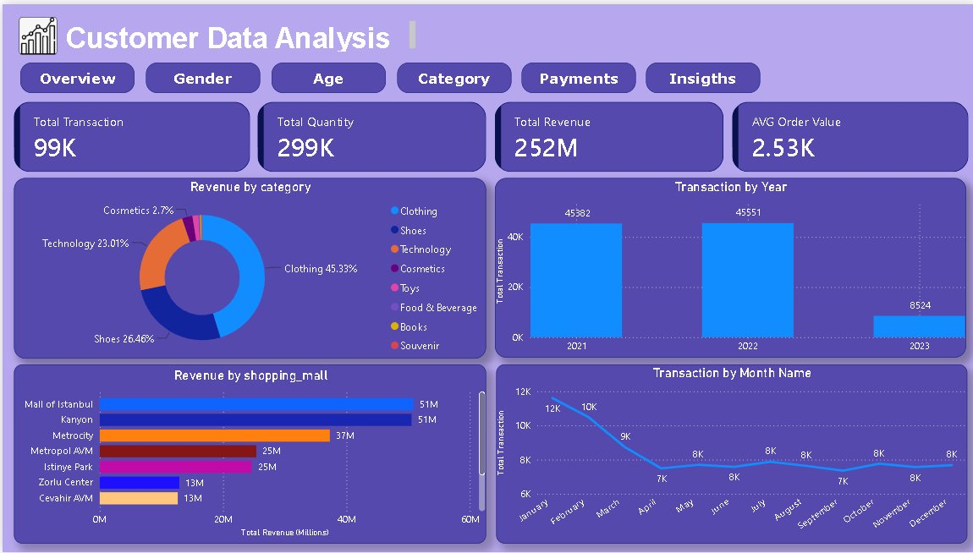
Figure 1: Power BI Dashboard – Overview

2. Gender-Wise Analysis

2.1 Shopping Distribution by Gender
Female customers account for 59.81% of all transactions (59K) compared to 40.19% for male customers (40K). This indicates that women are the dominant shopper segment across the malls studied, contributing nearly 1.5 times the transaction volume of men.

2.2 Product Quantity Sold by Gender
Female customers purchased a significantly higher quantity of products — 179K units — compared to 120K units purchased by male customers. This confirms that not only do more women shop, but each shopping session also tends to involve a comparable or higher item count, reinforcing female customers as the primary volume driver.

2.3 Revenue Generated by Gender
Female customers generated ₺150 million in revenue versus ₺101 million from male customers. Females contribute approximately 60% of total revenue, consistent with their higher share of transactions and quantity.

2.4 Category Distribution Relative to Gender
Clothing is the top category for both genders, with females generating ₺68M and males ₺46M. The pattern holds across all categories — Shoes (₺39M female vs ₺27M male) and Technology (₺35M female vs ₺23M male) — with females leading in every category. Cosmetics, Toys, Food & Beverage, Books, and Souvenirs contribute marginally (under ₺4M each) for both genders.
Payment method preference is also consistent by gender: Cash is the leading method for both females (27K transactions) and males (18K), followed by Credit Card (21K female, 14K male) and Debit Card (12K female, 8K male).
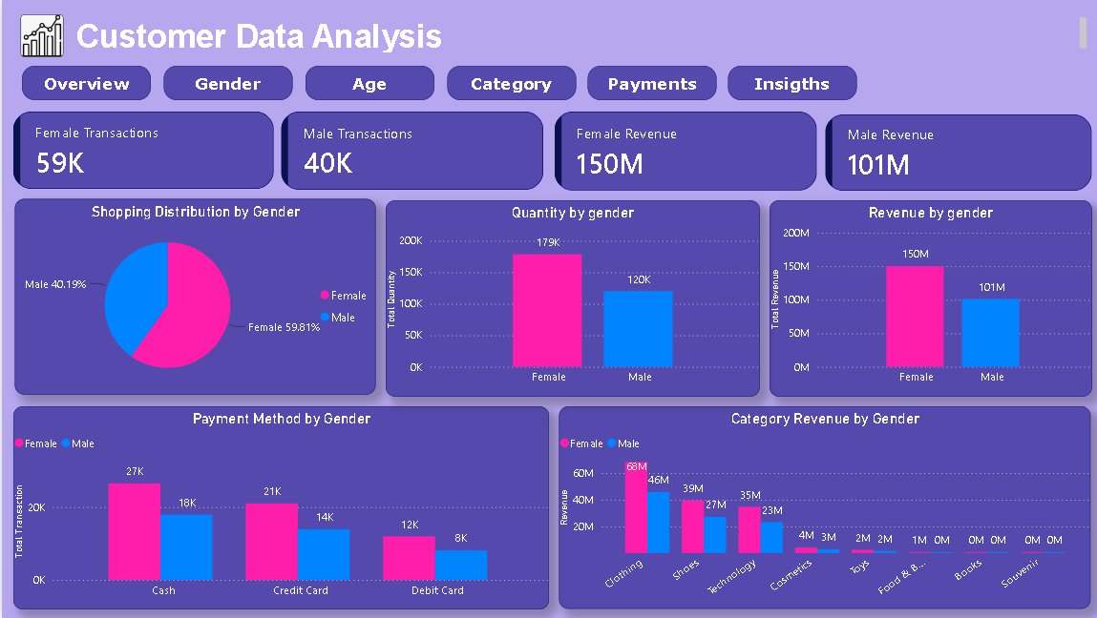
Figure 2: Power BI Dashboard – Gender Analysis

3. Age Group Analysis

3.1 Shopping Distribution by Age Group
Transactions are fairly distributed across age groups, with the 31–45 segment leading at 29K transactions (28.99%), closely followed by 46–60 at 28K (28.59%) and 18–30 at 25K (25.16%). The 60+ segment trails significantly at 17K transactions (17.26%), making it the least active age group.

3.2 Product Quantity Sold by Age Group
The 31–45 age group purchased the highest quantity at 87K units, followed by 46–60 (85K) and 18–30 (75K). The 60+ segment purchased only 52K units — the lowest among all groups, reinforcing this segment's lower overall engagement.

3.3 Revenue Generated by Age Group
Revenue follows a similar pattern: 31–45 generates the highest revenue at ₺73M, closely trailed by 46–60 at ₺72M and 18–30 at ₺63M. The 60+ group generates the least at ₺44M, confirming it as the most under-monetized segment despite representing a meaningful share of the customer base.

3.4 Category Distribution Relative to Age Group
Clothing dominates revenue across every age bracket: ₺63.05M (18–30), ₺73.13M (31–45), ₺71.80M (46–60), and ₺43.52M (60+). Cash remains the leading payment method in every age group, led by 18–30 and 31–45, while the 60+ group shows the lowest transaction counts across all three payment types — Cash (7.8K), Credit Card (6.0K), and Debit Card (3.4K) — consistent with their overall lower shopping activity.
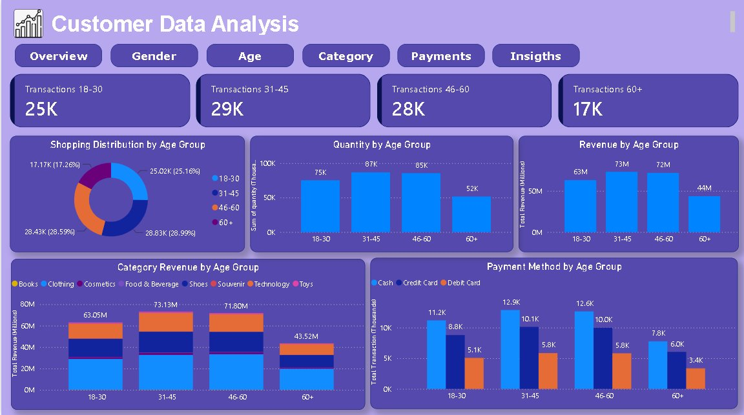
Figure 3: Power BI Dashboard – Age Group Analysis

4. Category Analysis

4.1 Revenue and Quantity by Category
Clothing is by far the top-performing category, generating ₺114M in revenue (45.33% of total) and 104K units sold — more than double any other category. Shoes follows with ₺67M revenue, then Technology at ₺58M. Despite Technology having a comparatively low unit count (30K), its revenue share remains high, indicating a significantly higher average price per unit than other categories.
Cosmetics, Toys, and Food & Beverage form a long tail, together contributing only about ₺12M combined, while Books and Souvenirs are negligible contributors (around ₺1M–₺2M each).

4.2 Category Distribution Relative to Other Columns
Clothing's dominance holds consistently across gender (62K units to females vs 42K to males) and across all age groups, where it contributes between ₺19.69M and ₺33.13M depending on the segment. This consistency suggests Clothing is a universal demand driver rather than a niche preference of any single demographic.
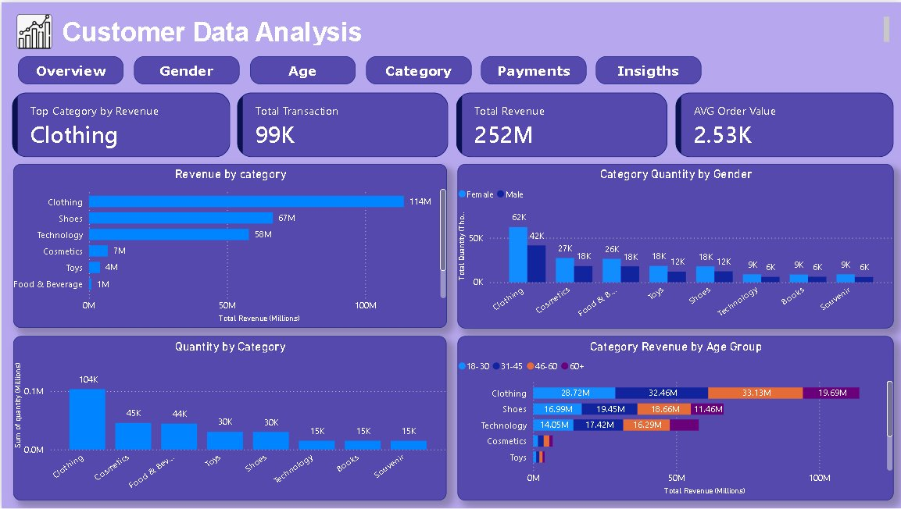
Figure 4: Power BI Dashboard – Category Analysis

5. Payment Method Analysis

5.1 Distribution of Payment Methods
Cash is the most commonly used payment method, accounting for 44.69% of transactions (44K), followed by Credit Card at 35.12% (35K) and Debit Card at 20.19% (20K). In revenue terms, Cash again leads with ₺113M, followed by Credit Card (₺88M) and Debit Card (₺51M).

5.2 Relationship Between Payment Method and Other Columns
The payment method shows a consistent relationship with both age and gender: Cash is the preferred method across every age bracket and both genders, with its share decreasing only slightly among older customers. The 18–30 and 31–45 age groups show the highest payment activity across all three methods, while 60+ customers show markedly lower usage of all payment types — consistent with their lower overall transaction volume rather than a distinct payment preference.
This suggests payment method choice is driven more by general transaction volume per segment than by a structural preference unique to any age or gender group, though the heavier reliance on cash overall (vs. card-based payments) is notable from a digital-payment-adoption perspective.
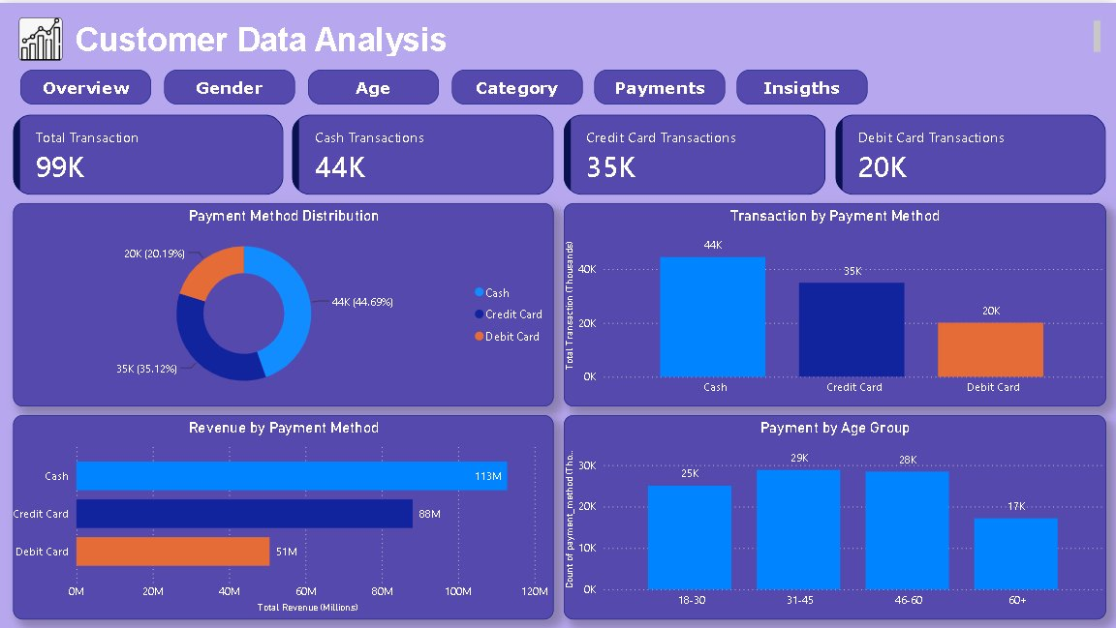
Figure 5: Power BI Dashboard – Payment Method Analysis

6. Key Insights
- Female customers dominate across every dimension — accounting for 60% of transactions (59K), 60% of revenue (₺150M), and 60% of quantity sold (179K units). This dominance is not limited to a single category; females outspend males in Clothing (₺68M vs ₺46M), Shoes (₺39M vs ₺27M), and even Technology (₺35M vs ₺23M), making gender the single most consistent predictor of shopping behaviour across the dataset.
- Clothing is the top revenue category at ₺114M (45% of total), and its dominance holds uniformly across gender and age. Female customers contribute ₺68M of that total, while the 31–45 age group alone accounts for ₺33M. This cross-segment consistency indicates that Clothing is a universal demand driver — not a niche preference — making it the single highest-leverage category for promotional investment.
- The 31–45 age group leads on every metric — 29K transactions, 87K units, and ₺73M in revenue — and is closely followed by 46–60 (28K transactions, ₺72M). Together, these two mid-life segments account for over 57% of total transactions and nearly 58% of total revenue, indicating that the middle-age demographic is the commercial backbone of these malls. The 18–30 segment, despite lower absolute spend, may represent the highest future-value cohort if engagement is built early.
- Cash accounts for 44.69% of transactions and ₺113M in revenue — the highest of any payment method. Critically, this preference is not driven by any specific age or gender group: Cash leads across every demographic segment, from 18–30 females to 60+ males. This broad-base preference for cash suggests a structural behavioural pattern, likely linked to trust or habit, rather than a segment-specific preference. It also signals a significant opportunity: shifting even a portion of this volume to card-based payments would improve transaction visibility and enable data-driven loyalty tracking.
- Technology generates ₺58M from only 30K units — an implied average unit price nearly 4x that of Clothing — making it the highest-value category per transaction. This high price-per-unit profile, combined with its relatively low transaction frequency, suggests Technology purchases are considered, planned decisions rather than impulse buys. Both male and female customers contribute to this category (₺23M and ₺35M respectively), indicating broad appeal across genders.
- Mall of Istanbul and Kanyon are the two highest-revenue malls, each generating approximately ₺51M. Mall of Istanbul’s lead in footfall makes it the most commercially critical location and an ideal test site for any new promotional or product strategies before rolling them out across other malls.
- The 60+ segment is the most under-monetised group, contributing only 17K transactions (17%) and ₺44M in revenue — roughly 40% less than the 31–45 group. Their low payment activity across all three methods (Cash: 7.8K, Credit Card: 6.0K, Debit Card: 3.4K) confirms that reduced engagement, not just lower spend per visit, is the core issue. This makes the 60+ segment the single largest addressable gap in the current customer base.
- 2022 was the peak transaction year; 2023 data spans only January to March and should not be compared against full-year figures. January consistently records the highest monthly transaction volume, suggesting a seasonal or post-holiday shopping pattern worth capitalising on through targeted January promotions.

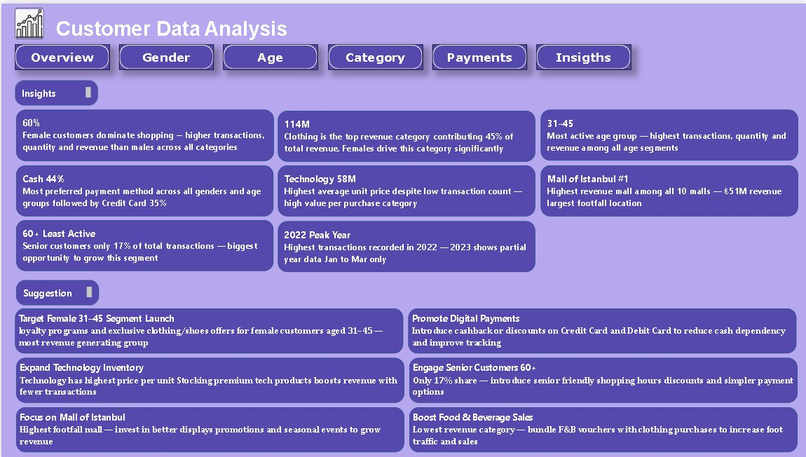
Figure 6: Power BI Dashboard – Insights Summary

7. Recommendations / Suggestions to the Company

7.1 Target the Female 31–45 Segment
Female customers aged 31–45 are the highest-value segment, contributing the most transactions, units purchased, and revenue across the entire dataset. To deepen engagement with this profile, the company should: (1) launch a tiered loyalty card programme that rewards repeat purchases in Clothing and Shoes — the two categories where this segment spends most; (2) run targeted seasonal promotions (end-of-season sales, new-collection previews) specifically during January, when transaction volumes peak; (3) introduce exclusive female-member events at Mall of Istanbul, the highest-footfall location, to build brand affinity. Retaining the spend of this segment should be treated as the single highest commercial priority.

7.2 Promote Digital Payments
Cash accounts for nearly 45% of all transactions, and this pattern holds universally across genders and age groups — indicating a habitual rather than demographic-specific preference. To shift behaviour toward card payments, the company should: (1) introduce a 5–8% cashback or discount incentive on Credit and Debit Card transactions for Clothing and Technology purchases, the two highest-revenue categories; (2) partner with major banks to offer co-branded mall credit cards with exclusive rewards at participating stores; (3) deploy contactless payment terminals at all high-traffic checkout points, particularly at Mall of Istanbul and Kanyon, where transaction volumes are highest. Increasing card payment adoption to 65% would substantially improve transaction traceability and enable data-driven customer profiling.

7.3 Expand Technology Inventory
Technology generates ₺58M from only 30K units — an average revenue per unit approximately 4x that of Clothing — making it the most capital-efficient category in the dataset. To maximise this advantage, the company should: (1) expand premium technology product lines (smartphones, laptops, wearables) at all 10 malls, prioritising the locations with the highest female footfall since females already contribute ₺35M of Technology revenue; (2) create dedicated experiential zones where customers can trial products before purchase, as higher-value items benefit from hands-on evaluation; (3) offer instalment payment plans linked to Credit Card partnerships to reduce the perceived price barrier for premium purchases. Even a 10% increase in Technology transaction volume would add an estimated ₺5.8M in incremental revenue.

7.4 Engage Senior Customers (60+)
The 60+ segment contributes only 17K transactions and ₺44M in revenue — a gap of roughly ₺29M compared to the top-performing 31–45 group. Their low activity across all three payment methods confirms that infrequent visits, rather than low spend per visit, is the primary driver. To increase engagement with this segment, the company should: (1) introduce dedicated “Senior Shopping Hours” (e.g., weekday mornings) with additional in-store assistance, noise reduction, and priority checkout lanes; (2) offer a fixed senior discount card (10–15% off Clothing and Shoes) to make regular visits financially rewarding; (3) run health-and-wellness themed events within malls to attract seniors who may not visit for shopping alone; (4) simplify payment interfaces at checkout counters to reduce friction for customers less comfortable with digital payments. A 20% improvement in 60+ transaction volume would generate approximately ₺8.8M in additional annual revenue.

7.5 Focus Investment on Mall of Istanbul
Mall of Istanbul leads all 10 locations with approximately ₺51M in revenue, making it the most commercially critical site in the network. To maximise its advantage and test scalable strategies, the company should: (1) establish it as the primary launch venue for new product categories, seasonal campaigns, and loyalty programme pilots before replicating them across other malls; (2) invest in premium in-store visual merchandising and digital signage in its Clothing and Technology sections, which are the two highest-revenue categories across the network; (3) analyse foot-traffic patterns at Mall of Istanbul to identify underperforming time slots and deploy targeted promotions (e.g., happy-hour discounts on weekday afternoons) to smooth revenue across the week. Learnings from this flagship location can then be systematically applied to Kanyon and other high-footfall malls to scale the impact.

7.6 Boost Food & Beverage Sales
Food & Beverage currently generates less than ₺4M in revenue — one of the lowest-performing categories in the dataset — despite its potential to increase overall dwell time and drive cross-category purchases. To unlock its growth potential, the company should: (1) bundle F&B vouchers (e.g., a free coffee or 10% off at a food court outlet) with every Clothing purchase above ₺500, creating a direct cross-category incentive; (2) introduce a meal-deal offer targeting the 31–45 family segment during weekends, when family shopping trips are more common; (3) redesign food court placement within malls to increase visibility from main shopping corridors, as poor location is often a key barrier to F&B footfall. Even a modest 30% increase in F&B revenue would add approximately ₺1.2M to overall mall performance and meaningfully extend average customer visit duration.

8. Conclusion
This analysis of 99,000 transactions across 10 Istanbul shopping malls reveals a customer base with clear commercial patterns and identifiable growth opportunities. Female customers aged 31–45 are the primary revenue engine — driving the majority of spend in Clothing, the top-performing category — and should be the anchor for all loyalty and promotional strategy. Cash dominates as a payment method across every demographic segment, presenting a significant opportunity to shift spend toward card-based channels through targeted incentives, which would also unlock richer customer data for future segmentation. Technology, despite its low transaction volume, delivers the highest revenue per unit and merits targeted inventory expansion. The 60+ segment remains materially under-monetised relative to its population share, and represents the most addressable growth gap through improved accessibility and targeted discounting. Mall of Istanbul, as the network’s flagship location, should serve as the strategic testing ground for all new initiatives. Translating these findings into the six specific actions outlined in Section 7 can help the company compound growth in its strongest segments while systematically closing the gaps in underperforming areas.

