**TASK 2:**

**SAMARTH GUPTA 17BCE2165**

[**Corpus of Contemporary American English**](https://www.english-corpora.org/coca/x1.asp)**:**

**1. SEARCH BY LIST:**

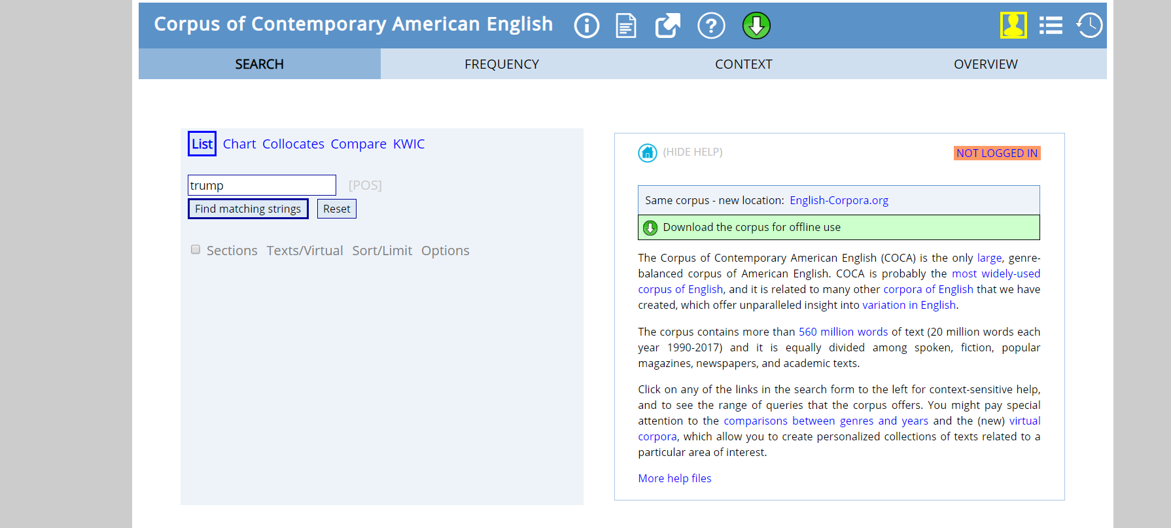

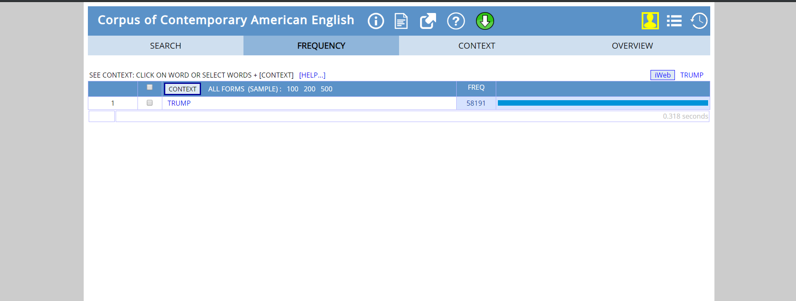

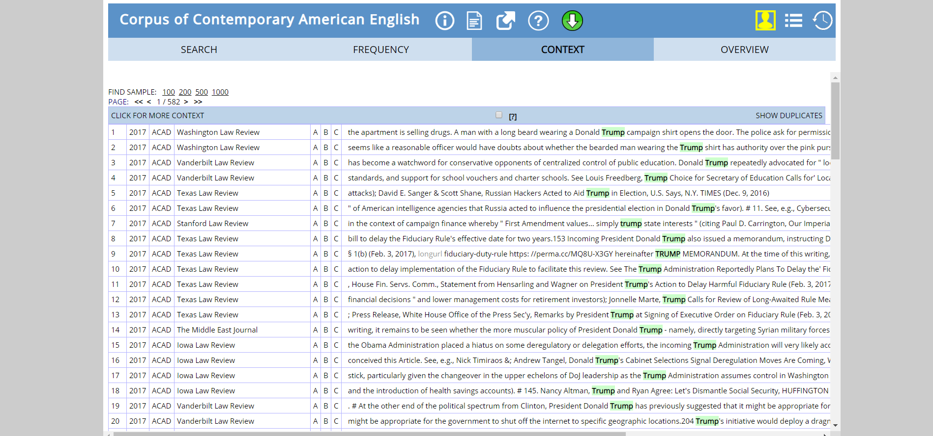

**2. SEARCH BY CHART:**

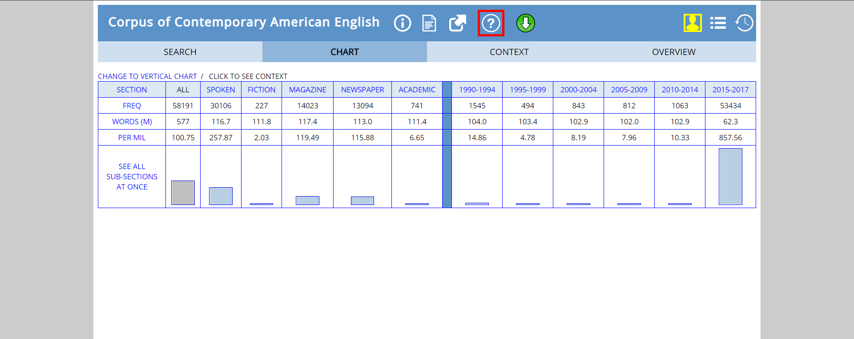

**Inference from stats:**

As we can see **“trump”** word has the maximum frequency in the year 2015-2017, as Donald Trump had been in race for US presidential election. His approval rating reached its highest point in months to close out 2017.

The stats basically reflect increase in trump’s popularity among people of USA and the world with time.