Demo Guide: Persona Registration, Login, & Functioning Flows
This guide outlines the step-by-step registration, login, and business functioning flow for every system persona. Use this to demonstrate user onboarding, secure authentication, and role-based action isolation.

📡 Core API Base URL
When running the server (npm run watch), the API endpoint is: http://localhost:4004/api/v1

1. PR Indenter (Purchase Requisition Creator)
- Business Role: PR
- Purpose: Creates purchase requisitions for materials. Restricted from viewing financials or vendor statements.

Step A: Registration
- Endpoint: /register (POST)
- Headers: Content-Type: application/json
- Request Body:
{
"username": "demo_pr_user",
"email": "pr.demo@company.com",
"password": "admin",
"fullName": "PR Indenter (Demo)",
"businessRole": "PR"
}
- Expected Response: "Registered"

Step B: Login
- Endpoint: /login (POST)
- Headers: Content-Type: application/json
- Request Body:
{
"username": "demo_pr_user",
"password": "admin"
}
- Expected Response:
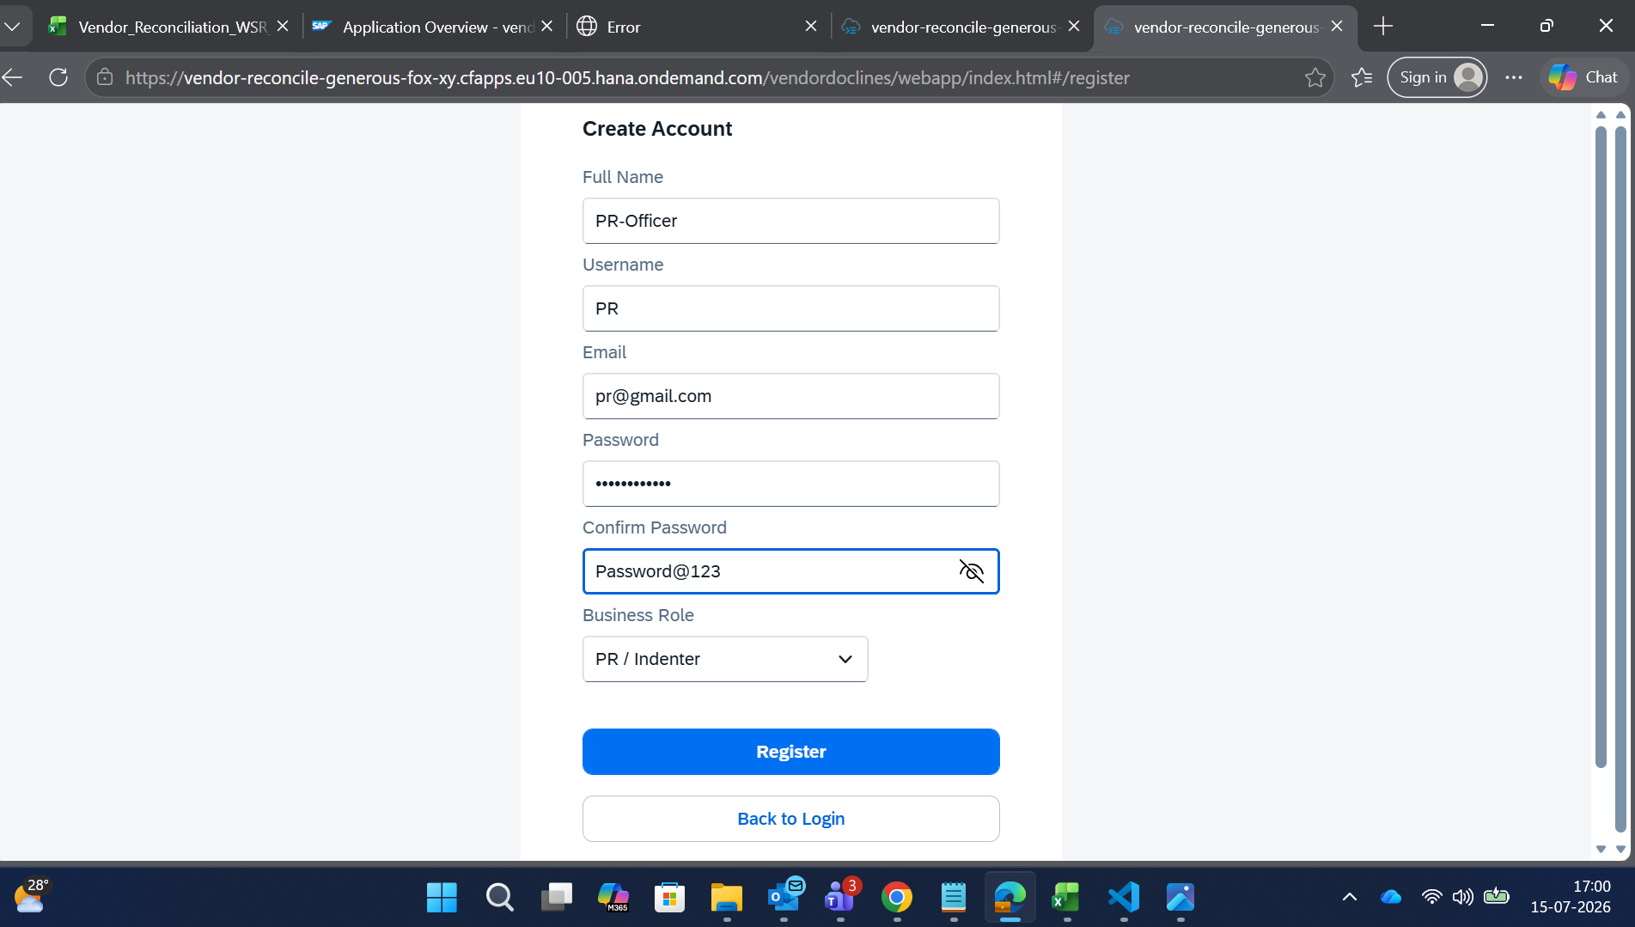
Screenshot: Screenshot 2026-07-15 170051.png
{
"ID": "894e7ed9-7105-47a0-af14-a7044c359b94",
"username": "demo_pr_user",
"email": "pr.demo@company.com",
"fullName": "PR Indenter (Demo)",
"businessRole": "PR",
"vendorCode": null
}

Step C: Functioning (Actions)
Once logged in, the PR Indenter can submit a new purchase requisition:
- Endpoint: /createPR (POST)
- Headers:
Content-Type: application/json
x-user-role: PR
- Request Body:
{
"material": "High Tensile Bolts 12mm",
"qty": 200,
"amount": 40000
}
- Expected Response:
{
"value": "{\"prId\":\"<Generated_PR_UUID>\",\"prNumber\":\"PR-0000001\"}"
}

2. PO Officer (Purchase Order Approver & Generator)
- Business Role: PO
- Purpose: Reviews pending requisitions, approves them, maps them to vendors, and generates formal POs.

Step A: Registration
- Endpoint: /register (POST)
- Headers: Content-Type: application/json
- Request Body:
{
"username": "demo_po_user",
"email": "po.demo@company.com",
"password": "admin",
"fullName": "PO Officer (Demo)",
"businessRole": "PO"
}
- Expected Response: "Registered"
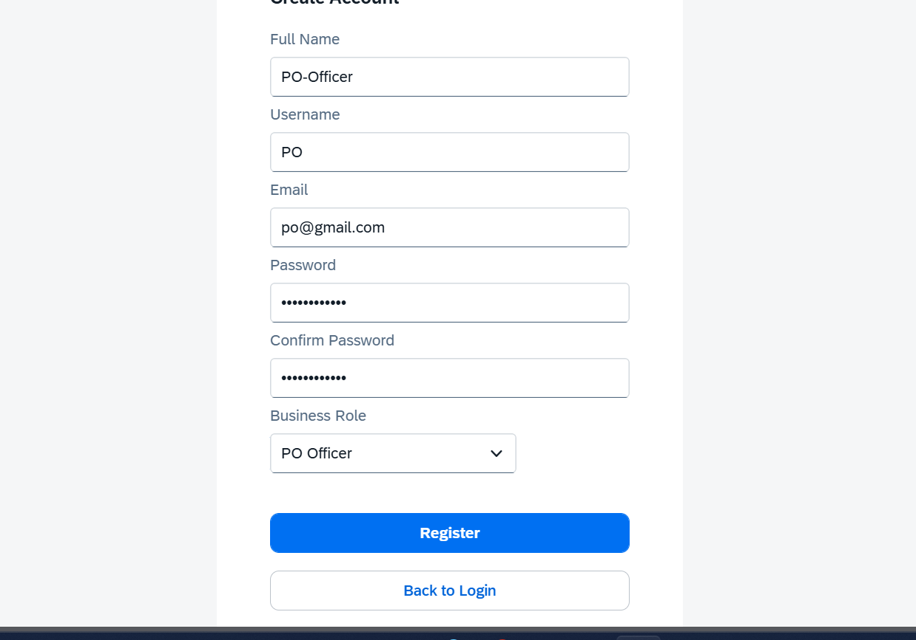
Screenshot: Screenshot 2026-07-15 170127.png

Step B: Login
- Endpoint: /login (POST)
- Headers: Content-Type: application/json
- Request Body:
{
"username": "demo_po_user",
"password": "admin"
}
- Expected Response:
{
"ID": "23d650b9-2df8-4aa7-ae0c-5ecb9132aa50",
"username": "demo_po_user",
"email": "po.demo@company.com",
"fullName": "PO Officer (Demo)",
"businessRole": "PO",
"vendorCode": null
}

Step C: Functioning (Actions)
The PO Officer approves the PR, creates the PO, and sends it to the Vendor:
- Approve PR:
  - Endpoint: /approvePR (POST)
  - Headers: x-user-role: PO
  - Request Body:
{
"prId": "<PR_UUID_FROM_STEP_1>"
}
- Convert to PO:
  - Endpoint: /createPO (POST)
  - Headers: x-user-role: PO
  - Request Body:
{
"prId": "<PR_UUID_FROM_STEP_1>",
"purchaseOrder": "PO-45000099",
"supplier": "V-1001"
}
- Dispatch PO to Vendor:
  - Endpoint: /sendPOToVendor (POST)
  - Headers: x-user-role: PO
  - Request Body:
{
"poId": "<PO_UUID_FROM_SUBSTEP_2>"
}

3. Vendor (Supplier Portal Account)
- Business Role: VENDOR (or AR)
- Purpose: External role. Vendor logs in to see their specific POs, mark dispatch status, upload bills, and view matched lines.
- Row-Level Security: Isolated strictly to their own vendorCode.

Step A: Registration
- Endpoint: /register (POST)
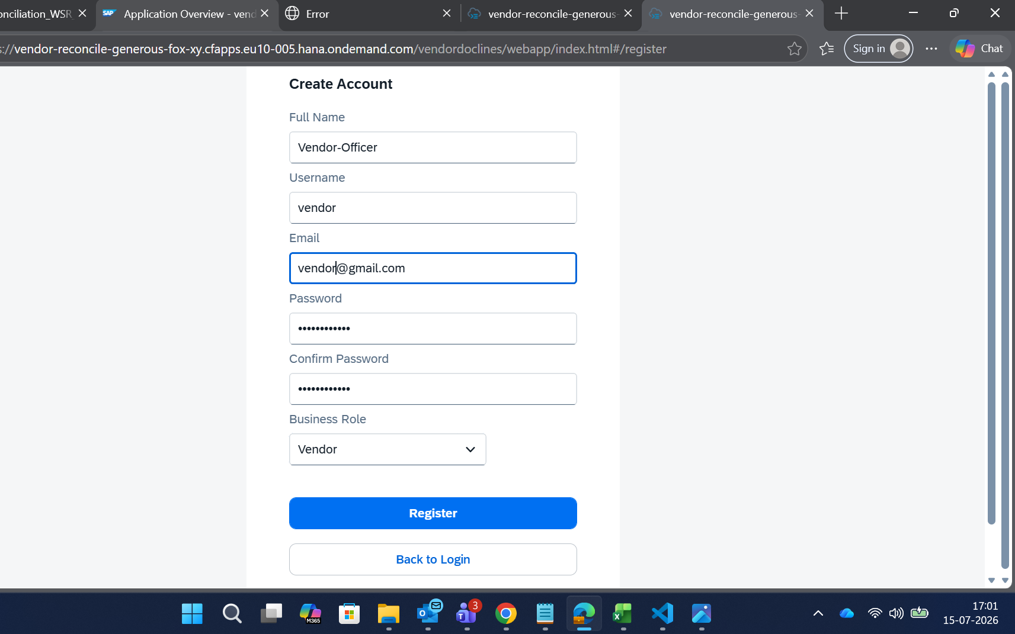
Screenshot: Screenshot 2026-07-15 170202.png
- Headers: Content-Type: application/json
- Request Body:
{
"username": "V-1001",
"email": "portal.v1001@vendor.com",
"password": "admin",
"fullName": "Sigma Supplier Portal",
"businessRole": "VENDOR",
"vendorCode": "V-1001"
}

Step B: Login
- Endpoint: /login (POST)
- Headers: Content-Type: application/json
- Request Body:
{
"username": "V-1001",
"password": "admin"
}

Step C: Functioning (Actions)
- Dispatch PO Goods:
  - Endpoint: /dispatchGoods (POST)
  - Headers:
x-user-role: Vendor
x-user-vendor: V-1001
  - Request Body:
{
"poId": "<PO_UUID_FROM_STEP_2>"
}
- Submit Invoice Document:
  - Endpoint: /VendorDocLines (POST)
  - Headers:
x-user-role: Vendor
x-user-vendor: V-1001
  - Request Body:
{
"vendorInvoiceNo": "INV-SIGMA-99",
"invoiceDate": "2026-07-15",
"invoiceAmount": 40000,
"currency": "INR",
"poReference": "PO-45000099",
"sourceVendorCode": "V-1001"
}

4. Goods Receipt Specialist (Warehouse / MIGO Clerk)
- Business Role: GR
- Purpose: Posts Goods Receipts and resolves physical quantity discrepancies.
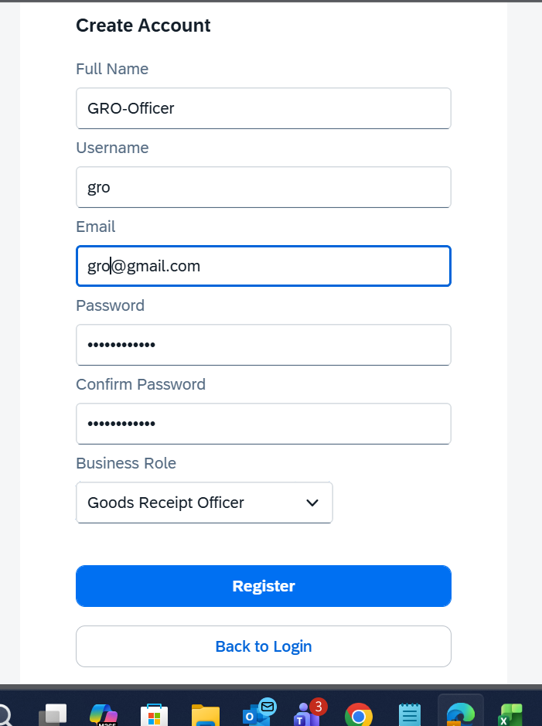
Screenshot: Screenshot 2026-07-15 170252.png

Step A: Registration
- Endpoint: /register (POST)
- Headers: Content-Type: application/json
- Request Body:
{
"username": "demo_gr_user",
"email": "gr.demo@company.com",
"password": "admin",
"fullName": "Warehouse GR Agent",
"businessRole": "GR"
}

Step B: Login
- Endpoint: /login (POST)
- Headers: Content-Type: application/json
- Request Body:
{
"username": "demo_gr_user",
"password": "admin"
}

Step C: Functioning (Actions)
- Post GR (MIGO):
  - Endpoint: /postGR (POST)
  - Headers: x-user-role: GR
  - Request Body:
{
"poId": "<PO_UUID_FROM_STEP_2>",
"grQty": 200,
"plant": "1000"
}
- Resolve Quantity Discrepancy Exception:
  - Endpoint: /resolveException (POST)
  - Headers: x-user-role: GR
  - Request Body:
{
"exceptionId": "<Exception_UUID>",
"note": "Quantities verified physically; corrections posted in ERP."
}

5. Finance Executive (Invoice Auditor / MIRO Specialist)
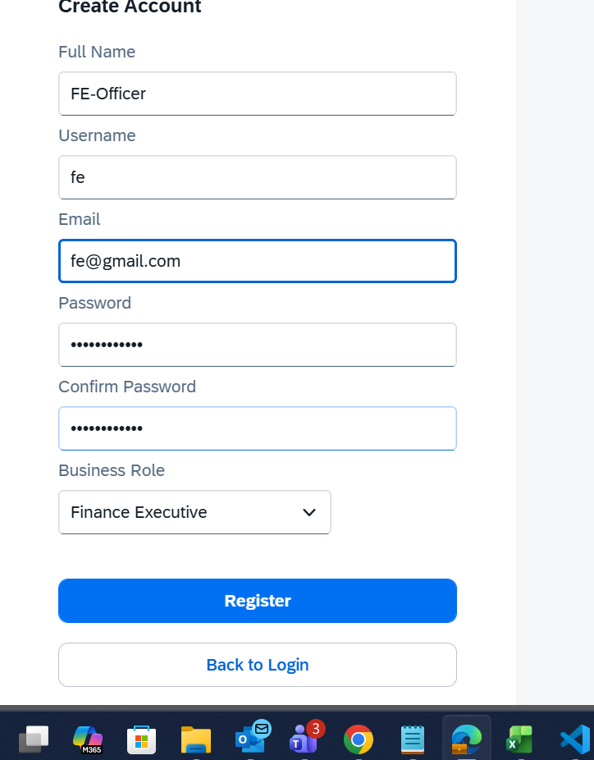
Screenshot: Screenshot 2026-07-15 170325.png
- Business Role: FINANCE
- Purpose: Performs invoice clearing simulations (MIRO), initiates matching algorithms, and clears/approves lines for payment.

Step A: Registration
- Endpoint: /register (POST)
- Headers: Content-Type: application/json
- Request Body:
{
"username": "demo_finance_user",
"email": "fin.demo@company.com",
"password": "admin",
"fullName": "Finance Auditor",
"businessRole": "FINANCE"
}

Step B: Login
- Endpoint: /login (POST)
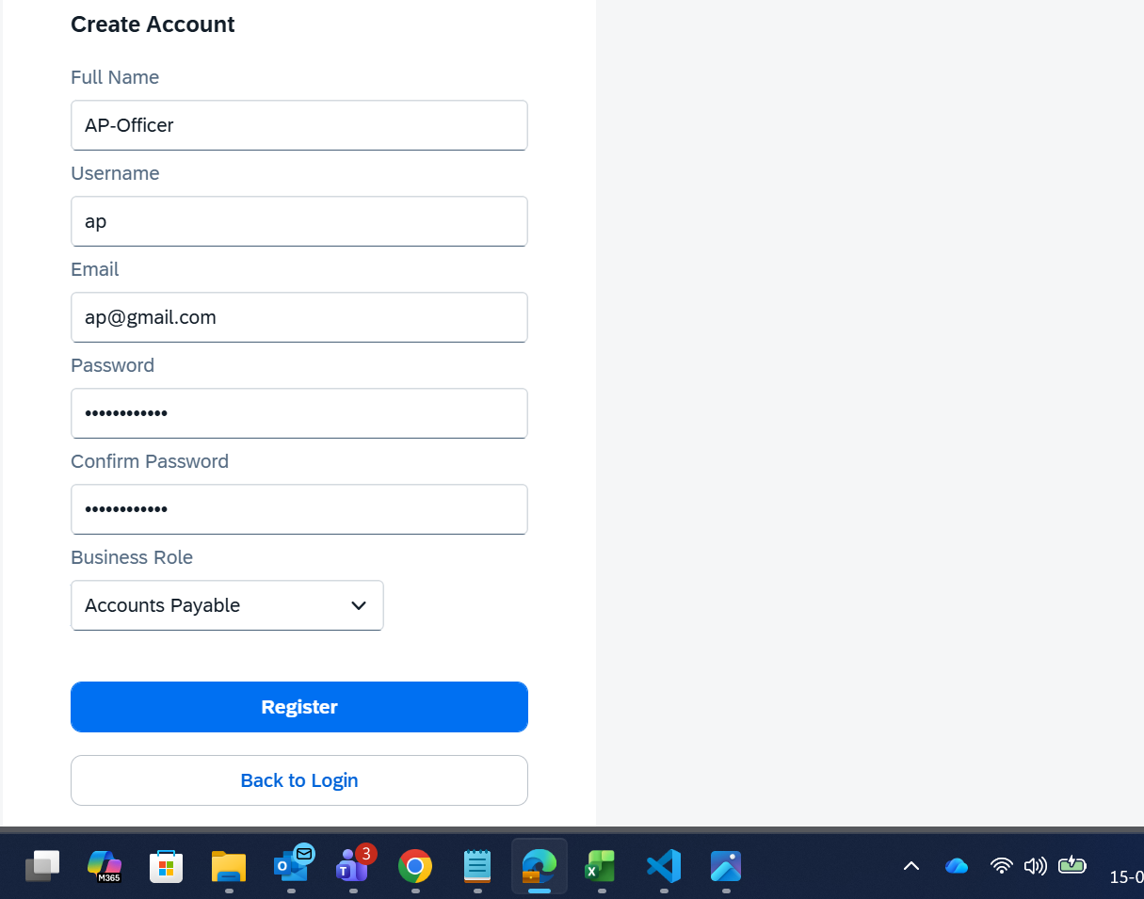
Screenshot: Screenshot 2026-07-15 170409.png
- Headers: Content-Type: application/json
- Request Body:
{
"username": "demo_finance_user",
"password": "admin"
}

Step C: Functioning (Actions)
- Simulate MIRO Entry (Post to Ledger):
  - Endpoint: /VendorLedgerItems (POST)
  - Headers: x-user-role: FINANCE
  - Request Body:
{
"supplier": "V-1001",
"companyCode": "1000",
"accountingDocument": "INV-SIGMA-99",
"documentDate": "2026-07-15",
"postingDate": "2026-07-15",
"amountInTransCrcy": 40000,
"transactionCurrency": "INR",
"isCleared": false
}
- Execute Reconciliation Matching:
  - Endpoint: /runMatching (POST)
  - Headers: x-user-role: FINANCE
  - Request Body: {}
- Approve Cleared Invoice for AP Payment:
  - Endpoint: /approveForPayment (POST)
  - Headers: x-user-role: FINANCE
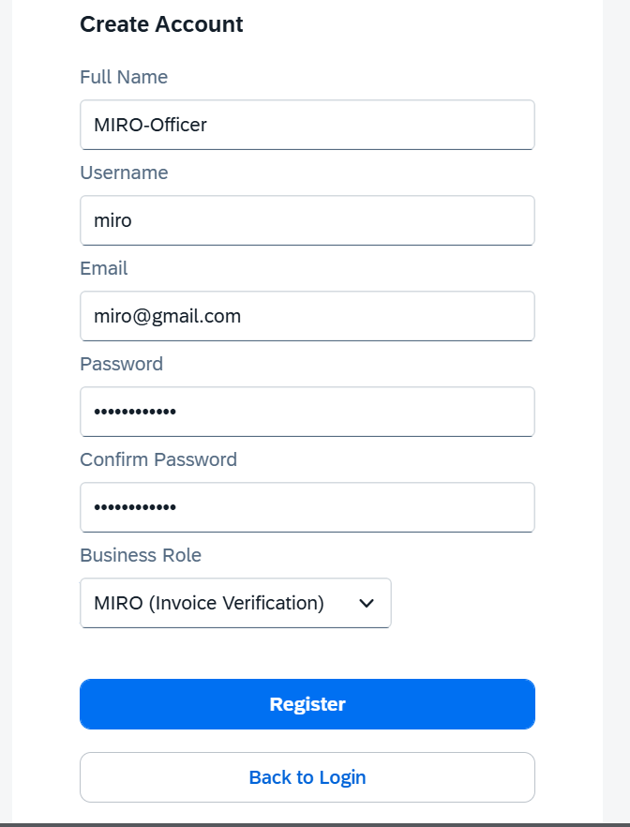
Screenshot: Screenshot 2026-07-15 170448.png
  - Request Body:
{
"docLineId": "<INVOICE_DOCLINE_UUID>"
}

6. Accounts Payable Manager (Admin / Controller)
- Business Role: AP
- Purpose: General controller. Oversees uploads, raises disputes on pending invoices, prepares payment proposals, and triggers final UTR-clearing payments.

Step A: Registration
- Endpoint: /register (POST)
- Headers: Content-Type: application/json
- Request Body:
{
"username": "demo_ap_user",
"email": "ap.demo@company.com",
"password": "admin",
"fullName": "Accounts Payable Controller",
"businessRole": "AP"
}

Step B: Login
- Endpoint: /login (POST)
- Headers: Content-Type: application/json
- Request Body:
{
"username": "demo_ap_user",
"password": "admin"
}

Step C: Functioning (Actions)
- Raise Exception Dispute:
  - Endpoint: /raiseDispute (POST)
  - Headers: x-user-role: AP
  - Request Body:
{
"exceptionId": "<Exception_UUID>",
"comment": "Audit discrepancy. Dispute initiated."
}
- Create Payment Proposal:
  - Endpoint: /createPaymentProposal (POST)
  - Headers: x-user-role: AP
  - Request Body:
{
"docLineIds": "[\"<INVOICE_DOCLINE_UUID>\"]"
}
- Execute Payment Run:
  - Endpoint: /executePaymentRun (POST)
  - Headers: x-user-role: AP
  - Request Body:
{
"paymentRef": "UTR-F110-XYZ",
"docLineIds": "[\"<INVOICE_DOCLINE_UUID>\"]"
}

