Assignment 2

Multiuser chat system

In my implementation of multiuser chat system server is directing message to all user when any single user is typing message and when user or client tag any other person then client-side program filter that message and only tagged user able to see message in the chat.

In client-side program thread is created for every user logged in for every user and this thread receive message from message.

Here server-side is program is just redirecting all message from the single user which has typed the message to all user which have logged in to program.

You can press Ctrl+C to stop server.

To compile and run program

1. Go to program folder which contain project (by cd)
2. Type make to compile client-side and server-side c program and server will also be open
3. Open another terminal, type ./client -pthread (this will open client-side program)

Input rule for user

1. If user or client type message with :@*xyz* (xyz is the name of the other user which is logged in the program ) then the message will only flashed on the screen on the tagged user, otherwise message will be delivered to all user on the server.
2. User can type :exit to exit from the program.

Output

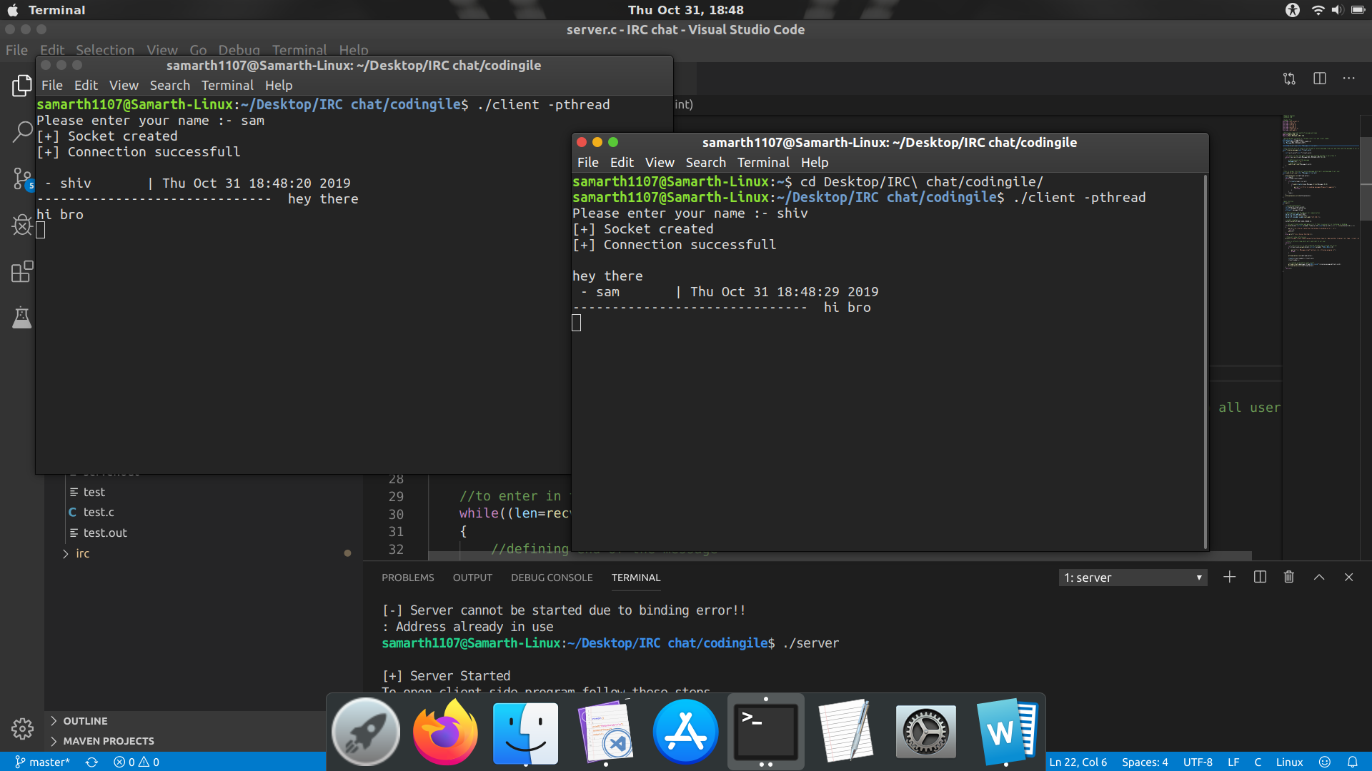

Here sam is the user with the time at which it was send to user shiv at end of the dotted line message is printed.

Possible Errors:

1. Segmentation error on the client-side program, this error can occur when server is not open, or when program is not compiled successfully.
2. [-] Error in socket creation, this will occur when socket is created successfully.
3. [-] Connection Failed, this will occur when client socket is not connected to server successfully
4. [-] Error in sending message, this will occur when there is error in sending message to server, this can occur then server is closed or server is open for very long time.
5. [-] Server cannot be started due to binding error, this can occur on the server side program if the address is already in use this can fix by waiting some time which will give way to use that address.
6. [-] Message accept failure, this will occur when message from the client is not acceptable or readable.