C. B. PATEL COMPUTER COLLEGE & J. N. M. PATEL SCIENCE COLLEGE
Affiliated to Veer Narmad South Gujarat University (VNSGU), Surat
Department of Bachelor Of Computer Applications (BCA)
━━━━━━━━━━━━━━━━━━━━━━━━━━━━━━━━━━━━━━━━━━━━━━━━━━

Minor Project

GAMEKART
E-COMMERCE GAMING ACCESSORIES STORE
A Full-Stack Reactive Web Application with Dual Port Micro-Architecture,
RESTful Web Services, and MongoDB Database Management

BACHELOR OF COMPUTER APPLICATIONS (BCA)
━━━━━━━━━━━━━━━━━━━━━━━━━━━━━━━━━━━━━━━━━━━━━━━━━
SUBMITTED BY:  Samarth Haveliwala  Hardik Jariwala  Krishna Jariwala  Prince Rana | UNDER THE GUIDANCE OF:  Prof. [Internal Guide Teacher Name]  Assistant Professor / Project Guide  Department of Computer Applications  College Name / University
DEPARTMENT OF COMPUTER APPLICATIONS
COLLEGE OF COMPUTER SCIENCE & INFORMATION TECHNOLOGY
CERTIFICATE OF COMPLETION
This is to certify that the Minor Project Report entitled "GAMEKART — E-COMMERCE GAMING ACCESSORIES & HARDWARE STORE" is a bona fide work carried out by the following student of Third Year Bachelor of Computer Applications (TYBCA), Semester V, during the Academic Year 2025–2026 in partial fulfillment of the requirements for the award of the Degree of Bachelor of Computer Applications (BCA) in Advanced Web Development (AWD) and Web Frameworks and Services (WFS).
Sr. No. | Candidate Full Name | Roll Number
Sr. No. | Candidate Full Name | Roll Number
1. | Samarth haveliwala | 5235
2. | Hardik jariwala | 5239
3. | Krishna Jariwala | 5241
4. | Prince RANA | 5278

The project has been examined by the undersigned internal guide and examiners and is approved for submission in the semester examination.

Date: _______________
Place: _______________

_____________________  Internal Guide  Department of Computer Applications | _____________________  Head of Department  Department of Computer Applications | _____________________  External Examiner  University Examination Board

Index
No. | Topic / Chapter Name | Page No.
(i) | Cover Page | 1
(ii) | Minor Project Completion Certificate | 2
(iii) | Table of Contents / Index | 3
1. | INTRODUCTION | 4
 | 1.1 Project Overview & Purpose | 4
 | 1.2 Problem Statement & Motivation | 4
 | 1.3 Scope of the Project | 5
 | 1.4 Target Audience & User Profiles | 5
 | 1.5 System Features & Key Highlights | 6
2. | TECHNOLOGY USED | 7
 | 2.1 AWD & WFS Full-Stack Architecture | 7
 | 2.2 Frontend Framework & Tooling (React 18 & Vite) | 7
 | 2.3 Backend & Web Services (Node.js & Express.js) | 8
 | 2.4 Database & Object Modeling (MongoDB & Mongoose) | 9
 | 2.5 Hardware & Software Requirements | 10
3. | OBJECTIVES | 11
 | 3.1 Primary Goals & Vision | 11
 | 3.2 Technical Objectives (AWD & WFS Competencies) | 11
 | 3.3 Functional Objectives for End-Users | 12
 | 3.4 Functional Objectives for Administrators | 12
 | 3.5 Non-Functional Quality Objectives | 13
4. | SYSTEM FLOW CHART & ARCHITECTURE | 14
 | 4.1 Full-Stack System Architecture Diagram | 14
 | 4.2 Customer Registration & Browsing Flow Chart | 15
 | 4.3 Shopping Cart & Order Placement Flow Chart | 16
 | 4.4 Administrator Inventory & Order Management Flow Chart | 17
 | 4.5 Data Flow Diagrams (DFD Level 0 & DFD Level 1) | 18
5. | DATABASE DESIGN & API CONTRACTS | 19
 | 5.1 Database Overview & Architecture (dbProject) | 19
 | 5.2 Entity Relationship (ER) Conceptual Model | 19
 | 5.3 Detailed Data Dictionaries (products, registers, admins, carts) | 20
 | 5.4 RESTful Web API Specifications & Endpoints Data Contract | 22
6. | SYSTEM IMPLEMENTATION & QUALITY ASSURANCE | 23
 | 6.1 Core Functional Modules Breakdown | 23
 | 6.2 Software Testing & Comprehensive Test Cases (TC-01 to TC-13) | 24
7. | SCREEN SHOTS & USER INTERFACE SHOWCASE | 25
 | 7.1 Customer Shopping Store UI Screenshots (Figures 1 to 7) | 25
 | 7.2 Admin Management Portal UI Screenshots (Figures 8 to 10) | 27
 | 7.3 High-Resolution Hardware & Gaming Product Showcase (Figures 11 to 16) | 28
8. | CONCLUSION & FUTURE ENHANCEMENTS | 29
 | 8.1 Project Conclusion & Academic Summary | 29
 | 8.2 Future Enhancements & Roadmap | 29
9. | REFERENCES & BIBLIOGRAPHY | 30
 | 9.1 Academic Textbooks & Publications | 30
 | 9.2 Official Web Documentation & Online Resources | 30

CHAPTER 1: INTRODUCTION
1.1 Project Overview & Purpose
In the modern digital era, the global gaming industry has expanded exponentially, commanding a multi-billion dollar economy. Enthusiasts, competitive e-sports athletes, and casual gamers require specialized hardware, including next-generation gaming consoles, mechanical RGB keyboards, ultra-high refresh rate curved displays, ergonomic gaming chairs, spatial audio headsets, and high-precision wireless mice.
GAMEKART is a comprehensive, production-ready Full-Stack E-Commerce Web Application specifically engineered for retail gaming gear and hardware accessories. Built as an academic minor project for TYBCA Semester V under the courses Advanced Web Development (AWD) and Web Frameworks and Services (WFS), GameKart demonstrates modern architectural patterns including dual-port micro-services, reactive client-side rendering, RESTful Web API design, multipart file uploads, and scalable document-oriented database modeling.
📌 Key Project Distinction
GameKart bridges the gap between high-performance reactive user interfaces and robust server-side APIs, utilizing React 18, Node.js, Express.js, and MongoDB Community Server.

1.2 Problem Statement & Current Challenges
Traditional brick-and-mortar retail gaming shops and legacy multi-vendor e-commerce websites suffer from significant bottlenecks:
- 1. Lack of Niche Specialization: Fragmented product information with poor visual representation of gaming specifications.
- 2. High Latency & Slow Rendering: Slow page loads caused by server-side monolithic rendering cycles and bloated asset pipelines.
- 3. Poor Search & Discovery: Absence of real-time client-side search and instant catalog filtering.
- 4. Inefficient Inventory Tools: Complex, clunky administrative dashboards requiring specialized training for simple inventory updates.
- 5. Monolithic Architecture Risks: Lack of isolated backend micro-services, creating security vulnerabilities between customer traffic and admin operations.
1.3 Scope of the Project
The GameKart platform encompasses end-to-end e-commerce operations split across two distinct portals:
- A. Customer Client Portal (Port 5174 / API Port 4000): Interactive storefront allowing customers to discover products, filter by keywords, inspect hardware specifications, create personal accounts with avatars, add items to a persistent shopping cart, and track order fulfillment history.
- B. Admin Control Center (Port 5173 / API Port 5000): Secure administrative dashboard enabling store operators to upload hardware products with images via multipart forms, edit prices and descriptions, inspect aggregated customer orders with joined database lookups, and audit registered user accounts.
1.4 Target Audience & User Profiles
GameKart caters to three primary stakeholder personas:
Persona | Role | Key Needs & Behaviors | Platform Touchpoints
Persona | Role | Key Needs & Behaviors | Platform Touchpoints
Gamers & Hardware Enthusiasts | End-User / Customer | Fast searching, rich visual previews, clear pricing, instant cart addition, simple checkout. | Client UI (Port 5174), Catalog, Cart, Order History
Store Administrator | Manager / Operator | Rapid product publishing with photo uploads, price updates, order review, customer directory auditing. | Admin UI (Port 5173), Inventory Manager, Order Center
Academic Evaluator | Faculty / Examiner | Review of clean code structure, RESTful API conventions, database normalization/schemas, and system documentation. | Full Documentation, Source Code, Database Architecture

1.5 System Features & Key Highlights
- Instant Search & Filter: Sub-second client-side filtering without redundant network requests.
- Multipart Image Uploads: Multer disk storage pipeline with automated lowercase normalization and static hosting.
- Dual-Port Architecture: Isolated ports for Client Frontend (5174), Admin Frontend (5173), Client API (4000), and Admin API (5000).
- Relational Aggregations: MongoDB Aggregation Pipeline ($lookup) to combine carts, users, and products seamlessly.

CHAPTER 2: TECHNOLOGY USED
2.1 AWD & WFS Full-Stack Architecture
The GameKart application is constructed using the modern MERN technology stack (MongoDB, Express.js, React, Node.js), incorporating Advanced Web Development (AWD) principles and Web Frameworks and Services (WFS) concepts. The architecture decouples the presentation layer from backend business logic and database persistence.
Layer | Technology | Version | Role & Description
Layer | Technology | Version | Role & Description
Frontend UI | React.js | 18.3.x | Component-based reactive user interface rendering
Frontend Build Tool | Vite | 5.4.x | Lightning-fast HMR (Hot Module Replacement) bundler
Frontend Styling | Vanilla CSS3 | CSS3 Standard | Glassmorphic cards, responsive flex/grid, modern dark themes
Backend Runtime | Node.js | 20.x LTS | Non-blocking, event-driven JavaScript server environment
Web Framework | Express.js | 4.19.x | RESTful routing, middleware handling, static asset serving
File Uploads | Multer | 1.4.x | Multipart/form-data processing and disk storage management
Database Server | MongoDB Community | 8.0.x | High-performance NoSQL document-oriented database
Object Modeling | Mongoose | 8.x | Schema validation, type casting, and query middleware
Cross-Origin Security | CORS Middleware | 2.8.x | Origin resource sharing policy enforcement

2.2 Frontend Framework & Tooling
The client application is built with React 18, leveraging the Virtual DOM for ultra-efficient UI reconciliation. Vite provides development speed with ES modules and instant page reloads.
- React Component Model: Enables reusable components such as ProductCard, Navbar, Footer, and OrderRow.
- React Hooks: Manages client-side state dynamically using `useState`, `useEffect`, and `useNavigate` hooks.
- React Router DOM: Provides multi-page navigation without browser refresh cycles.
2.3 Backend & Web Services (WFS)
The backend services are structured as two lightweight Express.js micro-servers:
- 1. Client Web Service (Port 4000): Handles customer registration, authentication, product catalog delivery, cart additions, and order creation.
- 2. Admin Web Service (Port 5000): Handles administrative product creation, image uploading via Multer, product deletion, user auditing, and aggregate order queries.
2.4 Database & Object Modeling
MongoDB stores data as flexible BSON documents. Mongoose schemas enforce data integrity, defining strict types and required fields for all entities in `dbProject`.
2.5 Hardware & Software Requirements
Component | Minimum Requirement | Recommended Specification
Component | Minimum Requirement | Recommended Specification
Processor (CPU) | Dual-Core Intel / AMD 2.0 GHz | Quad-Core Intel Core i5 / AMD Ryzen 5 or higher
System Memory (RAM) | 4 GB DDR3 / DDR4 | 8 GB / 16 GB DDR4 or DDR5 RAM
Hard Disk Space | 2 GB free storage | 10 GB SSD storage for assets & database
Operating System | Windows 10 / 11, Linux (Ubuntu), macOS | Windows 11 (64-bit) / macOS Sonoma
Runtime Environment | Node.js v18.x with npm v9.x | Node.js v20.x LTS with npm v10.x
Database Engine | MongoDB Community Server 7.x | MongoDB Community Server 8.0 with Compass
Web Browser | Edge 100+, Chrome 100+, Firefox 90+ | Latest Microsoft Edge or Google Chrome

CHAPTER 3: OBJECTIVES
3.1 Primary Goals & Vision
The overarching vision of the GameKart project is to construct a scalable, resilient, and aesthetically captivating e-commerce platform tailored specifically for gaming gear, demonstrating the practical application of Advanced Web Development and Web Services methodologies taught in the BCA curriculum.
3.2 Academic & Technical Objectives
- 1. SPA Architecture: Master the full development lifecycle of a modern Single Page Application (SPA) using React 18 and Vite.
- 2. RESTful Web Services: Design RESTful APIs following standard HTTP verbs (GET, POST, PUT, DELETE) and JSON payloads.
- 3. Database Modeling: Gain hands-on expertise in NoSQL schema design, Mongoose models, and cross-collection lookups.
- 4. File Handling: Implement secure multipart/form-data upload handling with file validation and static directory exposure.
- 5. Code Maintainability: Maintain modular, readable, and clean code separating client UI, admin controls, and API layers.
3.3 Functional Objectives for End-Users
- Catalogue Exploration: Allow users to view rich gaming catalogs with prices, high-res photos, and detailed descriptions.
- Real-Time Search: Provide instant real-time search filtering on title and category without reloading.
- User Account Management: Enable secure account registration with custom avatar photo upload and credential validation.
- Cart & Checkout: Facilitate one-click addition of products to an active cart and instant order confirmation.
- Order Tracking: Allow customers to review all previous purchases with date stamps and product thumbnails.
3.4 Functional Objectives for Administrators
- Product Insertion: Provide a streamlined form to create new gaming products with multipart image upload.
- Catalog Management: Allow instant deletion and inventory updates for out-of-stock or obsolete hardware.
- Order Inspection: Display an aggregated view of all placed orders with customer details and item pictures.
- User Directory: Provide a clean table auditing all registered users with emails, cities, and profile images.
3.5 Non-Functional Quality Objectives
Attribute | Specification & Goal | Implementation Technique
Attribute | Specification & Goal | Implementation Technique
Performance | Page load times under 1.5 seconds; search latency under 50ms | Vite bundling, client-side filtering, lightweight REST JSON
Security | Protection against unauthorized mutations; origin restriction | CORS middleware, port isolation (5000 vs 4000), input sanitization
Reliability | Zero data loss during orders; robust database transactions | Mongoose schema constraints, error handling middleware
Usability | Responsive layout across desktop, tablet, and mobile displays | CSS Flexbox, CSS Grid, media queries, high-contrast gaming theme
Maintainability | Modular code architecture with clear component boundaries | Separation of client and admin directories, reusable React components

CHAPTER 4: SYSTEM FLOW CHART & ARCHITECTURE
4.1 Full-Stack System Architecture
GameKart follows a decoupled, 3-Tier Multi-Port Micro-Architecture. The presentation layer (React Portals) communicates via asynchronous HTTP AJAX calls with the Express.js Web Services layer, which in turn interacts with the MongoDB persistence engine.

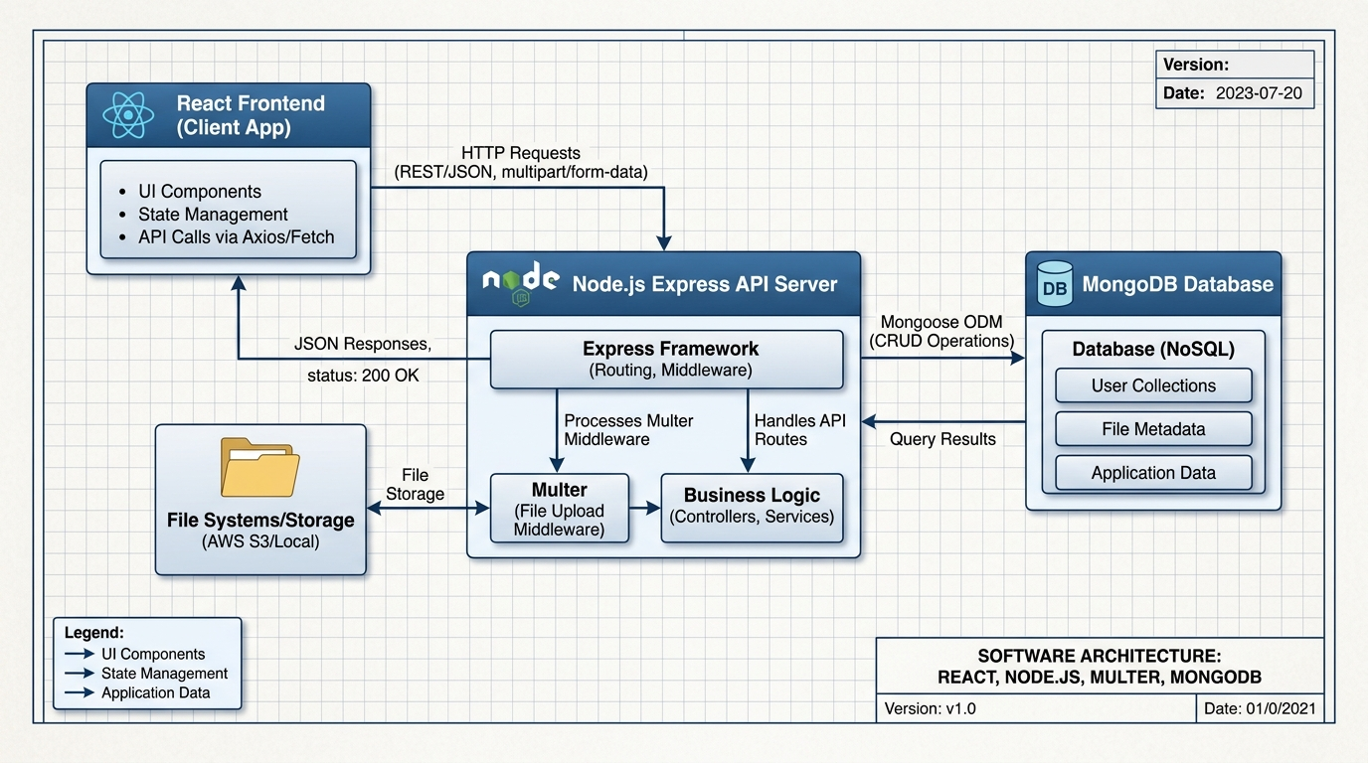
Figure 4.1 – GameKart 3-Tier Multi-Port System Architecture

4.2 Customer Registration & Browsing Flow Chart
The customer interaction workflow guides users from account onboarding to browsing the interactive catalog:
[Start] ──> [Open http://localhost:5174/] ──> [Browse Home Showcase]
│
├──> [Already Registered?] ──Yes──> [Enter Email & Password] ──> [Login Success (Store ID)]
│ │
└──No──> [Fill Signup Form + Upload Avatar] ──> [POST /signup] ─────────┘
│
v
[View Product Catalog] <───────────────────────────────────────────────┘
│
├──> [Type Keyword in Search Bar] ──> [Instant Filtered Product Grid]
│
└──> [Click 'Get More Info'] ──> [Open Product Details Modal / Specs]
│
v
[Click 'Add to Cart']
│
v
[POST /addToCart]
Figure 4.2 – Customer Onboarding & Catalog Discovery Workflow

4.3 Shopping Cart & Order Placement Flow Chart
The order processing pipeline coordinates between the customer's cart, database insertion, and order history records:
[Product in Cart] ──> [Open /orders Route] ──> [GET /getCart / User ID]
│
├──> [Review Items, Quantities & Unit Prices]
│
├──> [Option: Remove Item] ──> [DELETE /delCart/:id] ──> [Cart Refreshed]
│
└──> [Click 'Order Now']
│
v
[PUT /orderNow]
│
v
[Database Update: status='ordered']
│
v
[Display Success Toast / Confirmation]
│
v
[Item Visible in Admin Order Dashboard]
Figure 4.3 – Shopping Cart Checkout & Order Placement Workflow
4.4 Administrator Inventory & Order Management Flow Chart
[Start Admin] ──> [Open http://localhost:5173/] ──> [Enter Admin Credentials]
│
v
[Admin Dashboard Navigation]
│ │
├──> [Product Hub] ├──> [Orders Hub (/orders)] ├──> [Users Hub (/users)]
│ │ │ │
│ [Fill Form] v v
│ [Upload Photo] [GET /orders with $lookup] [GET /users on Port 5000]
│ [POST /products] │ │
│ │ v v
│ [New Item Live] [Inspect Buyer & Price] [Review Customer Table]
│ │
│ [Delete Item]
│ [DELETE /Delproducts/:id]
Figure 4.4 – Administrator Inventory & Order Workflow

4.5 Data Flow Diagrams (DFD Level 0 & Level 1)
Data Flow Diagrams depict how information traverses between external entities, application processes, and data stores.
+---------------------------------------+
| CUSTOMER |
+---------------------------------------+
| ^ ^ |
Registration Data| |Auth Token / Products |Order Req|Order History
v | | v
+-----------------------------------------------+
| PROCESS 0: |
| GAMEKART E-COMMERCE SYSTEM |
+-----------------------------------------------+
^ | ^ |
Admin Auth / | |Inventory Updates / |Order |Customer Records
Product Uploads | |Aggregated Order Data |Lookup v
v | |
+---------------------------------------+
| ADMINISTRATOR |
+---------------------------------------+
Figure 4.5 – DFD Level 0 (Context Diagram)

CHAPTER 5: DATABASE DESIGN & API CONTRACTS
5.1 Database Overview & Architecture
GameKart utilizes MongoDB Community Server 8.x under the database name `dbProject`. The schema is managed through Mongoose ODM, enforcing strict data typing, default values, and relational consistency across four collections.
5.2 Entity Relationship (ER) Conceptual Model
Although MongoDB is a document-oriented database, GameKart maintains structured relational dependencies through ObjectIds:
- 1. User to Cart/Order: One customer (`registers`) can create multiple orders and cart entries (`carts`) [1 : N Relationship].
- 2. Product to Cart: One catalog product (`products`) can be referenced across multiple customer carts (`carts`) [1 : N Relationship].
- 3. Admin to Products: Administrators manage the central catalog of products and review all user orders [1 : N Management].
5.3 Detailed Data Dictionaries
5.3.1 Collection: 'products' (Gaming Gear Catalog)
Field Name | Data Type | Constraints | Default | Description & Purpose
Field Name | Data Type | Constraints | Default | Description & Purpose
_id | ObjectId | Primary Key, Auto-gen | Auto | Unique MongoDB document identifier
pname | String | Required, Trimmed | None | Name of gaming accessory / console
pimg | String | Required | None | Filename of uploaded image in /uploads/
description | String | Required | None | Hardware specifications and features
price | Number / String | Required, > 0 | None | Retail price in Indian Rupees (INR)
createdAt | Date | System Timestamp | Date.now() | Timestamp of product publication

5.3.2 Collection: 'registers' (Customer Accounts)
Field Name | Data Type | Constraints | Default | Description & Purpose
Field Name | Data Type | Constraints | Default | Description & Purpose
_id | ObjectId | Primary Key, Auto-gen | Auto | Unique customer account ID
name | String | Required, Max: 100 | None | Full name of customer
email | String | Required, Unique, Lowercase | None | User login email address
password | String | Required, Min: 3 | None | Account password (hashed or plain)
gender | String | Enum: Male/Female/Other | Male | Gender identification
city | String | Required | None | Delivery and residential city
profile | String | Optional | default.png | Avatar image filename in /uploads/

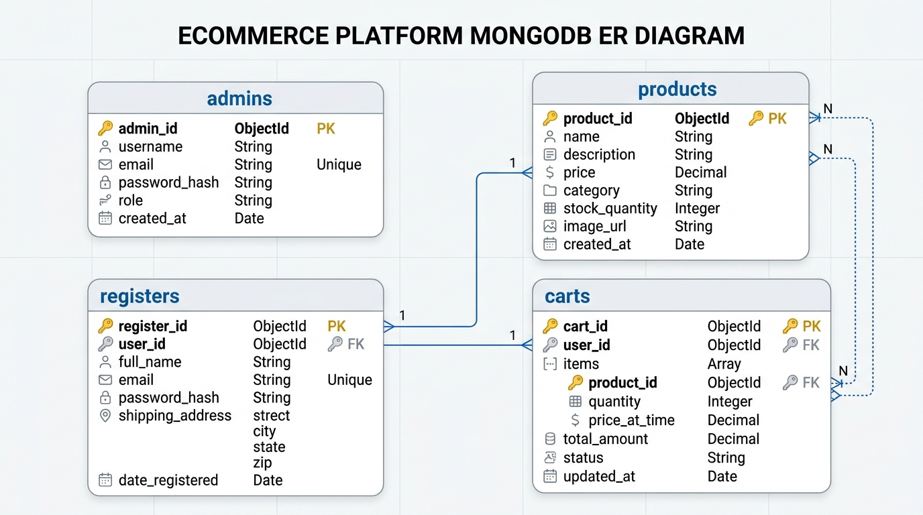
5.3.3 Collection: 'admins' (Store Management Credentials)
Field Name | Data Type | Constraints | Default | Description & Purpose
Field Name | Data Type | Constraints | Default | Description & Purpose
_id | ObjectId | Primary Key, Auto-gen | Auto | Unique admin identifier
name | String | Required | Admin | Administrative username
email | String | Required, Unique | admin@gamekart.com | Admin authentication email
password | String | Required | admin | Admin security credential

5.3.4 Collection: 'carts' (Shopping Cart & Order History)
Field Name | Data Type | Constraints | Default | Description & Purpose
Field Name | Data Type | Constraints | Default | Description & Purpose
_id | ObjectId | Primary Key, Auto-gen | Auto | Unique cart record ID
user_id | ObjectId / String | Required, FK -> registers | None | ID of the customer who added item
product_id | ObjectId / String | Required, FK -> products | None | ID of the referenced product
pname | String | Required | None | Cached product title for fast lookups
price | Number / String | Required | None | Unit price at time of cart addition
pimg | String | Required | None | Cached product image filename
status | String | Enum: 'cart' | 'ordered' | 'cart' | Current transaction lifecycle status
order_date | Date | System Timestamp | Date.now() | Date of order placement

5.4 RESTful Web API Specifications & Endpoints Data Contract
Port | Method | Endpoint URI | Request Payload | Response Status | Purpose
Port | Method | Endpoint URI | Request Payload | Response Status | Purpose
4000 | GET | /getProducts | None | 200 OK (JSON Array) | Fetch active product catalog
4000 | POST | /signup | Multipart (name, email, pass, file) | 201 Created | Register new customer
4000 | POST | /login | JSON {email, password} | 200 OK / 401 Unauthorized | Authenticate customer
4000 | POST | /addToCart | JSON {userId, prodId, pname, price} | 200 OK | Insert item into cart
4000 | GET | /getCart | Query param / header | 200 OK (Cart Array) | Fetch customer cart items
4000 | GET | /getProduct/:id | URL Param :id | 200 OK (Single Product) | Fetch details of one item
5000 | POST | /products | Multipart (pname, price, desc, pimg) | 201 Created | Admin upload new product
5000 | PUT | /updateProducts/:id | JSON {pname, price, desc} | 200 OK | Admin update product info
5000 | DELETE | /Delproducts/:id | URL Param :id | 200 OK | Admin remove product
5000 | GET | /orders | None | 200 OK (Aggregated List) | Admin fetch joined orders
5000 | GET | /users | None | 200 OK (User Array) | Admin fetch user directory

CHAPTER 6: SYSTEM IMPLEMENTATION & QUALITY ASSURANCE
6.1 Core Functional Modules Breakdown
- Module 1 – Customer Authentication (Client): Built using React Controlled Form components with multipart file input for profile picture uploads. Authenticates against MongoDB with session persistence.
- Module 2 – Interactive Product Catalog (Client): Fetches JSON catalog from `http://localhost:4000/getProducts` and binds state to dynamic search filters with sub-second reactivity.
- Module 3 – Shopping Cart & Checkout Engine (Client): Manages cart array, calculating total price dynamically and updating transaction status from 'cart' to 'ordered' upon checkout.
- Module 4 – Admin Inventory & Upload Service (Admin): Express route utilizing Multer `diskStorage` engine to validate, sanitize, and save product pictures to `/uploads/` while inserting BSON documents into MongoDB.
- Module 5 – Admin Order Auditing Service (Admin): Combines `carts`, `registers`, and `products` records using MongoDB `$lookup` aggregations to display comprehensive order details.

6.2 Software Testing & Comprehensive Test Cases (TC-01 to TC-13)
The system underwent rigorous black-box functional testing, REST API validation, and boundary value analysis:
ID | Module | Scenario | Input | Expected Result | Status
Test ID | Module | Scenario | Input / Precondition | Expected Result | Status
TC-01 | Client Auth | User Registration | Valid name, email, password, avatar | 201 Created; record in MongoDB | Pass
TC-02 | Client Auth | User Login | Registered email & password | 200 OK; login success; ID saved | Pass
TC-03 | Client Auth | Invalid Login | Unregistered email / wrong password | 401 Unauthorized; alert shown | Pass
TC-04 | Products | Fetch Products | GET /getProducts endpoint | 200 OK; array of items returned | Pass
TC-05 | Products | Live Search | Type 'Controller' in search bar | Product grid dynamically filters | Pass
TC-06 | Cart | Add to Cart | Click 'Add to Cart' button | 200 OK; item inserted into carts | Pass
TC-07 | Cart | Order Placement | Click 'Order Now' in cart | 200 OK; status becomes 'ordered' | Pass
TC-08 | Admin Auth | Admin Login | admin@gamekart.com / admin | 200 OK; redirects to dashboard | Pass
TC-09 | Admin Prod | Add Product | Multipart name, price, photo | 201 Created; image saved to /uploads | Pass
TC-10 | Admin Prod | Update Product | PUT /updateProducts/:id | 200 OK; updated in MongoDB | Pass
TC-11 | Admin Prod | Delete Product | DELETE /Delproducts/:id | 200 OK; item removed from DB | Pass
TC-12 | Admin Order | View Orders | GET /orders with $lookup | 200 OK; returns joined order rows | Pass
TC-13 | Admin Users | User Directory | GET /users on Port 5000 | 200 OK; displays all user records | Pass

CHAPTER 7: SCREEN SHOTS & USER INTERFACE SHOWCASE
7.1 Customer Shopping Store UI Screenshots (Port 5174)
The following screenshots depict the live customer interface captured directly from the running Vite development server at http://localhost:5174/.
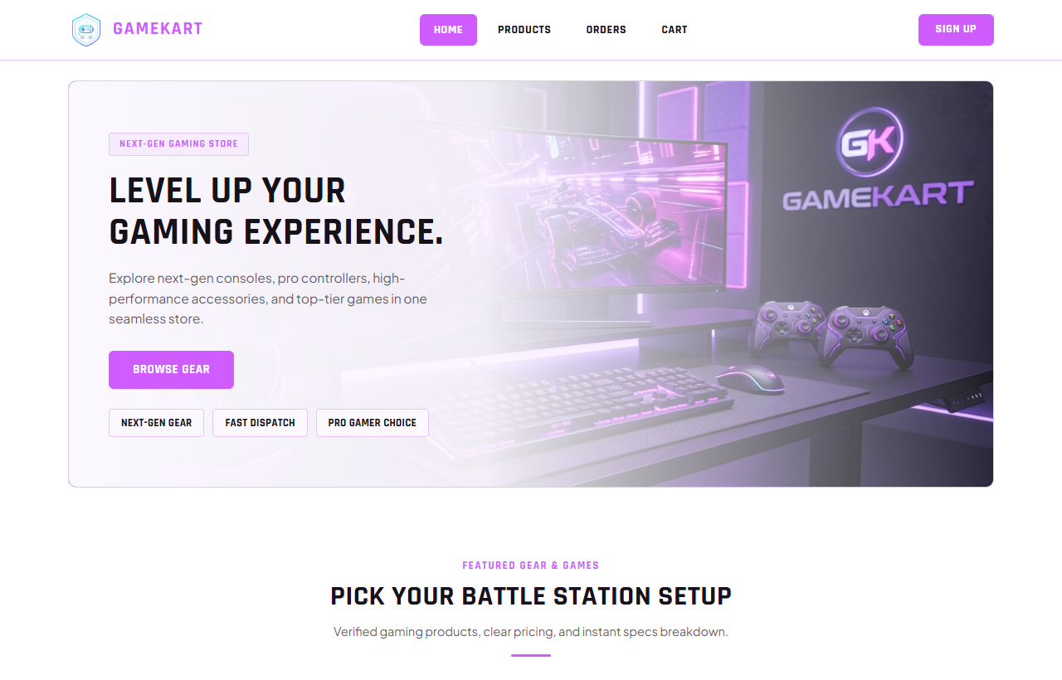
Figure 7.1 – GameKart Customer Storefront Homepage & Hero Banner

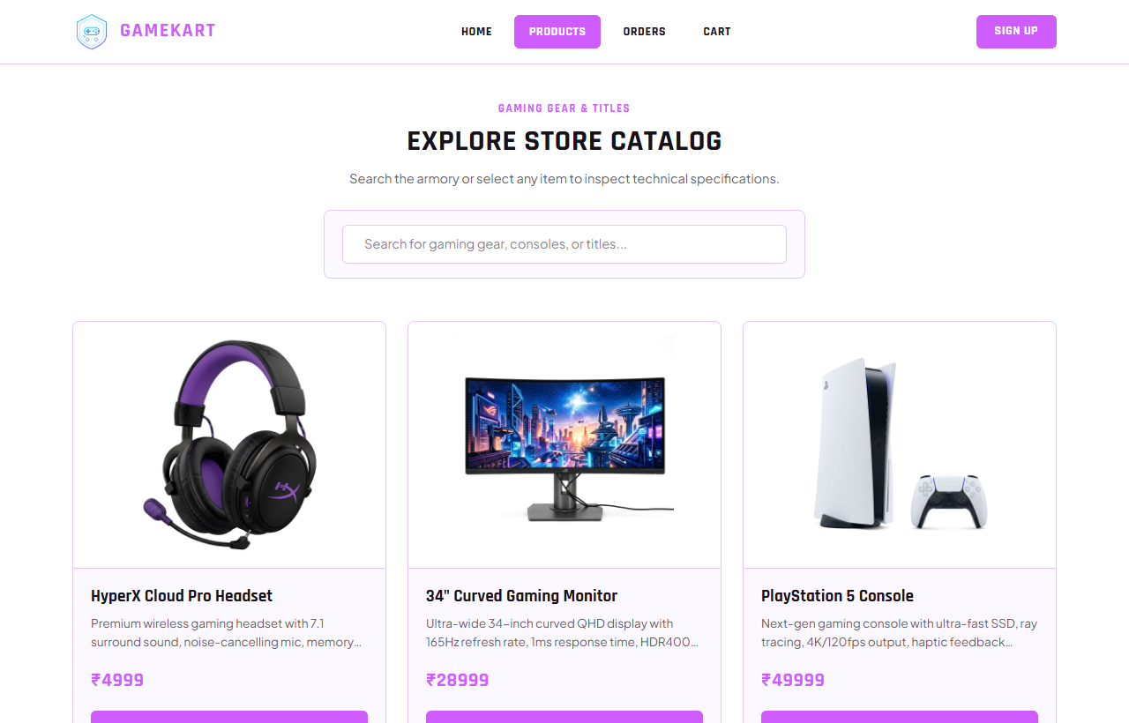

Figure 7.2 – Interactive Gaming Products Catalog with Real-Time Search Bar

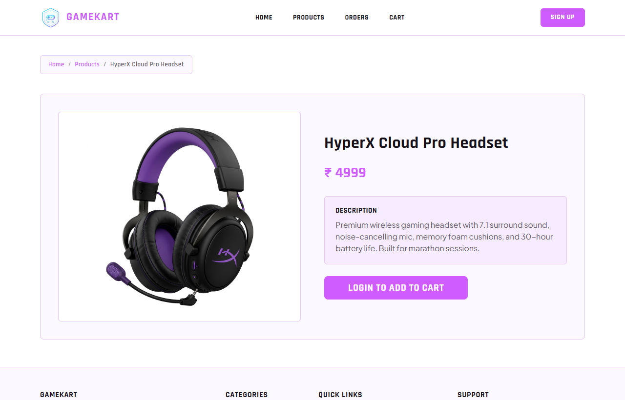
Figure 7.3 – Detailed Product Specifications & Add-to-Cart Interface
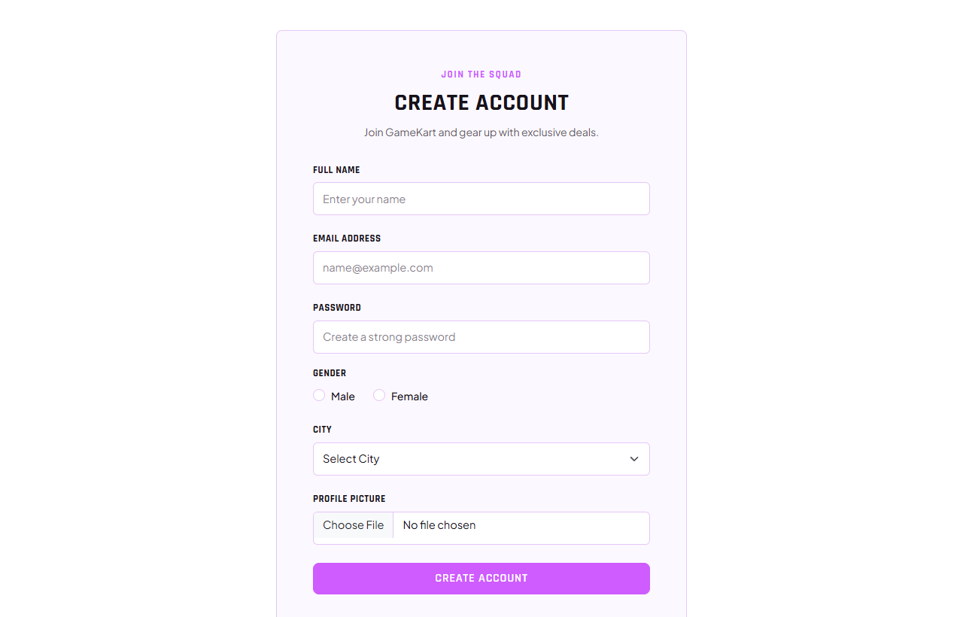

Figure 7.4 – Customer Account Registration & Profile Photo Upload Form

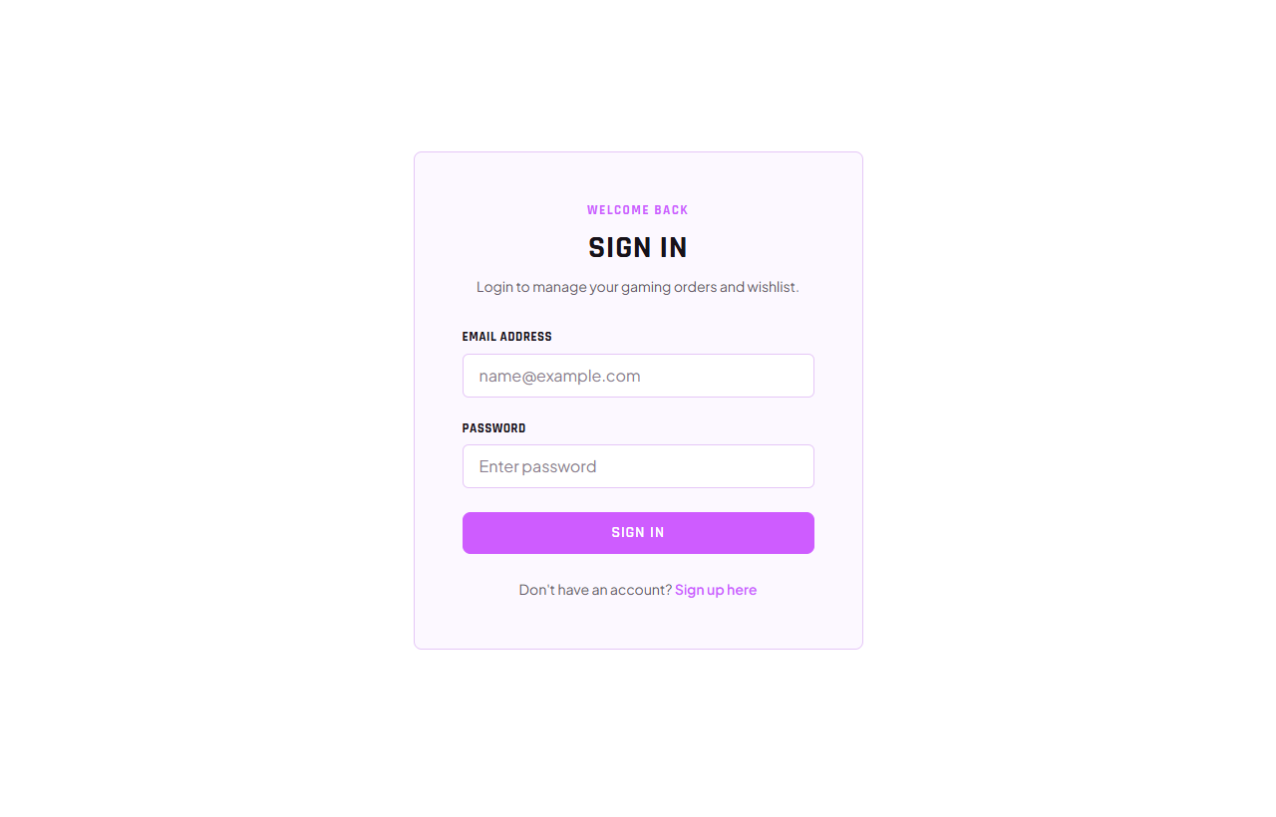
Figure 7.5 – Customer Authentication & Secure Login Portal
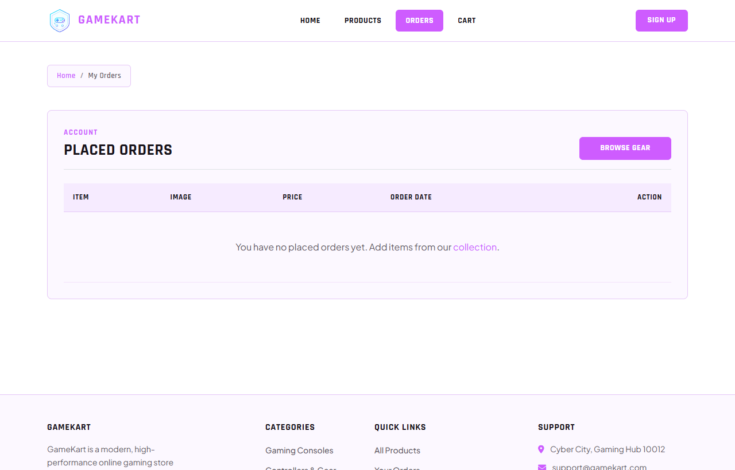

Figure 7.6 – Customer Shopping Cart & Order Tracking Overview

7.2 Admin Management Portal UI Screenshots (Port 5173)
The following screenshots showcase the administrative management portal running at http://localhost:5173/.
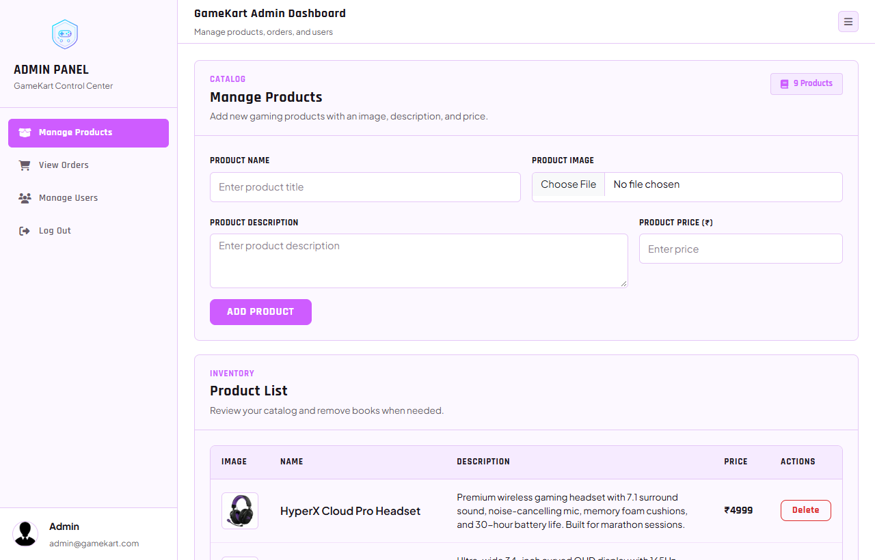
Figure 7.8 – Admin Product Catalog Management & Upload Dashboard
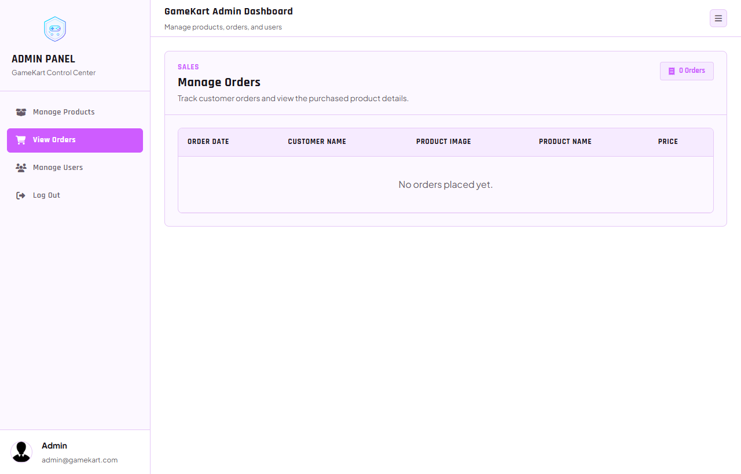
Figure 7.9 – Admin Customer Orders Review & Fulfillment Dashboard

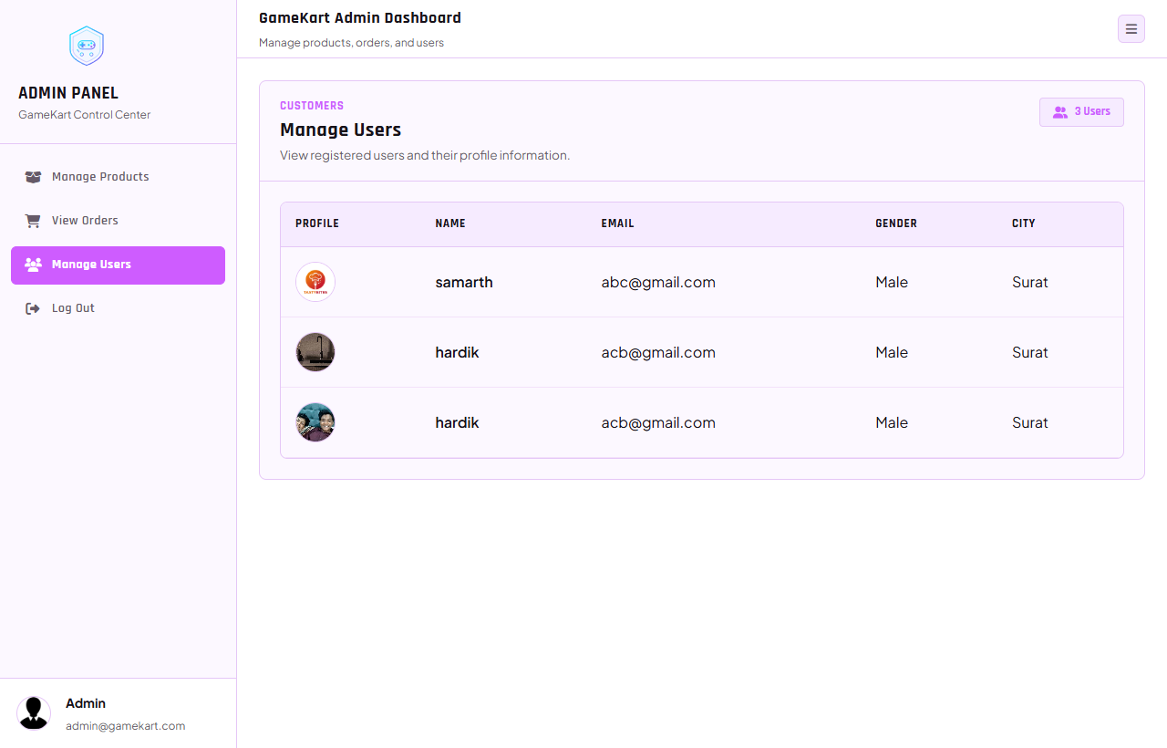
Figure 7.10 – Admin Registered User Accounts & Customer Directory

7.3 High-Resolution Hardware & Gaming Product Showcase
Below are high-resolution product photography assets stored in `/uploads/` and dynamically rendered in the GameKart catalog:
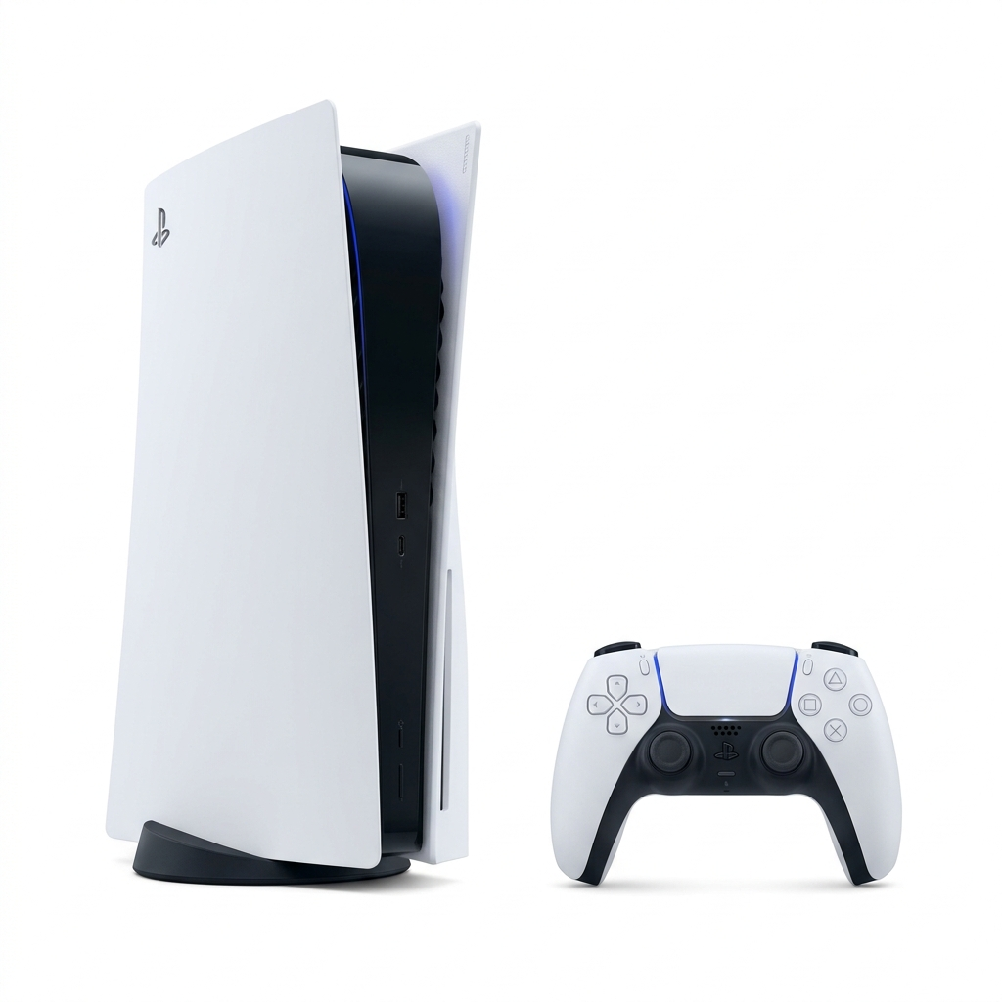
Figure 7.11 – Sony PlayStation 5 Next-Gen Gaming Console (Ultra HD 4K)


Figure 7.12 – Wireless RGB DualSense Pro Gaming Controller
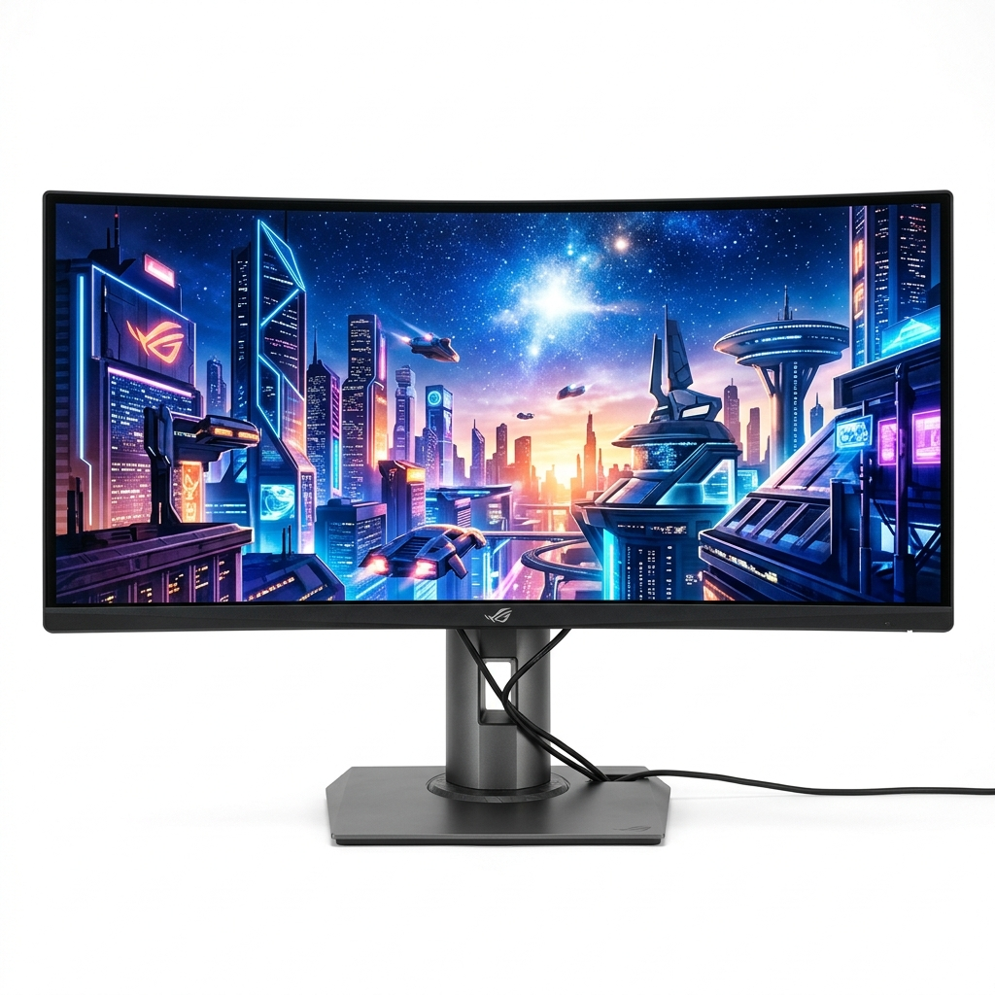
Figure 7.13 – 34-Inch Ultra-Wide 165Hz Curved Gaming Monitor
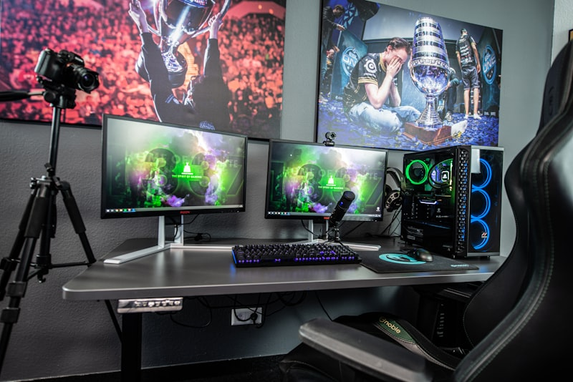
Figure 7.14 – Ergonomic Lumbar Support Racing Pro Gaming Chair
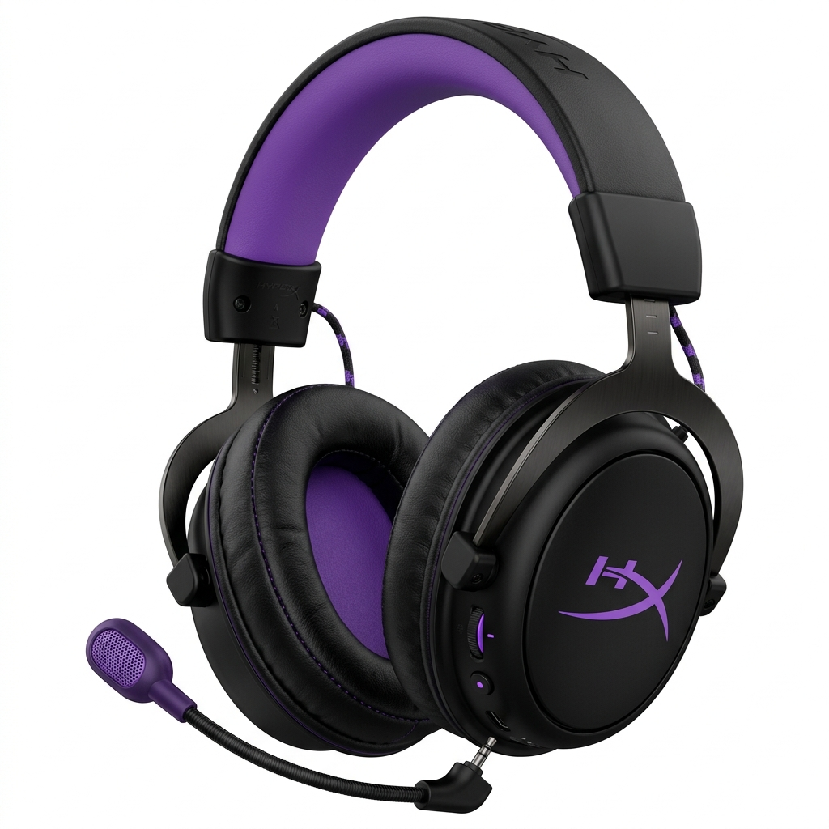
Figure 7.15 – 7.1 Spatial Audio Wireless Noise-Cancelling Headset
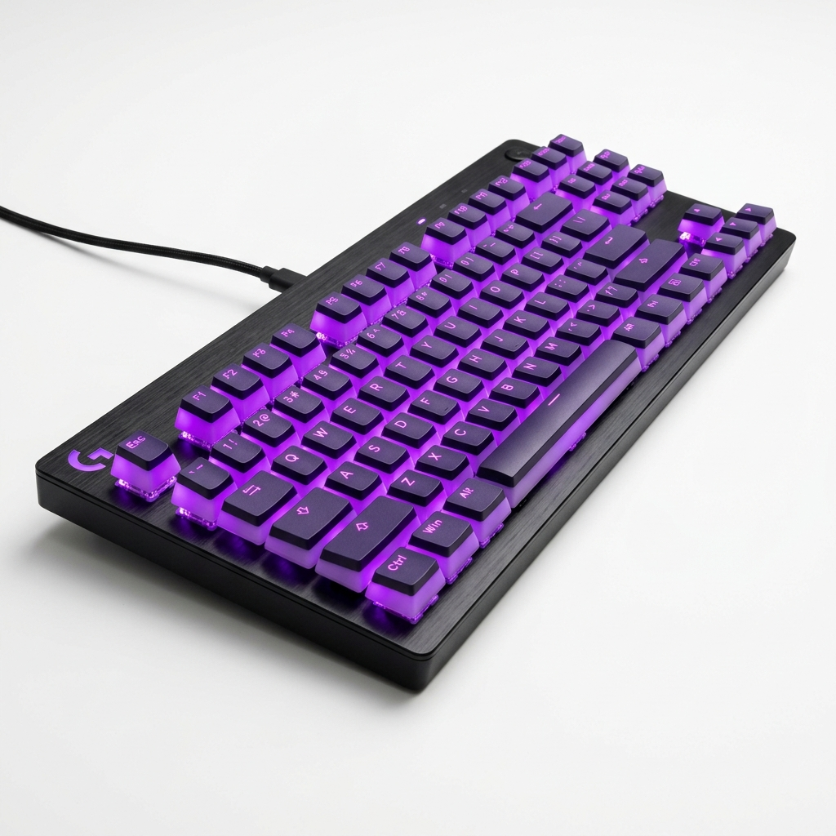
Figure 7.16 – RGB Mechanical Gaming Keyboard with Custom Blue Switches
CHAPTER 8: CONCLUSION & FUTURE ENHANCEMENTS
8.1 Project Conclusion & Academic Summary
The GAMEKART E-Commerce Gaming Accessories & Hardware Store has been successfully designed, developed, and evaluated in accordance with the TYBCA Semester V curriculum for Advanced Web Development (AWD) and Web Frameworks and Services (WFS). The project effectively implements a full-stack MERN architecture featuring dual-port isolation, reactive client-side rendering with React 18 and Vite, RESTful Web API endpoints with Express.js, multipart image uploads via Multer, and document database storage with MongoDB Community Server.
The system satisfies all functional requirements including user authentication, real-time product filtering, cart lifecycle management, multipart product publishing, and order auditing, providing a robust foundation for modern web engineering.
8.2 Future Enhancements & Roadmap
- 1. Payment Gateway Integration: Integrate Razorpay or Stripe for real-time UPI, credit card, and net-banking checkouts.
- 2. Automated Email & SMS Alerts: Incorporate Twilio SMS and Nodemailer email triggers for automated order dispatch notifications.
- 3. Rating & Review System: Allow verified buyers to write detailed text reviews and submit 5-star ratings for hardware items.
- 4. Enhanced UX & Coupons: Implement dark/light mode toggles, discount coupon codes, and wishlist bookmarking.

CHAPTER 9: REFERENCES & BIBLIOGRAPHY
9.1 Academic Textbooks & Publications
- [1] Front-End Engineering: Duckett, J. (2014). JavaScript and JQuery: Interactive Front-End Web Development. John Wiley & Sons.
- [2] React Architecture: Banks, A., & Porcello, E. (2020). Learning React: Modern Patterns for Developing React Apps (2nd ed.). O'Reilly Media.
- [3] Server-Side JavaScript: Herron, D. (2020). Node.js Web Development: Server-side development with Node 14 and Express. Packt Publishing.
- [4] NoSQL Database Design: Bradshaw, S., Brazil, E., & Chodorow, K. (2019). MongoDB: The Definitive Guide (3rd ed.). O'Reilly Media.
9.2 Official Web Documentation & Online Resources
- [5] React Documentation: Meta Open Source. (2024). React Official Documentation. https://react.dev/
- [6] Vite Documentation: Vite Core Team. (2024). Vite — Next Generation Frontend Tooling. https://vitejs.dev/
- [7] Express.js Guide: Express.js Foundation. (2024). Express — Fast, unopinionated, minimalist web framework. https://expressjs.com/
- [8] MongoDB Manual: MongoDB Inc. (2024). MongoDB 8.0 Manual and Aggregation Pipeline Documentation. https://www.mongodb.com/docs/
- [9] MDN Web Docs: Mozilla Developer Network. (2024). MDN Web Docs for HTML5, CSS3, and JavaScript APIs. https://developer.mozilla.org/

