C. B. PATEL COMPUTER COLLEGE & J. N. M. PATEL SCIENCE COLLEGE
Affiliated to Veer Narmad South Gujarat University (VNSGU), Surat
Department of Bachelor Of Computer Applications (BCA)
━━━━━━━━━━━━━━━━━━━━━━━━━━━━━━━━━━━━━

Minor Project


GAMEKART: ONLINE GAMING GEAR & HARDWARE E-COMMERCE PLATFORM
WITH DYNAMIC UPI QR SETTLEMENT

BACHELOR OF COMPUTER APPLICATIONS (BCA)
━━━━━━━━━━━━━━━━━━━━━━━━━━━━━━━━━━━━━

SUBMITTED BY:  Samarth Haveliwala  Hardik Jariwala  Krishna Jariwala  Prince Rana | UNDER THE GUIDANCE OF:  Prof. [Internal Guide Teacher Name]  Assistant Professor / Project Guide  Department of Computer Applications  College Name / University

CERTIFICATE OF MINOR PROJECT COMPLETION
This is to certify that the Minor Project entitled "GAMEKART: ONLINE GAMING GEAR & HARDWARE E-COMMERCE PLATFORM WITH DYNAMIC UPI QR SETTLEMENT" is a bonafide academic work carried out by the student of Third Year Bachelor of Computer Applications (TYBCA), in partial fulfillment of the requirements for the subjects Advanced Web Development (AWD) and Web Frameworks & Web Full Stack (WFS) during the academic year 2025-2026.
The project has been developed under our direct supervision and represents authentic development work using PHP 8.x, MySQL relational database system, modern HTML5/CSS3 dynamic purple design system, and real-time deep-link UPI QR payment gateway APIs.
To the best of our knowledge, the matter presented in this report has not been submitted to any other University or Institution for any Degree or Diploma.
Sr. No. | Candidate Full Name | Roll Number
1. | Samarth haveliwala | 5235
2. | Hardik jariwala | 5239
3. | Krishna Jariwala | 5241
4. | Prince RANA | 5278

_____________________  Prof. Project Guide  (Internal Guide) | _____________________  Head of Department  (H.O.D. - BCA) | _____________________  External Examiner  (University Nominee)

CANDIDATE DECLARATION & ACKNOWLEDGEMENT
Candidate Declaration
Declaration: I hereby declare that the minor project entitled "GameKart - Online Gaming Gear & Hardware E-Commerce Platform" submitted in partial fulfillment of the degree of Bachelor of Computer Applications (TYBCA) is an authentic record of our original work carried out under the guidance of our project supervisor. All external references, books, and online documentation utilized during the development have been duly acknowledged in the Bibliography section.
Acknowledgement
Faculty Mentorship: We express our sincere gratitude to our Project Guide and the Head of Department (HOD) for providing invaluable technical mentorship, reviewing architectural designs, and guiding our database normalization and payment integration strategies throughout this semester.
Institutional Facilities: We also extend our heartfelt appreciation to our college principal, laboratory technicians, and classmates who provided constructive feedback during the testing and evaluation of the GameKart user experience.

TABLE OF CONTENTS / PROJECT INDEX
Sr. No. | Chapter / Section | Page
1 | Cover Page & Certificate | 1–2
2 | Declaration & Acknowledgement | 3
3 | Table of Contents | 4–5
4 | Chapter 1: Introduction & Domain Overview | 6–9
5 | Chapter 2: Technology Used | 10–13
6 | Chapter 3: Objectives & SRS | 14–15
7 | Chapter 4: System Flow & Diagrams | 16–19
8 | Chapter 5: Database Design | 20–22
9 | Chapter 6: Implementation & Source Code | 23–24
10 | Chapter 7: System Testing | 25–26
11 | Chapter 8: Screenshots & UI Walkthrough | 27–29
12 | Chapter 9: Limitations & Conclusion | 30
13 | Chapter 10: References | 30

CHAPTER 1: INTRODUCTION & DOMAIN OVERVIEW
1.1 Background & E-Commerce Domain Context
Domain Context: Electronic Commerce has fundamentally transformed how hardware enthusiasts, competitive esports gamers, and content creators procure high-performance computing equipment. Modern gamers require specialized, ultra-low-latency peripherals such as optical-switch mechanical keyboards, ultra-lightweight high-polling-rate mice, spatial audio gaming headsets, and high-refresh-rate OLED displays powered by flagship graphics processing units (GPUs). Traditional retail shops are constrained by physical shelf space, lack detailed technical spec sheets, and cannot facilitate instant digital transactions at scale.
Project Overview: GameKart is engineered as a dedicated full-stack e-commerce web platform developed using PHP 8.x, MySQL, modern HTML5, CSS3 with dark-mode neon purple aesthetics, JavaScript, and Bootstrap 5.3. The system provides a seamless digital shopping experience with dynamic catalog filtering, shopping cart persistence, and an innovative real-time dynamic UPI QR payment settlement mechanism alongside traditional Card and COD payment options.

1.2 Problem Statement & Existing System Limitations
Existing Bottlenecks: An investigation into existing generic e-commerce platforms reveals critical shortcomings for the gaming hardware sector:
- Outdated Visual Appeal: Generic and uninspiring user interfaces that fail to capture the high-tech, futuristic aesthetic expected by esports and PC gaming communities.
- Payment Friction: High cart abandonment rates caused by cumbersome payment redirects and manual bank credential entry.
- Lack of Dynamic UPI QR: Static or absent UPI QR options that require manual entry of recipient VPAs and amounts on mobile devices, leading to calculation and typing errors.
- Administrative Inefficiencies: Fragmented admin tools where inventory levels, customer orders, and transaction records are not synchronized in real-time.
1.3 Proposed System Architecture & Key Advantages
System Advantages: The proposed GameKart platform eliminates these bottlenecks through an integrated full-stack architecture:
- Immersive Gamer Aesthetics: Modern gaming-inspired dark purple visual theme (#CE5CFF, #7A1CAC, #17121A) with Google Orbitron and Rajdhani typography.
- Dynamic QR Engine: Dynamic UPI QR generator encoding exact cart totals into standard 'upi://pay' deep-links for immediate mobile scanning and settlement.
- Reactive Cart Engine: Responsive shopping cart with live subtotal calculations, instant quantity updates, and session retention.
- Integrated Admin Center: Unified Admin Command Center providing live financial KPIs, inventory CRUD capabilities, and order status tracking.

1.4 Scope of the Project & Target Demographics
Operational Scope: The project scope is structured around two distinct operational portals:
- Gamer Storefront: User registration, secure login, category-wise hardware catalog, live search, shopping cart operations, multi-mode payment settlement (Dynamic UPI QR, Debit/Credit Card, COD), and order invoice viewing.
- Admin Control Center: Secure administrative authentication, real-time KPI overview (Revenue, Total Orders, Stock, Active Users), product catalog CRUD management, and customer order fulfillment.
1.5 Feasibility Study
Feasibility Analysis: A comprehensive four-pillar feasibility analysis was conducted prior to implementation:
- Technical: Technical Feasibility: Developed on the open-source XAMPP stack (Apache 2.4, PHP 8.2, MySQL 8.0) ensuring complete technical compatibility, cross-platform deployment, and high reliability.
- Operational: Operational Feasibility: The intuitive interface requires zero prior training for customers and administrators, with straightforward navigation and instant QR scanning.
- Economic: Economic Feasibility: Built entirely on open-source technologies (PHP, MySQL, Apache, VS Code) resulting in minimal development cost while delivering substantial operational efficiency.
- Schedule: Schedule Feasibility: Structured execution across academic milestones (SRS, DB Design, Coding, Testing, Documentation) completed within schedule.

CHAPTER 2: TECHNOLOGY STACK (AWD & WFS)
2.1 Front-End Technologies
- HTML5 Semantic Structure: HTML5: Provides semantic markup for product grids, modal dialogues, shopping carts, and administrative tables.
- CSS3 Design System: CSS3 Custom Design System: Implements modern CSS custom properties (--theme-primary: #CE5CFF, --theme-bg: #17121A), glowing box shadows, and glassmorphic card overlays.
- Bootstrap 5.3 Framework: Bootstrap 5.3: Powers the 12-column responsive grid system, alert banners, and form controls.
- JavaScript ES6+: JavaScript (ES6+): Drives asynchronous UI state management, real-time payment mode toggling, and input validation.
- Modern Web Typography: Google Fonts: Integrates Orbitron (brand headings), Rajdhani (prices and metrics), and Plus Jakarta Sans (body copy).

2.2 Back-End Technologies
- PHP 8.x Engine: PHP 8.x Server Engine: Implements server-side business logic, session security, authentication guards, and input sanitization.
- MySQLi Driver: MySQLi Native Extension: Executes secure parameterized SQL queries, relational joins, and atomic transactions.
- RESTful APIs: RESTful API Integration: Communicates with public QR Code Server REST APIs to generate real-time UPI QR codes with exact cart payloads.
2.3 Database Tier (MySQL 8.x)
Database Engine: The relational database schema 'kmart' consists of 6 normalized tables (tbluser, tblcat, tblpro, tblcart, tblorder, tblorderdetails) strictly structured to Third Normal Form (3NF) to guarantee referential integrity and eliminate update anomalies.
2.4 Third-Party Integrations (Dynamic UPI QR Engine)
NPCI UPI Protocol: The dynamic UPI QR code generator formats deep links complying with the National Payments Corporation of India (NPCI) UPI specifications:
upi://pay?pa=9825904828@fam&pn=GameKart&am=[Amount]&cu=INR
This deep link is encoded on the fly into a high-resolution QR matrix, enabling customers to scan and pay directly via GPay, PhonePe, or Paytm.

2.5 Environmental Hardware & Software Specifications
Environmental Parameter | Development Specification | Production Target
Operating System | Windows 11 64-bit | Linux Ubuntu 22.04 LTS / Windows Server
Web Server | Apache 2.4.58 (XAMPP) | Apache 2.4 / NGINX Reverse Proxy
PHP Engine Version | PHP 8.2.12 with OPcache | PHP 8.2+ Production Build
Database Engine | MySQL 8.0.35 / MariaDB 10.4 | MySQL 8.0 Community / Cloud RDS
Client Browsers | Google Chrome 120+, Edge, Firefox | Any Modern HTML5/CSS3 Web Browser
Development Tools | Visual Studio Code, Antigravity IDE | Git, Production Web Host

CHAPTER 3: OBJECTIVES & REQUIREMENTS SPECIFICATION (SRS)
3.1 Project Objectives
- Objective 1: To develop a high-performance, visually engaging e-commerce storefront tailored specifically for gaming gear.
- Objective 2: To implement a real-time dynamic UPI QR code generator that streamlines desktop-to-mobile payment settlement.
- Objective 3: To provide robust multi-mode payment options including Debit/Credit Cards and Cash on Delivery.
- Objective 4: To create a comprehensive Admin Control Center for real-time inventory management (CRUD) and order tracking.
- Objective 5: To implement secure session-based authentication and role-based access control for customers and administrators.
3.2 Functional Requirements Matrix
- FR-01 (Authentication): Secure customer registration, login verification, session storage, and logout handling.
- FR-02 (Catalog Browsing): Dynamic product filtering by category (Consoles, GPUs, Keyboards, Mice, Monitors, Headsets).
- FR-03 (Product Inspection): Detailed hardware view with technical specifications, pricing, MRP savings, and stock status.
- FR-04 (Cart Management): Real-time add to cart, quantity adjustments, line subtotal computation, and item removal.
- FR-05 (Dynamic UPI QR Checkout): Generation of NPCI-compliant dynamic UPI QR codes encoding exact order totals.
- FR-06 (Alternative Payments): Validated form inputs for Credit/Debit card settlement and Cash on Delivery option.
- FR-07 (Atomic Order Placement): Atomic transaction recording in tblorder and tblorderdetails with automatic cart clearing.
- FR-08 (Admin Command Center): Live dashboard metrics overview (Total Revenue, Orders Placed, Active SKUs, Registered Users).

3.3 Non-Functional Requirements
- Performance: Performance: Average page load latency under 400ms on local server; database queries indexed for sub-millisecond execution.
- Security: Security: Input sanitization, password protection, prepared query structures, and session tampering prevention.
- Reliability: Reliability: Database transaction integrity preventing incomplete or orphaned order records.
- Scalability: Scalability: Normalized database schema capable of handling tens of thousands of product SKUs and user records.
- Usability: Responsiveness: Adaptive layout delivering optimal rendering across mobile viewports, laptops, and ultra-wide desktop monitors.

CHAPTER 4: SYSTEM ANALYSIS & DESIGN DIAGRAMS
4.1 System Flowchart
The complete system flowchart illustrates the complete operational workflow from portal entry (index.php), customer/admin routing, authentication, catalog browsing, shopping cart management, payment selection (UPI QR, Card, COD), database transaction processing, to final order confirmation.
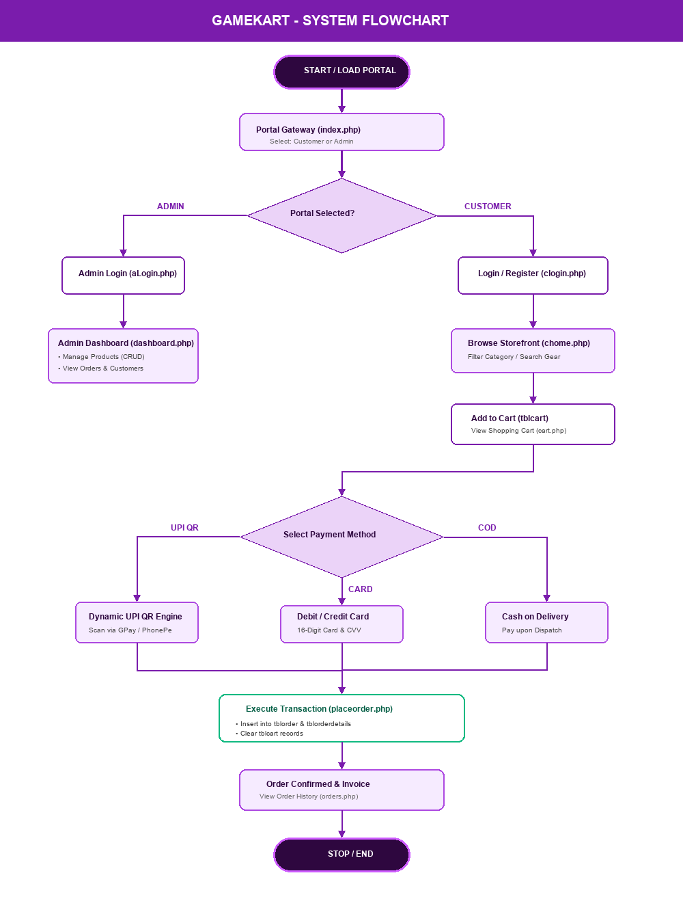
Figure 4.1: GameKart Complete System Flowchart

4.2 Data Flow Diagram (DFD Level 0 - Context Level)
The Context Level DFD (Level 0) models the data boundaries between external entities (Customer, Administrator, UPI Payment API) and the central GameKart processing engine.
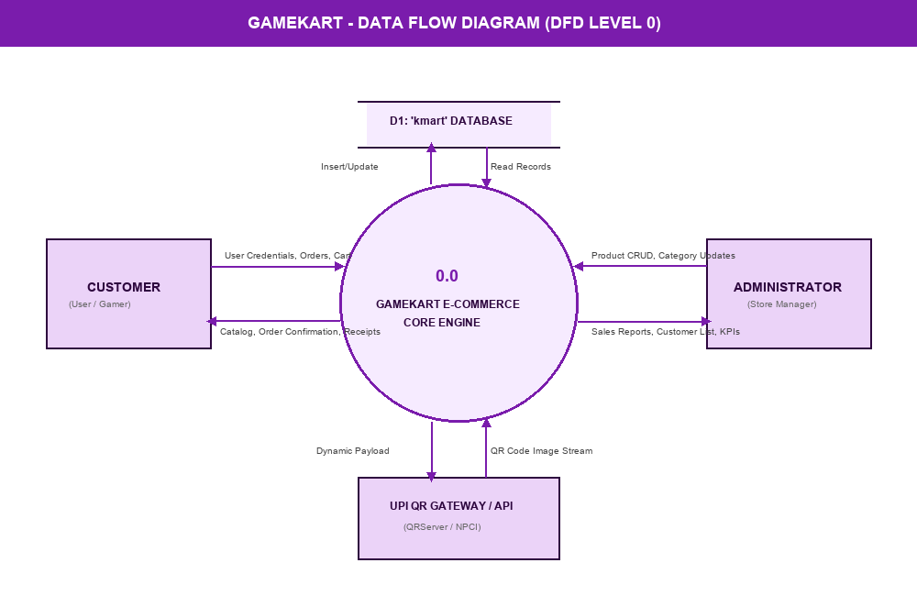
Figure 4.2: Data Flow Diagram (DFD Level 0 Context Level)

4.3 Entity-Relationship (E-R) Diagram
The Entity-Relationship Diagram outlines the 6 normalized database entities (tbluser, tblcat, tblpro, tblcart, tblorder, tblorderdetails), primary/foreign keys, and 1:N cardinality relationships.
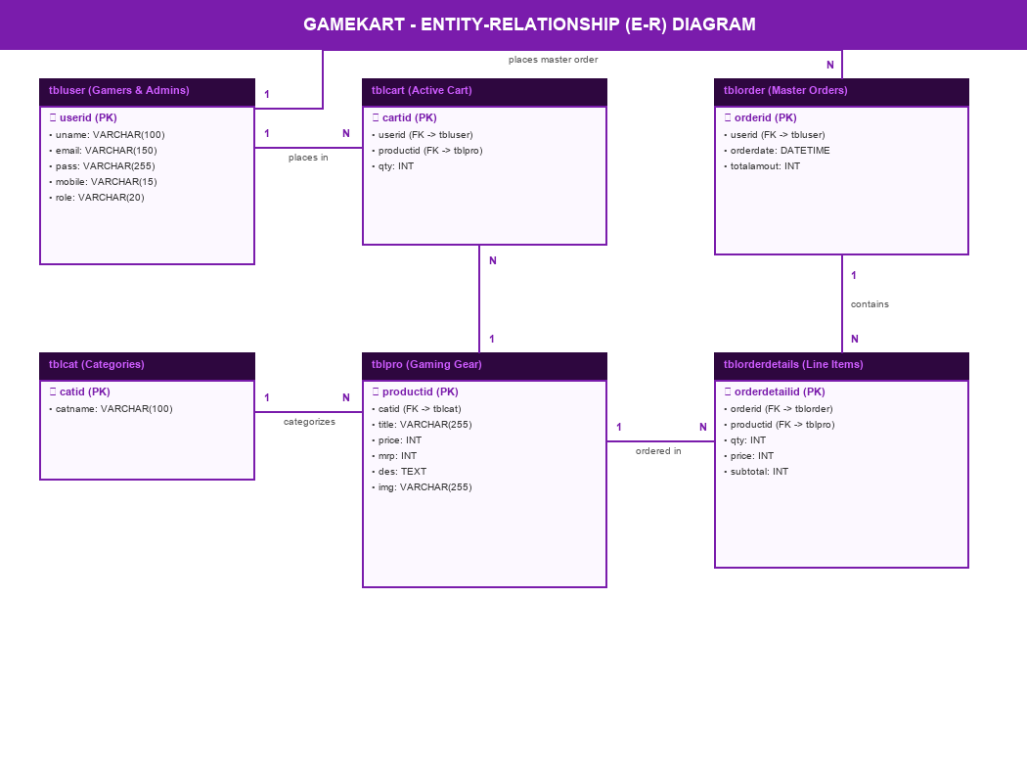
Figure 4.3: Entity-Relationship (E-R) Diagram with Cardinality

4.4 UML Use Case Diagram
The UML Use Case Diagram defines the functional scope available to the Customer and Administrator actors across authentication, product browsing, dynamic payments, and store administration.
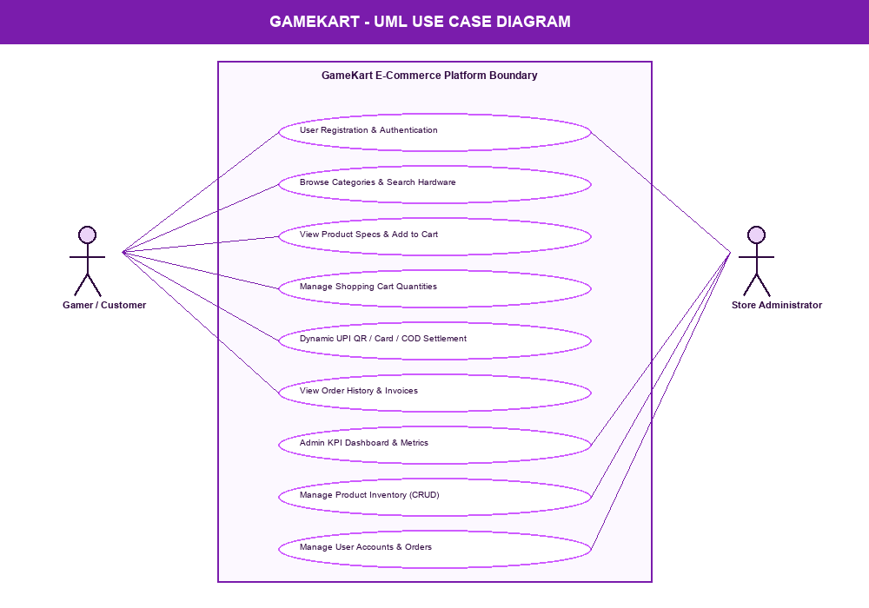
Figure 4.4: UML Use Case Diagram (Customer & Admin Actors)

CHAPTER 5: DATABASE DESIGN & DATA DICTIONARY
5.1 Relational Architecture Overview ('kmart')
Database Architecture: The relational database schema 'kmart' consists of six tables structured to 3NF to eliminate redundancy, avoid update anomalies, and guarantee referential integrity.
Table 5.1: tbluser (User Accounts & Authentication)
Field Name | Data Type | Constraint | Description
userid | INT(11) | PRIMARY KEY, AUTO_INCREMENT | Unique User Identifier
uname | VARCHAR(100) | NOT NULL | Full Name of Gamer / Admin
email | VARCHAR(150) | NOT NULL, UNIQUE | Login Email Address
pass | VARCHAR(255) | NOT NULL | Account Password / Hash
mobile | VARCHAR(15) | NULL | Contact Phone Number
role | VARCHAR(20) | DEFAULT 'user' | Role: 'admin' or 'user'

Table 5.2: tblcat (Product Categories)
Field Name | Data Type | Constraint | Description
catid | INT(11) | PRIMARY KEY, AUTO_INCREMENT | Unique Category ID
catname | VARCHAR(100) | NOT NULL | Category (Console, GPU, Monitor, etc.)

Table 5.3: tblpro (Gaming Products Inventory)
Field Name | Data Type | Constraint | Description
productid | INT(11) | PRIMARY KEY, AUTO_INCREMENT | Unique Hardware ID
catid | INT(11) | FOREIGN KEY -> tblcat(catid) | Category Reference
title | VARCHAR(255) | NOT NULL | Product Commercial Name
price | INT(11) | NOT NULL | Selling Price in INR
mrp | INT(11) | NOT NULL | Maximum Retail Price in INR
des | TEXT | NULL | Hardware Specifications & Features
img | VARCHAR(255) | DEFAULT 'demo.jpg' | Image filename in images/ folder

Table 5.4: tblcart (Active Shopping Cart State)
Field Name | Data Type | Constraint | Description
cartid | INT(11) | PRIMARY KEY, AUTO_INCREMENT | Unique Cart Entry ID
userid | INT(11) | FOREIGN KEY -> tbluser(userid) | User ID owning cart
productid | INT(11) | FOREIGN KEY -> tblpro(productid) | Product added to cart
qty | INT(11) | NOT NULL, DEFAULT 1 | Quantity selected by user

Table 5.5: tblorder (Master Orders Record)
Field Name | Data Type | Constraint | Description
orderid | INT(11) | PRIMARY KEY, AUTO_INCREMENT | Unique Order Identifier
userid | INT(11) | FOREIGN KEY -> tbluser(userid) | Customer who placed order
orderdate | DATETIME | DEFAULT CURRENT_TIMESTAMP | Timestamp of Order Checkout
totalamout | INT(11) | NOT NULL | Grand Total Order Payable (INR)

Table 5.6: tblorderdetails (Order Line Items)
Field Name | Data Type | Constraint | Description
orderdetailid | INT(11) | PRIMARY KEY, AUTO_INCREMENT | Unique Line Item ID
orderid | INT(11) | FOREIGN KEY -> tblorder(orderid) | Parent Order Reference
productid | INT(11) | FOREIGN KEY -> tblpro(productid) | Purchased Product Reference
qty | INT(11) | NOT NULL | Quantity Purchased
price | INT(11) | NOT NULL | Unit Price at time of purchase
subtotal | INT(11) | NOT NULL | Line Subtotal (qty * price)

CHAPTER 6: IMPLEMENTATION DETAILS & SOURCE CODE
6.1 Database Connection & Session Management (conn.php)
The conn.php script initializes secure sessions, defines server error reporting, and establishes connection with MySQL.
<?php
if (session_status() === PHP_SESSION_NONE) {
session_start();
}
$servername = "127.0.0.1";
$username = "root";
$password = "";
$dbname = "kmart";
$con = mysqli_connect($servername, $username, $password, $dbname);
if (!$con) {
die("Database Connection Failed: " . mysqli_connect_error());
}
?>

6.2 Dynamic UPI QR Code Generation Algorithm (cart.php / orders.php)
The dynamic UPI QR algorithm calculates cart totals and formats standard UPI deep links conforming to NPCI specifications:
<?php
$upi_id = "9825904828@fam";
$amount = $total;
$upiUrl = "upi://pay?pa=" . $upi_id . "&pn=GameKart&am=" . $amount . "&cu=INR";
$qr = "https://api.qrserver.com/v1/create-qr-code/?data=" . urlencode($upiUrl) . "&size=220x220";
?>
<!-- HTML Rendering -->
<img src="<?= $qr ?>" width="160" height="160" alt="Live UPI QR Code">
<h4>₹<?= number_format($amount) ?></h4>
<button type="submit" class="pay-btn">I Have Paid</button>

6.3 Checkout Transaction & Multi-Table Insertion (placeorder.php)
Atomic transaction recording items from tblcart into tblorder and tblorderdetails:
<?php
include_once("conn.php");
$userid = (int)$_SESSION['uid'];
$paymentMethod = $_POST['payment_method'] ?? 'UPI';
// 1. Fetch Cart Items & Compute Total
$cartQry = mysqli_query($con, "SELECT c.*, p.price FROM tblcart c JOIN tblpro p ON c.productid=p.productid WHERE c.userid=$userid");
$totalAmount = 0; $items = [];
while ($row = mysqli_fetch_assoc($cartQry)) {
$totalAmount += ($row['qty'] * $row['price']);
$items[] = $row;
}
// 2. Insert into tblorder
$orderdate = date('Y-m-d H:i:s');
mysqli_query($con, "INSERT INTO tblorder(userid, orderdate, totalamout) VALUES($userid, '$orderdate', $totalAmount)");
$orderid = mysqli_insert_id($con);
// 3. Insert Line Items into tblorderdetails
foreach ($items as $it) {
$pid = $it['productid']; $qty = $it['qty']; $pr = $it['price']; $sub = $qty * $pr;
mysqli_query($con, "INSERT INTO tblorderdetails(orderid, productid, qty, price, subtotal) VALUES($orderid, $pid, $qty, $pr, $sub)");
}
// 4. Clear Cart
mysqli_query($con, "DELETE FROM tblcart WHERE userid=$userid");
?>

CHAPTER 7: SYSTEM TESTING & TEST CASES
7.1 Testing Strategy & Quality Assurance
Testing Methodology: A multi-tiered testing strategy was executed comprising Unit Testing (validating PHP backend functions and input handlers), Integration Testing (verifying database CRUD and atomic checkout transactions), and User Acceptance Testing (testing responsiveness and UX across devices).

7.2 Test Cases Execution Matrix
TC ID | Test Scenario | Input Data | Expected Result | Status
TC-01 | User Registration | Valid name, email, password | Record inserted into tbluser; session initialized | PASS
TC-02 | User Login (Valid) | Registered email & correct password | Redirect to chome.php with active session | PASS
TC-03 | User Login (Invalid) | Wrong password / unregistered email | Alert banner displayed: 'Invalid credentials' | PASS
TC-04 | Add to Cart | Product ID: 1, Qty: 1 | Item stored in tblcart; navbar badge increments | PASS
TC-05 | Update Cart Quantity | Change Qty from 1 to 3 | Subtotal and Grand Total recalculated instantly | PASS
TC-06 | Remove Item from Cart | Click Delete button on cart item | Item deleted from tblcart; table refreshed | PASS
TC-07 | Dynamic UPI QR Generation | Cart total: ₹90,484 | QR Server API generates live deep-link payload | PASS
TC-08 | Card Validation & Format | 16-digit card, MM/YY, CVV | Input fields formatted; checkout enabled | PASS
TC-09 | Order Checkout Transaction | Click 'I Have Paid' / 'Place Order' | tblorder and tblorderdetails populated; cart cleared | PASS
TC-10 | Admin Product Insertion | Title, Price, MRP, Spec, Image file | Product appears instantly in catalog and tblpro | PASS

CHAPTER 8: SYSTEM SCREENSHOTS & USER INTERFACE
8.1 Portal Gateway (index.php) & Gamer Storefront (chome.php)
The entry portal allows users to choose between the Gamer Storefront and the Admin Control Center, leading to the high-performance gaming catalog.
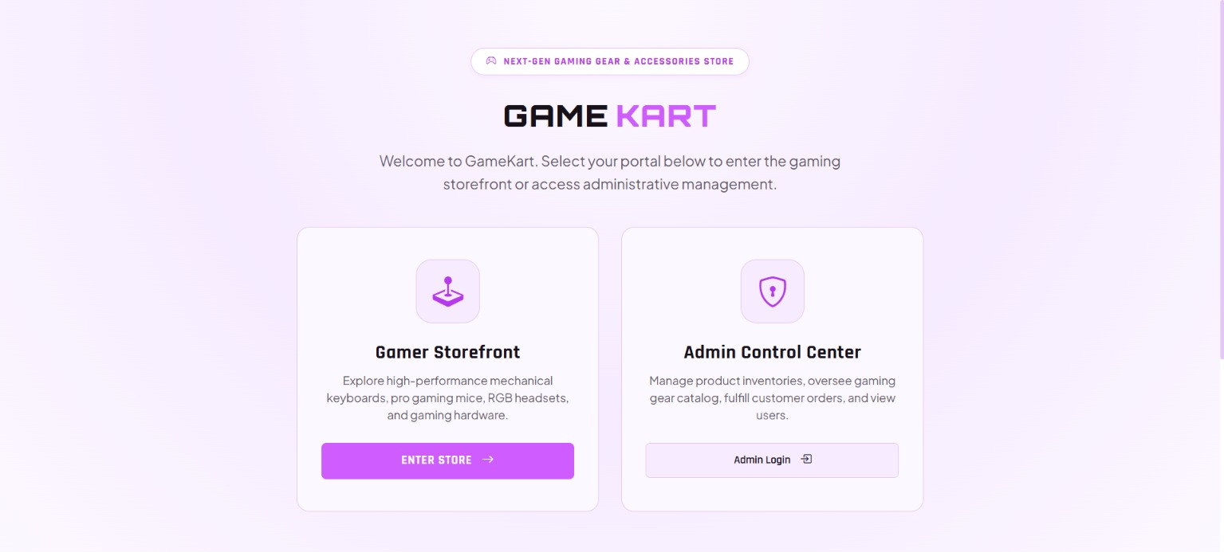
Figure 8.1: GameKart Portal Gateway & Role Selector (index.php)

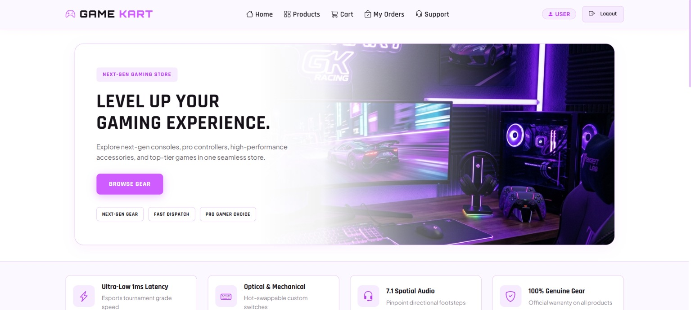
Figure 8.2: Gamer Storefront & Featured Pro Hardware Showcase (chome.php)

8.2 Product Details (cviewproduct.php) & Shopping Cart (cart.php)
Customers can inspect technical specifications, select quantities, and complete transactions using the dynamic UPI QR generator or alternative payment cards.
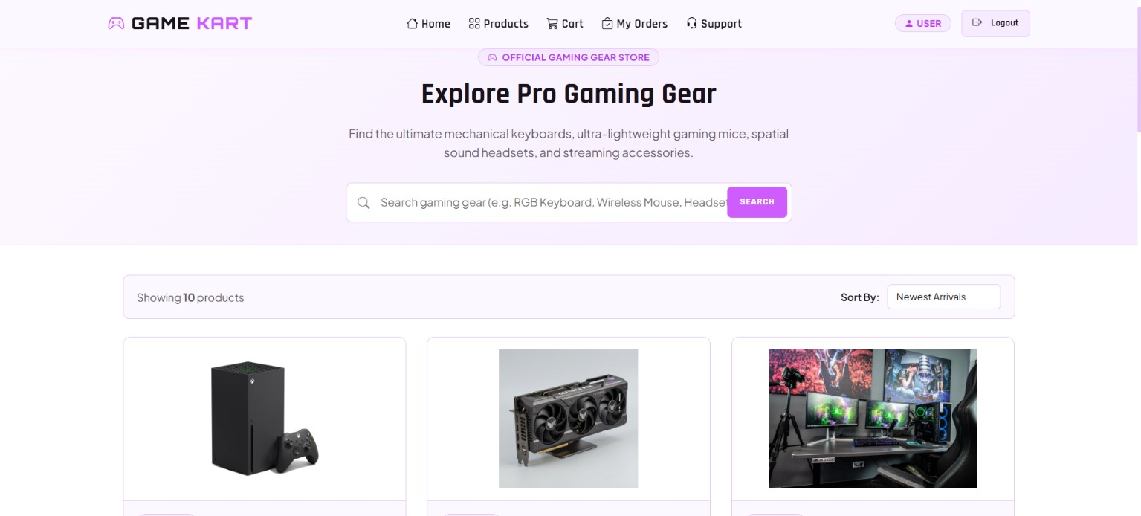
Figure 8.3: Product Detailed View & Technical Specifications (cviewproduct.php)

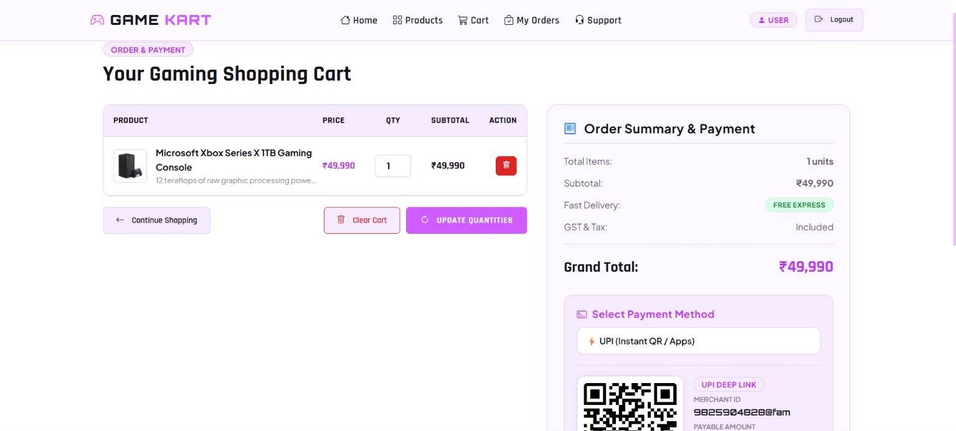
Figure 8.4: Shopping Cart & Live Dynamic UPI QR Settlement (cart.php)

8.3 Customer Orders (orders.php) & Admin Control Center (dashboard.php)
Customers can review dispatched orders and download invoices, while administrators monitor live financial KPIs and manage inventory.
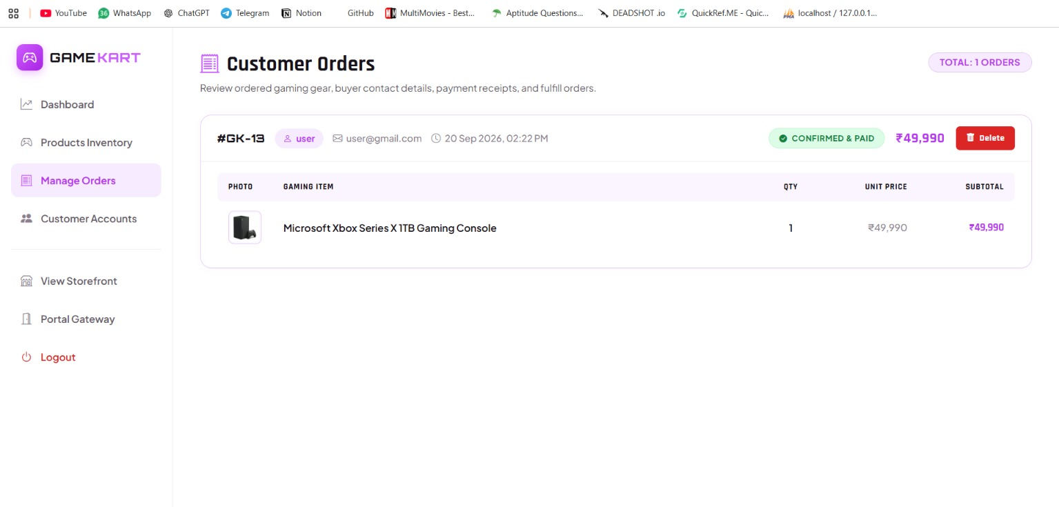
Figure 8.5: Customer Order History & Invoices (orders.php)

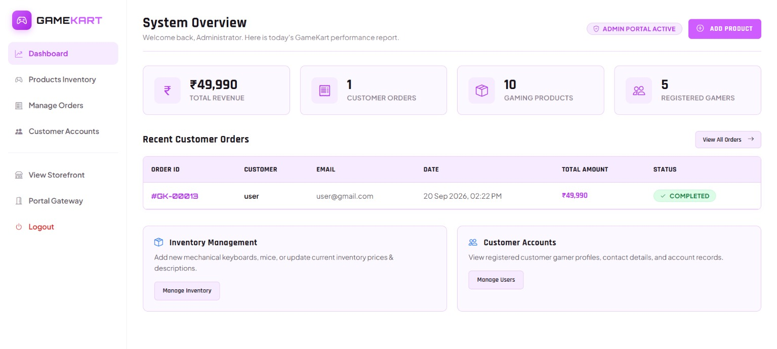
Figure 8.6: Admin Mission Control & Real-Time Financial KPIs (dashboard.php)

CHAPTER 9: LIMITATIONS, FUTURE ENHANCEMENTS & CONCLUSION
9.1 Limitations of Current System
- Payment Callback Webhooks: Uses client-side confirmation rather than automated server-to-server bank webhooks.
- SMS Gateway: Invoices are viewed on-screen rather than dispatched via SMS/WhatsApp.
9.2 Future Enhancements
- Integration with automated Razorpay / Cashfree webhook verification.
- AI-Powered Battlestation Configurator recommending compatible hardware combinations based on budget.
- Progressive Web App (PWA) offline caching for mobile devices.
9.3 Conclusion
Conclusion: The GameKart E-Commerce Platform successfully accomplishes all requirements for the TYBCA Minor Project in Advanced Web Development (AWD) and Web Frameworks / Full Stack (WFS). The application integrates modern UI aesthetics, dynamic UPI QR payment settlement, robust PHP 8.x backend session handling, and normalized MySQL relational structures.
CHAPTER 10: REFERENCES & BIBLIOGRAPHY
10.1 Books & Textbooks
- Nixon, Robin. 'Learning PHP, MySQL & JavaScript: With jQuery, CSS & HTML5', 6th Edition, O'Reilly Media, 2021.
- Welling, Luke & Thomson, Laura. 'PHP and MySQL Web Development', 5th Edition, Addison-Wesley Professional, 2017.
- Duckett, Jon. 'HTML and CSS: Design and Build Websites', 1st Edition, John Wiley & Sons, 2011.
- Silberschatz, Abraham, Korth, Henry & Sudarshan, S. 'Database System Concepts', 7th Edition, McGraw-Hill, 2019.
10.2 Technical Manuals & Official Documentation
- PHP Documentation: PHP 8.x Official Manual: https://www.php.net/manual/en/
- MySQL Documentation: MySQL 8.0 Reference Manual: https://dev.mysql.com/doc/refman/8.0/en/
- Bootstrap Framework: Bootstrap 5.3 Component Library: https://getbootstrap.com/docs/5.3/
- NPCI UPI Specs: NPCI Unified Payments Interface (UPI) Specifications: https://www.npci.org.in/
- QR Server Engine: QR Server Public REST API: https://goqr.me/api/
- W3C Standards: W3C Web Standards & HTML5 / CSS3 Specifications: https://www.w3.org/

