PES University — Dept. of CSE
Lab 1: Requirements Engineering & UML Use-Case Modelling
Problem Statement #45 — Multi-Cloud Asset Cost Optimization Portal
Developer Tools & IT Operations

1. Problem Context & Overview
A FinOps analytics portal that ingests AWS, Azure, and GCP billing CSV exports, identifies unattached storage volumes and idle compute instances, and dispatches budget breach alerts to stakeholders.
Target Stakeholders / Actors: FinOps Analyst, Cloud Administrator (with the Cloud Billing System and Notification Service as supporting external systems).

2. Deliverables in this Document
- Complete Requirements Table — 5 Functional Requirements (FR-001–FR-005) and 2 Non-Functional Requirements (NFR-001–NFR-002)
- UML Use-Case Diagram — all actors and primary use cases, including one «include» and one «extend» relationship
- Use-Case Flow Specification — Preconditions, Postconditions, Main Success Scenario, and one Alternate Flow for the core use case "Monitor Budget Threshold & Dispatch Breach Alert"

3. Requirements Table
Functional Requirements (FR-001 – FR-005) and Non-Functional Requirements (NFR-001 – NFR-002).
ID | Type / Priority | Description | Priority | Acceptance Criteria | Rationale
FR-001 | Functional | The system shall ingest cloud billing CSV exports from AWS, Azure, and GCP, categorize costs by service and project tag, and flag compute instances with average CPU utilization below 5% over a rolling 14-day window as idle. | High | Pass: An idle instance is flagged with a monthly savings estimate within 24 hours of CSV ingestion.  Fail: An active instance (>5% CPU) is misclassified as idle, or a valid service/project tag is omitted during categorization. | Idle-compute detection is the core value proposition of the portal and directly drives the cost-savings recommendations FinOps analysts rely on.
FR-002 | Functional | The system shall scan ingested storage billing records across all three cloud providers and identify unattached (orphaned) storage volumes that have not been mounted to any compute instance for more than 7 consecutive days. | High | Pass: An unattached volume older than 7 days appears in the "Unattached Assets" view with provider, size, and estimated monthly cost.  Fail: A volume currently attached to a running instance appears in the unattached list. | Orphaned storage volumes are a common, easily overlooked source of recurring cloud waste; automated detection removes the need for manual cross-account audits.
FR-003 | Functional | The system shall allow a FinOps Analyst to configure a monthly budget threshold per cloud account or project, continuously compare actual and projected spend against the threshold, and dispatch an alert to designated stakeholders when the threshold is breached. | High | Pass: An alert is dispatched within 5 minutes of spend crossing 90% of the configured threshold, including account, current spend, and projected overage.  Fail: No alert is generated on breach, or a duplicate alert is sent for the same breach event within 24 hours. | Proactive breach notification prevents budget overruns and is a primary reason FinOps teams adopt cost-governance tooling.
FR-004 | Functional | The system shall render an interactive cost dashboard that visualizes spend by provider, service, and project, and displays cumulative estimated monthly savings from flagged idle instances and unattached volumes. | Medium | Pass: Dashboard reflects the most recently ingested billing data and updates savings totals when an asset is marked as remediated.  Fail: Dashboard shows data older than the last successful ingestion cycle. | Visualization converts raw billing data into decision-ready insight, enabling analysts to prioritize remediation effort.
FR-005 | Functional | The system shall allow a FinOps Analyst to export a savings and cost-optimization report (PDF/CSV) filtered by date range, provider, and project, restricted to users with the Analyst or Administrator role. | Medium | Pass: An authorized user downloads a report matching the selected filters within 30 seconds.  Fail: A user without Analyst/Administrator role can generate or access an export. | Exportable reports support cross-team budget reviews and audits, while role restriction protects sensitive billing data.
NFR-001 | Performance & Security | The portal must parse multi-gigabyte cloud billing CSV files (up to 5 GB) and refresh cost dashboards in under 2 minutes under a simulated peak load of 50 concurrent ingestion jobs. | High | Pass: Benchmark tests confirm dashboard refresh completes within 2 minutes for a 5 GB file under peak simulated load.  Fail: Refresh exceeds 2 minutes or the ingestion pipeline fails under load. | FinOps decisions are time-sensitive; slow ingestion delays idle-asset remediation and increases realized cloud spend.
NFR-002 | Security | The system shall enforce role-based access control (FinOps Analyst, Cloud Administrator), encrypt billing data at rest (AES-256) and in transit (TLS 1.2+), and maintain an immutable audit log of all configuration changes and alert dispatches. | High | Pass: A penetration test confirms no role can access another role's data, and all data transfers are verified as TLS-encrypted.  Fail: Any billing data is transmitted or stored unencrypted, or an audit log entry is missing for a configuration change. | Billing data reveals sensitive organizational spend patterns; strong access control and encryption are required for enterprise adoption and compliance.

4. UML Use-Case Diagram
Actors: FinOps Analyst and Cloud Administrator (primary/human actors); Cloud Billing System and Notification Service (supporting system actors). The diagram includes one «include» relationship (Ingest Billing CSV Data includes Validate File Format) and one «extend» relationship (Escalate Critical Alert extends Monitor Budget & Dispatch Alert).
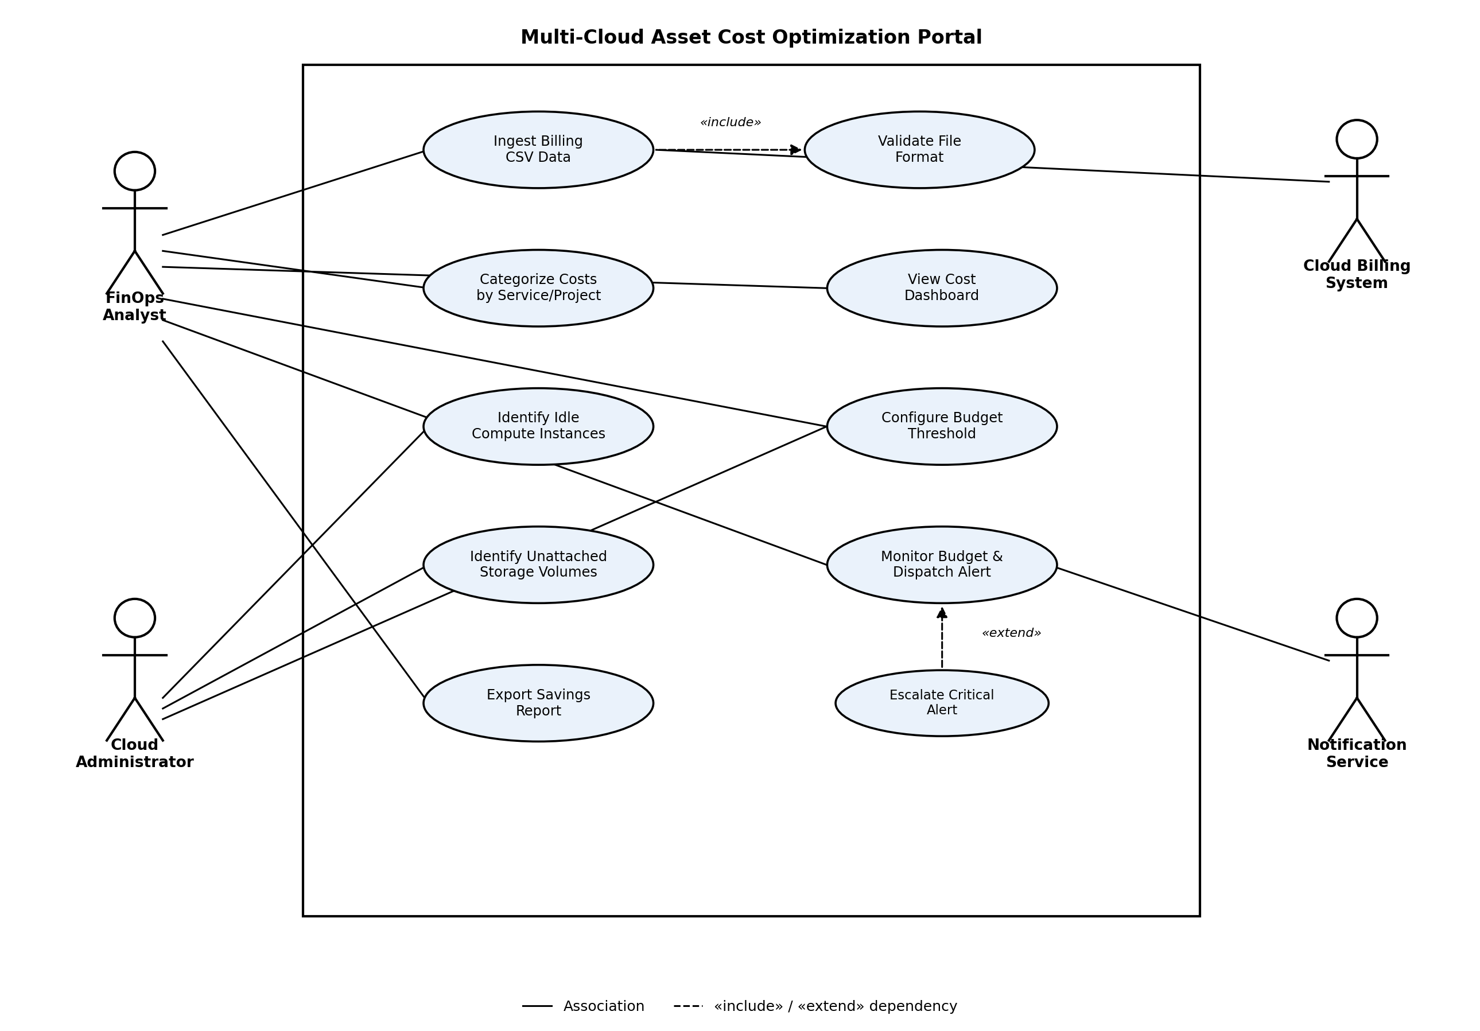

5. Use-Case Flow Specification
Use Case: Monitor Budget Threshold & Dispatch Breach Alert
Primary Actor: FinOps Analyst | Secondary Actor: Notification Service, Cloud Administrator
Preconditions
- The FinOps Analyst is authenticated and holds the Analyst or Administrator role.
- At least one budget threshold has been configured for the target cloud account/project (see Configure Budget Threshold).
- Billing data for the current period has been successfully ingested and categorized (see Ingest Billing CSV Data).
Postconditions
- Success: An alert has been generated and delivered to the configured recipients, and the breach event is recorded in the audit log with a timestamp and spend snapshot.
- Failure: No alert is delivered; the breach status remains "Pending" for retry.
Main Success Scenario
- 1. The system recalculates projected month-end spend every 5 minutes for each configured budget threshold, using the latest ingested billing data.
- 2. The system compares projected spend against the configured threshold percentage (default 90%).
- 3. The system detects that projected spend for a project has crossed the threshold.
- 4. The system composes a breach alert containing the account/project name, current spend, projected spend, and threshold percentage.
- 5. The system dispatches the alert via the Notification Service to the recipients configured by the FinOps Analyst (email and/or webhook).
- 6. The Notification Service confirms successful delivery.
- 7. The system records the breach event, alert content, and delivery confirmation in the audit log.
- 8. The system updates the budget's status indicator on the dashboard to "Breached."
Alternate Flow A1 — Notification Delivery Failure
- 5a. If the Notification Service returns a delivery failure at step 5 (e.g., invalid webhook endpoint, bounced email):
- 5a.1 The system logs the delivery failure with the error reason.
- 5a.2 The system retries delivery up to 3 times with exponential backoff (1, 5, 15 minutes).
- 5a.3 If all retries fail, the system flags the alert as "Undelivered" on the dashboard and notifies the Cloud Administrator to check the recipient configuration.
- 5a.4 The use case resumes at step 7, with delivery status recorded as "Failed."
Extension — Escalate Critical Alert («extend»)
- 3a. If projected spend exceeds 100% of the threshold (a critical breach rather than a warning-level breach), the extension point «Escalate Critical Alert» is triggered.
- 3a.2 The system marks the alert severity as "Critical" and adds the Cloud Administrator to the recipient list, in addition to the FinOps Analyst.
- 3a.3 The use case resumes at step 4 with the elevated severity applied.

