E-Commerce Sales Funnel & Revenue Analysis

- What is the number of unique users at each stage of the sales funnel,
from page view to add to cart, checkout, payment information, and final purchase?

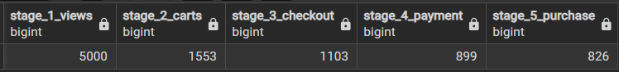

- What is the conversion rate between each stage of the sales funnel,
and what percentage of visitors ultimately complete a purchase?

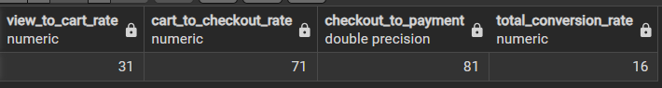

- How does the sales funnel perform across different traffic sources,
and which traffic sources generate the highest number of purchases and conversion rates?

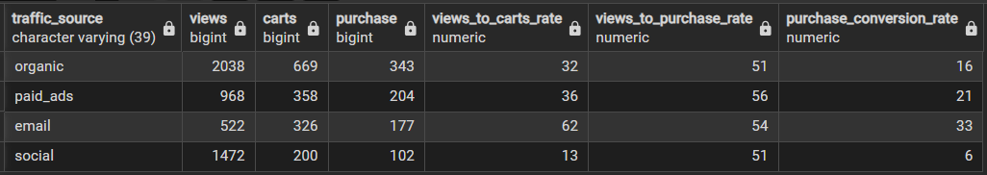

- How much time do converted users take to move from page view to cart,
from cart to purchase, and from the initial view to the final purchase?

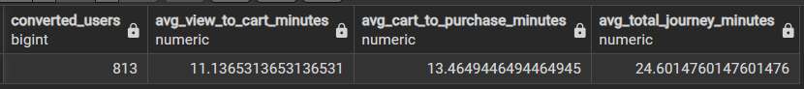

- What is the overall revenue performance of the sales funnel,
including total visitors, purchasing users, total revenue, average order value,
and average revenue generated per visitor?



