

**Computer Science and Engineering**

**Building Management System (BMS)**

**Analysis Specification – Version 3.0**

Document Number: Analysis Specification-001

Team Number: C9

Team Members:

|  |  |
| --- | --- |
| **NAME** | **NYU EMAIL** |
| Tenzing Rabgyal | tr1440@nyu.edu |
| Samarthraj Balachandra Hegde | sh4636@nyu.edu |
| Sivakumar Srikumar | ss11437@nyu.edu |

**Revision History**

|  |  |  |
| --- | --- | --- |
| **Date** | **Version** | **Description of Change** |
| 10/13/2018 | 1.0 | Initial Document |
| 11/05/2018 | 2.0 | Added Requirements section |
| 12/04/2018 | 3.0 | Added Analysis section |

Table of Contents

**1 Introduction**

* 1. Purpose

**2 Scope**

2.1 Identification

2.2 Bounds

2.3 Objectives

2.4 System Overview

**3 Business Requirements**

3.1 Technology

3.2 Economics

3.3 Regulatory and Legal

3.4 Market Considerations

3.5 Risk and Alternatives

3.6 Human Resources and Training

**4 Context Diagram**

4.1 Diagram

**5 Requirements**

5.1 Functional Descriptive Requirements

5.2 Requirement Use Cases

5.3 Use Case Diagrams

5.4 Non-Functional Descriptive Requirements

**6 Analysis**

6.1 Component Architecture Diagram

6.2 Component Descriptions

6.3 Class Diagrams

6.4 Class Relationship/Interaction Diagrams

6.5 Events

6.5.1 Motives

6.5.2 Event Diagrams

6.6 Activity/State Diagrams

6.7 State Logic Diagram

6.8 Sequence Diagram

**7 Dictionaries**

7.1 Class

7.2 Methods

7.3 Attributes

7.4 Relationships

7.5 Key Event

1. Introduction

1.1 Purpose

The purpose of this document is to identify the business requirements of Building Management System (BMS). It provides a high-level overview and objectives of the system. It analyzes the various business requirements of the system. It also provides a high-level Context Diagram of the system which shows how external systems interact with BMS.

The audience of this document are:

* Client
* Software Development Team
* Project Management

2. Scope

2.1 Identification

Team Name: Team C9

Project Name: Building Management System (BMS)

Version Number: 1.0

Date: 10/17/2018

2.2 Bounds

The BMS consists of several sub-systems which could be either internal and external to the system. The BMS will receive inputs from some of the external systems or entity and provides the office security and climate control of the leased zone.

The system shall have the following external systems:

1. The Heating, Ventilating, And Cooling(HVAC) Systems
2. The Lighting System.
3. Magnetic Card Reader (which will also have a number pad on it)
4. Thermostat
5. Door lock
6. Security Alarm

The system shall have the following internal system:

1. Database to store various information
2. Notification mechanism.

2.3 Objectives

Deliverable Dates:

|  |  |
| --- | --- |
| Project Deliverables | Date |
| Project Proposal | 9/26/2018 |
| Project Business Requirements | 10/17/2018 |
| Project Requirements | 11/07/2018 |
| Project Analysis | 11/28/2018 |
| Presentation | 12/05/2018 |

2.4 System Overview

BMS is an integrated system which enables building owners to provide their lessees a better service and reduce operational costs at the same time. BMS is able to achieve this via integrating various sub-systems such as card reader system, climate control system, notification system, database system, etc. These subsystems, which may be internal or external to the BMS, are integrated to provide the building owner and the building lessee a greater service.

The primary responsibilities of the BMS are office security and office climate control. The BMS shall have the following features:

* Control the climate/lighting of the zones via set points from the building lessee
* Have a security feature (make use of card readers & number pads)
* Have a database that holds the following info:
  + Which businesses have rented which zones of the building as office space
  + What are the set points for each day set by the lessee
  + What are the security features of each door defined by the lessee
* The lessee has the ability to disable the doors between rooms with the same clearance level
* The building supervisor has the ability to release a room from zone control at the request of an employee
* The system should set up an alarm to notify the security guard of a security breach if an employee is denied access 5 times in a 15-minute period at the same door.

3. Business Requirements

3.1 Technology

BMS shall have a micro-controller which sends commands to the HVAC, lighting system, door locks. The micro-controller shall be programmed to control the external components in such a way that lessees receive a high level of services while reducing operational costs at the same time. BMS will maintain a database to store all the information such as set points, businesses which have leased zones in the building, security features of each door. BMS will set off an alarm in case of security breach.

3.2 Economics

The fundamental aspect of BMS is to provide the property owners greater management control at reduced operational costs. Hence the concept of cost-saving, in BMS, is achievable to a considerable extent but not completely (due of security feature where one could not possibly compromise). But here are a few ways one could save money:

1. Federal Energy Rebate: Almost all states in the US provides up to $3000 HVAC rebate to people who have installed a qualified system using a qualified installer.
2. Installation of efficient lighting: One can choose compact fluorescents over incandescent bulbs which can last up to nine times longer. This provides much more efficient lighting and cost savings in the long run.
3. Installation of programmable thermostats: This provides automatic temperature control and helps save energy.

3.3 Regulatory and Legal

Regulations are inevitable in a business aspect and focuses primarily on the protection of the consumers. There are various regulations fabricated by regulatory bodies of different states in the US to ensure smooth transactions between consumers and business owners. Hence it is the fundamental duty of a business corporation to follow these regulations. With the creation of the new administration in US in 2017, a number of new regulations have been introduced for the HVAC control system. The primary duty of HVAC system is the air filtration, which results in the emission of Ozone Depleting Substances (ODS). The section 608 of the Clean Air Act was revised by including new requirements in the handling of Ozone Depleting Substances (ODS) such as chloroflourocarbons (CFC) and hydrochloroflourocarbons (HCFC) in air conditioning and hydroflourocarbons (HFC) in refrigeration equipment as these as highly hazardous to the stratospheric ozone.

Electronic Access Control Systems play a pivotal role in ensuring proper authorization of valid people entering and leaving various rooms and zones in a commercial building. It is mandatory for a commercial building to acquire UL294 certificate issued by Underwriters Laboratory, an organization accredited by the American National Standard Institute (ANSI). There are over 1500 standards set for various industries to qualify for this certificate. A few of them include the following:

1. The access control system should be installed in a visible position under proper lighting.
2. Should be operable with single hand.
3. The doors should automatically lock once the power supply is disconnected.

3.4 Market Considerations

BMS aims to provide climatic control and higher level of security services to buildings. The major consumers here are the employees of different businesses and other staff members of the building. This could be extended to be used in other locations such as shopping malls which is accessed by the public, in airports, in regular households etc. By adding specific features in our system, BMS can provide support to various applications.

3.5 Risks and Alternatives

**Business Risk:** Another company creates a product that performs the functionality of the BMS System but is more cost effective and/or performs better.

* **Probability:** Medium to High
* **How discovered:** There are talented companies that are interested in entering the Building Management Software sector.
* **Responsible Party:** Other companies
* **Status:** Future Consideration
* **Mitigation Plan:** The key to a successful company in this sector is a great product and customer satisfaction.

**Operational Risk:** Degradation of software quality.

* **Probability:** Medium
* **How discovered:** A degradation in the software quality is a risk that is common and should be considered.
* **Responsible Party:** Employees
* **Status:** In Progress
* **Mitigation Plan:** Team C9 will prevent the risk of degradation of software quality by:
  + - * + Attracting the best talent by investing heavily in employee salaries and benefits.
        + Use SCRUM for software development.

**Technology Risk:** System’s security gets breached.

* **Probability:** High
* **How discovered:** Security breaches are expected.
* **Responsible Party:** Hackers
* **Status:** In Progress
* **Mitigation Plan:** Our software engineers will put an emphasis on security while building the system. Tests to breach the system’s security will run regularly and in multiple phases of the software development lifecycle.

**Economic Risk:** The client loses the budget for the Building Management System.

* **Probability:** Low
* **How discovered:** While the probability is low, this is a risk that should be considered.
* **Responsible Party:** Client
* **Status:** Future Consideration
* **Mitigation Plan:** Our software team will use SCRUM framework in order to be able to adapt to rapid change.

3.6 Human Resources and Training

Not applicable. This section will be updated at a later date.

4. Context Diagram

4.1 Diagram

High Level Context Diagram (Level 0 DFD)

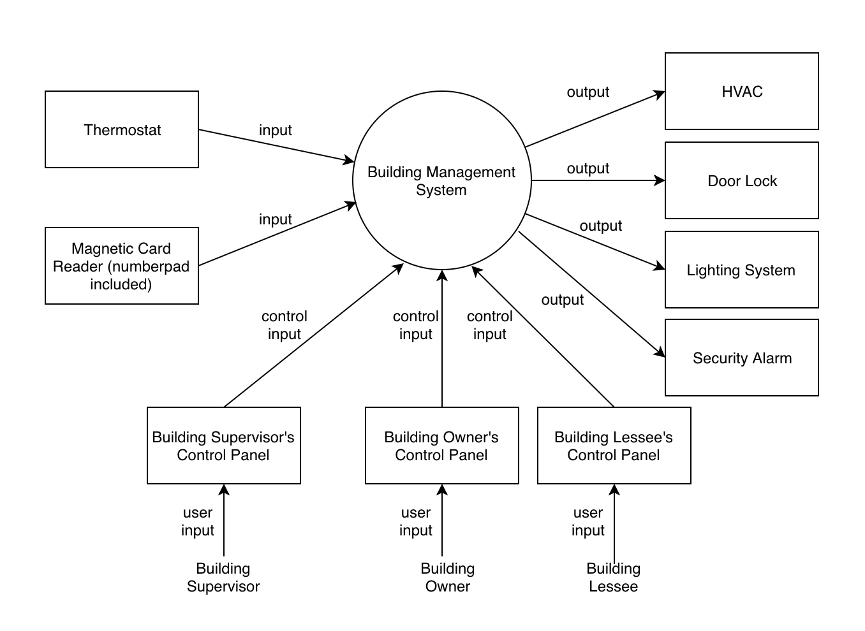

5. Requirements

5.1 Functional Descriptive Requirements

**1. The building lessee shall have the ability to:**

1. **Establish the set points of climate/lighting of the zone.**
2. **Set/disable the security levels of each door inside the zone.**

This requirement allows the building lessee to have a greater control over the climate and security of the office environment. The Building Lessee shall be able to access the system via *Building Lessee’s Control Panel*.

**2. The building owner shall have the ability to:**

1. **Combine rooms into a zone that can be leased to a business.**
2. **Remove certain rooms from being able to be leased.**
3. **Add/remove/edit building lessees’ information.**

This requirement allows the building owner to have a greater management control over their building. The building owner shall be able to make the changes listed above via *Building Owner’s Control Panel*.

**3. The building supervisor shall be able to release a room from zone control at the request of an employee.**

An employee can request to the building supervisor to release a certain room from the zone’s set point. The building supervisor is able to make this change via *Building Supervisor’s Control Panel*.

**4. After the set point is released for a particular room, the employee shall be able to set the desired temperature via thermostat:**

The business might lower the temperature of the zone to save money on heating bills during weekends or off hours. If an employee working in a room is uncomfortable, upon the authority to do so, he/she can use the thermostat setting in that room to set the desired temperature instead of the fixed set point.

**5. The employee shall be able to interact with the magnetic badge reader and number pad in order to access a room with a higher security level:**

If an employee wants to enter a room with a higher security clearance, he/she is required to interact with the magnetic badge reader. Employees are required to tap their ID badge on the magnetic badge reader and must be able to identify that they are in fact the person designated by the ID badge by entering a five-digit code on the number pad.

**6. The security guard shall be alerted about a security breach by the system if an employee is denied access 5 times in a 15-minute period at the same door:**

Security checks are executed only when an employee desires entry to a room with a higher security level than the room in which the employee currently occupies. Security breach occurs when an employee tries to enter of room with higher security clearance. If the same employee is denied access 5 times within 15-minute period at the same door then the system notifies the security guard by setting off an alarm.

5.2 Requirement Use Cases

List of actors that interact with the Building Management System (BMS):

* Building Lessee
* Building Owner
* Building Supervisor
* Employee

Use Cases:

1. Building Lessee sets the climate set points.
2. Building Lessee changes the security level of a room.
3. Building Owner removes a room from being able to be leased.
4. Building Supervisor releases the climate set point of a room.
5. Employee changes the temperature setting of a particular room via Thermostat.
6. Employee tries to enter a room unsuccessfully 5 times within 15 minutes, which sets off the security alarm.

5.3 Use Case Diagrams

Use Case #1:

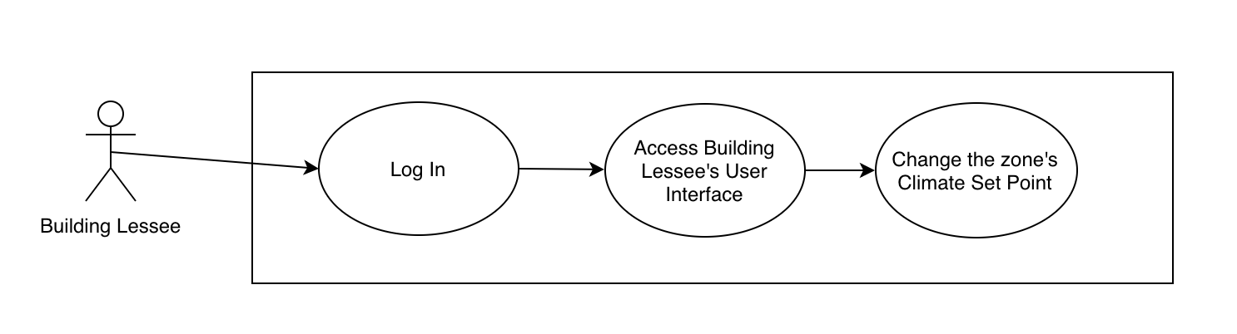

|  |  |  |
| --- | --- | --- |
| **Functional requirement that this Use Case is derived from:** #1 | | |
| **Description** | Building Lessee sets the climate set points. | |
| **Pre-Conditions** | The actor (Building Lessee) has access to BMS via *Building Lesse’s Control Panel*. | |
| **Flows** | **Basic or Normal Flows** | 1. The actor inserts his/her credentials on the ‘Log In’ page. 2. The actor gains access to *Building Lessee’s UI*. 3. The actor changes the zone’s climate setpoint. |
|  | **Alternative Flows** | None |
| **Post Conditions** | The actor (Building Lessee) has successfully changed the zone’s Climate Set Point. | |
| **Special Requirements** | The Building Lessee needs to have a valid username and password in order to access the BMS. | |

Use Case #2:

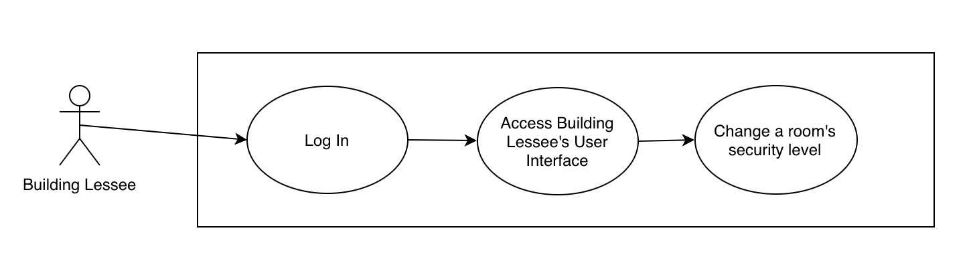

|  |  |  |
| --- | --- | --- |
| **Functional requirement that this Use Case is derived from:** #1 | | |
| **Description** | Building Lessee changes the security level of a room. | |
| **Pre-Conditions** | The actor (Building Lessee) has access to BMS via *Building Lesse’s Control Panel*. | |
| **Flows** | **Basic or Normal Flows** | 1. The actor inserts his/her credentials on the ‘Log In’ page. 2. The actor gains access to *Building Lessee’s UI*. 3. The actor changes the room’s security level. |
|  | **Alternative Flows** | None |
| **Post Conditions** | The actor (Building Lessee) has successfully changed the room’s security level. | |
| **Special Requirements** | The Building Lessee needs to have a valid username and password in order to access the BMS. | |

Use Case #3:

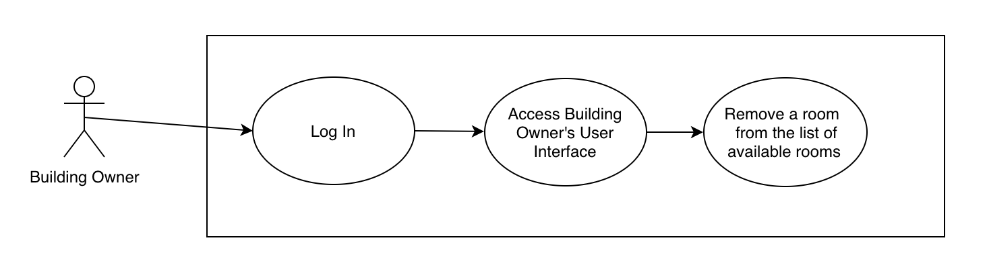

|  |  |  |
| --- | --- | --- |
| **Functional requirement that this Use Case is derived from:** #2 | | |
| **Description** | Building Owner removes a room from being able to be leased. | |
| **Pre-Conditions** | The actor (Building Owner) has access to BMS via *Building Owner’s Control Panel*. | |
| **Flows** | **Basic or Normal Flows** | 1. The actor inserts his/her credentials on the ‘Log In’ page. 2. The actor gains access to *Building Owner’s UI*. 3. The actor removes a room from the list of available rooms. |
|  | **Alternative Flows** | The actor adds a room to the list of available rooms. |
| **Post Conditions** | The actor (Building Owner) has successfully removed a room from the list of available rooms. | |
| **Special Requirements** | The Building Owner needs to have a valid username and password in order to access the BMS. | |

Use Case #4:

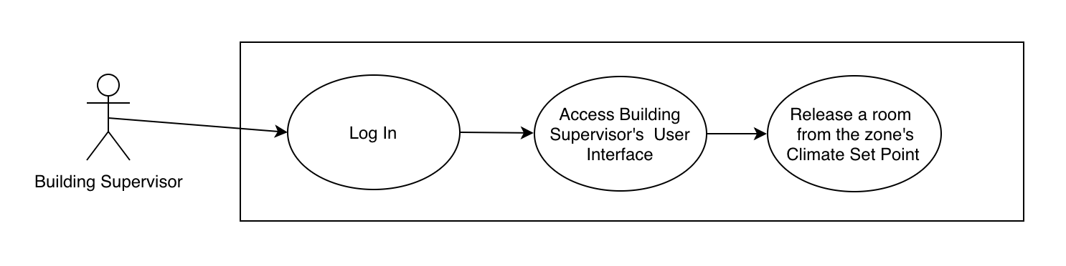

|  |  |  |
| --- | --- | --- |
| **Functional requirement that this Use Case is derived from:** #3 | | |
| **Description** | Building Supervisor releases the climate set point of a room. | |
| **Pre-Conditions** | The actor (Building Supervisor) has access to BMS via *Building Supervisor’s Control Panel*. | |
| **Flows** | **Basic or Normal Flows** | 1. The actor inserts his/her credentials on the ‘Log In’ page. 2. The actor gains access to *Building Supervisor’s UI*. 3. The actor releases a room from the zone’s Climate Set Point. |
|  | **Alternative Flows** | None |
| **Post Conditions** | The actor (Building Supervisor) has successfully released a room from the zone’s Climate Set Point. | |
| **Special Requirements** | The Building Supervisor needs to have a valid username and password in order to access the BMS. | |

Use Case #5:

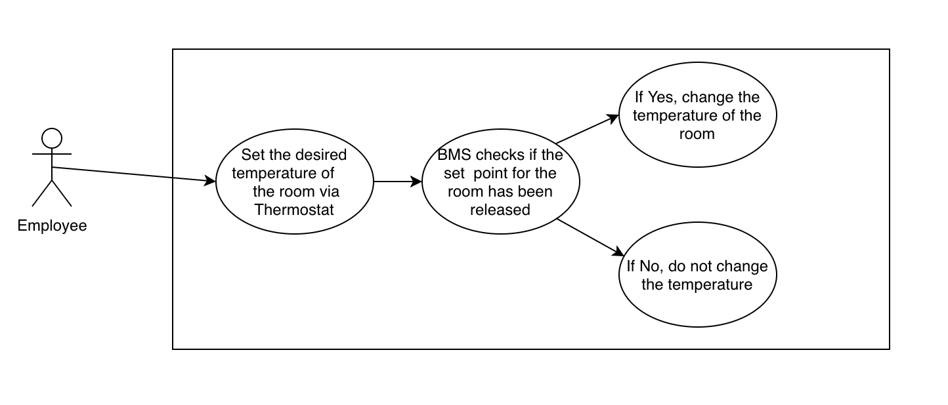

|  |  |  |
| --- | --- | --- |
| **Functional requirement that this Use Case is derived from:** #4 | | |
| **Description** | Employee changes the temperature setting of a particular room via Thermostat. | |
| **Pre-Conditions** | The Building Supervisor must release the room from zone’s Climate Set Point prior to the actor (Employee) changing the temperature via Thermostat. | |
| **Flows** | **Basic or Normal Flows** | 1. The actor sets the desired temperature of the room via Thermostat. 2. The BMS checks that the pre-condition was met. 3. The room temperature is set according to the Thermostat. |
|  | **Alternative Flows** | 1. The actor sets the desired temperature of the room via Thermostat. 2. The BMS checks that the pre-condition was NOT met. 3. The room temperature is NOT set according to the Thermostat. |
| **Post Conditions** | The actor (Employee) has successfully changed the temperature of the room. | |
| **Special Requirements** | 1. The Employee must have access to the Thermostat. 2. The Employee must have the ability to use the Thermostat. | |

Use Case #6:

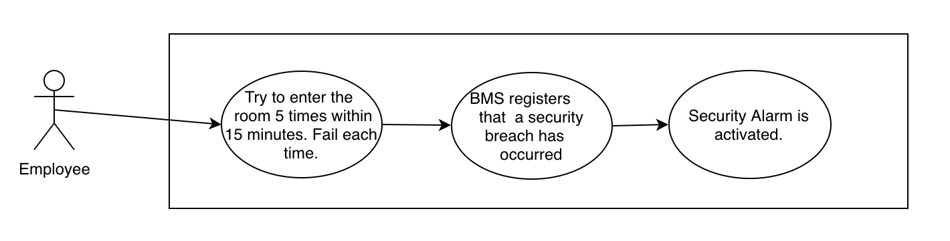

|  |  |  |
| --- | --- | --- |
| **Functional requirement that this Use Case is derived from:** #5 | | |
| **Description** | Employee tries to enter a room unsuccessfully 5 times within 15 minutes, which sets off the security alarm. | |
| **Pre-Conditions** | The actor (Employee) has a magnetic card. | |
| **Flows** | **Basic or Normal Flows** | 1. The actor tries to enter the room 5 times within 15 minutes. The actor fails each time. 2. BMS registers that a security breach has occurred. 3. Security Alarm is activated. |
|  | **Alternative Flows** | None |
| **Post Conditions** | Security guards investigate the Employee. | |
| **Special Requirements** | None | |

5.4 Non-Functional Descriptive Requirements

**System Capabilities, conditions, and constraints**

The system shall be able to receive multiple inputs and control multiple external systems at the same time. The system shall have a database to store the information of the users. The badge card reader shall have a built timer to check if a security breach occurs within a 15-minute duration by the same employee at the same door. The system shall follow the schedule of climate and lighting set points established by the business for one or more rented zones. When a lease expires, set points will automatically be deleted unless they are currently scheduled for an additional valid lease extension.

**Physical Resource Requirements**

Physical Requirements:

* Microcontrollers
* Thermostats
* Alarm
* Door Locks
* Magnetic badge Reader with number pad on it
* HVAC
* Lights
* Electronic circuits

**System Performance characteristics**

The system is required to be functioning 24/7 without interruption since the company might be functional almost every day. That requires a high performing microcontroller embedded into our system. The system shall have the ability to control multiple external systems at the same time. The system shall have multiple control panels to interact with different kind of users. The system shall have the ability to be controlled remotely. All of these requirements of the system demand large memory space of the database and high functional speed.

**Safety Requirements**

The system shall be designed such that it only allows access to employees who successfully pass the security clearance level. In case of failure, it notifies the security guard. The system shall be built in a way that it does not cross any dangerous temperature levels. The maintenance team will carry on a regular check of the system so that the system works as intended without deviating from the set point.

**Security and Privacy Requirements**

The system has to validate the employee ID code which exists in the database of the system. In case of security breach, the system should turn on an alarm and notify the security guard. Our software engineers will put an emphasis on privacy while building the system so that the information from the database does not get leaked to the hackers. Tests to breach the system’s security will run regularly and in multiple phases of the software development lifecycle.

**System Human Interfaces**

The system shall have user-friendly interfaces. The business owner can interact with the system via *Building Owner’s Control Panel*. The Building Lessee shall have a control over the climate/security via *Building Lessee’s Control Panel.* The building supervisor is able to make any changes to the system via *Building Supervisor’s Control Panel*. The employee is required scan their key card and enter a 5-digit code on the number pad of the magnetic badge reader.

**System Maintainability**

The system shall be maintained by a maintenance team. The whole system shall undergo hardware testing, configuration management, and periodic repairs if needed.

6. Analysis

6.1 Component Architecture Diagram

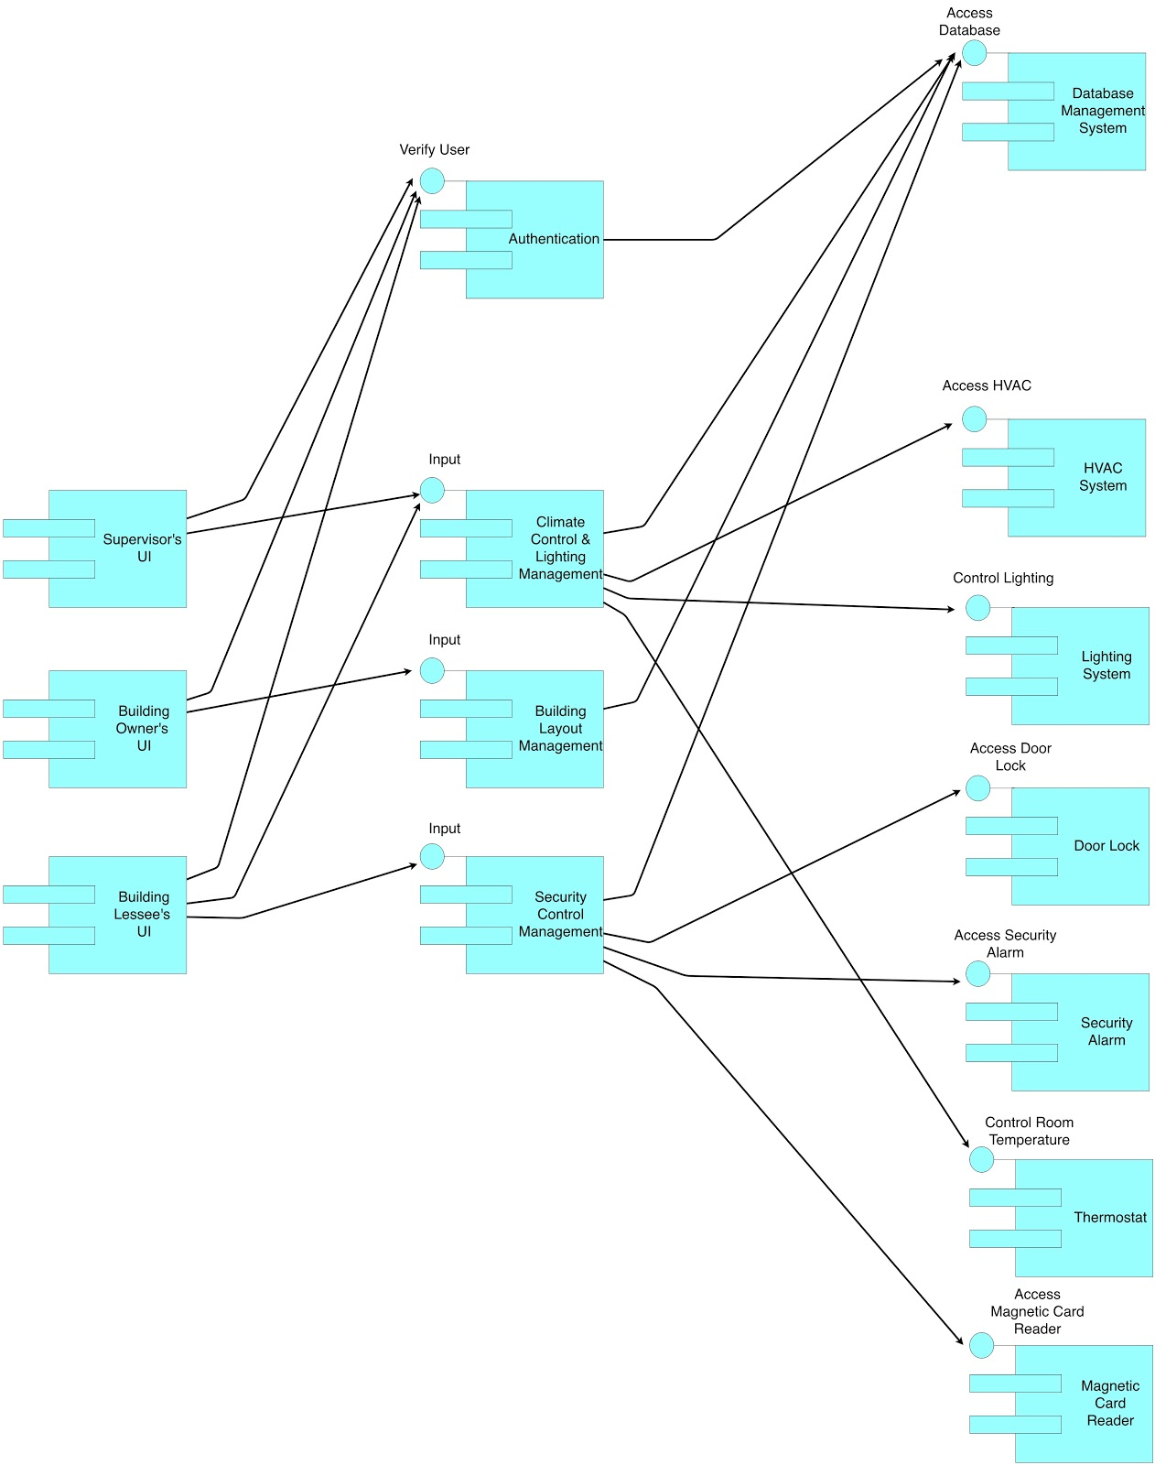

6.2 Component Descriptions

**Supervisor’s UI:** Supervisor’s UI will be the gateway for the supervisor to access the Climate & Lighting control management. This component is connected to the Climate &Lighting control management to have access to the set points of the temperature & lighting of rented zones.

**Building Owner’s UI:** Owner’s UI will be the gateway for the building owner to access the Building Layout management. This component is connected to the Building Layout management to have the details about the number of rooms which are combined to form a rented zone. It shall also access the building lessees’ information.

**Building Lessee’s UI:** Building Lessee’s UI will be the gateway for the building lessee to access the Climate & Lighting control management and Security Control management. This component shall be connected to the Climate & Lighting control management to establish the set points of the temperature & lighting of rented zones. This component shall also be connected to the Security Control management to have access to the security levels of each door inside rented zone.

**Climate & Lighting control management:** Climate & Lighting control management shall be used by the Supervisor and also the Building Lessee. This component shall be connected to DBMS, Authentication, HVAC, Lighting, Thermostat. This component accepts the set points from the Building Lessee and passes it onto the HVAC, Lighting systems. After the actions are performed, changes will be updated on the DBMS. Upon the input from the Building Supervisor, this component queries the database and releases the required room from zone control. At the same time, employer will be given access to the thermostat to change the climatic settings.

**Building Layout management:** Building Layout management shall be used by the Building owner to perform operations such as add, remove, edit over the rented zone. This component is connected to the DBMS to query the zone details and also update the changes performed by the owner over the rooms in the rental zones. Upon the request from building owner, this component can also query the DBMS for building lessees’ information.

**Security Control Management:** Security Control management shall be used by the Building Lessee to set the security access levels of each doors in the rented zone. This component will be connected to the DBMS, Authentication, Door lock mechanism, Alarm, Magnetic Card Reader. It accepts the locking configuration inputs from the Building Lessee and sets up the Door Lock mechanism for each door in the rented zone. Upon an employee successfully authenticating his access through the Magnetic Card Reader, this component opens the Door lock for 3 seconds and then closes it. In case if any employee is denied access to a room more than five times within a 15-minute window, this component triggers the alarm thus notifying the security guard about the security breach. All the information pertaining to the security such as  the level of clearance for each door, Magnetic card reader login details and password shall be stored in the DBMS.

**DBMS:** This is a database management system to store all the information related to the Building Management System. We shall do operations such as add, delete, update and querying on it

**Authentication:** Each and every user of the system like Building Owner, Building supervisor, Building lessee will be authenticated by this component whenever they access their respective user interface.

**HVAC:** Heating, Ventilating, And Cooling (HVAC) Systems will be controlled at the room level to control the maintenance of specific room temperatures upon activation of a defined set point. This component is controlled by the Climate & Lighting control management subsystem.

**LIGHTING SYSTEM:** Lighting System  will be controlled at the room level to control the maintenance of specific room temperatures upon activation of a defined set point. This component is controlled by the Climate & Lighting control management subsystem.

**DOOR LOCK:** The door lock is a mechanism which implements the level of clearance for every door in each direction. This component will be controlled by theSecurity Control management subsystem. It opens for 3 seconds only after an employee is authenticated by the Magnetic card Reader. The door opens just by pushing release bar when employee wants to enter the room with lower level security clearance. Doors between rooms at the same clearance level should have their locks physically disabled by the business tenant.

**SECURITY ALARM:** This component will be triggered by Security Control management upon the occurrence of security breach. Security alarm notifies the security guard in the building.

**THERMOSTAT:** This component allows the employee to change the temperature of a room after the supervisor releases the room from the zone control.

**MAGNETIC CARD READER:** This component is a magnetic card reader which reads the employee’s card upon tapping over it. It shall also have number pad over it to enter the passcode. Given a valid password, the employee will be authenticated. If any employee is denied access to a room more than five times within a 15-minute window, it notifies the Security Control management to trigger the alarm.

6.3 Class Diagrams

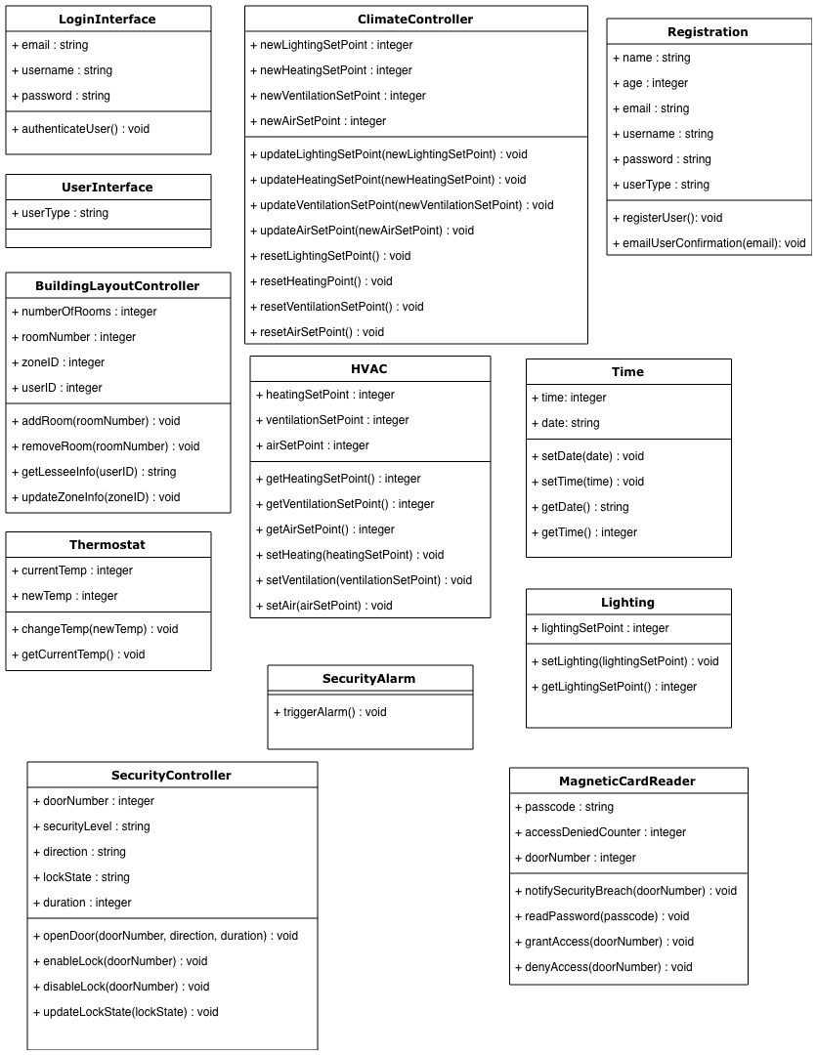

6.4 Class Relationship/Interaction Diagram

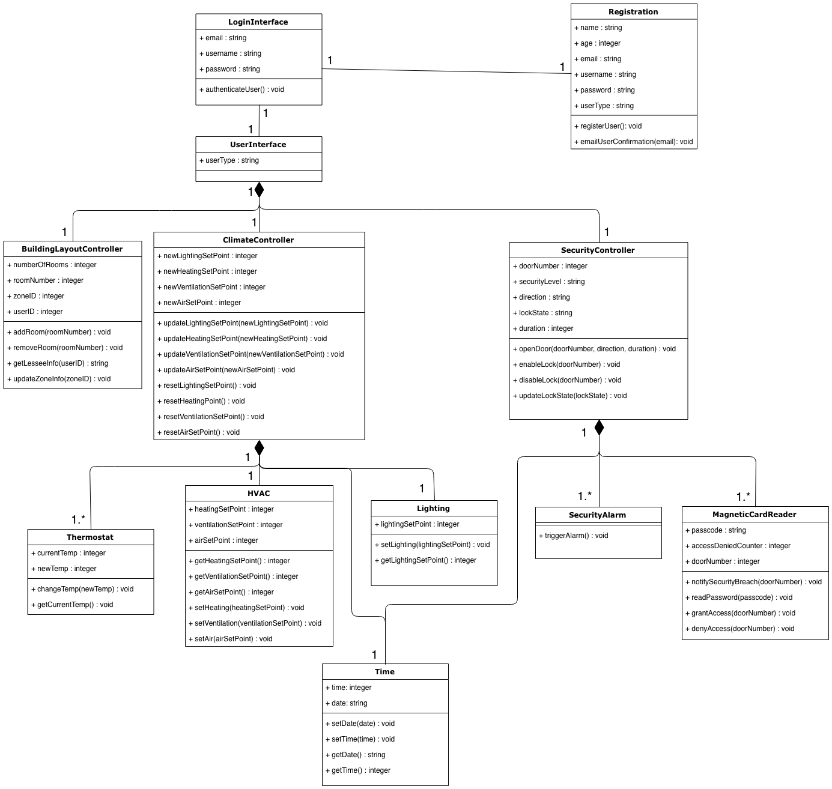

6.5 Events

*6.5.1 Motives*

1. User Registration: The user must first get registered to the system by providing the basic necessary details. A registered user can access the system functionality. The user must select their identity as a building owner or a lessee (business tenant) or a building supervisor during initial registration. So whenever a user logs in, the respective GUI will be displayed.

2. User Login: The user is required to enter the login credentials in order to verify their identity and to access the system.

Office Rental:

3. Owner defines layout for zones: The building owner defines the layout of the building in the form of zones so that they can be rented out to the business tenants. The building owner can redefine the zonal layout according to the business requirement.

Office Climatic Control:

4. Lessee fixes set points at zone level: The Lessee (business tenant) must fix and control the climatic set points and desired lighting conditions (on and off) of the rented zones. The set points will be fixed collectively to all rooms in the rented zonal area.

5. Employee request to supervisor: There is a scenario where an employee can make a request to the building supervisor to release the occupied room from the zone. This allows the employee to make use of a thermostat that will be present in each room to control the temperature manually instead of using the actual set points.

6. Special request by authorized employee: There is a special scenario where an authorized employee can make a remote request to the building supervisor asking to change the conditions of the occupied room during non-working hours like weekends. By doing so, the supervisor can change the set points to the requested temperature.

Office Security:

7. Lessee establish level of clearance for each room: The Lessee (business tenant) has the control over the building security. Each business has different levels of security for each room. The lessee can define the level of clearance for an employee to enter each room.

8. Employee entrance into a building: The employee who wants to enter a building must scan their ID and enter a 5-digit code to confirm their identity. Each entrance to a room has a locking mechanism that’s controlled by a magnetic badge reader. Once done so, the entrance will be unlocked for 3 seconds and automatically locks again.

9. Employee access denial and security breach: If an employee is denied access from entering a room for up to 5 times within a time span of 15 minutes, this is considered as a potential security breach and this is notified to the security guard. In such circumstance, all attempts to access a secure room will be logged in the database.

10. Lessee can manually disable all locks: The lessee (business tenant) can override security procedures by manually disabling all locking mechanisms for the rented space. This always makes the rooms to be left unlocked.

*6.5.2 Event Diagrams*

1. User Registration

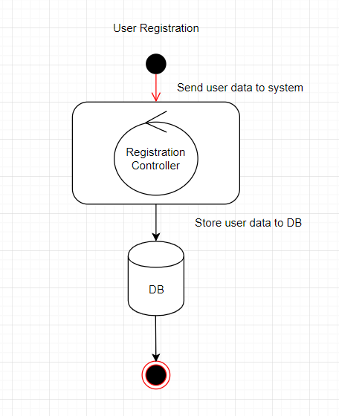

2. User tries to login

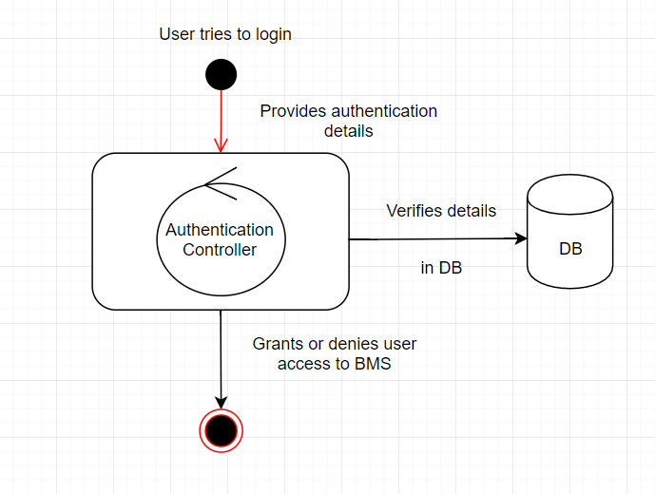

3. Owner define layout for zones

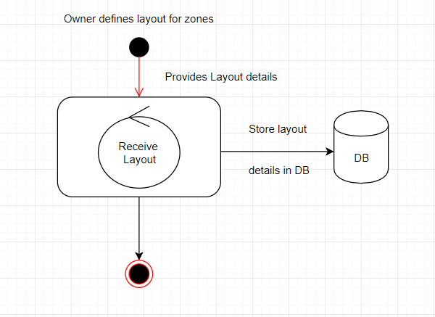

4. Lessee fixes set points

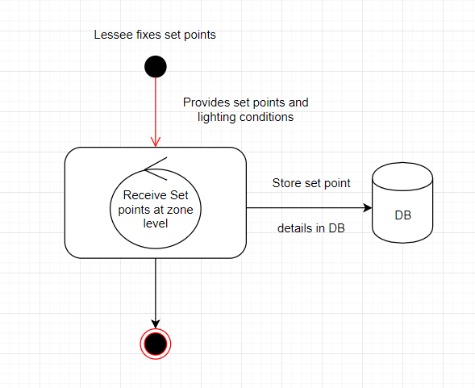

5. Employee request to supervisor

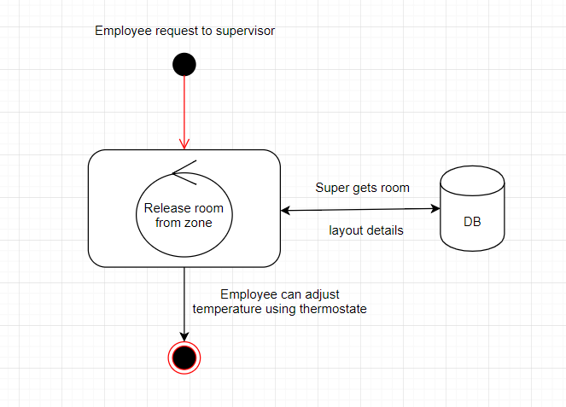

6. Employee request to supervisor

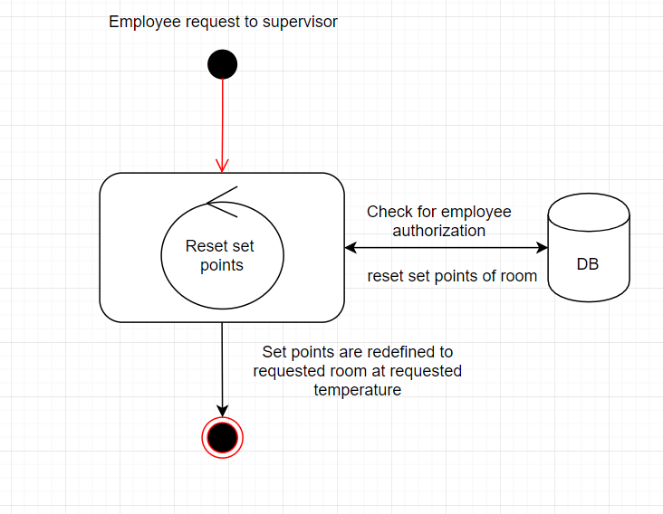

7. Lessee sets security clearance level

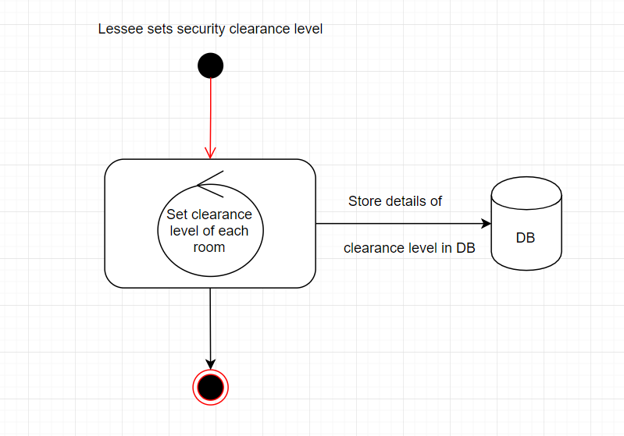

8. Employee entry into building

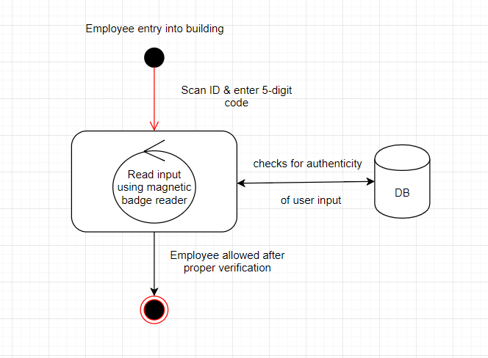

9. Employee access denial & security

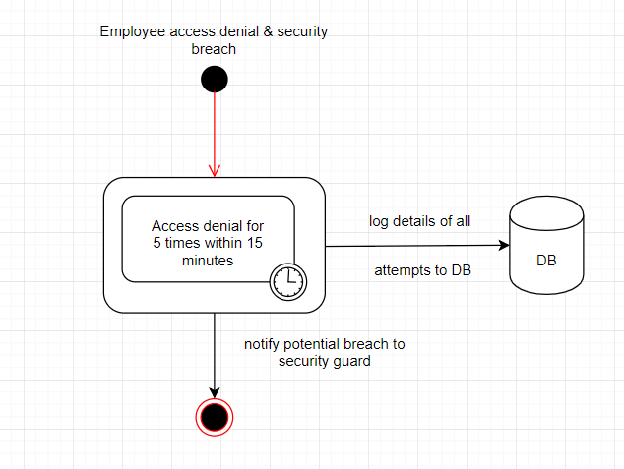

10. Lesse overrides security procedure

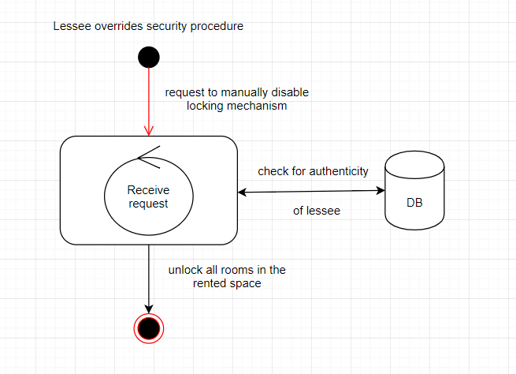

6.6 Activity/State Diagrams

Scenario 1: User Logging

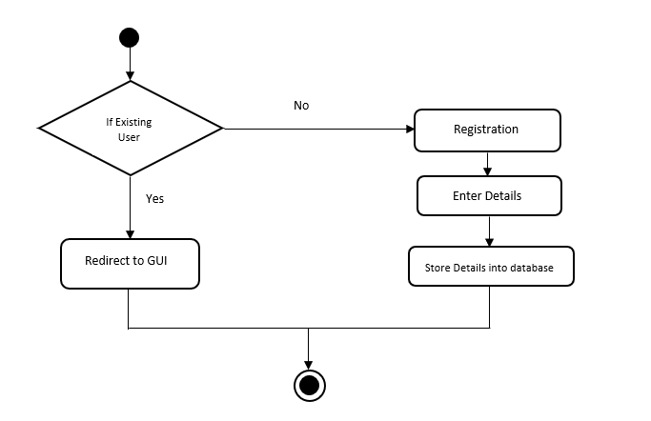

Scenario 2: Owner defines the layout for zones

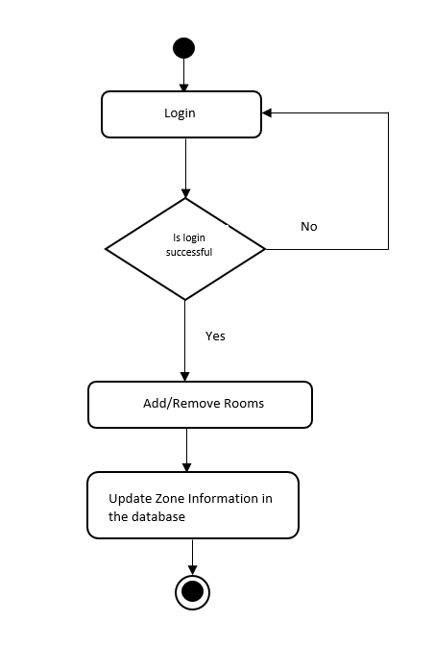

Scenario 3: Lessee fixes set points at zone level

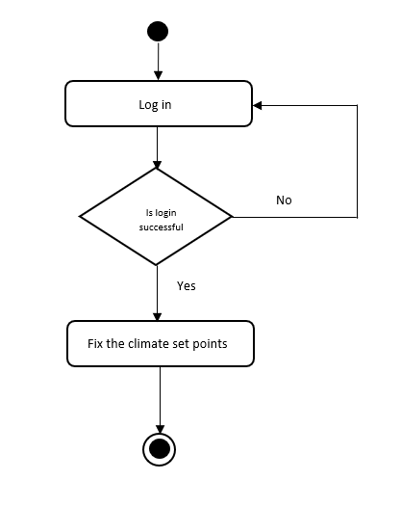

Scenario 4: Employee request to supervisor

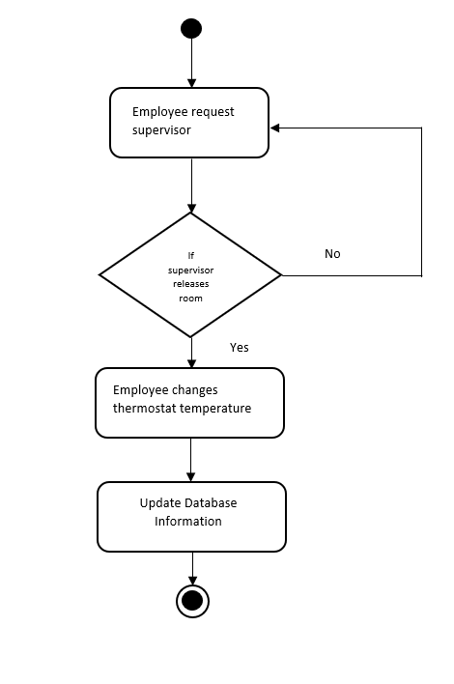

Scenario 5: Lessee establishes level of clearance for each room

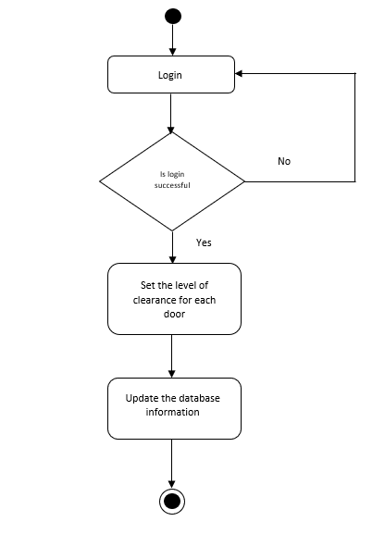

Scenario 6: Employee entry into a building

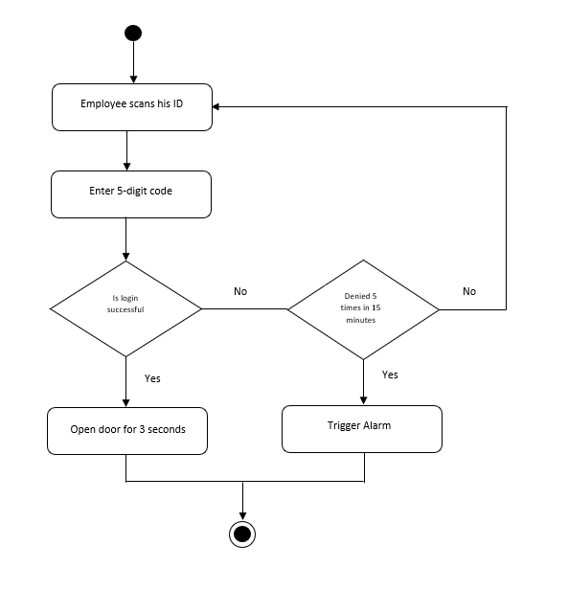

Scenario 7: Lessee disables all locks manually

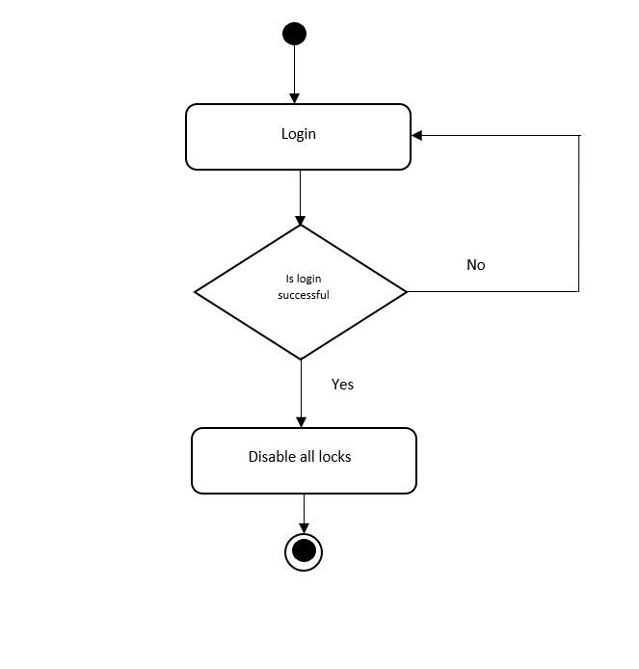

6.7 State Logic Diagram

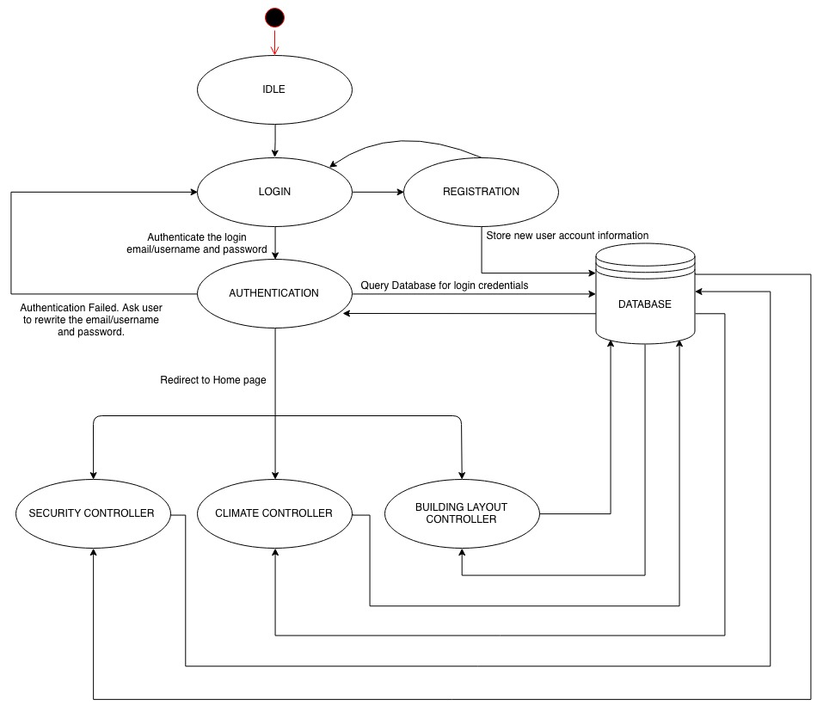

6.8 Sequence Diagrams

1.

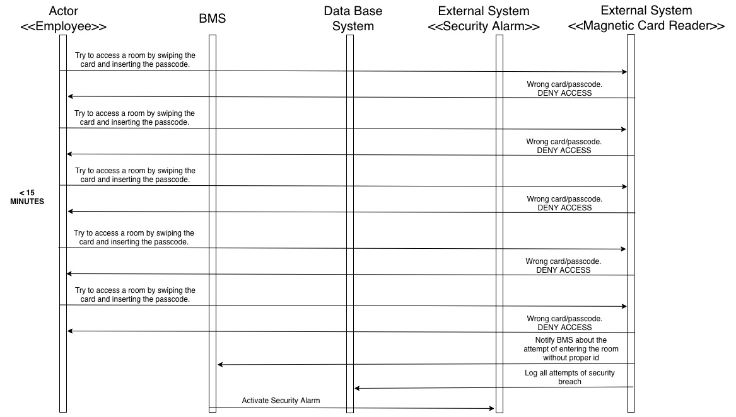

2.

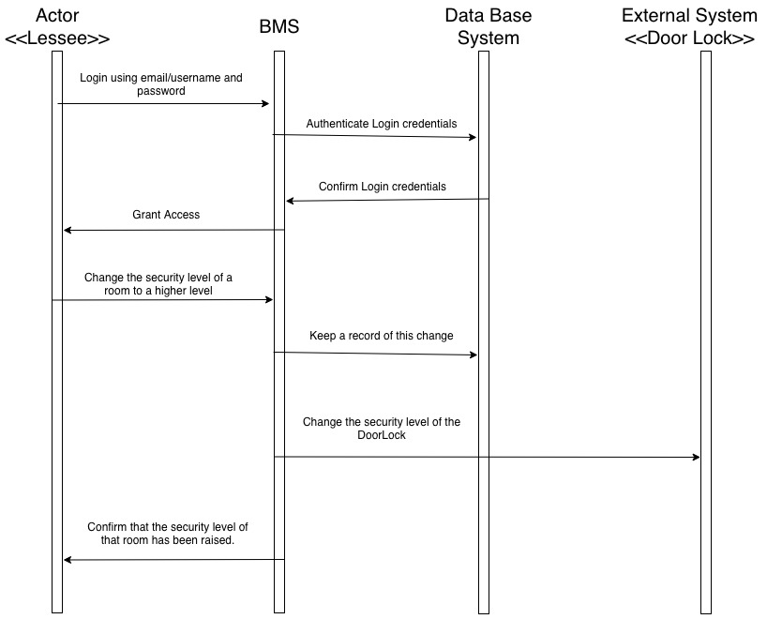

3.

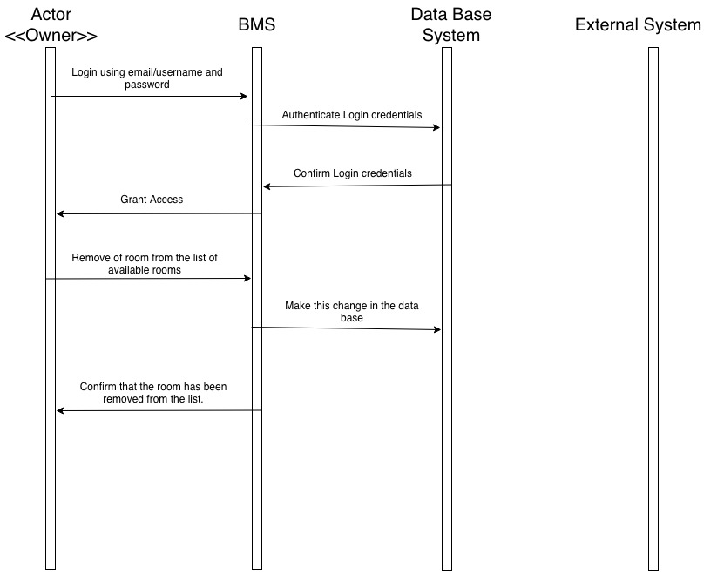

4.

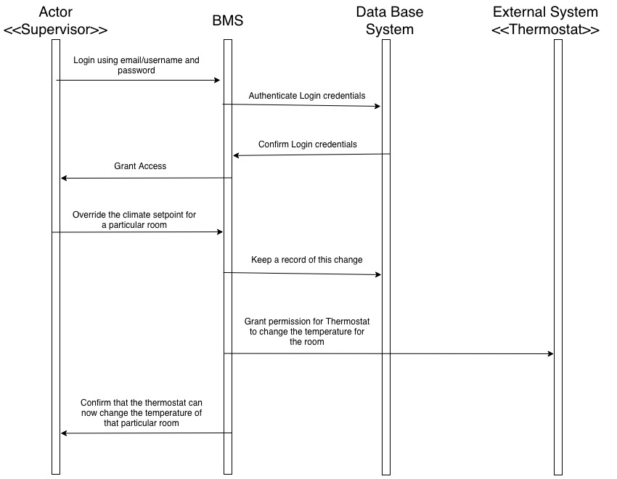

7. Dictionaries

7.1 Class

|  |  |  |  |
| --- | --- | --- | --- |
| **Name** | **Description** | **Methods** | **Attributes** |
| LogInInterface | This will be used to login by each user to access the BMS | authenticationUser() | email  username  password |
| Registration | The class registers the new user | registerUser()  emailUserConfirmation | name  age  email  username  password  userType |
| UserInterface | This class identifies the userType and gives access only to the required controller |  | userType |
| BuildingLayoutController | This class provides the operations to modify the number of rooms in the zone. It also provides Lessee information | addRoom  removeRoom  getLesseeInfo  updateZoneInfo | numberOfRooms  roomNumber  zoneID  userID |
| ClimateController | This class provides the operations to update and reset the HVAC and lighting set points. | updateLightingSetPoint  updateHeatingSetPoint  updateVentilationSetPoint  updateAirSetPoint  resetLightingSetPoint  resetHeatingSetPoint  resetVentilationSetPoint  resetAirSetPoint | newLightingSetPoint  newHeatingSetPoint  newVentilationSetPoint  newAirSetPoint |
| SecuityController | This class provides the operations to open door, enable & disable lock, update lock status giving each employee the security level access | openDoor  enableLock  disableLock  updateLockState | doorNumber  securityLevel  direction  lockState  duration |
| Thermostat | This class provides the information about the room temperature. Also, employee can change the room temperature using Thermostat. | changeTemp  getCurrentTemp | currentTemp  newTemp |
| HVAC | This class provides the user with getters and setters for HVAC | getHeatingSetPoint  getVentilationSetPoint  getAirSetPoint  setHeatingSetPoint  setVentilationSetPoint  setAirSetPoint | heatingSetPoint  ventilationSetPoint  airSetPoint |
| Lighting | This class provides the get and set methods to perform operations over the lighting conditions | setLighting  getLighting | lightingSetPoint |
| SecurityAlarm | This class has the method to trigger an alarm | triggerAlarm |  |
| Time | This class provides the information about the timestamp | setDate  setTime  getDate  getTime | timeStamp |
| MagneticCardReader | This class does all the operations related to the employee authentication to access a room of higher security level | notifySecurityBreach  readPassword  grantAccess  denyAccess | doorNumber  passcode  accessDeniedCounter |

7.2 Methods

|  |  |  |  |
| --- | --- | --- | --- |
| **Name** | **Description** | **Class** | **Arguments** |
| authenticateUser | The method matches the entered details by the user in the database | LogInInterface |  |
| registerUser | This method registers user in the database | Registration |  |
| emailUserConfirmation | This method checks if the provided email is already registered | Registration | email |
| addRoom | This method adds more rooms to the rented zone | BuildingLayoutController | roomNumber |
| removeRoom | This method removes rooms from the rented zones | BuildingLayoutController | roomNumber |
| getLesseeInfo | This method provides the information of a given building lessee | BuildingLayoutController | userId |
| updateZoneInfo | This method updates any changes done on the rented zone to the database | BuildingLayoutController | zoneId |
| updateLightingSetPoint | This method updates the lighting set point with new set point | ClimateController | newLightingSetPoint |
| updateHeatingSetPoint | This method updates the heating set point with new set point | ClimateController | newHeatingSetPoint |
| updateVentilationSetPoint | This method updates the ventilation set point with new set point | ClimateController | newVentilationSetPoint |
| updateAirSetPoint | This method updates the air set point with new set point | ClimateController | newAirSetPoint |
| resetLightingSetPoint | This method resets the lighting set point to the old set point | ClimateController |  |
| resetHeatingSetPoint | This method resets the heating set point to the old set point | ClimateController |  |
| resetVentilationSetPoint | This method resets the ventilation set point to the old set point | ClimateController |  |
| resetAirSetPoint | This method resets the air set point to the old set point | ClimateController |  |
| openDoor | This method opens the door on successful authentication | SecurityController | doorNumber,direction,duration |
| enableLock | This method enables lock for a door | SecurityController | doorNumber |
| disableLock | This method disables a lock for a door | SecurityController | doorNumber |
| updateLockState | This method updates the changes to the lock state | SecurityController | lockState |
| changeTemp | This method changes the room temperature via thermostat | Thermostat | newTemp |
| getCurrentTemp | This method gets us the current temperature reading on the thermostat | Thermostat |  |
| getHeatingSetPoint | This method gets the established heating set point | HVAC |  |
| getVentilationSetPoint | This method gets the established ventilation set point | HVAC |  |
| getAirSetPoint | This method gets the established air set point | HVAC |  |
| setHeating | This method sets the established heating set point | HVAC | heatingSetPoint |
| setVentilation | This method sets the established ventilation set point | HVAC | ventilationSetPoint |
| setAir | This method sets the established air set point | HVAC | airSetPoint |
| setDate | This method sets the date on the clock | Time | date |
| setTime | This method sets the time on the clock | Time | time |
| getDate | This method gets the date on the clock | Time |  |
| getTime | This method gets the gets on the clock | Time |  |
| setLighting | This method sets the lighting condition to the given value | Lighting | lightingSetPoint |
| getLighting | This method gets the current lighting condition value | Lighting |  |
| triggerAlarm | This method triggers the alarm | SecurityAlarm |  |
| notifySecurityBreach | This method notifies the system about the security breach | MagneticCardReader | doorNumber |
| readPassword | This method reads the password entered by the employee on the number pad | MagneticCardReader | passcode |
| grantAccess | This method grants access to the employee | MagneticCardReader | doorNumber |
| denyAccess | This method denies access to the employee | MagneticCardReader | doorNumber |

7.3 Attributes

|  |  |  |
| --- | --- | --- |
| **Name** | **Description** | **Type** |
| email | The email id of the user | string |
| username | The username of the user who logins into BMS | string |
| password | The password of the user who logins BMS | string |
| name | Name of the user who is using BMS | string |
| age | Age of the user | integer |
| userType | Stores whether the user is an owner or lessee or supervisor | string |
| numberOfRooms | Holds the number of rooms in a zone | integer |
| roomNumber | Holds the number of a room in a zone | integer |
| zoneID | Stores the ID of a zone | integer |
| userID | Stores the ID of user who defined or last changed the layout of a zone | integer |
| newLightingSetPoint | Holds the new value of a lighting set point in a zone | integer |
| newHeatingSetPoint | Holds the new value of a heating set point in a zone | integer |
| newVentilationSetPoint | Holds the new value of a ventilation set point in a zone | integer |
| newAirSetPoint | Holds the new value of an air set point in a zone | integer |
| doorNumber | Stores the number of each door in a room | integer |
| securityLevel | Stores the level of security for each room | string |
| direction | Holds the direction in which the door opens and closes | string |
| lockState | Shows whether locking mechanism is turned on or off. | string |
| duration | Duration for which the door remains open | integer |
| currentTemp | Stores the value of current temperature of a room | integer |
| newTemp | Stores the value of new temperature of a room | integer |
| heatingSetPoint | Holds the current value of heating set point | integer |
| ventilationSetPoint | Holds the current value of ventilation set point | integer |
| airSetPoint | Holds the current value of air set points. | integer |
| lightingSetPoint | Holds the current value of lighting set point | integer |
| passcode | Stores the value of passcode of each employee | string |
| accessDeniedCounter | Keeps count of how many times an employee is denied access | integer |
| timeStamp | Displays the current time and date | integer |

7.4 Relationships

|  |  |  |  |  |  |
| --- | --- | --- | --- | --- | --- |
| **Name** | **Description** | **From Class** | **To Class** | **Optional/Mandatory** | **Cardinality** |
| New User Registration | If the user is new to the system and haven’t registered to BMS yet, the login page will redirect the user to the Registration page. | LoginInterface | Registration | Mandatory | 1 - 1 |
| Login - UI page | Once the user has verified their login credentials, the user will be directed to their respective UI page. | LoginInterface | UserInterface | Mandatory | 1 - 1 |
| Setpoints definition | The user can define setpoints or modify existing setpoints to a new value and this value will be updated to the HVAC controller. | ClimateController | HVAC | Mandatory | 1 - 1 |
| Security-MagneticCard | The security Controller shall have at least one Magnetic Card Reader. There shall be one Magnetic card Reader  in one direction for each door. The SecurityController class controls all these MagneticCardReaders | Security Controller | MagneticCardReader | Mandatory | 1 - 1.* |
| SecurityController-Alarm | The security Controller shall have at least one Security Alarm. There are more than one floors in the building and each floor requires at least one alarm. SecurityController class triggers the alarm on security breach | Security Controller | SecurityAlarm | Mandatory | 1 - 1.* |
| ClimateController-Thermostat | ClimateController shall have one or more thermostats in the system. Each room shall have at least one thermostat. Employee shall change the room temperature via thermostat upon granted permission. | ClimateController | Thermostat | Mandatory | 1 - 1.* |

7.5 Key Event

|  |  |  |  |  |  |  |
| --- | --- | --- | --- | --- | --- | --- |
| **Name** | **Description** | **Motive** | **Action** | **Pre condition** | **Post condition** | **State Change** |
| Registration | The user can register in the system. | The user wants to use BMS to define layouts, set climatic conditions. | The user registers in the system. | The user is not registered yet. | The user is now registered in BMS. | The actor becomes the user of BMS. |
| Layout Definition | The building owner defines the layout for zones. | The building space needs to be defined as zones to be rented out to business tenants. | Define or redefine layout according to tenant requirement. | Building space has no proper layout. | Building space has a proper layout according to user requirement. | Building space gets divided into zones for user occupancy. |
| Set points definition | The business tenant defines the climatic set points & lighting conditions at zone level. | The zones needs appropriate climatic & lighting conditions during working and non-working hours. | Define/control climatic set points & desired lighting conditions. | No set points for zones. | Existing set points or new set points for zones. | The set points are fixed collectively to all rooms in the rented zonal area. |
| Clearance level definition | The business tenant defines the level of security clearance for each room. | Each room needs different clearance level to stop unauthorized access. | Define level of security clearance for each room in rented area. | No security level for each room. | Each room has appropriate security clearance. | Only authorized employee will be allowed to access highly secure room. |
| Security Breach | Employee access denial & security breach. | In order to stop any kind of unauthorized access into the building or highly secure rooms. | If an employee is denied entry for more than 5 times within 15 minutes, security guard is notified. | Unauthorized people can enter the building premises. | Unauthorized people are stopped from entering secure areas. | Any kind of security breach is notified to security guard. |
| Manually disable all locks in the building | The business tenant can override all security procedures by manually disabling all locks. | This could be done in times of emergency, maintenance works. | Disable all locks manually. | Security features and locking mechanisms work fine. | Security features and locking mechanisms are disabled. | Emergency and maintenance works can be handled successfully. |