Low-Precision Transformer Accelerator for Edge LLMs

Overview / Summary
This project proposes the design and implementation of a low-precision hardware accelerator for Transformer-based language models on a Xilinx Kria KV260 or AUP-ZU3 FPGA platform. The goal is to accelerate quantized inference for a reduced Transformer block (TinyLlama-scale) while addressing memory bandwidth limitations (“memory wall”) common in edge AI systems.
The system uses a heterogeneous architecture: the ARM processor handles tokenization, scheduling, and baseline execution, while the FPGA fabric accelerates matrix multiplications and normalization using a custom INT8 compute engine with DDR streaming and double buffering. Phase 2 explores mixed-precision INT4 weights and limited attention support.

Block Diagram
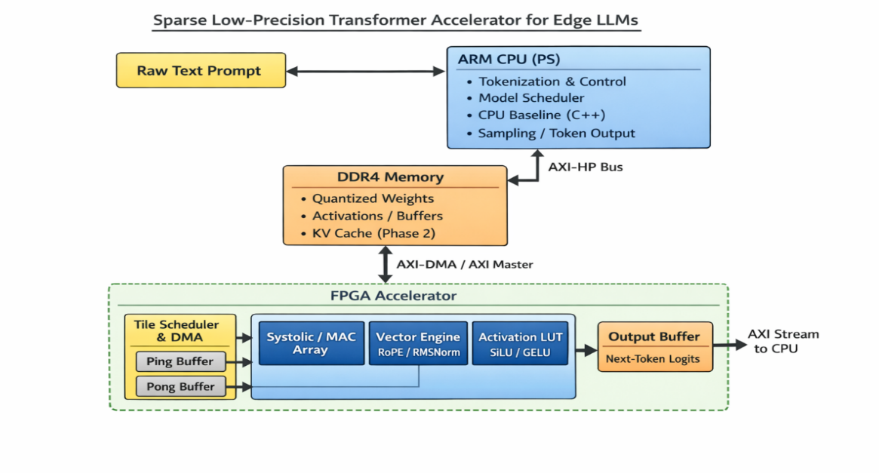

Objective / Motivation
Transformer inference is dominated by matrix multiplication and memory movement. On edge platforms, memory bandwidth is often the primary bottleneck. This project explores compute–memory co-design for quantized Transformer acceleration.
Objectives:
- Design an INT8 matrix multiplication accelerator.
- Implement DDR streaming with double buffering.
- Measure latency and resource utilization.
- Explore INT4 weight compression to reduce bandwidth.
The focus is on accelerating key components of a Transformer block (linear layers and feed-forward network) rather than full multi-layer LLM deployment.

Plan / Methods
The project will proceed in two structured phases:

Phase 1
- Quantize a reduced Transformer block to INT8.
- Implement INT8 MAC array with INT32 accumulation.
- Store weights in DDR4 and stream via AXI-DMA.
- Implement double buffering in BRAM.
- Accelerate feed-forward network (two linear layers + activation).
- Compare FPGA vs ARM CPU latency.
- Report LUT, DSP, BRAM, and Fmax.

Phase 2
- Support packed INT4 weights.
- Implement limited single-head attention with approximate softmax.
- Add bounded KV cache support.
- Evaluate memory bandwidth impact.

Software / Hardware

Hardware Platform
- Xilinx Kria KV260 or AUP-ZU3 (Zynq UltraScale+)

Development Tools
- Vivado / Vitis
- Verilog RTL (primary hardware description)
- AXI-DMA IP cores
- Python (model quantization, golden reference)
- C/C++ (ARM baseline implementation)

Software Components
- Tokenization and scheduling on ARM
- CPU baseline Transformer block in C++
- Host-side performance measurement tools

Expected Outcome
By the end of the semester, we expect to demonstrate:
- A working INT8 Transformer component accelerator.
- Correct results validated against a software baseline.
- Measurable latency improvement over ARM CPU execution.
- Detailed resource utilization report.
- Analysis of compute vs memory bottlenecks.
If Phase 2 is partially completed, we expect to demonstrate bandwidth reduction from mixed precision and limited attention acceleration.

