In conjunction with National Fire Safety Week, the Willowfork Fire Department will hold Open Houses at both of its fire stations on Saturday, October 14th from 1 p.m. to 4 p.m. Willowfork Station #1 is located at 24655 Westheimer Parkway, and Willowfork Station #2 is located at 26950 Cinco Ranch Boulevard. The public is invited to tour the stations, view the firefighting equipment and apparatus, and meet their local firefighters. There will also be activities for the younger visitors, including a Junior Firefighter Obstacle Course and fun fire safety giveaways. In addition, information will be provided on the theme for this year’s nationwide Fire Safety Week …“Every Second Counts: Plan 2 Ways Out.”

The Willowfork Fire Department is operated by Fort Bend County Emergency Services District #2. Administrative offices are located at 24655 Westheimer Parkway, Katy, TX  77494. You can learn more about the Willowfork Fire Department by visiting its website: [www.willowforkfire.com.](http://www.willowforkfire.com/)

STATION #1 LOCATED AT 24655 WESTHEIMER PARKWAY                                                

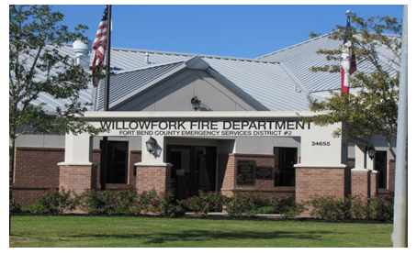

**Station # 2 located at 26950 Cinco Ranch Blvd, Katy, TX 77494**

