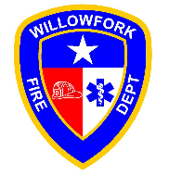

Willowfork Fire Department (Fort Bend County Emergency Services District # 2) will be partnering with Fort Bend County Animal Services to hold a special Dog Adoption Day giving members of the community an opportunity to provide good homes to some very special fur babies. This event will take place Saturday, November 4, 2017, from 10:00 am - 2:00 pm, at our Station 2 location, 26950 Cinco Ranch Blvd, 77494. All that is needed to adopt is a Driver License and $50.00 (cash only). All pets are spayed/neutered, microchipped, up to date on vaccines and heartworm tested. If adoption is not an option but you would like to help the cause of getting animals placed in good homes, feel free to drop by with donations: dog food, cat food (any brand, broken bags accepted), rawhides, bones, treats, flea/tick prevention treatments, blankets, towels, and toys. We look forward to seeing each one of these fur babies adopted out to new families. Please spread the word to your friends and families. If you have any questions, contact Willowfork Fire Department’s District Administrator, Lou Ann Matthews, at 281-395-0011 extension 120 or email her at [wfdinfo@willowforkfire.com](mailto:wfdinfo@willowforkfire.com).

