Current issues that are present in ODLC for SUAS

1. The RPN: the current RPN is unable to be run on our current Hardware and due to dropping mechanism we are not able to get multi angle images.
2. The CNS: the color detection and segmentation prosses has a 91 percent accuracy but when forced to only work on provided color names that are given in contest rules the accuracy drops to 4 percent
3. The classifier: on yolo shape detection is near perfect except when it comes to diamonds and squares refer to graph below: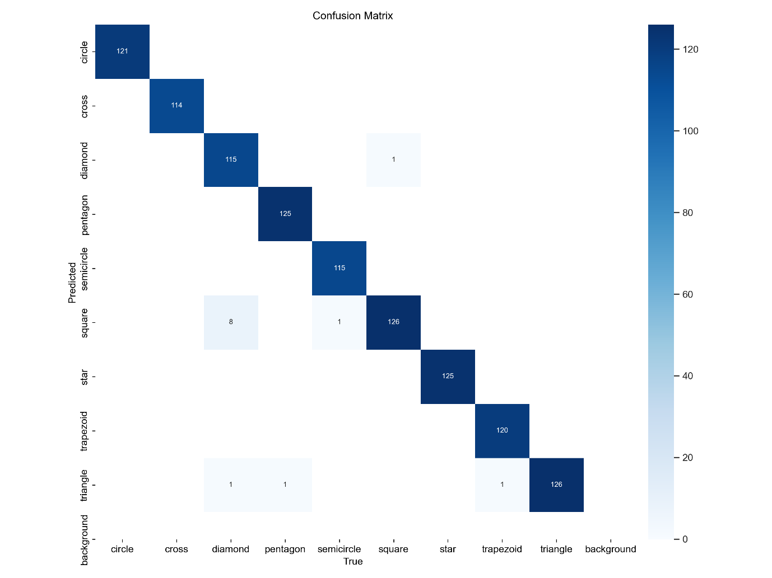
4. The classifier: on yolo char detection is near perfect except when it comes to simper characters refer to graph below: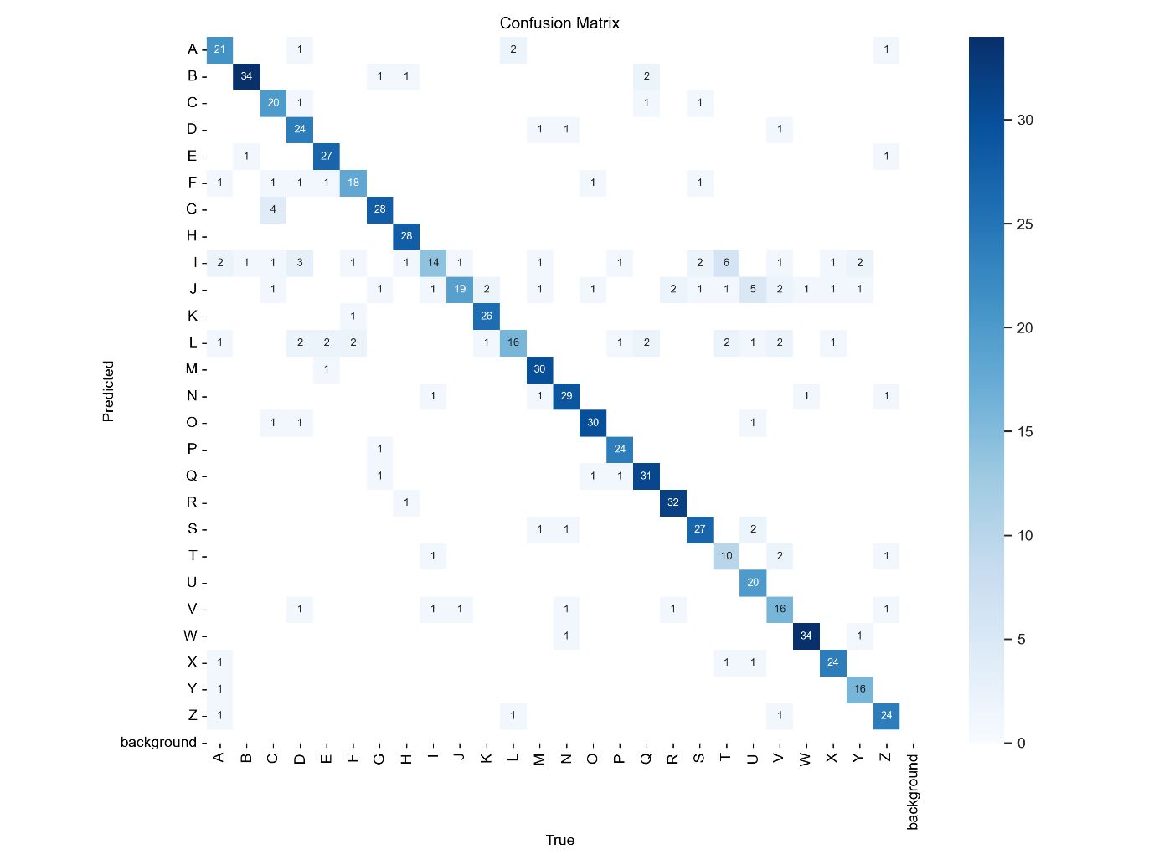
5. Vid streaming: If the RPN is to run on GCS then we need a robust setup and code to get vid to the ground without delay.