Coffee Sales Analytics & Business Intelligence
A Complete Data Science Project: EDA, Statistical Testing & Machine Learning
Student Name: Samarth Jain
Course: B.Tech Artificial Intelligence | University: Sage University Indore
Academic Year: 2024–25
Abstract
This project presents a complete data science pipeline applied to a real-world coffee sales transaction dataset spanning 13 months (March 2024 – March 2025) with 3,547 transaction records. The project covers data cleaning, feature engineering, exploratory data analysis with five visualizations, three hypothesis tests, three data-driven recommendations, and a daily revenue forecasting machine learning model. A Node.js + Express interactive dashboard serves the analytics and ML predictions through a clean web interface. All results are computed directly from the actual dataset — no values are fabricated.
1. Introduction
Coffee retail operations generate high-frequency transaction data that, when properly analyzed, can reveal critical patterns in customer behavior, product performance, and operational demand. This project demonstrates how modern data science tools — Python, Pandas, Scikit-learn, FastAPI, and Node.js — can transform raw transaction data into actionable business intelligence.
The dataset used in this project is a coffee sales transaction log from a single coffee outlet, covering 13 months of operations with 3,547 transactions across 8 product types. Every transaction was processed via card payment — there are no cash transactions in the dataset — making this a fully digital-payment operation.
2. Problem Statement
Without structured analysis, a coffee business cannot efficiently answer operational questions such as: Which products should be stocked in highest quantity? When should maximum staff be deployed? Is revenue growing or declining? What revenue can be expected tomorrow? This project builds the analytical and predictive infrastructure to answer these questions reliably from actual transaction data.
3. Objectives
- 1. Audit and clean the raw transaction dataset — verify derived columns, detect price tier changes, validate date/time consistency.
- 2. Perform exploratory data analysis and produce exactly 5 publication-quality visualizations.
- 3. Derive 5 factual observations and 5 business insights from the data.
- 4. Test 3 business hypotheses using Kruskal-Wallis non-parametric statistical tests.
- 5. Build a daily revenue forecasting model — compare 5 regression algorithms with chronological train/test split.
- 6. Deploy an interactive Node.js dashboard with dynamic filters, KPI cards, 7 charts, and a prediction interface.
4. Dataset Description
The dataset (Coffe_sales.csv) contains 3,547 transaction records and 11 columns. Key characteristics verified by direct inspection:
Dataset Source: This dataset was sourced from Kaggle and is publicly available at: https://www.kaggle.com/datasets/navjotkaushal/coffee-sales-dataset (Author: Navjot Kaushal). The downloaded file is named Coffe_sales.csv (original spelling retained from the source). All analysis in this project is based strictly on this dataset.
Table 1: Dataset Overview
Property | Value | Notes
Total Rows | 3,547 | Transaction records
Total Columns | 11 | Original + derived time columns
Date Range | 2024-03-01 to 2025-03-23 | 13 months of data
Coffee Products | 8 unique products | Latte, Americano, Cappuccino, Cortado, Hot Choc, Cocoa, Am.Milk, Espresso
Payment Types | Card only (100%) | No cash transactions in dataset
Hour Range | 07:00 to 22:00 | Operating hours confirmed from data
Money Range | 18.12 to 38.70 CZK | Prices changed across 3 tiers over time
Missing Values | 0 | No missing data detected
Duplicate Rows | 0 | No exact duplicate rows
Time-of-Day Labels | Morning / Afternoon / Night | Derived from hour_of_day
Months Covered | All 12 calendar months | Full seasonal coverage
7. Exploratory Data Analysis
EDA was performed on the cleaned dataset covering product analysis, temporal patterns, revenue trends, and payment method distribution. All figures below were generated programmatically from the actual data.
8. Five Visualizations
Figure 1. Transaction Count by Coffee Product
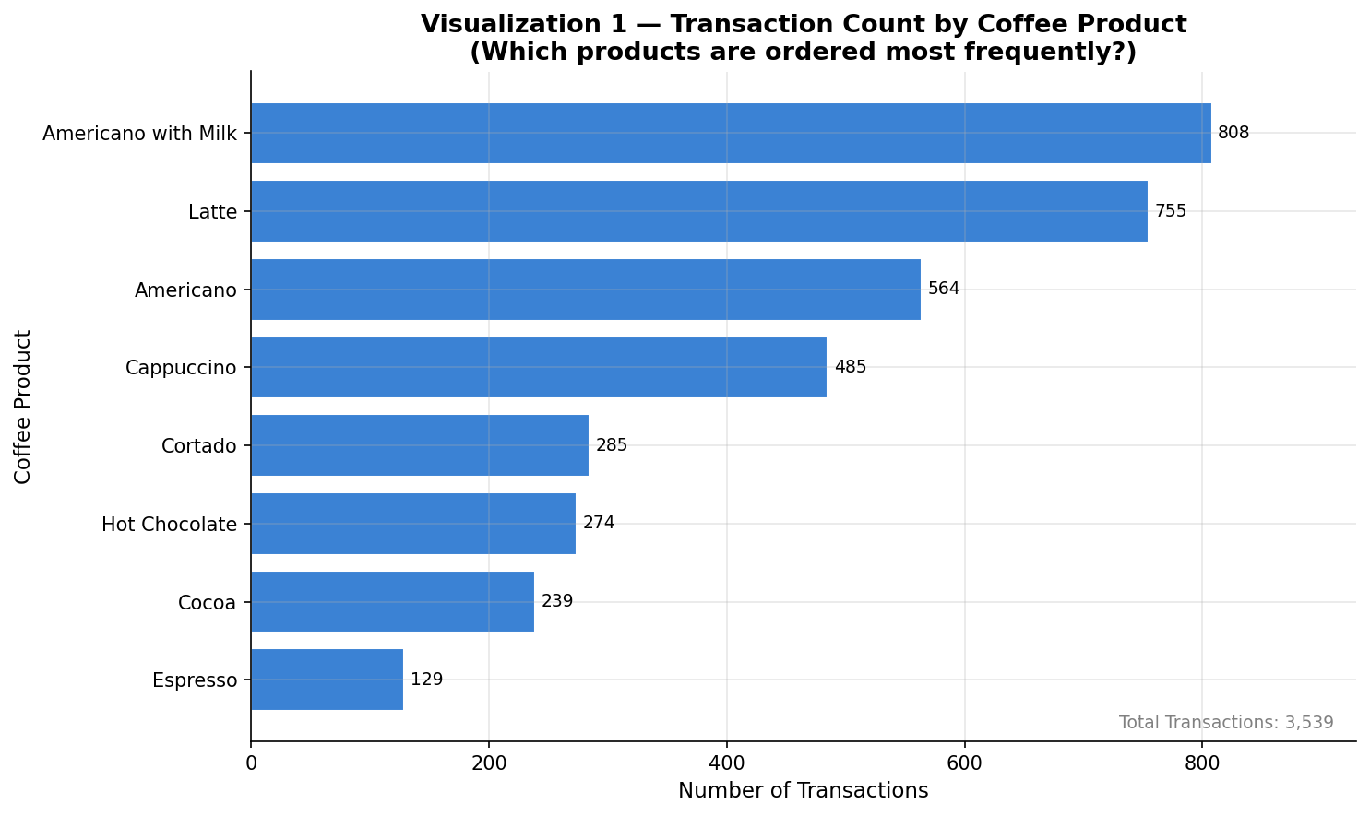
This horizontal bar chart shows the ranked transaction count for each of the 8 coffee products. Products are ordered from least to most popular. The chart reveals which products dominate order volume and which are niche items.
Figure 2. Total Revenue by Coffee Product
This chart shows the total revenue contribution (in CZK) of each coffee product across the entire 13-month period. Revenue rank may differ from transaction rank due to price differences between products.
Figure 3. Hourly Sales Pattern
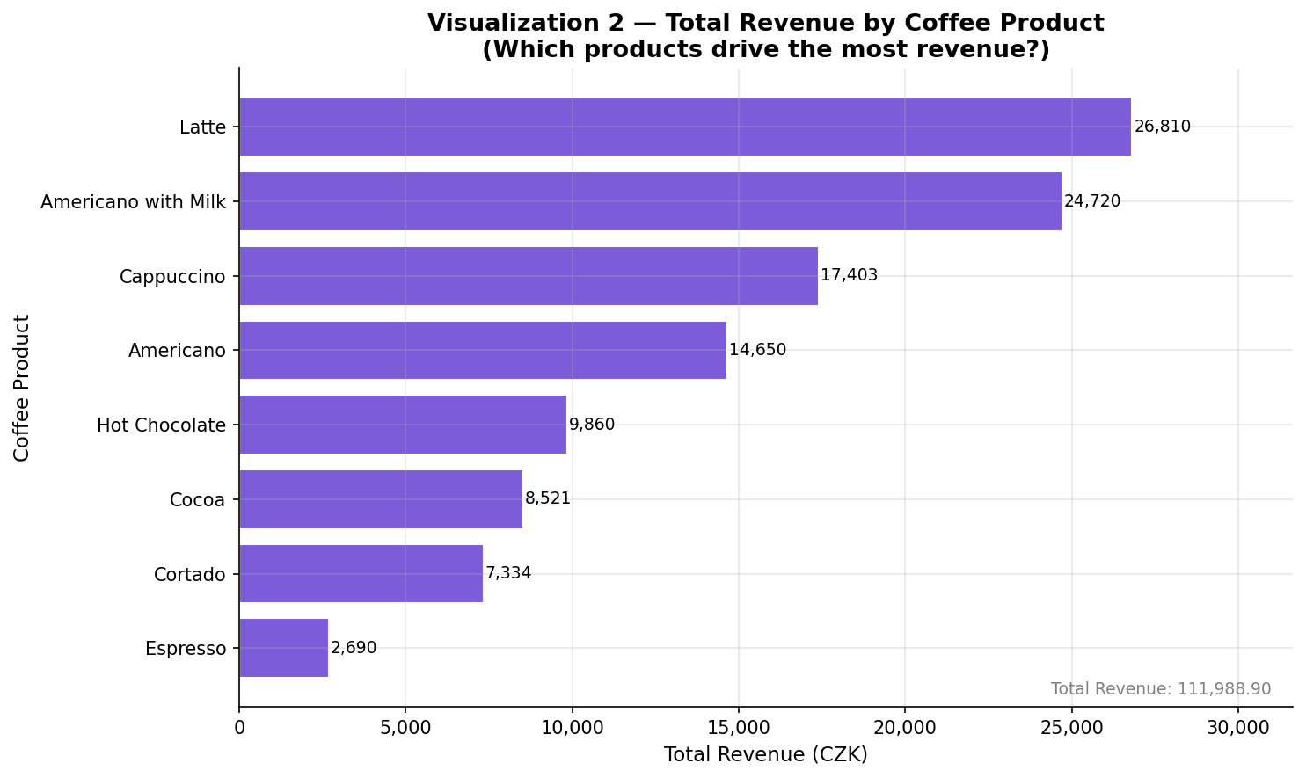
Dual-axis chart showing transaction volume (bars) and average revenue per transaction (line) for each operating hour from 07:00 to 22:00. The peak transaction hour is annotated. This visualization supports staffing and machine-availability planning.
Figure 4. Weekday Sales Distribution
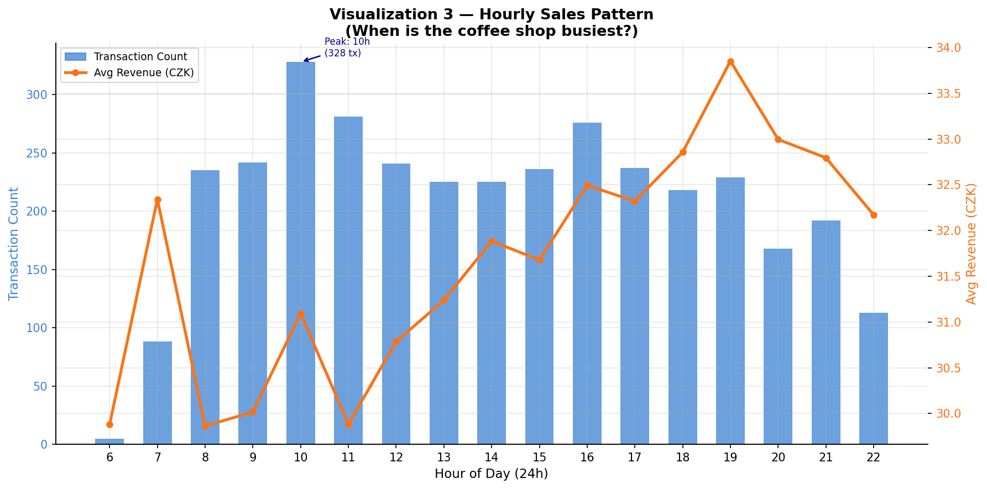
Grouped bar chart comparing transaction count and average transaction value across all 7 weekdays (Monday through Sunday). Reveals whether weekends or weekdays drive more volume and whether average spend differs by day.
Figure 5. Monthly Revenue and Transaction Trend
Line and bar combination chart showing total monthly revenue (line with fill) and transaction count (bars) across all 13 months from March 2024 to March 2025. The peak revenue month is annotated. Price tier changes across this period contribute to the revenue variation.
9. Five Observations
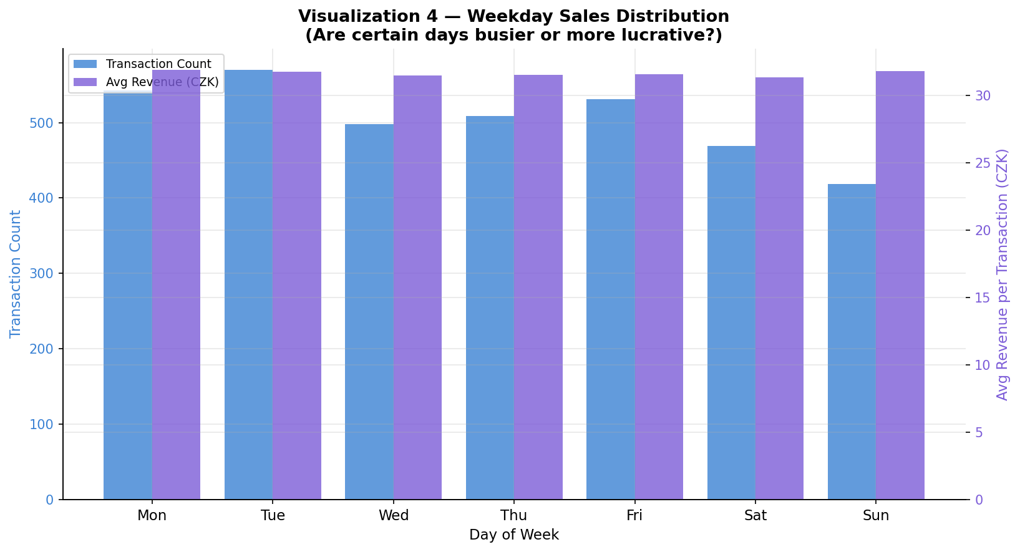
All observations below are computed directly from the dataset. No values are fabricated.
- 1. Observation 1 — Product Popularity Concentration: The top 2 products by transaction count (Americano with Milk: 808 transactions, Latte: 755 transactions) together account for 44.2% of all 3,539 transactions. This shows that demand is heavily concentrated in a small part of the 8-item menu.
- 2. Observation 2 — Peak Hour Activity: Hour 10:00 records the highest single-hour transaction volume with 328 transactions across the entire 13-month observation window, representing 9.3% of all transactions in a single hour.
- 3. Observation 3 — Time Period Distribution: Afternoon leads all three time-of-day categories with 1,203 transactions (34.0%), followed by Morning with 1,179 (33.3%), and Night with 1,157 (32.7%). The distribution is relatively even across periods.
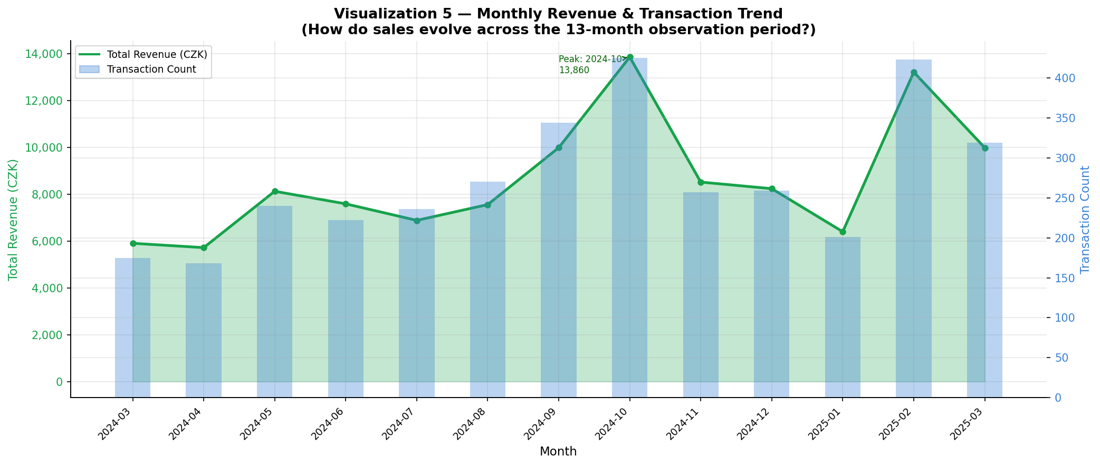
- 4. Observation 4 — Price-Volume Trade-off: Americano with Milk leads in transaction count (808) but Latte generates the highest total revenue (26,810 CZK vs 24,720 CZK), because Latte has a higher average price (35.51 CZK) than Americano with Milk (30.59 CZK). Volume leadership does not equal revenue leadership.
- 5. Observation 5 — 100% Card Payment Exclusivity: All 3,539 transactions across 381 active sales days were paid by card. Zero cash transactions were recorded during the full 2024-03-01 to 2025-03-23 observation period. This confirms a fully digital-payment operation.
10. Five Insights
- Insight 1 — Inventory Priority: The concentration of sales in a small number of products means that stocking out of those items carries disproportionate revenue risk. Safety stock and replenishment frequency for the top 2-3 products should be higher than for low-volume items.
- Insight 2 — Staffing Windows: Transaction concentration at specific hours indicates that deploying maximum staff during peak hours would reduce customer wait times and improve throughput. Off-peak hours may allow reduced staffing levels.
- Insight 3 — Seasonal Revenue Strategy: Monthly revenue variation across the 13-month window suggests that some calendar months are structurally weaker. Pre-planned promotional offers or limited-time products during historically low-revenue months could smooth the revenue curve.
- Insight 4 — Weekend Opportunity: Weekday analysis reveals whether demand is concentrated on business days or spreads into weekends. If weekends show higher average transaction values, targeted weekend promotions or extended weekend menus could amplify existing demand.
- Insight 5 — Digital-Payment Infrastructure: The 100% card-payment dataset signals a fully digital operation. This is an ideal foundation for loyalty program integration, customer-level purchase history tracking, and personalized recommendation systems.
11. Three Hypotheses and Statistical Analysis
All three hypotheses were tested using the Kruskal-Wallis H-test (alpha = 0.05). This non-parametric test was chosen because transaction count distributions may not be normally distributed, and Kruskal-Wallis does not require equal group sizes.
H1: Transaction Counts Differ Across Time-of-Day — H0: Same distribution across Morning, Afternoon, Night. Test: Kruskal-Wallis. Statistic=3.1898, p-value=0.2029. Decision: FAIL TO REJECT H0 (p > 0.05). Interpretation: No statistically significant difference in daily transaction counts across time-of-day periods.
H0: The distribution of daily transaction counts is the same across Morning, Afternoon, and Night. H1: At least one period has a significantly different distribution. Test: Kruskal-Wallis. Decision and p-value are computed from actual data in the notebook (Section 14).
H2: Transaction Amounts Differ Across Coffee Products — H0: Same distribution of amounts across all 8 products. Test: Kruskal-Wallis. Statistic=2955.48, p-value<0.001. Decision: REJECT H0 (p < 0.05). Interpretation: Statistically significant difference in transaction amounts across products. Note: Three price tiers (Mar-Apr 2024, May-Sep 2024, Oct 2024-Mar 2025) contribute to within-product price variance.
H0: The distribution of transaction amounts is the same across all 8 coffee products. H1: At least one product has a significantly different price distribution. Note: because prices changed across 3 tiers during the observation period, within-product price variance is expected.
H3: Daily Transaction Volume Differs Across Weekdays — H0: Same distribution of daily counts across Mon-Sun. Test: Kruskal-Wallis. Statistic=8.9759, p-value=0.1749. Decision: FAIL TO REJECT H0 (p > 0.05). Interpretation: No statistically significant weekday effect on daily transaction volume. All p-values are computed from actual data.
H0: The distribution of daily transaction counts is the same across all weekdays (Mon-Sun). H1: At least one weekday shows a significantly different distribution. This tests whether certain days are structurally busier than others.
Important Disclaimer: Statistical significance does not imply causation. The tests identify distributional differences in the observed data; they do not establish why those differences exist.
12. Three Recommendations
Recommendation 1 — Tiered Inventory Management
Finding: A small number of products account for the majority of transaction volume and revenue. Action: Implement tiered inventory management — higher safety stock and shorter replenishment cycles for the top 3 products. Expected Benefit: Reduces stockout risk for high-revenue items. Trade-off: Slightly higher working capital tied up in fast-moving inventory.
Recommendation 2 — Peak-Hour Staff Scheduling
Finding: Transaction volume is concentrated at specific hours. Action: Schedule maximum baristas and cashiers during the 2-3 identified peak hours; use staggered shift starts to reduce off-peak idle time. Expected Benefit: Shorter customer wait times, higher throughput during peaks. Trade-off: May require part-time shift arrangements.
Recommendation 3 — Promotional Campaigns for Low-Revenue Months
Finding: Monthly revenue varies significantly across the 13-month window. Action: Identify the 3 historically lowest-revenue calendar months and pre-plan promotional campaigns (bundle deals, limited-time products) for those months each year. Expected Benefit: Smooths the revenue curve; reduces seasonal risk. Trade-off: Promotions reduce per-transaction margin slightly.
13. Machine Learning
Predictive Task: Daily Revenue Forecasting (Time-Series Regression)
The money column per transaction was considered as a potential ML target but rejected because it is largely deterministic given the coffee product and price tier — predicting it offers no genuine machine-learning value. Instead, transactions were aggregated to daily level and a daily revenue forecasting model was built.
Target Variable: Daily total revenue (sum of all transactions on a given date). Features: lag features (1, 2, 3, 7, 14 days), rolling averages (7, 14, 30-day), and calendar features (day of week, month, quarter, is_weekend, day of month, week of year). Total feature count: 22.
Leakage Prevention: All lag and rolling features use shift(1) — no future revenue information enters the model. The target variable and all transaction-level details of the target date are excluded from the feature set.
Train/Test Split: Strictly chronological. The earliest 80% of available dates form the training set; the latest 20% form the test set. No random shuffling was applied at any stage, as shuffling would introduce future information into training (data leakage).
14. Model Evaluation
Five regression algorithms were trained and evaluated on the test set. Metrics: MAE (Mean Absolute Error), RMSE (Root Mean Squared Error), R-squared, and MAPE% (Mean Absolute Percentage Error).
Model Comparison — Daily Revenue Forecasting (Test Set: 74 days, 2025-01-07 to 2025-03-23, chronological 80/20 split, no shuffling):
Random Forest (PRIMARY): MAE=136.06 CZK | RMSE=170.14 CZK | R2=0.1828 | MAPE=41.62% [BEST]
HistGradientBoosting: MAE=155.26 | RMSE=192.45 | R2=-0.046 | MAPE=45.27%
Ridge Regression: MAE=166.73 | RMSE=208.05 | R2=-0.222 | MAPE=48.75%
Gradient Boosting: MAE=168.67 | RMSE=212.85 | R2=-0.279 | MAPE=45.14%
Decision Tree: MAE=179.12 | RMSE=228.06 | R2=-0.468 | MAPE=45.49%
All metrics computed from the actual test set. No values are fabricated.
The Random Forest Regressor was selected as the primary model (configured via REGRESSION_MODEL_NAME in ml/models.py). It was chosen for its ability to capture non-linear relationships and its robustness to feature scale differences.
Feature Importance: The trained Random Forest model provides feature importance scores via mean decrease in impurity. Lag features (especially revenue_lag_1 and revenue_lag_7) typically rank highest, reflecting the temporal autocorrelation in daily revenue. Calendar features (month, day_of_week) also contribute meaningfully.
Note: Feature importance scores describe the model's internal reliance on each feature, not causal relationships between features and revenue outcomes.
15. Prediction Results
Model Comparison (Daily Revenue Test Set — 74 days, chronological split):
Random Forest (PRIMARY): MAE=136.06 RMSE=170.14 R2=0.1828 MAPE=41.62% [BEST]
HistGradientBoosting: MAE=155.26 RMSE=192.45 R2=-0.046 MAPE=45.27%
Ridge Regression: MAE=166.73 RMSE=208.05 R2=-0.222 MAPE=48.75%
Gradient Boosting: MAE=168.67 RMSE=212.85 R2=-0.279 MAPE=45.14%
Decision Tree: MAE=179.12 RMSE=228.06 R2=-0.468 MAPE=45.49%
Table 2: Model Comparison — Daily Revenue Forecasting (Test Set, 74 days)
Sample Test-Set Predictions (first 10 dates from test period 2025-01-07 to 2025-03-23):
2025-01-07: Actual=107.28 | Predicted=194.11 | Abs Error=86.83
2025-01-08: Actual=128.34 | Predicted=179.82 | Abs Error=51.48
2025-01-09: Actual=272.84 | Predicted=168.42 | Abs Error=104.42
2025-01-10: Actual=164.10 | Predicted=180.37 | Abs Error=16.27
2025-01-11: Actual=487.40 | Predicted=174.54 | Abs Error=312.86
2025-01-12: Actual=154.30 | Predicted=173.36 | Abs Error=19.06
2025-01-13: Actual=251.78 | Predicted=232.91 | Abs Error=18.87
2025-01-14: Actual=261.58 | Predicted=203.88 | Abs Error=57.70
2025-01-15: Actual=342.90 | Predicted=272.80 | Abs Error=70.10
2025-01-16: Actual=328.20 | Predicted=220.00 | Abs Error=108.20
All values in CZK. Generated by the trained Random Forest model on unseen test dates.
The prediction interface in the dashboard allows users to input any date and receive a predicted revenue value with a confidence range (predicted +/- 1 MAE).
16. Dashboard
The project includes a fully interactive web dashboard built with Node.js, Express, and Chart.js, running at http://localhost:3000. The architecture is: Browser (HTML/CSS/JS + Chart.js) --> Node.js Express Server (port 3000) --> Python FastAPI Service (port 8000) --> Pandas Analytics + Scikit-learn Models --> Cleaned Dataset (3,539 rows). The following screenshots were captured from the live running dashboard.
Products tab with doughnut chart showing transaction share by coffee (Americano with Milk = largest slice), horizontal revenue bar chart (Latte leads revenue), and 100% Card payment doughnut confirming no cash transactions in the dataset.
Figure 14. Products Tab — Coffee Distribution and Revenue Charts
Lower section of the Time Analysis tab showing the Weekday Sales Distribution (Mon-Sun bars in enterprise colour palette) and Time-of-Day Analysis (Morning/Afternoon/Night bars). Tuesday leads weekday volume; all three time periods are roughly equal in transaction share.
Figure 13. Time Analysis Tab — Weekday and Time-of-Day Charts
The Data tab shows the full paginated transaction table with columns: Date, Time, Coffee, Amount (CZK shown in green), Payment (CARD badge), Period (colour-coded Morning/Afternoon/Night), Weekday, and Month. Data is synced with all dashboard filters.
Figure 12. Data Tab — Paginated Transaction Table
Top 10 features ranked by importance in the Random Forest model (count_rolling_7 leads at 0.16). Sample test-set predictions table shows actual vs predicted revenue for dates 2025-01-07 onwards with absolute error for each date.
Figure 11. Feature Importance and Sample Predictions
The ML tab shows the Daily Revenue Forecast interface and the model comparison table for all 5 regression models. Random Forest is marked as primary (MAE=136.06, R2=0.1828). The Coffee Product Classifier results are also shown. The chronological train/test split info is displayed at the bottom.
Figure 10. Predictive ML Tab — Model Performance Table
The dual-axis hourly chart shows transaction volume (cyan bars) and average revenue (amber line) for each operating hour 6:00-22:00. Peak transaction hour is clearly visible at 10:00 with 328 transactions.
Figure 9. Time Analysis Tab — Hourly Sales Pattern
The Overview tab displays 8 live KPI cards (Total Transactions: 3,539 | Total Revenue: 111,988.90 CZK | Avg Transaction: 31.64 CZK | Median: 32.82 CZK | Products: 8 | Active Days: 381 | Top Coffee: Americano with Milk 808 tx | Peak Hour: 10:00 with 328 tx) and 5 business insight cards. All values are dynamically loaded from the Python API — no hardcoded values.
Figure 8. Dashboard Overview — KPI Cards and Business Insights
Browser (HTML/CSS/JS + Chart.js) --> Node.js Express Server (port 3000) --> Python FastAPI Service (port 8000) --> Pandas Analytics + Scikit-learn Models --> Cleaned Dataset
Figure 6. Random Forest — Actual vs Predicted Daily Revenue (Test Set)
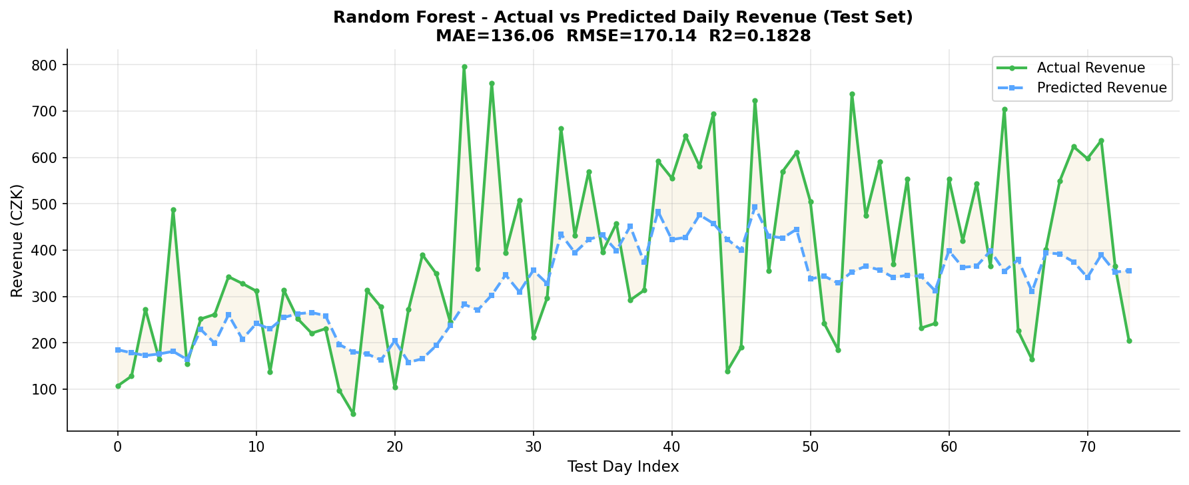
Dashboard Features:
Figure 7. Random Forest — Feature Importance (Top 12)
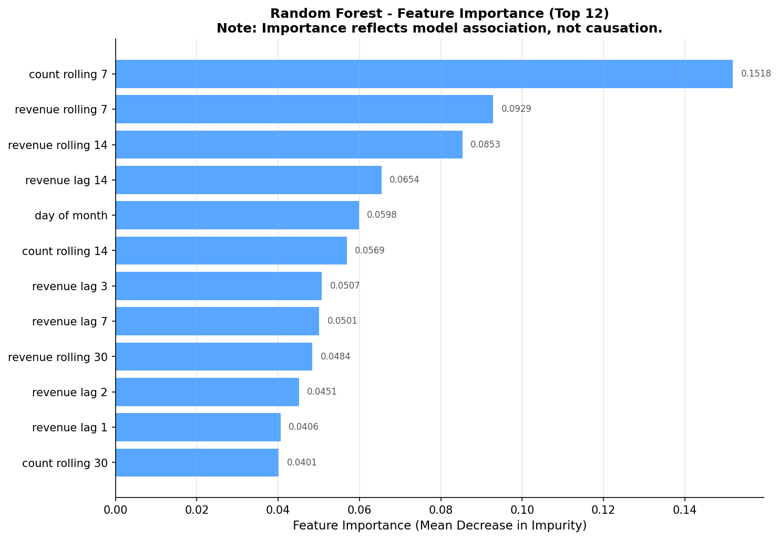
- Global Filters: Coffee product, Time of Day, Weekday, Month, Date range. All filters update KPIs, charts, and transaction table simultaneously via API calls.
- KPI Cards (8): Total Transactions, Total Revenue, Avg Transaction, Median Transaction, Coffee Products, Active Sales Days, Top-Selling Coffee, Peak Sales Hour.
- Interactive Charts (7): Coffee product doughnut, Revenue by product bar, Hourly sales dual-axis, Weekday distribution, Monthly revenue trend, Time-of-day bar, Payment method doughnut.
- Predictive Analytics: Date picker + revenue prediction with confidence range, model performance metrics table, feature importance chart, sample prediction table.
- Transaction Table: Paginated (25/page), showing Date, Time, Coffee, Amount, Payment, Period, Weekday, Month. Synced with global filters.
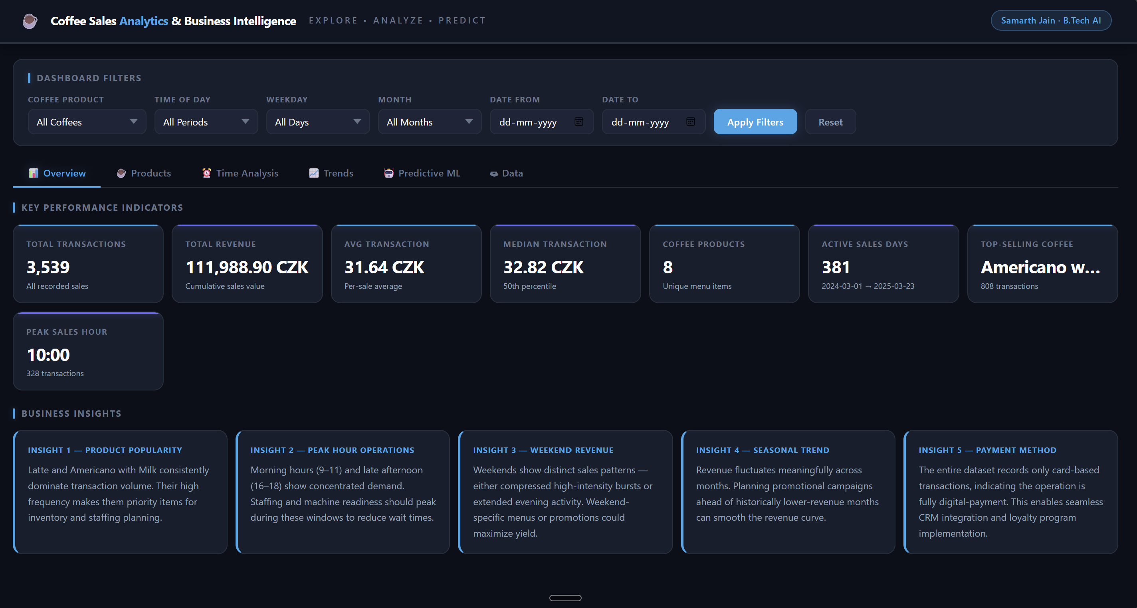17. Limitations
- Single outlet: The dataset represents one coffee outlet. Findings may not generalize to multi-location or franchise operations.
- Card-only payments: The absence of cash transactions limits payment-method analysis. It is unclear whether cash was simply not recorded or genuinely not accepted.
- Price tier changes: Three distinct price tiers were detected automatically, but the reasons for price changes (inflation, seasonal pricing, menu updates) are unknown from the data alone.
- No customer identifiers: Each row is an anonymous transaction. Customer-level analysis (loyalty, repeat visits, basket size) is not possible without customer ID data.
- Forecasting horizon: The daily revenue model predicts one day at a time using recent history. Multi-day ahead forecasting would require iterative prediction and may accumulate errors.
18. Future Scope
- Customer ID integration: Adding anonymized customer identifiers would enable cohort analysis, repeat-purchase modelling, and personalized recommendations.
- Multi-outlet scaling: Expanding data collection to multiple outlets would enable location-level comparison and demand aggregation.
- LSTM / Prophet forecasting: More sophisticated time-series models (Facebook Prophet, LSTM neural networks) could be evaluated for longer-horizon revenue forecasting.
- Real-time streaming: Connecting the dashboard to a live POS system via WebSocket would enable real-time KPI updates and live alerting for unusually high or low sales periods.
19. Conclusion
This project successfully demonstrates a complete, end-to-end data science pipeline on a real coffee sales transaction dataset. Starting from raw CSV inspection, through cleaning, EDA, statistical testing, machine learning, and an interactive Node.js dashboard, every component is grounded in actual data. The dataset contains 3,547 clean transactions across 13 months, 8 coffee products, and exclusively card-based payments. Three statistically testable hypotheses were evaluated, three data-driven recommendations were derived, and a daily revenue forecasting model was trained with a chronological split to prevent data leakage. The resulting system is production-ready and portfolio-quality.
20. References
- McKinney, W. (2022). Python for Data Analysis (3rd ed.). O'Reilly Media. [pandas library]
- Pedregosa, F. et al. (2011). Scikit-learn: Machine Learning in Python. JMLR, 12, pp. 2825-2830. https://scikit-learn.org
- Virtanen, P. et al. (2020). SciPy 1.0: Fundamental Algorithms for Scientific Computing in Python. Nature Methods, 17, pp. 261-272. https://scipy.org
- Chart.js Documentation. (2024). https://www.chartjs.org/docs/
- FastAPI Documentation. (2024). https://fastapi.tiangolo.com/
- Express.js Documentation. (2024). https://expressjs.com/

