Git Hands-on Lab Report
Exercise 5: Clean Up and Push Back to Remote Git

Objective
Verify the repository is clean, list branches, pull latest changes from the remote repository, push pending changes (if any), and verify the remote repository state.

Step 1 - Verify repository status
Verified the working tree was clean and synchronized with origin/master.
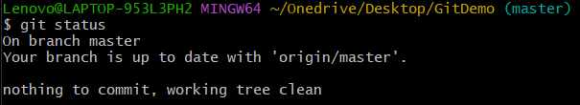

Step 2 - List branches
Listed available branches. Only the master branch exists.
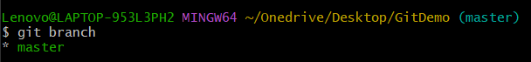

Step 3 - Pull latest changes
Pulled the latest changes from the remote repository. Repository was already up to date.
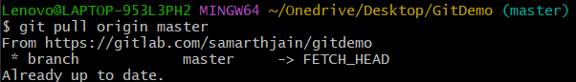

Step 4 - Push changes
Pushed local repository to GitLab. No pending commits; everything was up to date.

Step 5 - Verify on GitLab
Verified that the repository on GitLab reflects the latest commits and project files.
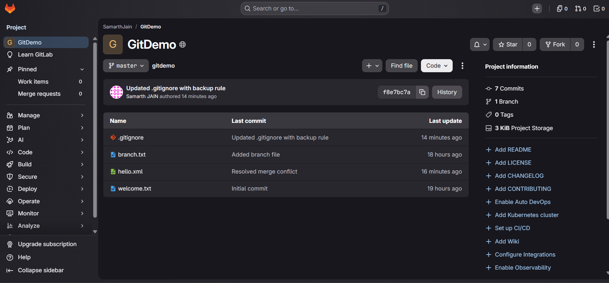

Result
The Git repository was successfully verified, synchronized with the remote GitLab repository, and all changes were confirmed on the remote repository.

