Week 6 - Git Exercise 1 Lab Report
Name: Samarth Jain
Course: Cognizant Digital Nurture 5.0 - Java FSE
Week: 6
Exercise: 1

Objective
To learn Git configuration, repository creation, file tracking, committing changes, and connecting a local repository with GitLab.

Verify Git Installation
Executed: git --version
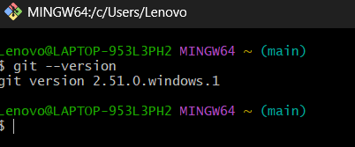

Configure Username and Email
Executed git config commands.
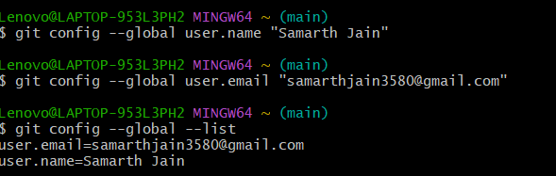

Verify Git Configuration
Executed git config --global --list.
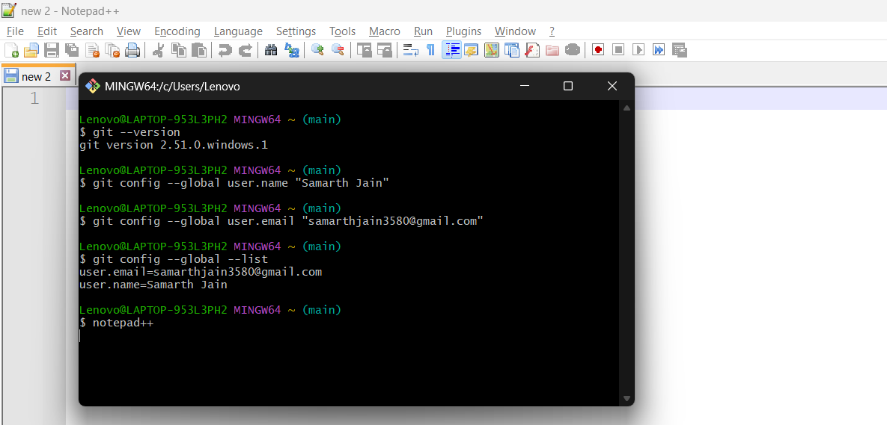

Configure Notepad++
Configured Notepad++ as default editor.
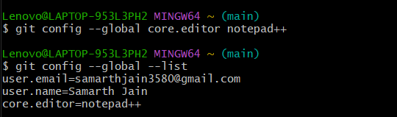

Navigate to Desktop
Verified location using pwd.
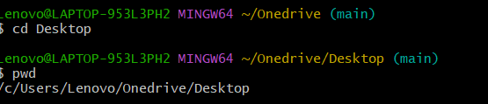

Create GitDemo Folder
Created directory using mkdir.
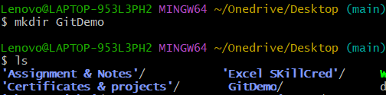

Open GitDemo
Changed directory and verified path.
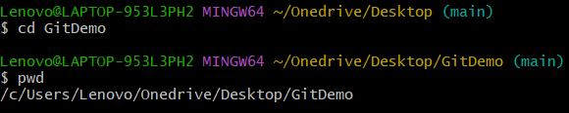

Initialize Repository
Executed git init.
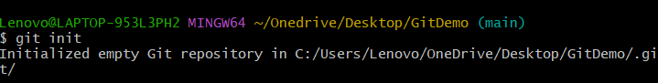

Verify .git
Executed ls -la.
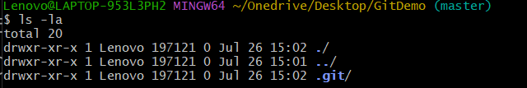

Create welcome.txt
Created and viewed welcome.txt.
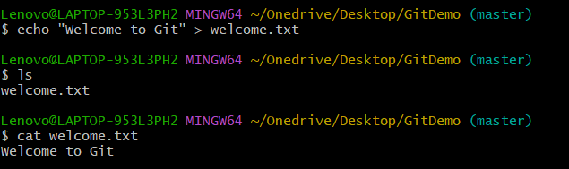

Git Status
Verified untracked file.
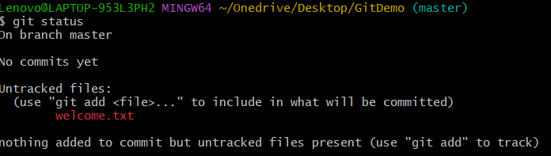

Stage File
Executed git add welcome.txt.
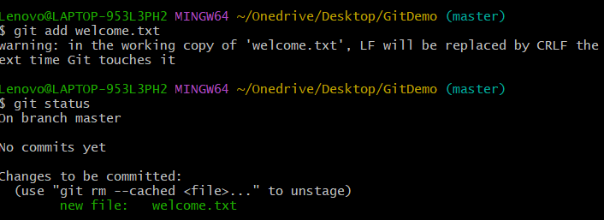

Initial Commit
Executed git commit.
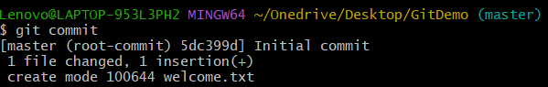

Create GitLab Project
Created blank GitLab project.
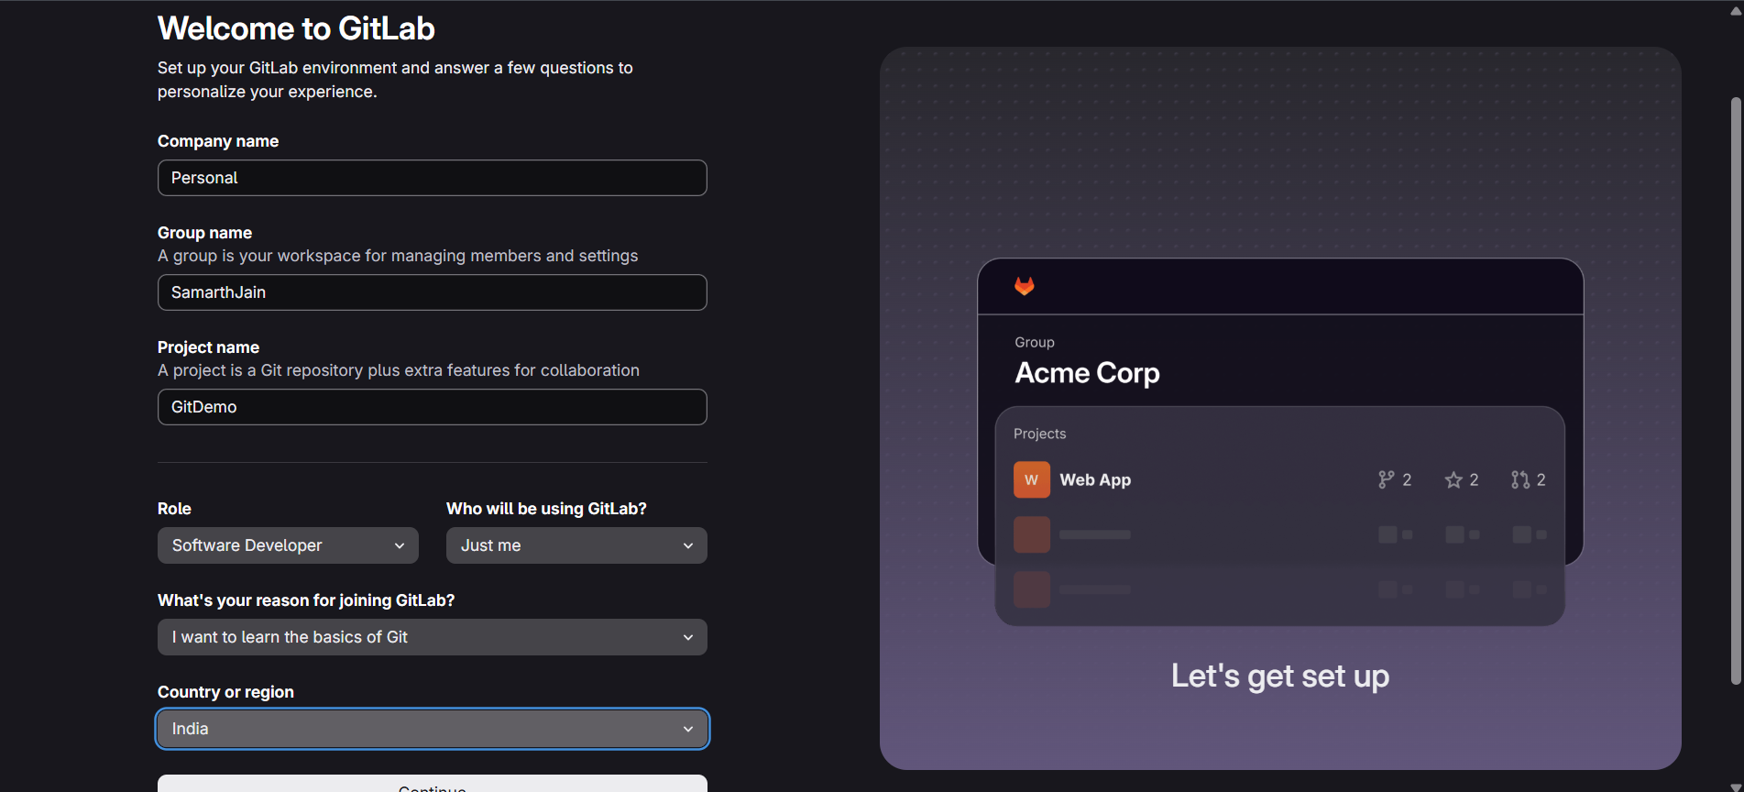

Add Remote
Executed git remote add origin.
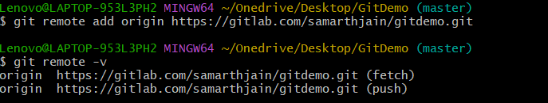

Verify Remote and Project
Verified remote URL and project.
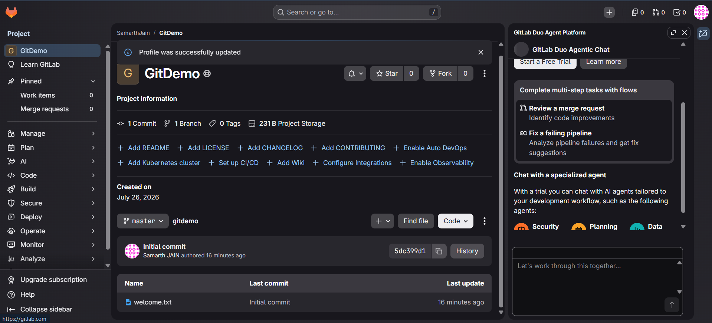

Result
Successfully configured Git, created a local repository, committed a file, created a GitLab repository, and linked the local repository with the remote repository.

