COGNIZANT DEEP SKILLING – WEEK 6

Exercise 2: Git Ignore

Objective
To learn how to use the .gitignore file to ignore unwanted files and folders in a Git repository.

Prerequisites
- Git installed and configured.
- Notepad++ configured as the default Git editor.
- Existing local Git repository (GitDemo).
- GitLab repository connected to the local repository.

Procedure
Step 1: Opened the existing GitDemo repository.
Step 2: Created app.log and a log directory containing error.log.
Step 3: Verified that Git detected these files as untracked.
Step 4: Created a .gitignore file.
Step 5: Added '*.log' and 'log/' entries.
Step 6: Verified that ignored files no longer appeared in git status.
Step 7: Staged and committed the .gitignore file.
Step 8: Pushed the commit to GitLab and verified the repository.

Execution Screenshots
Screenshot 1: git status showing app.log and log/ as untracked files.
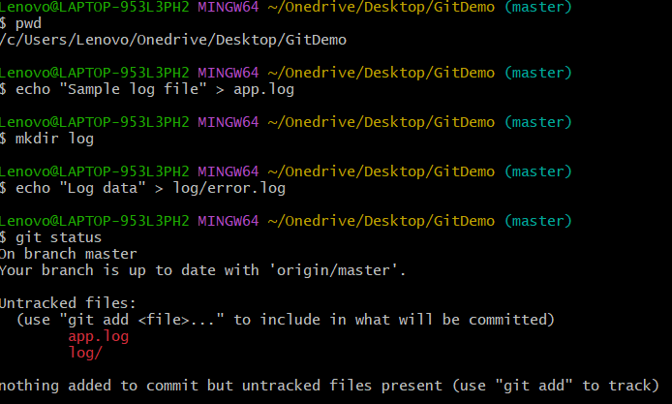
Screenshot 2: Contents of the .gitignore file.
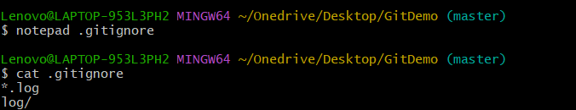
Screenshot 3: git status showing only .gitignore.
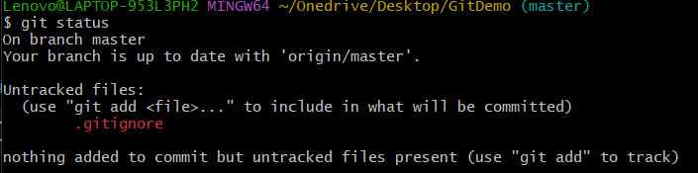
Screenshot 4: Staging .gitignore using git add.
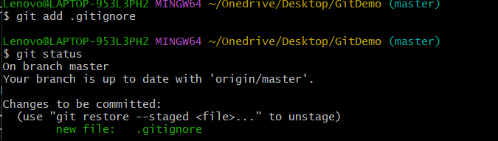
Screenshot 5: Successful commit of .gitignore.
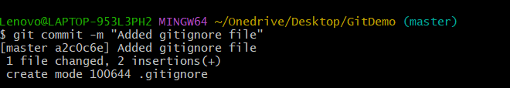
Screenshot 6: GitLab repository after pushing the changes.
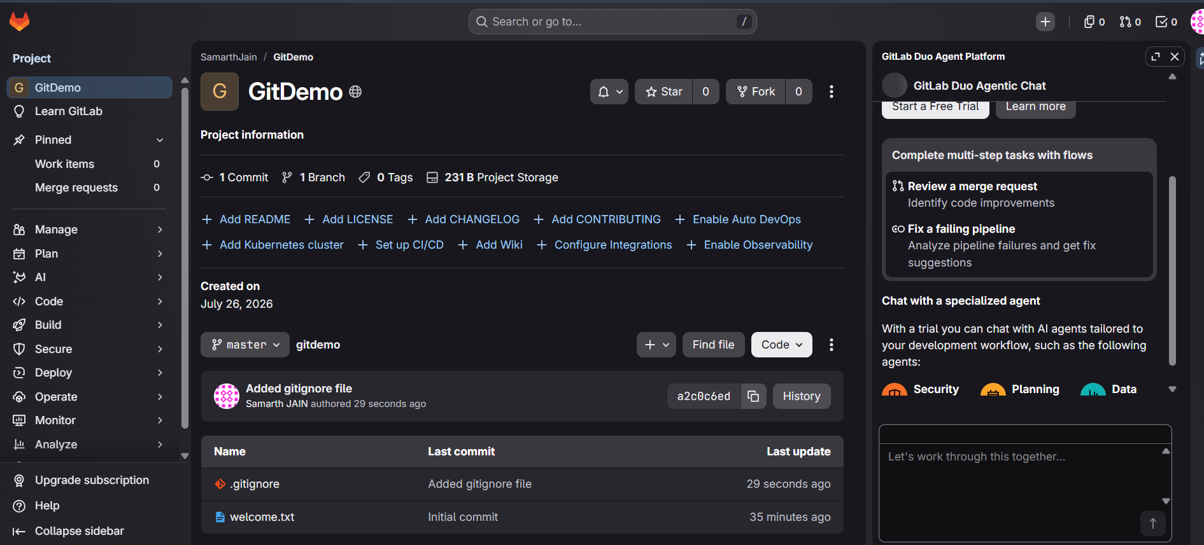

Result
The .gitignore file successfully ignored all .log files and the log directory. Only the required project files were tracked and committed.

Conclusion
This experiment demonstrated the use of .gitignore to exclude unnecessary files and folders from version control and keep the repository clean.

